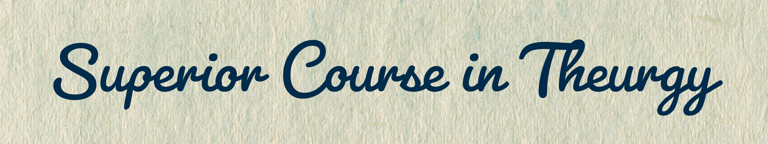
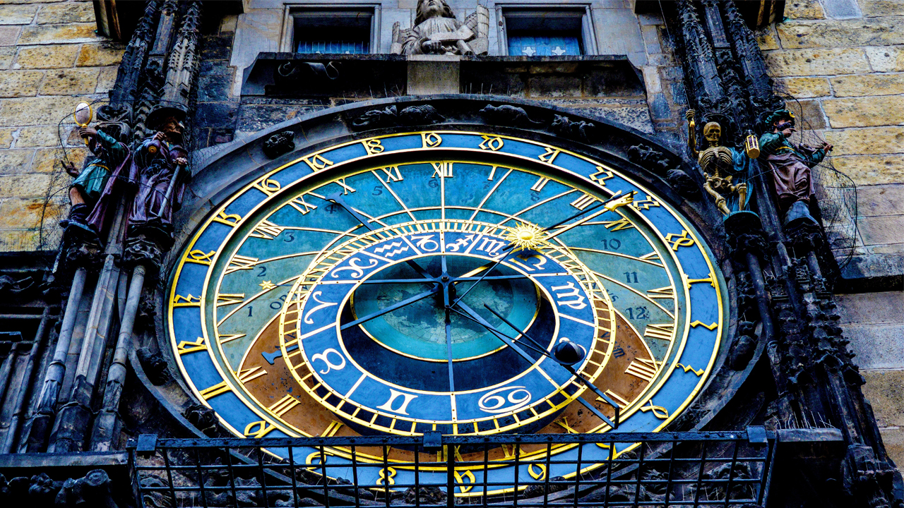
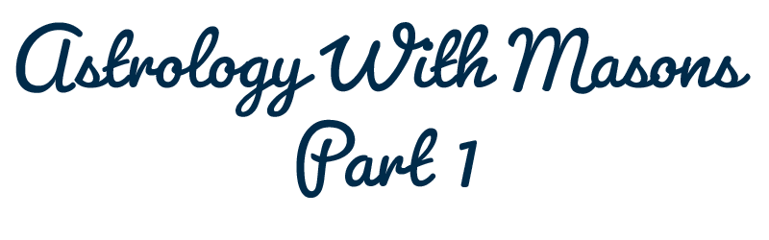




By Ven. Master T. A-O Domingo Días Porta

O
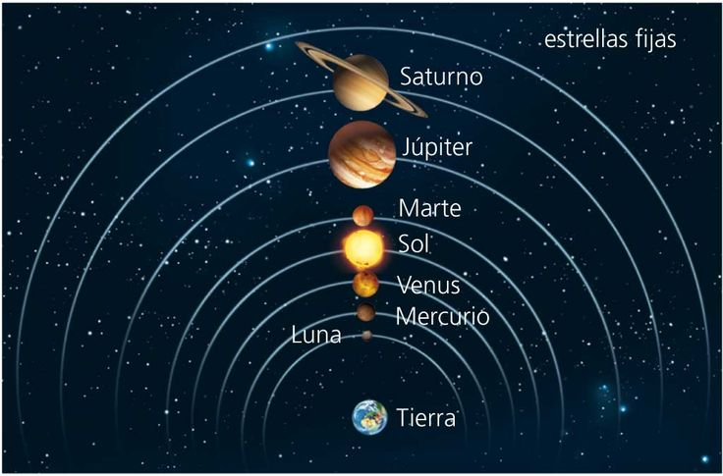
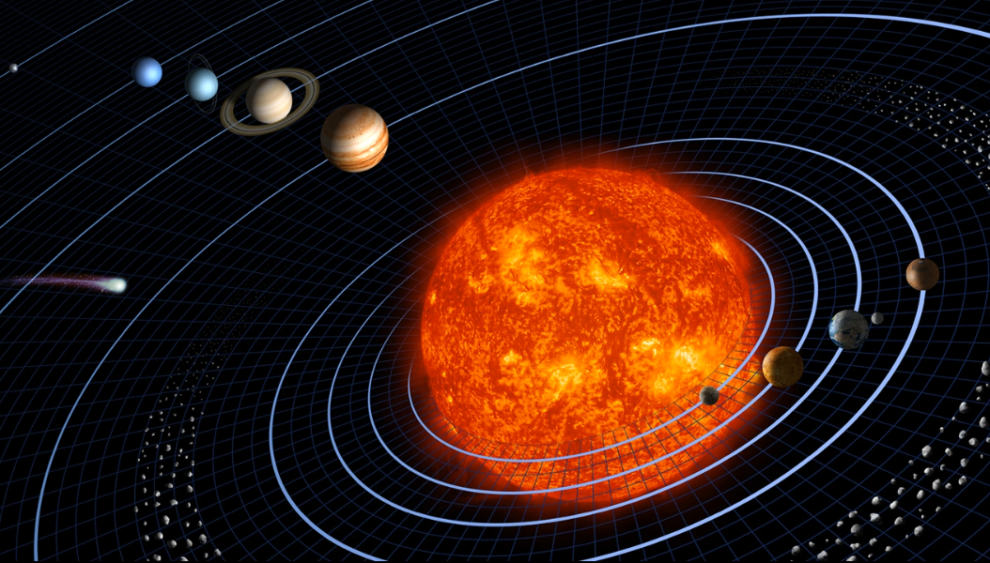
ne main basic difference for when you talk to an astronomer is that astronomy is heliocentric. It puts the Sun as the center, and astrology is geocentric, the Earth is in the center. Because the idea is, as you say, astrology studies the influences on Earth. Thus, the Earth is the central theme and the other stars revolve around the Earth; instead, astronomy studies the heliocentric system, the Sun at the center, which is an astronomical reality.

Yes, the subject of Astrology is different from the subject of Astronomy. Astronomy studies, let's say, the anatomy of the stars: size, distance, speed, chemical composition, distance from the Sun, etc. And Astrology studies the psychology of the stars: how it affects us when there is a full moon, when there is a new moon, when Mars is in a fire sign, and so on.
It’s like the person, the anatomist of the human being, what he knows are organs, kidneys, liver, but he does not study psychology. Yes, he does not know the human being as a being, because he knows only the body. On the other hand, psychology studies the human being independently of the physical part, as a center, then. Of course, psychology understands very well that a liver disorder alters the character, there is no separation in reality. We are, as they say in psychology, a human being is a biopsychosocial unit: "bio", biological. We cannot deny that we are..., "psyche", the psychological and social part, because we are shaped by the environment. We are people of the twentieth century, of a mestizo society, with a lot of European influence, denying what is ours; our culture, our languages, we ignore them.
So, we are modeled like this, half-Europeans, but since we are not in Europe, well, we do not understand each other. We are, as Simón Bolívar said, we are a strange graft, we are neither Natives, nor whites, nor blacks. Bolívar said, and that is true, we have not defined ourselves because we have in the blood, in the genetic code, we have the three inheritances. But, of course, in deep psychology, I would say, one has the right, if I have three inheritances, I have the right to choose the one that interests me. And so, I decided for the Native, and I activate my Native genetic code. There are people who say, “I come from the Spaniard such”, from the conqueror, the hero who killed ten thousand Natives and they feel proud, they chose the white genetic code. And others are defined by the black[genetic code}. Well, that's the part... let's say, the study of the Being.
So, the main difference for the starting point between Astrology and Astronomy is that Astrology takes the Earth as its center, studies the apparent movement of the sun around the Earth, the planets, the stars. And then, we say in astrology that the sun is born in the east and astronomy says, no, the sun is not born, it is that the Earth moves from west to east, and it seems that the Sun rises; but be that as it may, the fact is that the Sun appears in the east in the morning. Whether one says that the Sun rises or that the Earth goes down, then astrology is realistic, isn't it?
Well, another important point is that Astrology is based on the signs of the Zodiac that we call intellectual zodiac, these twelve signs of the same size all, of 30° of arc each, these are not stars, they are signs. The constellations of the Zodiac, on the other hand, there are some that are large, and others are small, those are not cut like this [the zodiac], this is a human concept and as in so many things, the human puts its focus.
Well then, Astrology considers the stars and planets that exist. This comes to be like a calendar, which I told you the other day, a more scientific calendar than the calendar we use now, which is the Gregorian Calendar, which says it begins on the first of January. There is no astronomical phenomenon that justifies that on the first of January the year begins. It is a Christian and political question, that January, January, what?
"No, I don't know," replies a student.
What indication does the month of January give us for our lives?
"From Janus," replies another student.
Yes Janus, which, in the old... in ancient times, in the Roman Empire, in Greece, etc., that month was dedicated to Janus, Janus in Latin.
January says nothing, the God Janus, who knows about the God Janus here? Who in January worships God Janus?
"No, no, I don't, nobody," says one person.
Who takes into account what Janus represents? February, February, the Shrovetide of Ancient Rome. In March. People live a mechanical time that is not reality, because time fluctuates: spring, summer, autumn, full moon, new moon, sunrise, noon, sunset, and so on. Time is rhythmic, like a dance, it changes; at a party the pieces change. That is time, but people in this civilization live in a mechanical time. They are not interested if its January or February.
On the first of January, what do people say? New Year, new life. Then, at fifteen days they follow the same routine as always. "New Year", it is the same old year with an appearance, because the first days of January, he puts on new clothes, but there is no such attitude. What could be the real New Year? Our birthday. There begins a new year for each of us, which adds to our years, but the first of January does not give us any indication. In astrology, on the day of the birthday one sees how the planets are placed, compares with one’s horoscope, to see what indications one can take to the new year. But it is useless to call the New Year on the first of January. People do not take provisions because they do not have this knowledge.
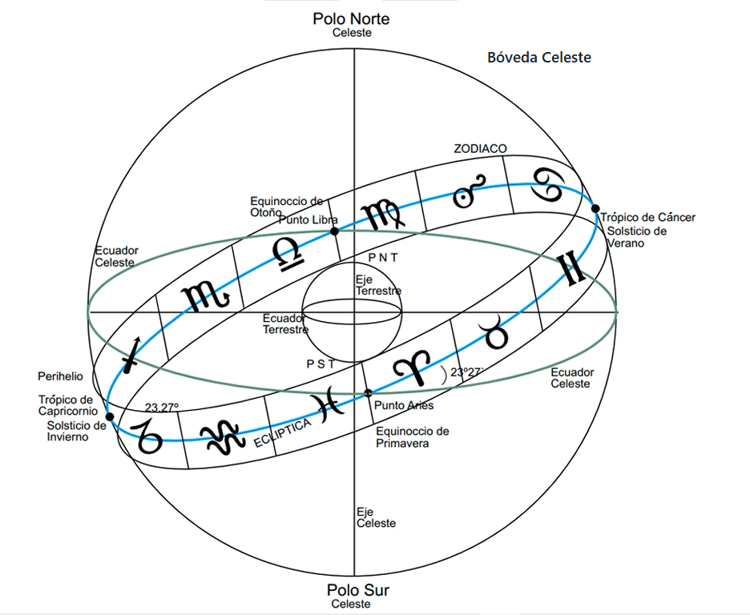
Well, so this is the calendar, this represents, astronomically, this intellectual zodiac. It is the ecliptic that the Sun travels in its apparent movement around the Earth. The track of the sun is divided into twelve months, because in a year the Sun goes around the Earth. Of course, the Earth is the one that travels around, but astrologically all the stars, the whole universe revolves around the Earth for this study. So, this is the track of the sun that is divided into twelve sectors, twelve months, scientifically. So, March 21 begins... Which one, which sign begins? Aries, I Am, that is the month of Aries. Instead of March, March does not tell us anything. Aries tells us that it is a sign of fire, spring begins, the earth warms up, the snow melts. What else does Aries say? It is a cardinal sign. Cardinal are the signs of the four seasons, Aries, spring; Libra, autumn; Cancer, summer; Capricorn, winter.
Cardinal, the key word of the cardinal sign, is Activity. They are those who bring activity to Earth. Those born in those signs are active, restless. What else does Aries tell us? A positive sign, of positive polarity. What does that mean? Positive and negative does not mean that it is good and bad. Positive is extroverted, outward, likes to be... When he is alone he gets annoyed, he goes out to the street. And negative means a more intense life internally. When he is alone he takes advantage, "Now I am going to study because nobody is going to interrupt me. I am going to meditate. I am going to paint ..." What else does Aries tell us? It is ruled by what planet? By Mars. What is Mars astrologically? Struggle, war, male strength.
That is worthy of study because for the Mayans, Venus was the planet of war, because Venus is closer to the Sun; it is very hot, the temperature is higher than that of Mercury. Mercury is closer to the Sun and yet Venus is hotter than Mercury, because of the atmosphere of Venus, which is a very dense atmosphere, thus it accumulates more heat, stores more heat. But, well, that's a matter of study.
The ruler is Mars, the key word: I Am. I am very individualistic, because I am like that, nobody is going to change my way of being. They like to stand out. And so, this give us a series of indications. Which planets are exalted? Because Mars is ruler of Aries, it is called the regency. What is the regency of Taurus? Venus. What is the regency of Gemini? Mercury, etc. That is a planetary dignity, but there is another dignity which is exaltation, a sign where the planet has a lot of strength and is not the ruler.
So, which one is exalted here, in Aries? Which is the one that has a lot of strength at the beginning of Spring? The Sun. The Sun is exalted in Aries, then, those of Aries are socially brilliant, their personality stands out. And thus, we can deepen, based on the keys. There are some who start inventing things that are not. With the key "I Am" then, the person can say, "I am like that...", etc.
Now let's see. So, it is clear, then, that this represents the ecliptic, the space that the sun travels around the Earth, in time. Three hundred and sixty-five days divided into twelve months (twelve sectors).
So, the signs. "I am from Aries because I was born from March 21 to April 20." Everyone who was born there is from Aries, the month. Aries is the name of the month, instead of March or April. Aries begins on March 21, the last week of March. Aries is more in April, three weeks of April. For the constellations, Astrology has another study, which we will see later, and the planets.
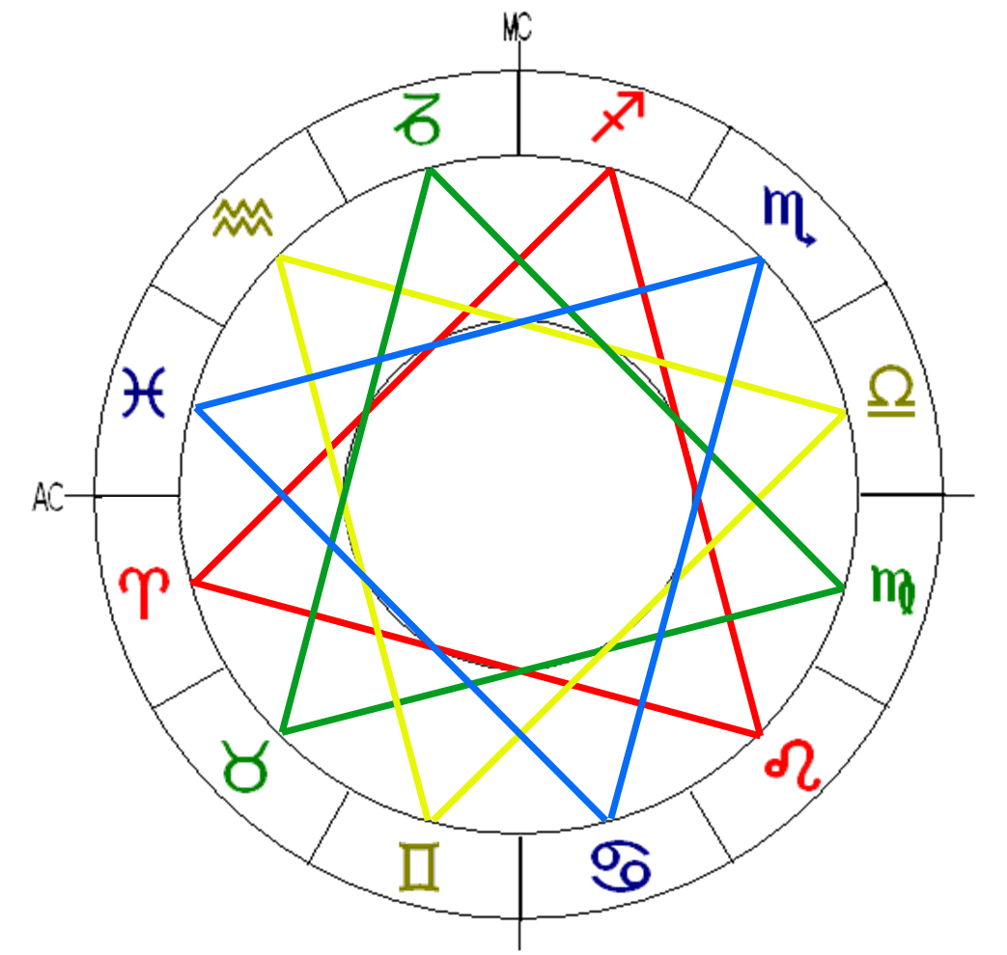
Well, then, it's important to look at the ranking because it has a system completely... let's say, geometric. Those painted in red are signs of fire, of the triangle of fire, an equilateral triangle. Then come the earth signs, in green, an equilateral triangle ... of earth. Those of air in yellow, and those of water in blue. These are the four triangles of the elements. In this sense we can say that there is an evolutionary process in the elements. Aries is the first sign of fire because it is when the year begins, it is a "childish" fire. Those of air are playful, they are... They like to have fun, to have friends. Leo is an adult fire, he has the ability to direct, he has the gift to command spontaneously, so they have ... what is that called, when people follow someone without being imposed? Charisma. Bolivar, Napoleon, Chavez, in short... those have stood out in the political and military part. But others stand out in art, like Beethoven who was Leo, or in philosophy, and so on. Well, then, this is the adult fire.
Sagittarius is the old fire, the fire that breaks off from the world, that doesn't want to lead anyone, doesn't want to stand out. So, what is the figure of Sagittarius like? A centaur, Chiron, a centaur. And what is the centaur figure like? Half beast, half man. And what is he doing? Pointing towards Heaven. It is the fire of the ideal, of overcoming, of liberation, but it represents humanity too, the lower part, the part of the horse, of the beast, the part of humanity then, that runs wild, that lets itself be carried away by passions, by ambitions, because it does not have self-control. The human part that is pointing to Heaven is also humanity, that part of humanity that aspires to improve, both personal and for a better world, and who fights for an ideal, ecological balance, global warming, peace, etc.
Aries, what figure is it? The ram, what is the ram like? In attitude, then, impulsive, yes, aggressive. Leo, the lion, king of the jungle, imposes.
This is then, the classification by the elements, three fire signs: Aries, Leo, Sagittarius; three of earth signs: Taurus, Virgo, Capricorn; air signs: Gemini, Libra, Aquarius; and water: Cancer, Scorpio, and Pisces. Each of these figures have their psychological meaning; it is a symbolism. Since ancient times it was used and people use it without realizing it; "So-and-so is a meek dove", the other, "Beware, that is a beast", the other, "No, he is a scorpion, he has a poisonous tongue". And, in reality, those popular sayings and this left by the ancient sages has a lot of truth. In our psychology, in our psyche, the evolution of life on Earth is written. We have animals both anatomically and psychologically, socially as well. When the beast is unleashed, well, millions go to war, kill each other.
Well, that's the ranking by the four elements. What is the other classification? Cardinal, fixed, and mutable. What are the cardinal signs? We already said: Aries, Cancer, Libra, and Capricorn, of the four seasons. The fixed: Taurus and its opposite, Scorpio; Leo and its opposite, Aquarius. And half of the rest, those that remain. So, the cardinals there... One of fire, one of water, one of air, and one of earth, and so on. Then, a combination is created: this is cardinal fire, and this is fixed fire, and this is mutable fire. So, fire works in a different way. You have to learn; with the keys, one can advance in astrology. Some start reading in astrology books and the astrologer thinks, that this, that... he puts too much into it. As our Master said would say... “A fertile mind”. They start looking for things and rather entangle the... What you read in magazines about signs, people get tangled.
What appears in magazines, which say, "those of Aries are like that". You gather a thousand people from Aries and they are very different from each other. Ten of Aries are different, that does not exist. Yes, he would be the pure type who had all the planets in Aries when he was born; then it would be. But one is not salad, no, who has the Sun... the one who was born in Aries has the sun in Aries, but you do not know where the other [planets]are. You have to do the calculations.
Well, then, we also have another key to understanding the difference in each sign. Each sign has a cycle: an ascending, culminating, and descending cycle. In astrology they are called decans, it is divided into 10 by 10 degrees. Each decan has a ruling planet. In Aries we have the Sun, the Moon, and Mars. This is an order method, which means that it follows the order of the weekdays. So, look here: Sun, what day is it? Sunday. Monday, the moon; Sunday, Monday, Tuesday, Wednesday... Then, the one who was born in Aries in the first ten days, has the Sun in his decan. Mars is combined with Aries, very violent.
Here it would be Mars with the Moon, very imaginative, and Mars with Mars, a warrior, a soldier, a general. It is also important that you investigate the distance of each planet from the Sun and the length of its year; that is, the duration of the planet's translation around the Sun. The duration of the Earth around the Sun, how much is it? Three hundred and sixty-five and a quarter. Mars almost the same, three hundred and sixty-six, I think. And do you know how long the year of Mercury lasts? Eighty-eight days. And that of Jupiter? Jupiter eleven years [11.9], to circle the Sun. We have been in the Era of Aquarius since 1948. It is supposed to be a very different civilization from the one we experienced in the era of Pisces. What is the main difference between Aquarius and Pisces? Aquarius is an air sign, although the word Aquarius sounds like water, it is air. And Pisces, of course, the word says it.
Then, in the era of Pisces predominated navigation by the sea, discoveries by the sea, naval empires; naval battles were decided at sea. This is the division of the sky, the clues of the... And the houses, they are divisions of the Earth, but not of the Earth geographically, but of human life on Earth. We divide everything that can happen to a person in his life into twelve houses. The first house represents the personality, childhood, among several things. There are many aspects of human life, but it’s general. That division of the houses is determined... Because, for example, you are of Cancer, you have the sun in Cancer, but that does not mean that this is your ascendant. How do you know what your ascendant is? What is the ascendant? It is the sign that is rising in the east at the time the person was born, not the time when the sun rises which is at six in the morning, unless the person was born from six to eight in the morning, then yes.
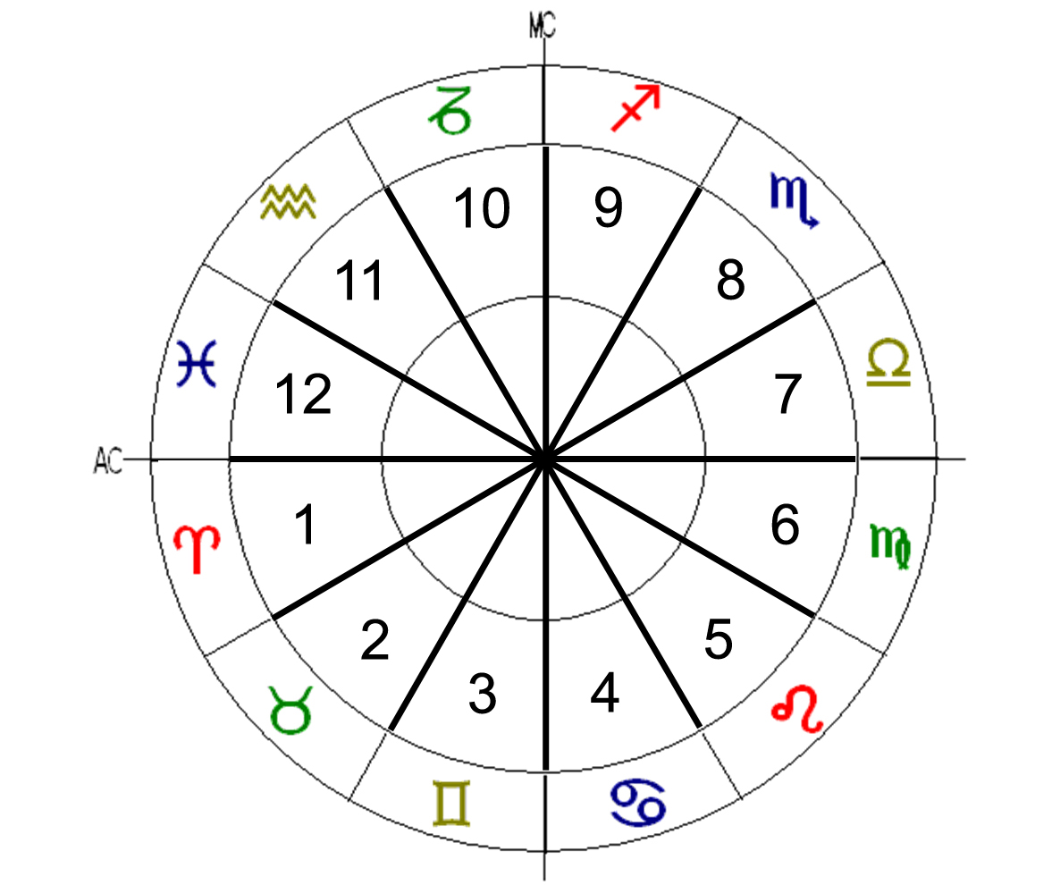
Then comes the second house, the next, the third house... So, the one who has the ascendant, for example, in Aries, is the in the first house, the second house would be the previous one, because I have the first house– I was born in Pisces, but I have the ascendant in Gemini – because I was born at noon. At six the sun rises; if I had been born from six to eight, I would have the ascendant in Aries, from eight to ten, Taurus, and from ten to twelve, in Gemini. I was born at eleven twenty, I have the first house in Gemini, house two in Cancer ... House ten is the one above, at the time I was born, the Midheaven it’s called. That governs destiny, social position. It’s when one stands out, reaches adulthood, maturity, has become a professional and everything; that is the culmination.
And, thus, each house has its meaning. The second house, among many things, what does it mean? Finance. Inheritance is house eight, the opposite is inheritance, and house two is finances. What is the difference between inheritance and finance? That finance is what one achieves for oneself, and inheritance and lottery, etc., are a stroke of luck, without one working for it; one receives an inheritance, wins the lottery and so on. So, house two represents achievements by personal effort, including finances. And so, house three, short trips, and the opposite, house nine, would be long trips. A short trip can be, for example, a short trip is not measured by kilometers, it is measured by the impact that the trip makes on one's life. If I move from Merida to Barinas, and I stay to live there, that is a long trip, because I completely changed my environment, and that affects and influences me; and if I go from here to China for fifteen days, on vacation, it is a short trip, the influence is small.
Well, those are the houses, they are divisions of human life on Earth. Everything that can happen to the human being is divided into twelve houses, following a certain logic, let's say. The important house is where there are planets; where there are no planets, that house does not have much influence. How would you know—a house that has no planets— how would you know how it influences the person? When there is no planet, if house two is for example in Leo, and there is no planet, you have to see where the Sun is, which is the one that governs Leo, and therefore, house two. Then, one sees, that house two of finances, is linked to the house of travel. So, he's going to be a traveling agent, and so on.
The houses that are occupied by planets are the ones that have the most strength. I have four planets in the tenth house, that is: the Sun, Mercury, Venus, and Uranus in the tenth house. The Sun and Mercury in Pisces and Venus and Uranus in Aries, because the houses do not start exactly at 0° of the sign. No, in the first house, the ascendant begins at 20° of Gemini, which includes part of Cancer. So, it means that the strongest house for me is the tenth house, the social position. I have stood out in the Society. In what aspect? Then comes another study, "You've traveled the world, traveled all over the Americas, toured Europe, and so on; carrying the message of the Era of Aquarius, teaching the disciplines, and so on.” So, I'm known like this in spiritual circles. And thus, another may stand out as a great general, so you have to see how the tenth house is and why a general, and so on.

Superior Course in Theurgy, By the Ven. Master T. A-O Domingo Días Porta
All Rights Reserved

