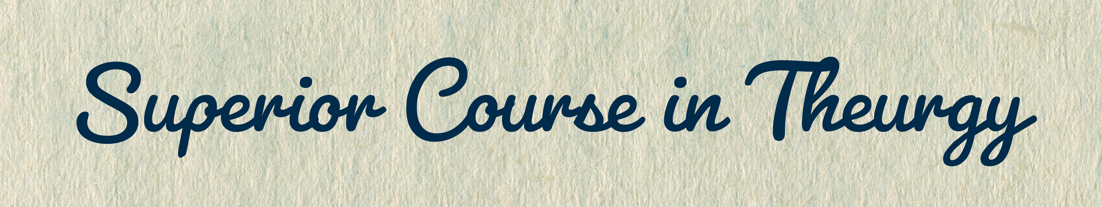
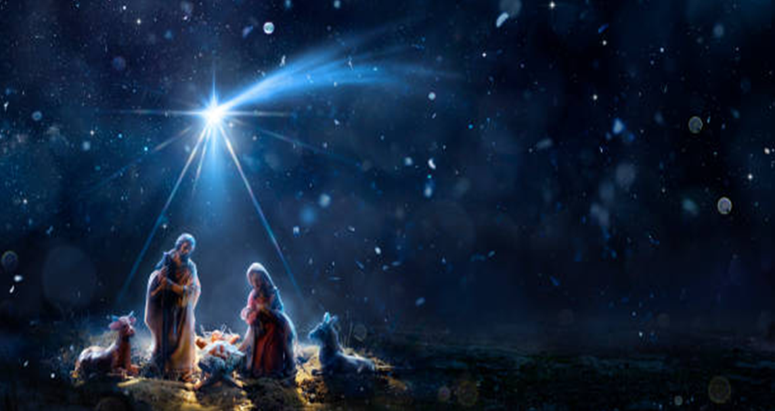





By Ven. Master T. A-O Domingo Días Porta

A
greeting of Christ’s Pash to all of you, to all beings, to all peoples. The most urgent food for Humanity is true peace, the peace that is built in our inner being, inner serenity in the face of the challenges that life presents us in this great academy that is our planet Earth. As every year in the Christian world, we are celebrating Christmas from a spiritual point of view. For some, a profane party, of fun, of gifts, of getaways. And for others, it is a sacred date. In addition to the celebration of the Christian world, a large portion of Christianity throughout the world, we get to present the Initiatic aspect, that is, the deep meaning of the celebration of this date from a cosmic concept, because it is linked to the winter solstice in the northern hemisphere of the Earth, by virtue of a position that our planet occupies in relation to the Sun.
So, it is not just a historical event to evoke what happened two thousand years ago, but an event that occurs every year on this date. As well as having a profound meaning for the evolution of Humanity, it also has an influence on our personal life. Above all, for those who are on the spiritual path, it is a date that brings us food, we can say, for the spirits.
"Man does not live by bread alone...", it has been said. And the current humanity is spiritually malnourished because it has not been taught to take nourishment for its spirit. The food it takes for its body, more often than not, brings illnesses instead of bringing health, because education has been lacking within the home; that is, a healthy life in peace, in harmony with the laws that govern life, in a state of happiness, which we could call of well-being, of social harmony, because coexistence is respectful at home, at work, in Society, and as responsible citizens.
Well, then, I insist that Christianity began with magic. According to this Christmas story, three Wise Kings arrived who were not kings of kingdoms, of empires, but kings of themselves. They had the self-government to direct the vital, emotional, and mental energies in a correct sense. And magicians, yes, in the sense of the word magic in the ancient world, because now it has been distorted and there is talk of theatre magic, [...] etc., the original idea has been lost [...] the College of Wizards has been closed.
So, the story tells us, whether iconic or mythical, that Christianity began with the Magi observing the stars. This means that Christianity began with Magic and Astrology. Because for the Magi to be guided by the stars, it was necessary to interpret that these stars indicated an important event on Earth, for the life of the peoples, and that is astrology.
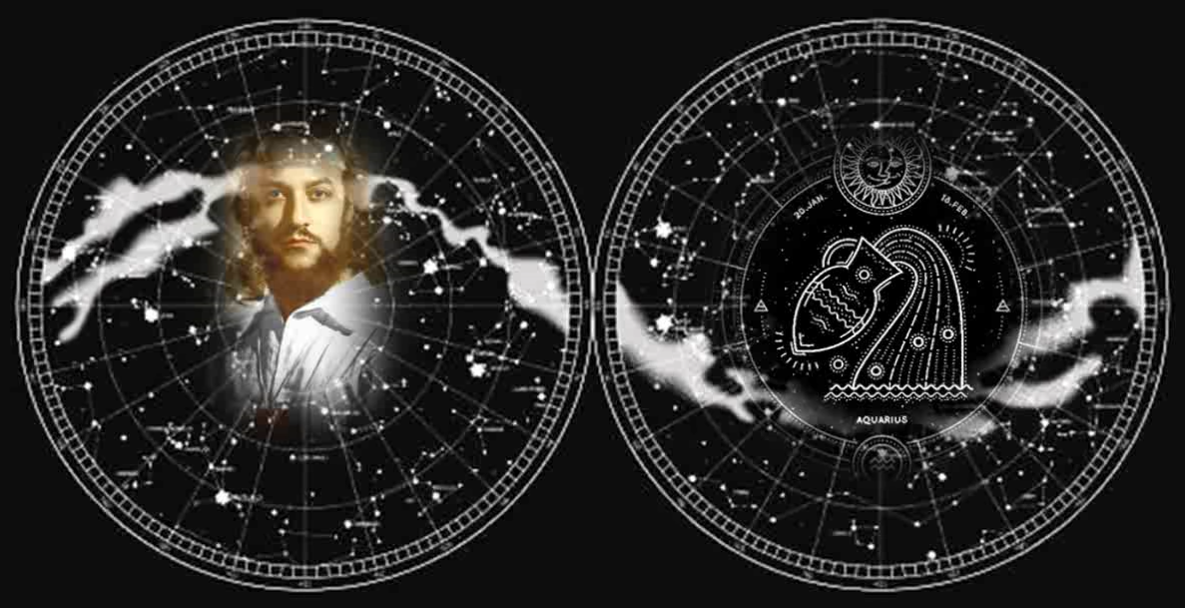
In addition to magic and astrology, in the original foundations of Christianity we are told that they brought gold. Gold represents Alchemy, that is, the transformation of lead into gold. The incense that they brought represents Astrology, and myrrh represents Magic, which was used in ancient times, for certain ceremonies. Our Maestre, Dr. Serge Raynaud de la Ferrière, the Avatar of the Era of Aquarius, which means: the first to bring the message of the Era of Aquarius, […] the Cosmos, the Book of Heaven, was pointing that the era of Pisces ended, that is, the last twenty centuries, and a new time began for Humanity […] The Avatar, Dr. Serge Raynaud de la Ferrière, which is the Era of Aquarius, because the great cycles of civilization, of religion, are governed by the Book of Heaven.
Dr. de la Ferrière says in his work Magic, Psychological Purpose # 22 of a series of thirty-six pamphlets, thus called, Psychological Purposes. He tells us there, on the first page of the treatise on magic, he tells us that the period of the end of December cannot pass indifferent to the peoples of the West. So, I say, how interesting! that Dr. de la Ferrière's treatise on magic begins by talking about Christmas. What does Christmas have to do with magic? But we'll talk […] that it all started with the arrival of the Three Magi in a certain place.
So, here the Maestre explains, he says:
“… But not only Christmas celebrated in its vulgar and material aspect —that is, the original meaning has been lost—, since there are many who, in any case, have realized the true meaning of the commemoration of the birth of a Messiah; furthermore, it is the whole mystery that is linked to the arrival of Christ Jesus.”
So, yes, there are people who have captured the deep meaning and so on these Christmas days they know how to behave, what to do on this sacred date.
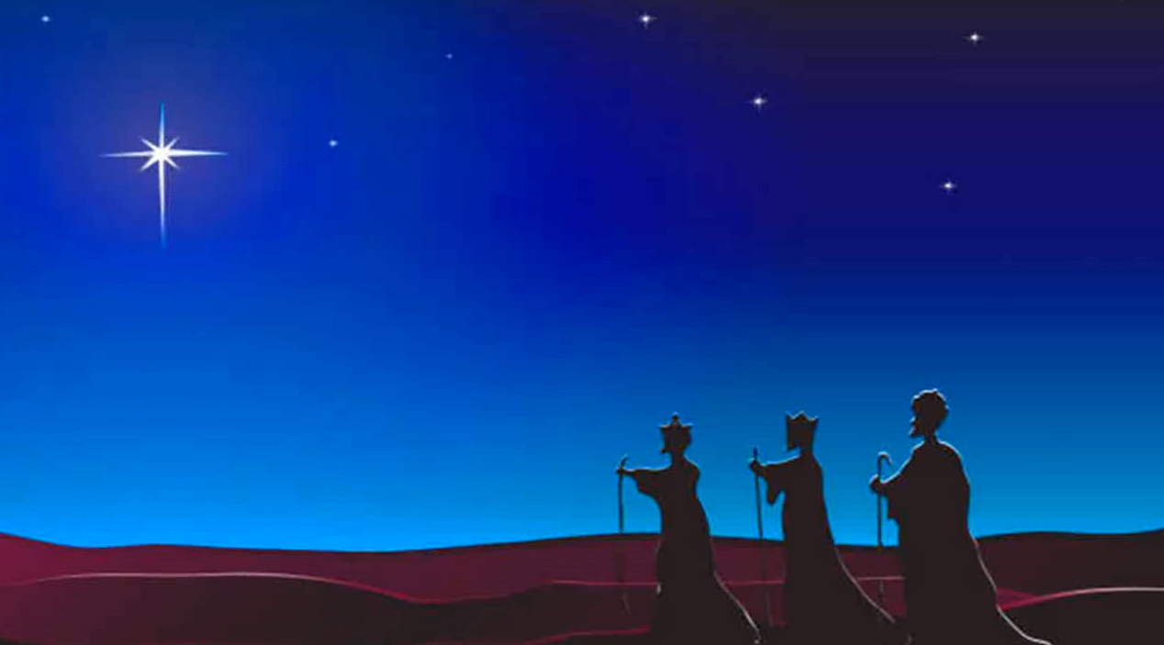
Then, in the following paragraph, it says that in the Catholic newspaper "El Voto" of France for the month of January 1958, the following can be read:
“The resplendent light of Bethlehem, the shining star of the Magi, came at the time of Christmas and Epiphany, to warm our faith, to direct our hearts towards supernatural realities and to our reflection, and finally to consolidate the reasons for our hope and our charity.”
The newspaper says that he came to warm our faith, to be renewed each year. This date is supposed to renew their faith, renew their hope, and make the necessary decisions for a Christian to take another step on the path that leads us to that redemption.
Well, now the Maestre speaks, he says:
“That light of Bethlehem contains a great symbol. First of all, that magnetic force of a place as the epicenter predestined to receive the Force from Above. A place on Earth, predestined and with magnetism to receive the Force from Above. Force from Above symbolized by that star foreseen by the Magi”.
So, here, in this sentence there is a very deep knowledge. In Heaven there is a force willing to descend. On Earth there must be a predestined place that receives the Force from Above. Just as in electricity there must be a positive pole, a radiant force and a negative pole that receives that energy. For the light to turn on, for example, there must be a mediator that joins the positive with the negative in the current. And in this case, likewise, for the Force from Above, symbolized by the star, to descend to the predestined place on Earth, then an intermediary is needed.
Then, further on, the Maestre explains that the predestined place was a place that has been called Bethlehem. Why is that place predestined? Because, as the Maestre explains, there was a crossroads where three great civilizations, or cultures, or peoples met. The peoples who came from the North, that is, from Europe. Those who came from the South, that is, from Africa. And those who came from the East, that is, from Asia.
The three Magi represent, says the Maestre, three great Initiatic schools [...] From the North, that is, from Europe, from the South, from Africa, and from the East, that is, from Asia. Three great Masters, rectors of the repeated Initiatic Order [...] Masters and disciples from each of the three great continents who met at that crossroads in the Middle East. At that site, three roads crossed for merchants, travelers, and also warriors, etc.
So, that place was magnetized by those three energies from those three continents. And those great Masters called Wise Men, in their studies in their respective Initiatic centers, in astrology studies with their [...] Masters and disciples, saw that a change was coming, a change of era, and that the stars that marked the change, were no longer the stars of the constellation of Aries. The […] lamb, Aries is the lamb. But instead, the stars of Pisces announced that the event in heaven, announced an event on Earth was approaching. The event in the sky is the entry of the sun in equinoctial precession to the displacement of the vernal point at zero degrees of the constellation Pisces. […]
Then, the three colleges came to an agreement, those three Orders of Wisdom consulted among themselves about the event that was coming. Where it should manifest itself, where should this shift from the civilization of the Era of Aries to the civilization of the Era of Pisces begin. They did their studies, exchanged those studies, and decided that this was the place in the Middle East, where the negative pole should be, the receptive pole to receive the Force from Above, that is, the positive pole, in accordance with those stars. It was not a single star.
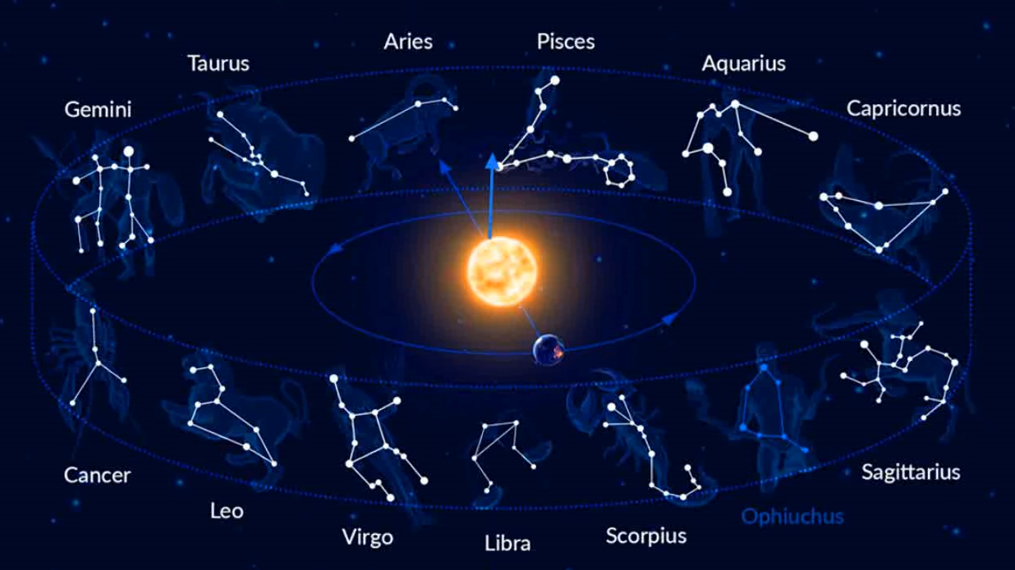
Here the Maestre says about it:
"... That star that has been the subject of so many comments could be a planet, perhaps Venus arranged in a very special place in the sky, like a sign or a comet, indicating an important event."
But it is just one case, Venus moves around the Zodiac every year, so it is always announcing different events of greater or lesser importance. It did not have to be Venus that announced it... And, a comet, well, there are comets almost every day of the year, they would not indicate such a date that is so transcendental.
The Maestre says:
"...or it would simply be a symbolic image, a figurative representation to make it understood that the Initiates had established a horoscope, seeking, with the help of astrology, the advent that had been foreseen for so long, the arrival of a Great Instructor."
And that is closer to understanding this movement of the Magi. They foresaw, through the study of Astrology, the exact date of the event and the place where it should manifest itself. It has already been studied, let's say, geographically and sociologically, it was that area in which these three great […] warriors, soldiers, merchants, scholars, etc.
Then the Maestre says:
"... In short, Initiates, Masters, Mastery, Magisterium, in a word: Magic."
In that simple phrase, he puts the word Magic in its place. The Magician is the magista, the one who overcomes the magisterium, the Master, the Initiate. True magic is realized within oneself when a pilgrim, a walker, a disciple, gets closer to the source of all [...] and thus, mainly, find their true identity and their true origin; [...] the Human Being, transcending the human condition, because as science says, we are rational animals with the use of reason. But, as our Elder Brother said, “Animals, after all”, although they have use of reason, they deprive the material part in the care of the body.
Taking care of the body can […] taking care of bodily appearance […] because if something characterizes a materialistic humanity, materialistic people, it is the neglect of their bodies. Hence, there are so many diseases, there are more and more diseases, more hospitals, more pharmacies. More people die prematurely because they do not maintain the body's machinery. People maintain cars, machines, but many do not maintain the engine. They take care of the bodywork, polish the car, clean the tires, etc., but in a few years that car is already going to the junk yards. There are some who do care about maintaining the engine, changing worn parts, etc.
And this happens with the human body. Most eat whatever, junk food, what they find on the street, in the market, without any knowledge of the science of nutrition. And they justify themselves by saying “No, that this, no, that the […].” These are superficial beliefs, they have no scientific basis.
So, then, the Magister, the true Magician, has [...] to heal within himself, and not live unconsciously, out of habit, out of routine, be concerned about what people will say, about the news, but has to awaken his higher consciousness. We say the state of consciousness. State of consciousness, for psychology is, for example, being attentive, being distracted, driving a vehicle, a machine, different states, then, before the reality that surrounds us. And for us, a state of consciousness means the level of spiritual maturity that a person has. There are very low states of consciousness that fall into vices, violence, indifference to true reality. And there are slightly higher states of consciousness that try to understand the world, and higher states of consciousness that try to understand themselves.
So, the Magician is the one who realized that his first and last name does not identify him, nor the profession, nor the nationality, nor the age, nor the marital status, nor the titles of prince, of this, of that. That does not identify us. They realized that these are false identities in relation to the search for who we really are. And that these are necessary identities to lead us in our society. The name is a whim of the parents, the last name is for social control and also the profession, to earn a living, etc. Marital status, to regulate the condition at home, for example, married, family, etc. But we are none of that.
At what stage of a person's life can we see what the true identity is? In a newborn. The newborn does not have a first or last name yet, it does not walk, it does not speak, it does not have a profession, it does not have titles. There it is, by observing it we are closer to what a being is. It does not matter that it does not have any of those social labels, there is the being, inside that body. That being smiles without external reasons, it moves, it looks happy and healthy, and it hasn't eaten yet, but it's happy.
So, observing a newborn, our mind gets a little closer to what the being really is. If that being is educated as it should be, he will become a Magician, a Magister, a Master of himself and, therefore, an educator for the peoples. A guide, a star on Earth, like a beacon that guides others. If they have not educated him as he should be, then he will be a so-and-so among so many who will have a place in his town, but he is not the being in all its fullness.
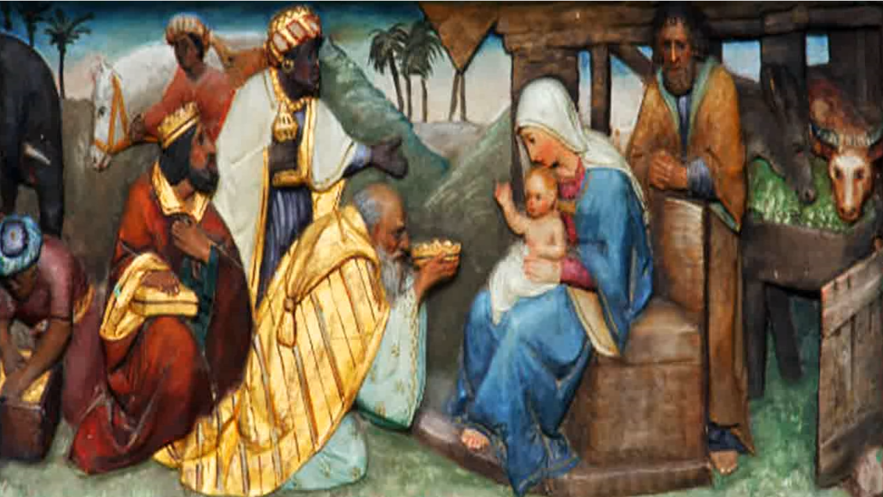
The Magi brought these gifts, for what, to whom? What would those gifts of gold, frankincense and myrrh be for? They already came prepared, they already knew the capital event in the life of the peoples, the coming of a Great Instructor, of a messenger […] the Tree of Heaven that was going to take shape on Earth to transmit its message, so that the peoples are not helpless from divine assistance. Those who do not want to pay attention to that message, in that way of living, then they will feel helpless. But assistance from the higher planes is never lacking for these pilgrim people on a pilgrimage through the Cosmos on the Earth ship. All this is worthy of meditation.
They came to that predestined place on Earth as a negative pole to receive the Force from the positive pole from Above. The force of Light on that night. A dark night for the Earth, the longest night of the year, the Winter solstice. But, when it is night on Earth, it is day in the sky, because we see the stars. And when it is day on Earth, it is night in the sky, we do not see any stars. We see a kind of celestial vault, blue, or cloudy at times, and only our star, the Sun.
So, on that sacred night they knew where they were going. What they were going to, they had already been informed. They tell us that […] if they knew where a king like them was going to be born, a king of himself, without a kingdom on Earth, without armies. They already knew the place, and they asked to see if people were aware. What that date of the Winter solstice, with the Sun entering zero degrees for the first time in the constellation of Capricorn, which was called in ancient times, the "Gate of the Gods". If the peoples were well oriented by their prophet, their religions, etc.; and no, people did not know about that event. They already arrived at the place, and then, there is the next step, in addition to magicians or magic, from the star in the sky about to become a star of Bethlehem or Astrology [...] of Alchemy, they arrived at the place where [...] sacred, so transcendental.
There they came and prostrated themselves before a baby. The representatives of three continents of three cultures, of three Great Initiatic schools, or Initiatic Centers, of three Orders that gave life to spirituality in those lands, as far as possible, in a very difficult time, of many trials for the peoples.

Superior Course in Theurgy, By the Ven. Master T. A-O Domingo Días Porta
All Rights Reserved

