Superior Course of Theurgy
From the
ACADEMY OF ANCESTRAL WISDOM
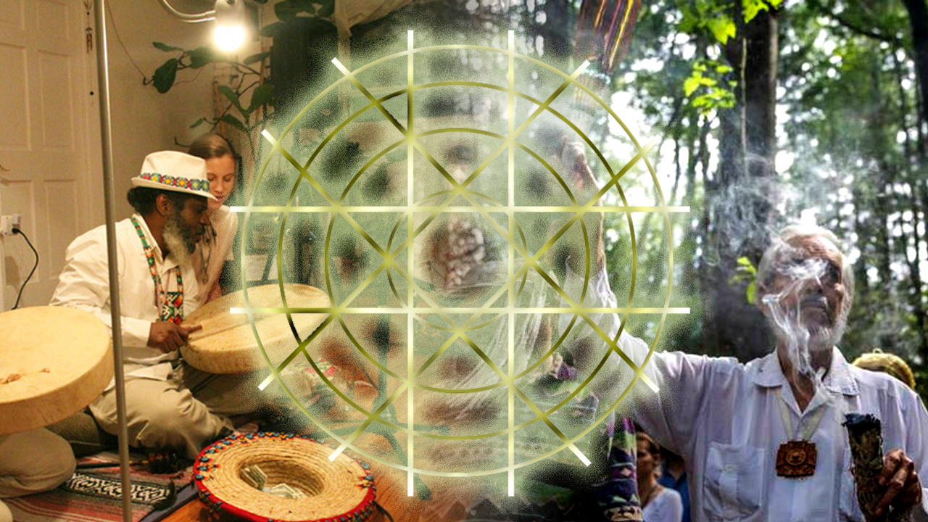

The Venerable Master T. A-O Domingo Días Porta
Presents
Lesson 199: The Sweat lodge’s Sacred Geometry, Part I
By Honorable Master Manuel Rufino

Pash, In lak'ech... A lak'en

As always it is a pleasure to be here. The only place where one can be is always here and now, the rest is an illusion. So, today's topic is an interesting topic because it invites us to explore a series of ideas, to work with traditions, not only from the American continent, but the world’s, and their values, ceremonies, philosophy, teachings that the ancestors have left us in all traditions. So, on this [occasion] we are focusing a bit on the indigenous tradition the (temazcal) sweat lodge. First let’s do a little sweat lodge history because temaz-cal... temaz-cal, comes from” temaz” meaning hot, and “cal or calli”, house: “the house of the hot rocks”.

There are many terms used around the world in all traditions, indigenous traditions. In the North they call it “Inipi” in the Lakota tradition. In the Russian traditions, the Mongols, the “shamans”, where the word "shaman" comes from, which comes from Mongolia, for that reason we say in America that we are not shamans because shamans are from Siberia, it is a Siberian term . While we were passing through there, well, we were studying with the Siberian shamans, in an Order that is two thousand one hundred and sixty years old, since it was founded directly at the beginning of the age of Pisces, and it has a two thousand one-hundred-and-sixty-year lineage. While we were there talking with one of the shamans, it was precisely with the main shaman with whom we were conversing because we wanted to know his opinions about certain things. And so, while we were there, he taught us about the different schools they have, their 7 schools of teaching: knowledge of working with metal, working with stone, working with herbs, working with different aspects of their tradition, obviously. While we were there, we tried to share the pipe or the "chanupa" and when we went to put tobacco I told him, “Well, we are going to share a little of our American tobacco.” And he laughed and said, "No, no, no, Maestro, look, we have had tobacco here forever. Europeans did not have tobacco, but we did. Europe did not have tobacco, but Asia did, so we have always used tobacco.”

We began talking a little about the “Tipi”, their sweat lodges, because they also have tipis, and they also have a sweat lodge; they have places to sweat. Thus, that which belongs to the Slavic traditions, the Mongolian traditions, the Russians eventually named them Banya. There are many here in the United States, in New York especially, there are many Russian baths with Banya. One goes there and of course, the spiritual part of the work has been lost, it is mostly smoking and drinking and sweating intensely, and the spiritual part has been lost. The person who is there gives you a massage, they use special leaves to give you...and to cleanse you, but nothing spiritual, all is just mechanical, partying.

Then, there is the Sami sauna from Finland, which is also, well, a European style sweat lodge because back then, it came down from Russia to Finland. There in Finland, for example, I think there are more saunas than cars, in every household there is a sweat lodge. There, the saunas are for daily home use. Back then the Sami were the original tribe of that part of ​​Europe, As we know, Europe underwent a great change with Christianity, and local traditions, Sami, Bavarians, Druids, etc., almost disappeared and only the Sami, which is a very old tradition of the shamanic tradition, survived. That is one of the only ancient traditions in Europe that survived the chaos. So, the sauna, a Finnish word, comes from the Sami word or “place for the hot house”.
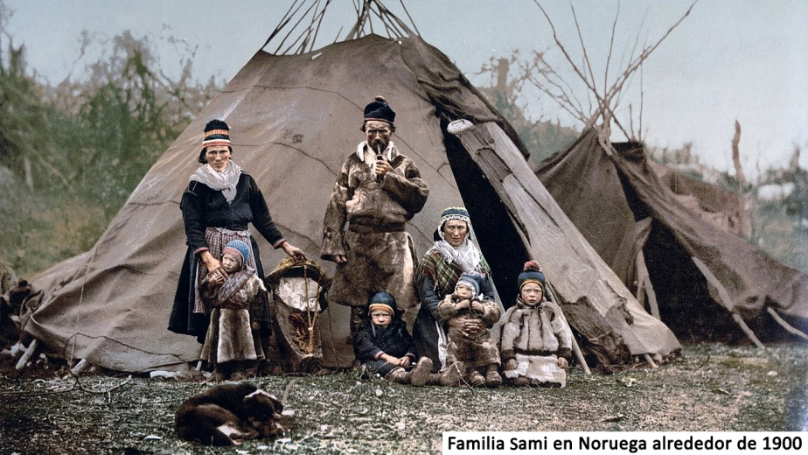
So, in Finland, people use it all the time as a daily thing, but as always, inside the sauna many people die because they use a lot of alcohol, a lot of meat, it's a party, it's not for healing. So, the meaning of the spiritual part of the work has been lost a bit, but the sauna, the sweat lodges of Europe, and the banyas are the Asian sweat lodges.
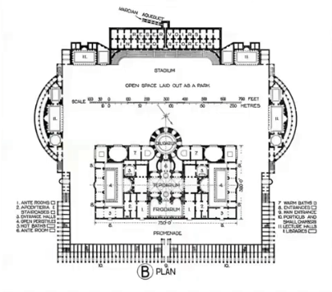
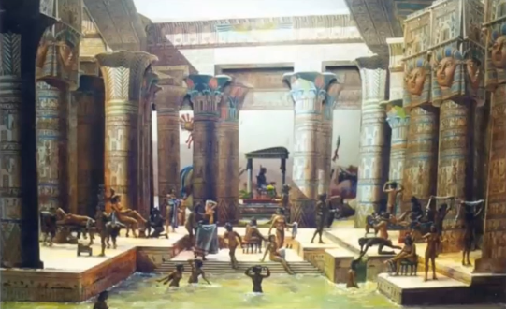
We also have the Egyptian African sweat lodges, which were always present in the Egyptian traditions, the sacred baths that eventually passed to the Greeks and the Romans. There they also developed the Turkish baths, but as we see here in this photo, it is an ancient Egyptian bath where the regular public bath was, and there is also the sauna, which was part of the tradition. Of course, bathing, cleansing oneself for ceremonies and special situations within the temples, was always used as a sacred part.

Thus, this passed to Italian/ Roman areas. As we see in this picture, the Romans had three levels of water work: cold water, warm water, and the hot part. This was all a public bath where the sauna was also the main attention of the work, but of course, the spiritual part was completely lost, because the songs, the knowledge of the songs, the incantations, the use of herbs, the use of music and prayers, all that was lost.

That tradition has been maintained a little with the shamans in Siberia. And the sweat lodge was maintained one hundred percent by the indigenous traditions here in the Americas as a sacred tradition and not just as a place to sweat, but rather for birthing and wedding ceremonies were held there. Before the wedding celebration, the sweat lodge was always used to purify the couple, to then enter the processes of the ceremony of union.

Children were also born there, childbirth, the birth of children inside the sweat lodge, as a sacred form for work, singing, and also purification. After someone died, they participated in a funeral ceremonial, then, they returned to the sweat lodge to purify themselves, to purify the whole process that just happened. I don't know, before starting a sweat lodge, I always explain that the sweat lodge is not a sauna, in the same way that yoga is not an exercise, in the same way that the "Vision Quest" is not going camping. So, there is the Initiatic, spiritual sweat lodge, which tends to search within, in the inner life, in the spiritual life. And that was what the elders of our traditions maintained; they managed to maintain the spiritual part that never disappeared.

So, the Initiatic sweat lodge is used to reach Enlightenment, to go within, to search, to transform, to purify yourself mentally, emotionally, and physically. Thus, it is a different sweat lodge. The same thing for yoga, yoga is not an exercise for recreation, to stretch, to relieve stress. The Hindus never used it for that, yoga was always used as a way to reach Enlightenment and attain Liberation.

The sweat lodge in Native traditions was not used as a form of recreation to go drinking, boozing, to make jokes in there, no, because this house is sacred. Thus, in the sweat lodge, in its process of Native traditions, the one who directs it needs many years of training, and he must be purified, not just go there to pretend to purify another, but be purified. The purification begins with the person who is going to run it, which is not simply going into a sauna to warm up, because that is what we see everywhere, in the big hotels, in the big places to go to relax and spending the day, where there is no one conducting the ceremony, because that is not a ceremony.

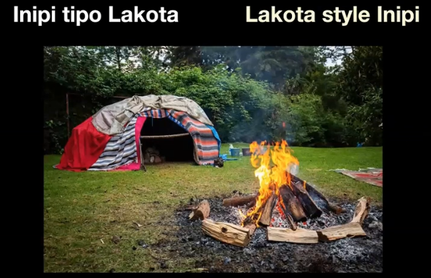
However, the sweat lodge requires many years of work, of purification. The person has to go through fasting, the person has to learn a minimum of sixteen songs that are performed inside depending on the tradition. In some traditions water is used, in some it is not, because it depends, because if it is held in the desert where there is no water and where water is precious, then the stones are heated, but no water is poured. The work of the sweat lodge is serious work, it requires much training, for there, you have to learn to control your emotions, to control your mind, the use of herbs, sacred herbs. Many people use herbs simply to... as they say out there, smoking... or get a little bit of a smudge, but no, to enter the sweat lodge you must cleanse yourself, for you are about to enter a sacred place, so that cleansing is required so as not to contaminate the environment where it is.

So, if the sweat lodge becomes recreational and simply becomes a place where you go to warm up and drink and smoke at the weekend sauna in the hotel or in some neighborhoods where people haven't really trained, then, instead to coming out cleansed, one comes out very filthy, because the person who is running it is not cleansed. It requires a cleansed character, a clean attitude towards life. One has to live life like in a purification process sweat lodge. The sweat lodge is then not something that is only done inside the house, but rather, it is a way of living, it is a path. For that, some shamans or elders only use the sweat lodge, they do not utilize anything else to heal or cleanse or teach, because the sweat lodge is also a small university. The sweat lodge is like a university, where one enters to learn the ancient tradition that is passed from one person to another, from a shaman to the disciple, from a Teacher to a student, etc.
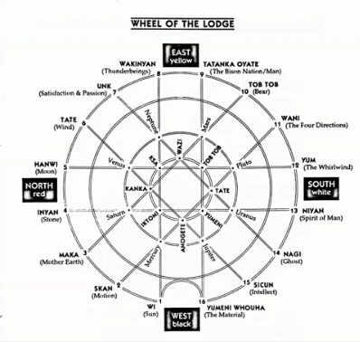
The sweat lodge is a small university. For example, in the Lakota tradition, the sacred form of the sweat lodge that is formed with sixteen sticks that cross from one place to another, symbolize the sixteen aspects of the Wakan Tanka, or Great Mystery. Here we see, for example, the east-west quadrant, the north-south quadrant, and the north-east quadrants, the east-south quadrant, the south-west quadrant, and the west-north quadrant. There are a certain number of stones that are used to enter the sweat lodge, depending on each tradition. In some traditions, the stones that are used are 7, but everything depends on the tradition and the shaman, or the leader who is conducting it to lead us to an understanding of the sweat lodge.

We realize that the sweat lodge, in this case, has five worlds, five worlds of the five levels of consciousness. Thus, in this sweat lodge, for example, in the Lakota tradition sweat lodge, one enters from the west (note the west in the picture), as the person enters that way, and before entering one says: “for all my relations”, Aho, Mitákuye Oyás'in, which means : “for all my relations”. When one enters, one enters to purify all relations, all relationships with wife/husband, family, children, environment, relationships with the animal kingdom, relationships with the plant kingdom, your relationships with the spiritual kingdom and its levels. These are a series of labors that are done inward, with the intention of purifying, with the intention of remembering.

The Maestre de la Ferrière says that what the Master does to the disciple is simply to try to make him remember his eternal life. As a result, the work inside the sweat lodge is to remember, the cleansing is done to be able to remember. So, when one enters the sweat lodge and the songs begin there, in this case, the Lakota tradition, sixteen songs are used, four for each door, and some extra songs for the center, which the person who is leading can decide thus. Four work doors are used, and in each door there are two doors, one of darkness and one of light. The sweat lodge begins with the door of light, when they begin to ask for the stones to bring them into the sweat lodge, which are brought from the fire, after they are heated, into the sweat lodge.

In this process we witness the purification that is taking place: First the stones are purified, herbs are added, cedar is added, sweet grass is added, copal is added, herbs are added according to the region. Each region has its knowledge, so there are associations in each door, for example: tobacco for the eastern door, sweet grass for the southern door, sage for the western door, and cedar for the northern door.

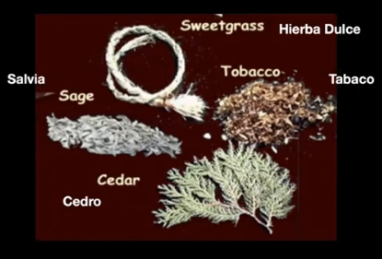
Each one of these herbs that are associated with each one of the directions, are then placed according to the direction. They are used according to the meaning that they want to give to the sweat lodge. So for example, if the sweat lodge is used to purify a family member, in the sweat lodge, the door songs are the songs of the south, which are relations, social life, married life, etc. Once inside, as the person enters they are called by name, songs are sung; if the person is sick, then, a purification takes place, depending on the person's illness; different herbs are also used for psychological problems, utilizing different colors, different flavors, different purifying smudges.

As we can see, the sweat lodge is not a party but a tool, rather, a sacred process in which you get involved daily. It is a way of life, it is not simply a way of coming to recreate. Thus, we are seeing that the work of the sweat lodge in the person who is leading must have years of purification, he himself has gone through several years of purification, for it is not simply for recreation. Recreationally, one can enter a sauna. A Sauna is not a sweat lodge ,it might seem like it, in the same way that the yoga practice seems like an exercise, and it seems like something to sit there to contort oneself, be admired, go up and down, but without the spiritual intention that Yoga has always been given in India. Thus, in the same way that there are sweat lodges in different traditions, there is also yoga in all traditions; there is Mayan yoga, there is Egyptian yoga, there is Tibetan yoga, there is Chinese yoga, there is yoga from different traditions. Thus, there are also Sweat lodges of different traditions.

As we continue observing and seeing, this is a process of looking within. And so, the sweat lodge has four doors of magical work. In the Lakota tradition, as we said before, the door is to the west, but in our tradition, the inter-tribal sweat lodge, the door is to the east, towards the beginning of life, towards the new generation, towards the new birth, towards the new age, etc.

All this is the sweat lodge, it is a purification process. What will it purify? It will purify your way of speaking, the your of seeing, will purify your way of hearing, it will purify your way of feeling, because it is there one will learn to speak, in there is the ceremonial way of speaking. A series of incantations is performed, invocations, one speaks with the different levels of the Universe, with the four directions, the four doors: towards the east, west, north, and south. A series of invocations are made, which the person who is leading must learn to speak. Such purification of speech is not only done by speaking beautiful things, but in general the person learns to communicate with other human beings, learns to communicate with the animals and the environment where he lives, the social environment. He must learn to walk in the way of a sweat lodge, that is, in a sacred way.

In other words, it's not just while he's there in the lodge, but that goes beyond the sweat lodge wheel, depending on the tradition, because that changes, for it is always changing. In my case, I begin by opening the eastern door, permission is asked at the Sun’s entrance, permission is asked of Spring, permission is asked of childhood, the elders are invoked, the Heart of the East is invoked; it is a series of invocations what one is trying to call, trying to see, to attract and understand. One must learn to see because one is inside the dark sweat lodge. There is a door of clarity as one begins, the light enters and then as one closes the canvas, one enters the inner life, one’s mother, one’s childhood, one’s interior life, the internal work.

So, you look within. It's not recreational, it's to really make changes in your daily life because nothing happens by simply being there in the dark receiving heat, but rather you have to learn to take the heat, many times strong heat. When life tests you with difficult things, there you will be in a complete process. Many times, people, students, arrive with serious problems. I tell them, “You are in a very hot sweat lodge, instead of complaining ask for more stones, because you have to learn to work with the sweat lodge of your daily life, which is often quite hot.” One wants to get out, as one is inside for a long period, one wants to get out. But you have to put up with it to learn, in daily life, to put up with your trials, your daily problems, the situations you go through, economic situations, emotional situations, mental situations, as you go through some cleansing processes.

You must appeal a little more, perhaps more stones to remove all the impurities. Thus, the sweat lodge requires training, for this reason, because it is not a sauna. It is used for an Initiatic process, for a spiritual life, for a direct connection with your inner life. Thus, the sweat lodge is not a game, that is, it is not a little house to enter there to put water and come out hot, but rather it is a process of the purification of your senses, that is, as they call it in Yoga, "pratyahara", control or cleansing of your senses.

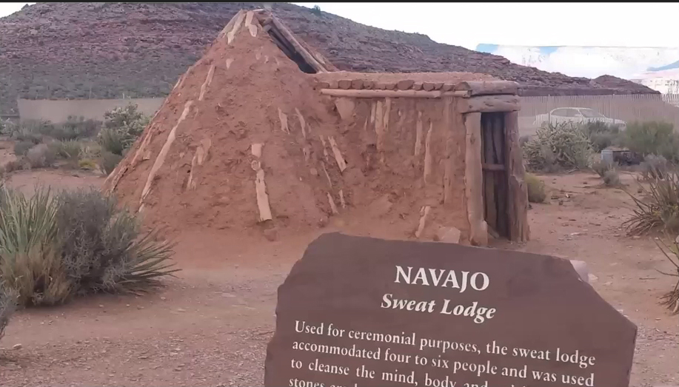
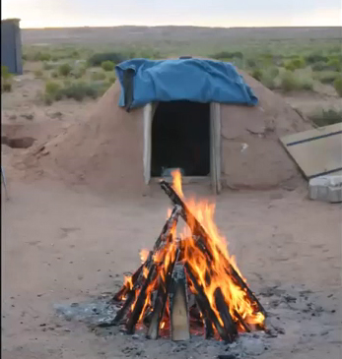
Here we see [images] of a sweat lodge in the Navajo style. There are two styles in the Navajo tradition: there is the round sweat lodge and there is the sweat lodge in the shape of a pyramid or in a cone, like these two. One is considered feminine, and the other is considered masculine. The one on the right, in pyramid form, is considered the masculine sweat lodge. So, this is done in a pyramid shape, a cone shape, and the stones are put in the same way. It is mostly… used by men in the tradition, because as always, in the traditions there are sweat lodges for women and sweat lodges for men. There are sweat lodges that are for both men and women, but in many of the traditions, many times only men enter and many times only women enter; depending on what they are celebrating.

The last time we were there in Navajo land, we went with Maestro Domingo Días Porta and his wife Maria Guadalupe, and there we found that they were celebrating the birthday of one of the elders, and it was only for men. Then, all the men went in, a fairly hot sweat lodge. They tried to test us to see if we could endure it, we held it well. Hot! Hot! Lastly, some of them even got out in a hurry. It was a tough sweat lodge to purify your daily life, purify your birthday, to celebrate your life, that is, there is a lot of inner purification for your whole year, a year, a cycle of your life. It is done there, in the sweat lodge for a birthday, and that birthday, that celebration, is to purify your life, to celebrate your life, so that your life begins with a new cycle, clean, so that you can face your new cycle with new ideas, already clean. You can start looking a little deeper into your life, you can start to see a little bit more, start to clarify your visions. So... that is the birthday sweat lodge. In this case it was for an elder and for that reason it was special. Then, other elders came and there we did many hours of work, it was very nice because... well...

Later we went to the mountain, on that same trip, to visit an elder who never comes down from his mountain, he was always there, and then his sweat lodge was without water; the previous sweat lodge we went to had water, and his was without water. Songs are sung there and some —and in that one, the drum was not used—… Thus, we are seeing the different types of ceremony, of invocations, of purifications.

So, there we were with this elder, and that's when he began to explain the two Navajo sweat lodges, the round one, and the pyramid one facing upwards. So, these two sweat lodges, one for men and the other for women, well, not for men and women, I should not use that term, rather it was that one is feminine and the other is masculine, men and women can enter, but one is of masculine vibration and the other is of feminine vibration. Well then, we are looking at the spiritual part of the work, the feminine and the masculine; which is not a sauna. It is a work purifying the feminine, purifying the masculine in that purification, in this process of the two sweat lodges.

Here we are looking at the internal work of the work, but of the feminine in the sweat lodge, and the work of the masculine in the sweat lodge. There is the women's sweat lodge where the women do the purifications they have to do for their nation, for their tribe, for their family group. The women enter there to work on the inner part, in this case, the feminine part . Doing work on the masculine and feminine is a purification. Learning to see what the work is in the feminine, what the work is in the masculine, the different purifications. So, if one is sick, mentally, emotionally, or spiritually speaking, one enters the sweat lodge. Different types of herbs are used there because the classic herbs are used for the common sweat lodge, but then, there are the herbs that are used for different types of illnesses or psychological problems, that are placed on the stones according to the needs of a family or a community.
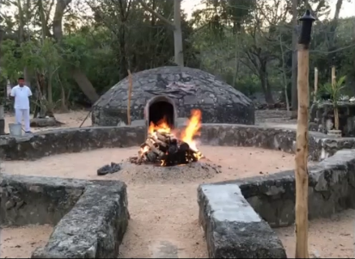

So, there is a communal sweat lodge and there is the family sweat lodge. They are two different sweat lodges, because the family sweat lodge is for daily use or it is of more frequent use when… It depends on how the family needs it, that is, the family sits there to pray. It is not a place to go to drink things or for vices and… no, it is a place to pray, for the family. And there they go, they cover themselves and the family prays for the benefit of the marriage, for the child, for the benefit of healing, for some situation that the family is going through. So, the sweat lodge, in this case, is with an intention. There is an intention in the sweat lodge. In this case we are going to purify a situation, be it family or a community. There we purify, it is a purification. The drum begins, the songs begin, the rattle begins, the maracas begin, the sounds begin, the purification begins. They wipe themselves, they wipe their heads, their faces, they clean, clean, clean, clean, clean...

Superior Course of Theurgy, by the V. M. T. A-O Domingo Días Porta
All rights reserved.

