

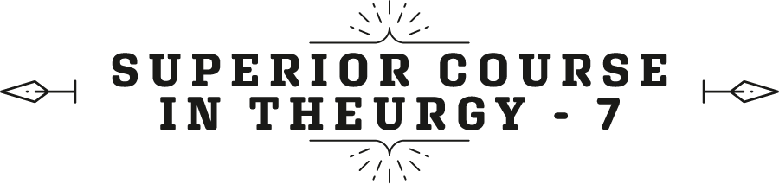




Ven. Master T. A-O Domingo Días Porta

By Dr. Mauricio Padilla

F
inally, note that it does not say Cholesterol here, it says HDL Cholesterol (7), the total cholesterol... Cholesterol is an extremely useful molecule in the body because it is a molecule..., it is the precursor of all sex hormones. Cholesterol makes the grandmother hormone from the cascade of youth hormones, called pregnenolone. And then comes dehydroepiandrosterone; estradiol, strong, estriol, testosterone; all of them, male and female, come from the grandmother hormone which is pregnenolone; pregne-nolone. The Pregnenolone hormone makes all the others and comes from cholesterol. Thus, cholesterol inside the cells is very useful because it manufactures hormones; we do not want it to be high in the blood, but inside the cells there must be cholesterol. Cholesterol is an essential molecule for health.
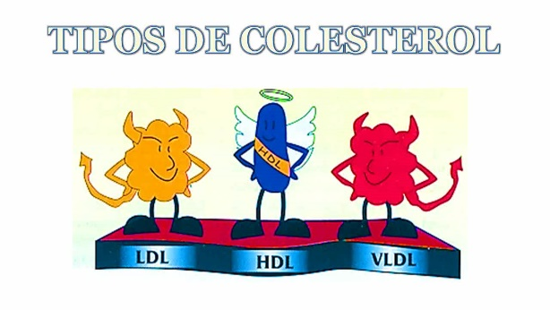
Fine then, cholesterol is divided into: HDL cholesterol, called high density, because it has more protein than fat. LDL because it has more fat than protein, and VLDL, which is very low density, which does not interfere much. The two are HDL, LDL. So, total cholesterol must be below 180, but HDL must be above 40 in men, above 50 in women; that is ideal. If a person has high cholesterol a little above 200, but HDL is above 50, it is 60, 70, 80, excellent. Exercise raises protective cholesterol, HDL is protective. LDL increases cardiovascular risk.
If you want to know a little more about how your specific outputs are, then, you take the total cholesterol, let's suppose that the person has 220, but the person's HDL is 75, it is very high, so, 220/75, this , gives 2.9, is excellent. This ratio between total cholesterol over HDL, called atherogenic risk, must be less than or equal to 3.5; This person has 2.9, the total HDL. The higher the HDL, the better; The lower the total, the better.
Next, comes blood pressure (8). We take blood pressure here with a manometer, sign-manometer, and we listen to heartbeats. What is blood pressure? Very simply, it is the output of the heart, the quantity, the volume of blood that leaves the heart, multiplied by the peripheral network resistance. That is to say, the network, are all the arteries, the arteries are contracted: the pressure rises. If there is a lot of liquid, the pressure increases. He eats a lot of salt, he retains fluid, he is not urinating, eliminating fluid, his blood pressure rises because there is more blood circulating. If the person is very tense: adrenaline, norepinephrine, tense, worried, there is vasoconstriction, and then the pressure rises. Blood pressure goes up when you talk, and when you listen, it goes down. Therefore, having a dialogue, speaking, exposing, listening, the more silence there is, the lower the blood pressure.
Blood pressure rises when the sympathetic system is activated; the person wants to control the outside. He doesn’t want this to happen, that other thing to happen, something else not to happen... He is too aware of things on the outside... Fumm!, the arterial pressure rises. A person, I don't know how to say it here, [in Mexico] we say that it slips away from him, he doesn't care, completely, whatever happens! Aah! Blood pressure goes down.—"Hey, but look, something’s burning...” “Well, someone will turn it off.” That is, very calm people, very... everything slips away, their blood pressure drops. The other factor is sleep. Very good, deep sleep, enough time, low blood pressure. The most common cause is high sodium-low potassium. What is high sodium- low potassium? The Merida diet [from Mérida], Monterrey [from Monterrey, Mex.], Mexican, Venezuelan, a modern city diet. What is the opposite of that? The Native diet.
In the native diet, there was no salt, there were no processed foods. Now there is salt even in the bread, “no, this is whole wheat bread”, well yes but, there is some fat… —Did you add salt? “Yes, of course, so that it tastes like something.”
And sugar, they also add it —comments an assistant. Salt, milk, egg… Oil… Butter… Fat —the students intervene.
That's bread, but it's whole wheat. So, all of this increases the tendency of blood pressure. The more relaxation there is, the more the blood pressure is lowered. Sympathetic activation is paying attention outward, parasympathetic is paying attention inward. The parasympathetic, the main control of the parasympathetic is the vagus nerve, the tenth cranial nerve, it is activated when you feel completely safe, completely protected, the vagus is activated, blood pressure is lowered, you harmonize, you feel very good; excellent.
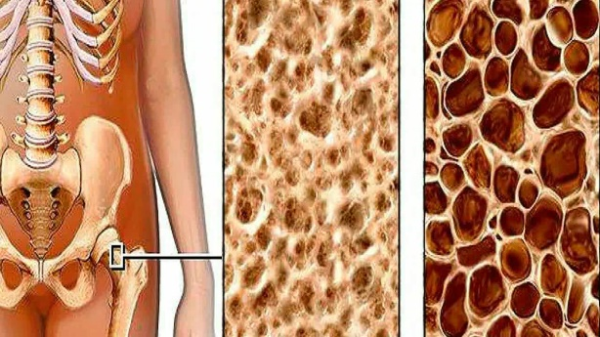
Now, bone density (9). We already talked a little about bone density. Bones improve when there is good muscle, and then comes the regulation of body temperature (10). What is the normal body temperature? —36.50C —answers a student. 36.5, 37 degrees Celsius, 38 normal. But, if you put yourself in cold water, what will happen? With age, there is less ability to regulate body temperature, but, when you subject your body to changes..., you go to the hot springs, you get into cold water, you subject your body to those exercises, your body will always have it regulated, even if you are seventy years old, eighty years old, your body will be well regulated […]; completely.
So, if I want to know if a person is regulating their temperature, the best way is the coldest time of the day. What is the coldest time of the day? The morning, before the person gets up. What do we do? Take our temperature, in the mouth, preferably, six minutes, before making any movement, and we write down the temperature: the day, time, and temperature. And we do it... Well, in women, for about ten, fifteen days, because if the woman is in the ovulatory period, she can go up a degree and a half.
—What if we are in menopause? —A student asks.
Well, there, not necessarily, no, no.
Now, these devices can measure it all night, and on average, for example, today, last night, my temperature was half a degree higher, half a degree, and it tells you; “Hey, your temperature is higher than average.”
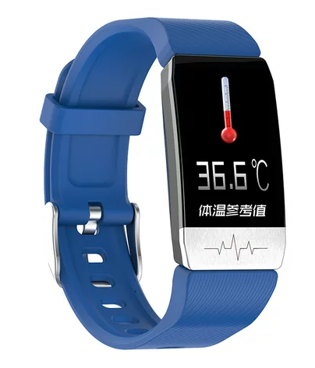
But, if I see the day before and the day before, and the day before. Ah, well, my temperature reached 38, I got chikungunya a few days ago, it went up to thirty-eight something, and the next day, a little lower, the next day lower, lower, lower. Last night, it was .9 higher on average, today it was .5, that is, in a few more days it will regulate. But what we want is... if you can't measure it every night, it's in the morning, first thing in the morning. What happens if a person is 35.5? It's not right, it's not right, your thyroid is not right, your thyroid is not functioning optimally.
Remember that right now there is a very serious problem with iodine. This is a low iodine zone. Why?
"Because it is far from the sea," the students answer.
That's one reason, what about the other?
[—…] —answer the students.
Of course, they are mountainous areas where there are landslides, and the minerals that were deposited here when this was under the sea, well..., that has already washed away. I live in an area..., yes, geologists have gone to study those mountains that were there millions of years ago. The iodine was lost, my area is a goitrogenic zone, there are areas where there is a thyroid problem and problems with iodine.
—So, the average is 26.5, right? —A student asks.
Yes, it should come out to that, yes.
So, we vegetarians want to have such a varied diet; where are vegetarians going to get iodine?
"From the seaweed," answers a person.
Seaweed is the richest source of iodine that we have access to.
"From radishes," the person adds.
Yes, but, if the radishes are from here, where do they get it from? That is... no, only marine algae, you can't fail there, because there is... A little piece like that [small] of kombu seaweed, you put it in there in beans, lentils..., when cooking it, you will never have an iodine problem.
In other words, how do we do it? Well, iodized salt was the first, as the World Health Organization (WHO) said. How to ensure that the people who are from Mérida do not have to travel to the coast and the islands…? What are the islands called here in…?
"Margarita," the students answer.
How do we make sure they don't have to travel there? And then, buy a little diving suit and get into [the sea], go grab seaweed... Iodized salt, that solved the problem. But now it turns out that people are buying salt from the Himalayas, salt from who knows where, and they started to stop consuming iodized salt. So, we have iodine problems. This is too important, too important. And, since no one is going to measure your iodine eh…,
—Is there no test for…? —A student asks.
Yes, of course there is, but it is not a common test.
We measure iodine in urine; the best way to measure iodine is in the urine. There must be a certain amount of iodine, but I doubt that anyone here is going to do that study on you. It is done by researchers who want to see how the iodine is in the population; they do studies of iodine in the urine, but it is not a clinical study, where you go to a laboratory and the iodine comes out. It can be done in blood, and it can be measured in urine. But, I would say, don't wait to get that out. You require iodine, I also require iodine, every day we require 150 mcg (µg) of iodine, absolutely every day.
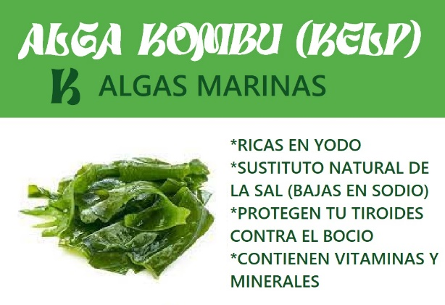
So, I do recommend the most accurate and fastest way, when you see kombu seaweed, kelp seaweed, buy a bag; that bag will last you months.
—And we put that in cream soups, in soups, in salads…, —comments a student.
It is called kombu, or kelp, they also call it macroalgae. All I want to tell you, is your body, when it goes in, will tell you: “Thank you, I've been waiting for this for a long time.” We have a deficit!
Iodine has a very important mechanism because iodine produces the thyroid hormone, T4, and T4 generates T3, in the body, and T3 activates the respiratory metabolism of your entire body. It is life; it is the cellular oxygen that helps your entire body to function. Vital, more vital than other ingredients... “No!, but why? Just because?” Ah, because it is generally deficient, and that is why we have to be careful with iodine.
"And we don't know," comments a student.
No. The next time I come, I would like a volunteer to measure the iodine in the locality.
Iodine is one of the minerals that has a small window of toxicity, you can use it from the sea. One kelp tablet, one, has 150 mcg (µg) all we need in a day. But the measure is the Japanese diet, for example. It has been seen lately that the Japanese diet has an amount of 3.0 mg per day, it is a very high amount of iodine. They are very well, the Japanese are very well.
So, it's not very easy for you to go overboard, unless you use iodine tablets. Potassium iodide or things like that, in tablets, well, you have to be careful there. There are very few elements that do not have iodine. The point is that the intake of these foods reaches the amount of 150 mcg (µg), which we require daily, which, in areas like this, and where I live is another example, we can fall short. There is a very great benefit that level of this mineral be raised.
When the microbiome is varied, your blood pressure tends to decrease sleep, but above all, is to reduce saturated fat. If a person eats meat or chicken, try to make sure it is non fatty, lean. If someone eats meat, let it be lean meat, without fat, and moderate consumption of oil, refined oil. Let ninety percent of the oil you eat come from avocado, seeds, almonds, walnuts, pine nuts; ninety percent; that is, very little oil.
…always, from now on, you will go from your house to the university, on foot. Walking is another thing that improves blood pressure, in a very, very important way; exercise, circulation, we want the arteries to dilate. Therefore, blood pressure is a biomarker of premature aging, it is a marker, it tends to vary. What are these biomarkers? What are they? It is a ponderable measurement. No. 1, that it varies gradually with age and can be reversed by lifestyle. A marker has three characteristics, what are they?
—That it can be reversed —answers a student.
Ponderable. No. 2, it changes with age. No. 3, it can be reversed with your lifestyle.
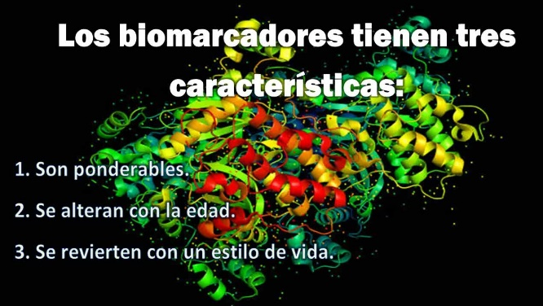
So, your doctor [your primary care doctor], I don't know him, but I'm going to correct his grammar; both of us are going to correct our grammar… Of course, “they are very dumb”… No, they see that every day. At older age, more pressure, that's what they see, that's the reality. Yes, that is correct, but he told her a word that I would change, “This is ‘normal’ for your age, no, it is ‘common’ for your age. It should be…
“Reverted,” a person finishes.
Yes, we want to reverse it. That is to say, if a person is 80, 90, with 135, some doctors suggest starting to medicate with something. Okay, that's not bad. But, I wouldn't just do that, I would do that along with measures so that your pressure resolves. How much sodium do you consume? Two grams? Three grams? Four, five? In dietary intake here, this is qualitative calculation, yes? Five to six grams.
… you put a little ice in there, you put yourself in cold water, a sitz bath, that your hip is submerged in there. In men, for example, the entire pelvic area is submerged for the prostate. Ah, you come out of there, a little bit of hot water, always ending with the cold, five, six times, that generates a change, a circulatory dynamism, movement. Remember that the pelvic funnel... Men don't have what happens to women. Women have a uterus, the endometrium is filled with blood; Yes, but that, is dislodged. The man how does he dislodge? In men it stays there, therefore, sitz baths, thermal changes, is a formidable medicine to help.
We want to boost pelvic circulation. In fact, for some people, that's ninety percent of the problem. The sympathetic system is the one that activates, generates stress, worry, and contracts the peripheral network of arteries; blood pressure rises.
… Yes, of course, there is no difference, but, if you start to see how that person lives and what he eats, and what his life is like, ah!, you realize that part of his diet, excess sodium, decrease of potassium, lack of magnesium, etc., and furthermore, the intensity outwards, ah! That is a combination of factors; most of the time a combination of factors.
…There are several types. The person says, no, he has essential hypertension, as they called it before, it means that it started at the age of twenty-seven. Ah!, that is very genetic, he is wired there, his father had it, ok. Yes, but outside of that, you may have a person who may have an excellent diet and their blood pressure is high; remains high. What difference is there in the pressure? None, it can be caused by emotional or excess sympathetic activation, lack of relaxation, sleep, or excess sodium. An extremely calm and meditative person who levitates two hours a day… And eats excess sodium? Ah, his blood pressure will be high. That is, the causes are together, mixed, in what percentage is one more than the other? No, we don't know that.
Remember what we want to do... There are people who tell you, “In the day I’m fine, I am fine, I am fine, but, around seven, eight at night things start to get worse. Well, she had a meeting with her cardiologist; she saw two cardiologists, and the truth is that they guided her well. She was medicated. I told her, you do require medicine. But she wanted to go off the meds. I said, well, in order to do that, we need a twenty-four-hour holter and see what time it goes up. "I don't need the holter..., when my husband arrives my blood pressure goes up! I don't need any holter." Okay... There are emotional events that raise it, yes? So, a holter is very useful, just twenty-four hours to know what is happening during the day.
Very good. I want to tell you that some of you have a digital device, yes? Well, those devices do work, but not so much. This is better, you are here, and you are listening. The digital ones can lie a little on the systolic.
-Which is which? Which is diastolic and which is systolic? —asks an assistant.
Yes, the systolic is the high one, the diastolic is the low one. Digital devices can lie a little on the high, they go up, yes? At the time of checking... One time my dad sent me to a friend of his, and the man arrived, the man was, well, my friends' father, he was, I don't know, sixty-five years old. Well, I was young. I simply put it on him and started; I took the measurement, wow! I stared at the device, I think he saw my face and said,
“Are you worried?”
“Yes”, I told him, “a little, yes.”
“Ah, don't worry.”
He was calming me.
No, don't worry, in my life I have had two hatreds, one is women and the other is doctors!! Ah, I understood, it couldn't be that he had... The meter wasn't enough to take... It's impossible for him to have that pressure; he had that pressure when I was measuring it. And thus, the benefit of a holter. A holter is inflating every fifteen minutes; asleep, awake and reading you.
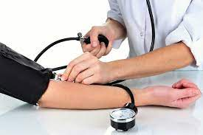
So, what we want is for the person to be calm, they can be lying down, they can be sitting, and that you... That there is nothing tight, constricted, that they are not... Yes, you can take it from both sides, normally there is one that is five points difference, it could be that one is higher, some cardiologists measure one side, they measure the other, the ankles.
I wanted to tell you something; it's good that you came today, that we coincided, we spent time together. Well, thank you very much, I hope it was an afternoon, like it was for me, of learning, of sharing, and I hope we see each other again soon.

Superior Course in Theurgy, By the Ven. Master T. A-O Domingo Días Porta
All Rights Reserved

