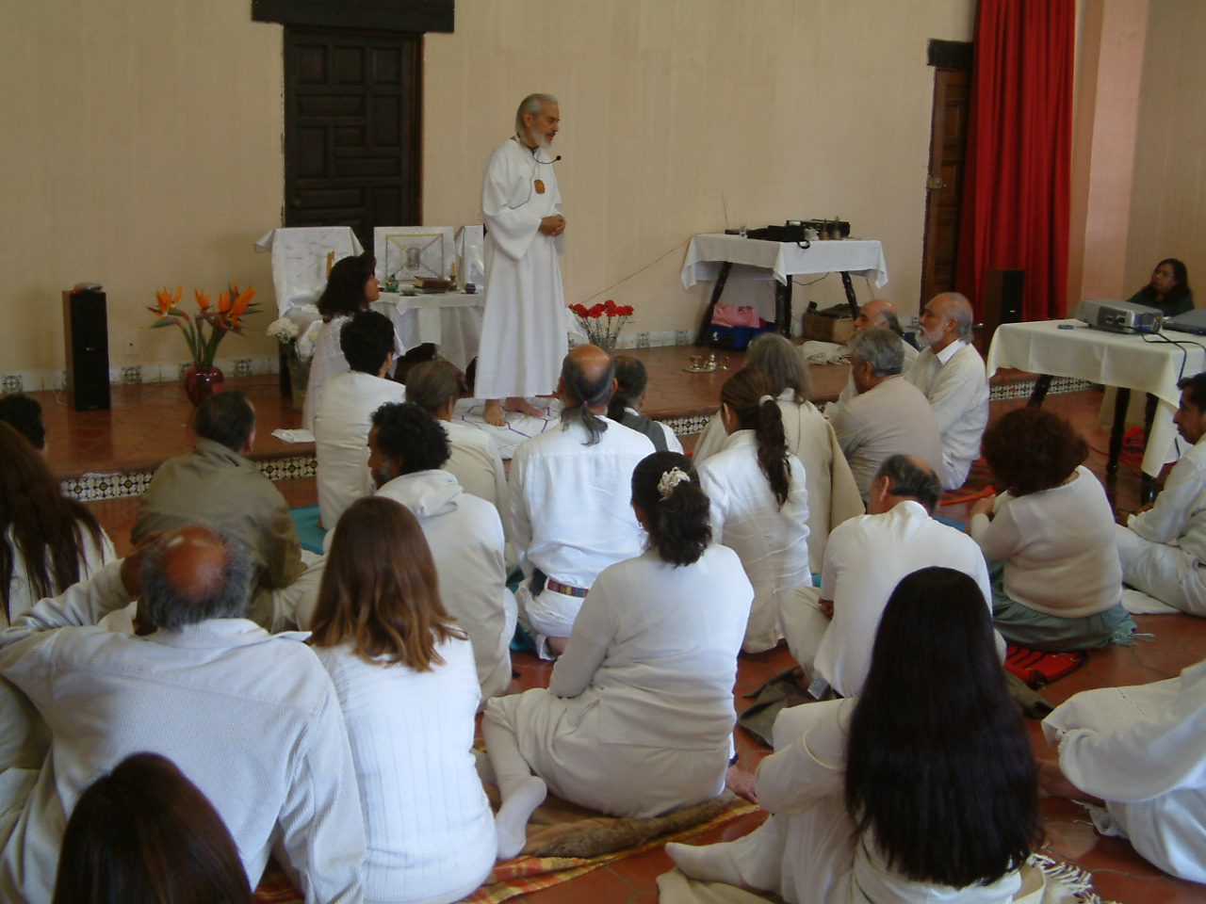
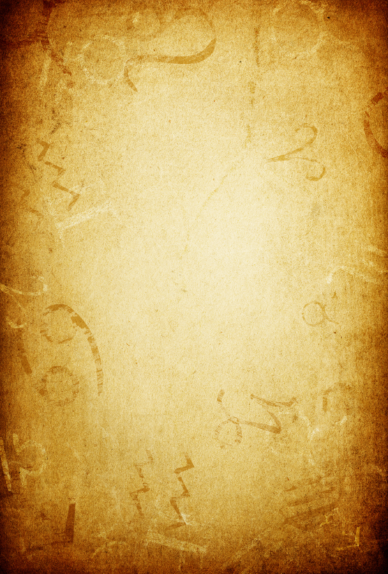
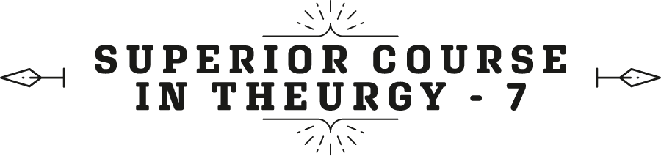


By the Ven. Master T. A-O Domingo Días Porta

W
ell, the Cosmic Ceremony is designed to be performed by man. And what ceremony can a man perform? We are going to study all of that, we are going to clarify it slowly, right? Not everything can be defined now.
Here's a question: Venezuela. —What is the name of the Venezuelan brother who created the Universal Prayer where Maestre de la Ferrière was at the “El Limón” Ashram? Year 1947… or 48.
Master. —Well, in “El Limón”, in that region of Venezuela, near the city of Maracay, in the center of the country, a disciple of the Maestre donated land to put the ashram there. When the Maestre was there, he met the poet Sonamir, a pseudonym—Sonamir is an Arabic word—of a poet who lived there, in that… At that time, it was a hamlet, now it is almost a city, El Limón. And, that poet wrote him a poem that the Maestre, when… Sonamir presented the Maestre, “Look, Maestre, this poem, it is almost a prayer, I didn't do it,” the Maestre read it, he said, “Ah! This is the prayer that I had to find in South America, only I have to make some arrangements to remove the poetic part and have the bases that the prayer should have.”
Then, the Maestre modified it, let's say, adapted it, and gave it the name Universal Prayer. I don't know the poet Sonamir's poem, I don't know his first name, I met him and his daughter Mireya, there, in El Limón.
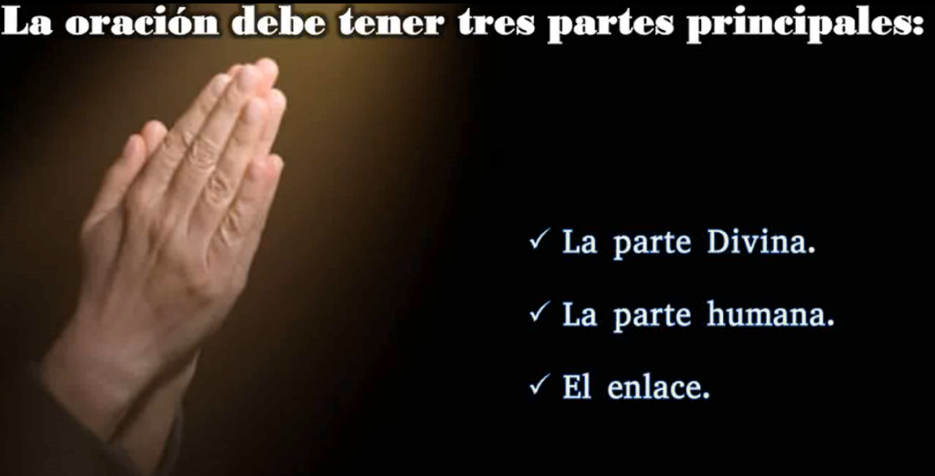
Well, then, a prayer must have three main parts: the divine part, the human part, and the link. So, in the Lord's Prayer, the first part is dedicated to GOD, "Our Father who art in Heaven, hallowed be Thy Name. Thy Kingdom come...", then comes the bridge: "...Thy Will be done in the Earth as it is in Heaven...", that is the bridge, and the rest is the human part, as it is commonly prayed, "... our daily bread...", etc.
The same with the Universal Prayer, the first part: “Blessed merciful GOD… There are four phrases without a verb, then comes the bridge: “… in this solemn hour, when our hearts are saturated with Your Love…,”. That is the link with the divine, and then the human supplication comes. And, they have other rules, the prayers that are made with Theurgy, with the grammar, let's say, of Ceremonial Magic.
Question. —Master Estrada told us that in each degree there are three levels of consciousness, is it considered, when you reach the third level, that you belong to the Aerosomic scale?
Master. —No, not even in the Pneumatic either, but what the Elder Brother said is that if we hear a little bit of the Elder Brother, we can no longer guarantee it, we have to hear the whole thing. The Elder Brother, Master Estrada, said that there are disciples, who from the beginning, you can see that they vibrate with the Aerosomic scale. It is not that they are on the scale, but from the beginning they point directly towards the mental state, they do not settle, with doing Yoga acrobatics, standing on their head, twisting their spine, etc., no, and they have a spirit of service, in short, there are manifestations. The state of consciousness cannot be measured. There is no thermometer but, “by their fruits you will know them”, by the way of speaking, acting, behaving, making decisions, etc., the Elder Brother realizes, what level.
“You come short, you’re not”...
“But Master... it hurts here, the doctor said”...
“Ah, well, it's okay. No, he’s still very somatic.”
And perhaps there is one or another that vibrates with the pneumatic scale, but no, it’s not like that, the Aerosomic has to manifest itself first.
We have the case of the Buddha and his two disciples, Bodhisattvas in stature, that when studying the career of the Buddha and his disciples, one sees what depth those two disciples brought, which gave them authority. He asked them questions to tell them about such a thing, and what the disciple, the Master, answered… “Correct! This is what you should do, the other disciples take into account, that is the teaching.” He supported it one hundred percent.
Fine then, yes they are not three levels, they are rather three potentials, let's say. Most bring somatic potential. Master Estrada's attempt to open the Aerosomic scale did not work because the people were not prepared. The Internal Ashram, the Secret Chamber, and other things that the Maestre put as a thermometer, the people did not respond to, the world remained cold, there was no answer. And the same thing happened to me when I wanted to do it there in Mexico, there was no response, so I made the attempt here, being in Venezuela, with the Aerosomic scale and the responses did not satisfy me, so I gave up on that. From the esoteric, internal, occult Order of Aquarius, Maha Kumbha Sangha, some instructor will come forth. This is not going to stay like this. Even if it dies, we all die, all of us who took to the Elder Brother and participated in the work of the Maestre, that is not going to end, that is going to come out.
If you don't do it..., the Maestre said, "if you don't do it, even the stones will speak", implying that if this group that claims to follow the Maestre doesn't work, some group will come forth from somewhere else. Who knows, from China, Africa, no one knows where, Russia, etc., from somewhere there will come those who will understand the arrival of an Avatar and get going. “Blessed are those who have not seen and have believed,” said Master Jesus. This work will not be lost, that is impossible, there is always a resurrection.
We continue analyzing our Cosmic Ceremony from the point of view of High Magic, of Ceremonial Magic at the level of Theurgy. The Maestre says in The Great Messages, in the chapter about the Cosmic Mass:
‹‹It is convenient to indicate that to officiate the Cosmic Mass, you must necessarily be an ordained priest, and, therefore, even if you are already an Aquarian Initiate, you must receive a special permission, a kind of transmission of power, to have the right and capability to officiate. It is a power that is transmitted from Master to disciple, with personal preparation to receive it from the General Directorate of the Order after an extraordinary ordination, in addition to the Initiatic degree. The others have only the possibility of following the ceremony, and none can say the words used by the priest…››
We have seen that there are people who begin to do the Ceremony as if they were priests, copying the instructions, watching some videos of the Ceremony, officiated by some Master, and that is an usurpation, which, as the Maestre here says, “Although he has an Initiatic degree, he has not received the transmission of power, ordination, and permission.” After receiving the ordination, permission is given for the Order to authorize the ceremonial to be officiated in the spaces of the Order. So, we have also seen cases of people who give ordination to one another, but the one who gives that ordination, has not received the direct ordination or the transmission of power and the authorization to officiate; therefore, it is a violation. It does not enter the field of Ceremonial Magic at the level of Theurgy, it is a simple prayer, no matter what they do, and pronounce mantras and..., etc., their prayer has no impact on the higher planes, because they have not received that ordination.
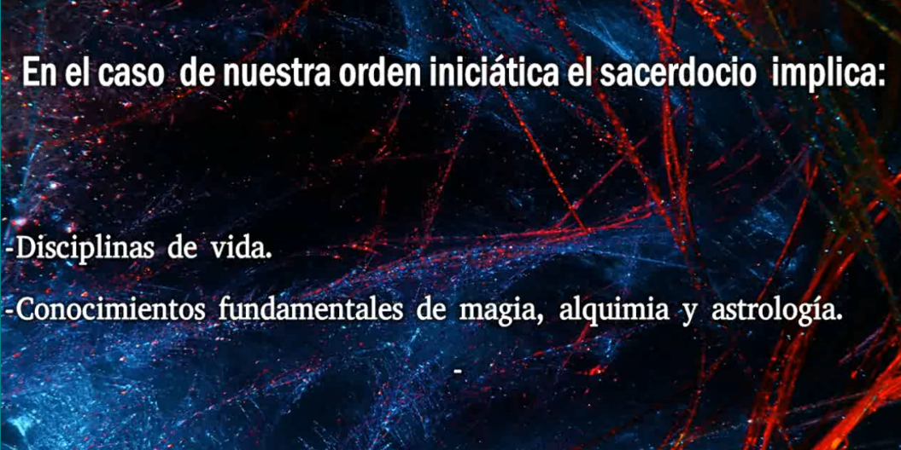
That ordaining is a connection with the light entities of higher planes; if he has not received it, it is useless for him to do what he does; it is nothing more than a theater or a simple prayer; it is not wrong for him to make prayers, but it is wrong for him to deceive himself and others by presenting himself as a priest.
In the case of our Order, an Initiatic Order, the priesthood implies disciplines of life, it implies fundamental knowledge of both Magic, Alchemy, and Astrology. The ceremony is called “Cosmic” because it is done in accordance with the Zodiac, since we saw that each part of the ceremony corresponds to a planet. They correspond, not only symbolically but because of the work the priest must do according to the symbology and the energy singular to each planet, according to where it is located in transit on the day he officiates the ceremony, in a determined sign. Each of the planets are used in the Ceremony, which are all except Pluto.
The Ceremony, during the days of the week, has seven parts that correspond to seven planets, considering the Sun and the Moon as planets, from an astrological point of view to simplify. And on Sundays and on Initiatic dates, the part of Uranus is added, which are the verses of David, pronouncing three of the seventy-two names of GOD. As we already explained, they are not names of people, but rather, they are positions, occupations, and mysteries to be exercised. And the part of Neptune, which is the song of the Tantum Ergo, after having transmitted the Communion, the song is prayed in Latin, the Tantum Ergo, in correspondence with Neptune. We already know the symbolism of Neptune, one of the three ruling planets of the Era of Aquarius. The sign of Aquarius is ruled by Uranus and is the primary ruler of the Era of Aquarius. Therefore, for the Era of Aquarius we see how the vibration of Uranus predominates in Society, as we move towards the definitive implementation of the Era of Aquarius.
With every moment, Uranus has more power. Uranus takes seven years in each sign. It is currently in the sign of Taurus. It will last perhaps three, four more years in Taurus, and we see the manifestation of Uranus in Taurus, in what is happening in the societies of Humanity, and in the personal lives of those who already vibrate with the spirit of the era.
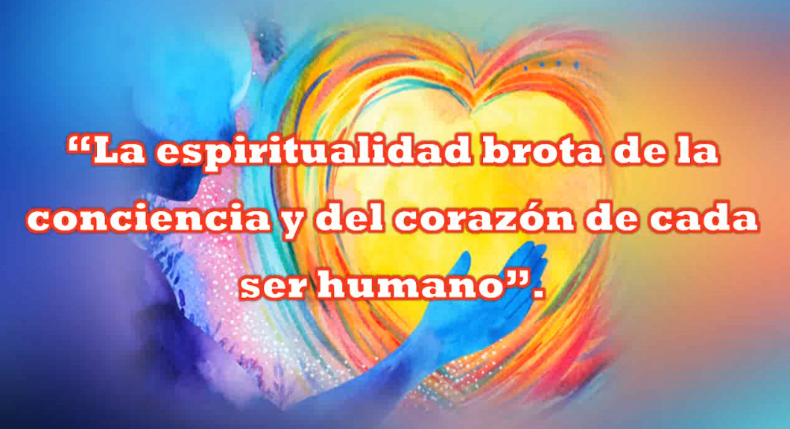
Thus, Neptune expresses the spirituality that the Era of Aquarius brings. As ruler of Pisces, the previous ruler was Jupiter, so Jupiter expresses and symbolizes power, the religious, political, and economic power, which was typical of the Era of Pisces. On the other hand, Neptune displaces Jupiter and brings spirituality instead of power, that is typical of Jupiter. Spirituality springs from the conscience and heart of each human being. Religious power is transmitted to the people through the doctrines of religion. In the Era of Aquarius, that spirit of believing, of accepting, let's say, the dogma, the postulates of each religion, that belief will be illuminated with the wisdom that the sign of Aquarius and the main ruling planet brings, that is , the planet of science, Uranus.
Thus, belief is illuminated with wisdom. It is not that there will be no belief, but that belief has to be based on solid knowledge. It must have an esoteric scientific basis and not accept belief without study, which was typical of the Era of Pisces, and it was justified because ignorance, illiteracy, lack of scientific development prevailed... Fine.
The Master continues by saying:
“However — it refers to those who attend the Ceremony, they cannot officiate because they have not received both the degree and the ordination, the transmission of power and the authorization given by the Directive of the Order. The Maestre says, “However, where no one has yet been ordained to act as a priest, members of the Order and the brotherhood in general can join together and tune in at a distance to mentally follow the Mass and take advantage of the magnetic effluvia radiated from a temple of the institution...”
That is, do the antennae —we say attunement— to connect remotely with the Master who is officiating in the main temple, the central temple, we have to clarify that. We connect, visualizing that the Most Sublime Maestre, in the Cosmic Cathedral, is officiating the Cosmic Ceremony. We are not going to connect with a temple in a city, since cities are still profane, contaminated, they are sick cities, but directly. Obeying the name of Cosmic Ceremony, we connect to the Cosmic Cathedral, the cathedral in the Heavens. That has its study. We visualize a cathedral built of light. That cathedral is like saying, the presence of GOD, taking the form of a wonderful, luminous temple. And there, the Son of GOD, the Great and Supreme Maestre, performs a Ceremonial for Humanity. There must always be an intermediary between Heaven and Earth, a mediator.
In our case, a human who represents, as ambassador of Heaven, that power before Humanity. This is explained in the Psychological Purpose 22 on Magic, on the first page. At that time of Humanity, the Three Wise Men served as mediators, intermediaries, observing in the sky the symbolic star that announced the beginning of an era. They set out on Earth to look for the one who would receive the power of Heaven as the Son of GOD, to bring the message corresponding to that era, in that case, the Era of Pisces and Master Jesus.
Well, then, everyone can participate when there is no presence of a Master, they come together so that, in a group prayer, they can connect with the Most Sublime Maestre in the Cosmic Cathedral.
The Maestre continues saying:
“… to benefit, they gather, as a group, from the spiritual waves emanating from the various sanctuaries of the Great White Brotherhood where the Ceremony is sufficiently organized.”
In other words, in this way we link ourselves, we make a chain throughout the Earth with the sanctuaries of the White Brotherhood. The White Brotherhood, the Great White Brotherhood, is made up of the secret Masters, distributed throughout the Earth, who also officiate the Cosmic Ceremony, and other ceremonies, and other works for the good of Humanity.
It is not that the White Brotherhood, the Great Initiates spread throughout the Earth, that planetary hierarchy, are in one place. No, they are distributed by those centers that the Maestre mentions, in magnetic points of the Earth, for the protection of the planet. There are always negative forces that try to end life on Earth, especially with the evolution of life. As we see today, many countries are arming themselves, their armies, with increasingly destructive weapons, in prevention of a next war. There are the dark forces trying to prevent the new humanity from ascending, in this Era of Aquarius, to a higher plane of life and consciousness. However, the Planetary Hierarchy is alert, and is also working, to neutralize those dark forces, where there are human beings participating, stimulating hatred, fanaticism, tyranny, etc., manipulated by dark forces on invisible planes.
Fine then, the Maestre continues:
“This small ceremony, called antennae or attunement, is guided under the direction of a person, initiated or not, who does nothing more than give the meanings of the mystical moment...”
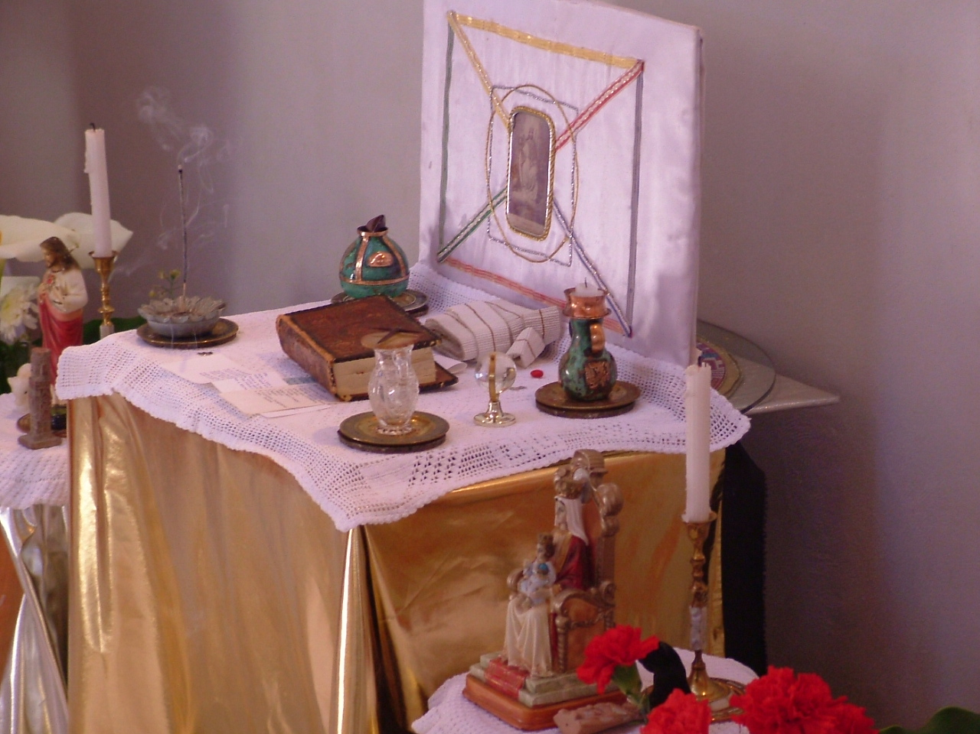
He is describing the steps, right? At this moment the Maestre prepares the Ceremony, at this moment we enter the first part ruled by Uranus, we all pronounce the Prayer of the 33 Taus. In the second part we visualize the Maestre taking the power of the Ceremony, he removes the pilgrim’s emblem, puts on the stole, pronounces the ritual formulas, receives the Anointing from Heaven, etc., and we all silently see the Maestre in that process. It is a moment of silence, visualizing the Maestre, acting as a priest. Thus, the third part is announced, the purification of the room, and then, the one who is guiding says, “Let us visualize the Maestre sprinkling water in the four directions and let us make a silent request.” And so on, progressively.
So, the guide may or may not be an Initiate, preferably a person who has discipline, if not, a person who has at least read the chapter about the Cosmic Ceremony in The Great Messages.
“… then, the antennae guide cannot go beyond the preparation of the altar and the first part —that is, the Prayer of the 33Taus— afterwards, it is the true beginning of the mass, and even if he is an Initiate, he does not yet have the right to officiate and can remain silent or continue explaining the direction of the mass, like a servant...”
Who gives the line of conduct, right? For example, at the moment of communion: “Let us open our hands to receive…”, the energy of Communion. In the Era of Pisces, the Catholic Church used matter. It used the host, which represents the sign of Virgo, and moistened in water or wine, which represents the sign of Pisces, because it was the Era of Pisces and the opposite polarity to Pisces is Virgo, so it was bread and fish. The Virgin and the fishers of men, Pisces and Virgo. Because it is water and earth.
Now, it happens that the Era of Aquarius is “air”, and the one that makes polarity with Aquarius is the opposite sign, which is Leo, it is fire. So, physical matter, bread and wine, is no longer used, but fire and air are used instead. Air then, represented by breathing and fire symbolizes Love, Supreme Love, Divine Love, the love of GOD, from which small loves, feelings, emotions, etc., derive.
Then, we make the gesture of receiving the gift of loving truly, true love, and we inhale deeply. We visualize that we are receiving the Divine Light for our mind, heart and mind. Heart and brain, let's say, heart, the fourth chakra, and brain, the mind, the sixth chakra, the seventh.

Superior Course in Theurgy, By the Ven. Master T. A-O Domingo Días Porta
All Rights Reserved

