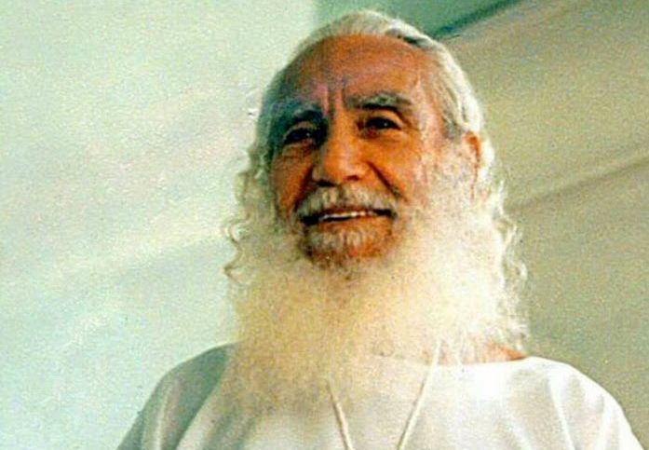

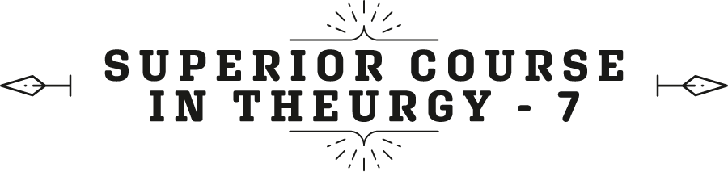




By the Ven. Master T. A-O Domingo Días Porta

Presentation by Sr. María Guadalupe de Días.
Good morning to all the spiritual family of any country where you are. As you know, we are celebrating the 123rd Anniversary of our Master Dr. José Manuel Estrada. Of course, it's not his birthday, we celebrated his birthday yesterday, on the 28th, which is when he was born. But, well, the Master [Domingo] wanted to do the Cosmic Ceremonial to give more strength to that activity also in a Major Ceremony. We are here, in the city of Mérida, Venezuela, with the group of coordinators, those who are present here with some assistants from other states and we are therefore pleased to have them in presence.
Maestro Domingo Días Porta.

F
Firstly, about the Cosmic Ceremony: it is an act of Ceremonial Magic, therefore, everyone who participates in the ceremony remotely or in person, must have studies of what Ceremonial Magic is at the theurgy level. Ceremonial Magic has many branches, some are dedicated to healing through magic, making personal requests, protection, etc. It is a level... let's say, medium, of Magic, but the highest level is to identify ourselves with the Divine Presence that fills everything. It is not a person in a corner of Heaven, no, it is a light, a universal mind, a cosmic consciousness, the source of all the energies that govern life on Earth, in the mineral, vegetable, animal, and cosmic kingdom. Without these studies, then, people do not know how to participate, how to receive blessings. The Era of Aquarius brings Knowledge, science above belief. It is not that belief ends, but that belief is illuminated with sapience, faith with knowledge.

The spirit of the Era of Aquarius is based on research, study, and solving mysteries. As the prophecy in the Apocalypse says, “The day will come when all mysteries will be revealed and everything that is hidden will be brought to light.” That is in the process of being fulfilled: the mystery of the atom, the mystery of the galaxy, the mystery of life in the Universe. Of this current universe, because there are universes throughout time, like civilizations, and universes at different levels, not only at the physical level.
With that knowledge, then, the magician’s apprentice is the one who has not received a priestly ordination. He begins to vibrate with that higher plane of Ceremonial Magic that is Theurgy.
Theurgy means The Work of GOD, participating in the work of GOD, in favor of the work of GOD. If you go against it, like those who pollute the environment, they are against the work of GOD. GOD creates forests and there are humans who cut down the forests, therefore, they are against the Universal Work. They pollute the air, the water, they commit this offense through irresponsibility, by not assuming responsibility before Creation and the Creator.
Well, today we are celebrating one more year of having come into this world of the First Apostle of the Era, our Elder Brother, Sat Guru, Dr. José Manuel Estrada. I want to read the first letter I received from the Maestre in 1951, a small piece of paper, but it is full of keys. It is already fading after so many years, and it says like this:
“To brother Domingo Días Porta, PASH! You must excuse me for the brief style, the incorrect paper, and all these unconventional forms that I use with you, but I have too many activities at the moment that prevent me, and do not allow me to respond to the leap of faith that I received in your letter.”
Look, July 7, 1951. July 7, seven-seven, and 1951 adds 16 which adds seven. I, without realizing it, wrote to him with the date seven-seven-seven, the Maestre was the one who noticed the key, and I started to investigate why he wrote to me like that. He answered me - in the end we will see... He answered me seven-seven-seven, in words. The letter continues:
“I do not have to thank you because it is a realization that you made now on the Path of Truth; however, I am always happy to see an adept of the Light in this work. Brother Estrada must be—notice—the ‘symbolic focus’ that you must follow.”
The Maestre's first letter to me. “Brother Estrada must be the symbolic focus that you must follow.” With that I have no doubts about the Elder Brother's mission.
“It is about this Honorable Dignitary that our institution, from which the Initiatic Tradition comes —What a confirmation. The sacred elements are missing, the director of our Mission is one of these, one of these columns on which the Sublime Temple must be built.” The sublime temple, not the temple of brick, of stone, the ‘sublime temple’. “You have happiness in Venezuela, that the person named be in your country.” The Elder Brother. Now, here comes 7-7-7. “My wishes for your Enlightenment and in magnetic contact with you at every moment of your meditation towards the Maestre.”
When I do meditation, I get in touch with the Maestre, with the spirit, with the essence, the sacred presence. […] seven-seven.
“With my blessing so that you fulfill your duty as a man —first seven— with your ideal of soul —second seven— and your spiritual need —third— R. de la Ferrière.”
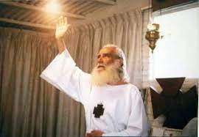
So there, in a few words the Maestre makes clear the mission of the Elder Brother as a column of the Sublime Temple, as the one that represents the Universal Initiatic Tradition. Well, it was after June 1951, we can say, in September maybe. Before, it was airmail, it wasn't that fast.
Ah!, but here is the date on the stamp —Sister Guadalupe clarifies.
It says, December 15th…
Intervention by Sister María Guadalupe:
How nice, right? That you have the privilege that the Master has read to you that very personal message from the Sublime Maestre to a disciple, back then, maybe a young man, depending on when he received, but it’s assumed that he was very young when he was already receiving correspondence from the Sublime Maestre. So, this is the little envelope, Master, at least, show it to them.
—It's the original. —the Master clarifies.
The original envelope —reaffirms Sister Guadalupe.
—With the stamps of France. —comments the Master.
So that they do not tell you stories. The Master, perhaps did not know Him in person, but he has many letters where he is receiving invitations, he is... It may have even be a scolding because a Master is a spiritual father. Yes, we say it like that, right?
Master Domingo.— And I also accompanied the Maestre in spirit. I had a dream for the different places where he fulfilled his mission. I told our Elder Brother my dreams and he showed me letters where he said that he was in that place, in France, in Jerusalem, in Egypt, etc., exactly as the dreams that I had. Of course, the Maestre did not say that I was with him; the Maestre reported on his activity in various places, and I had dreams that I accompanied him in spirit. I even dreamed of his retirement before he retired. The Elder Brother explained to me that this symbolic dream announced something important that was going to come from the Maestre, he announced it, he did not tell me what it was about. Then about three months later, the message arrived from the Maestre announcing his retirement from public activity, to enter his secret mission.
Fine then, we consider our Elder Brother the first Apostle of the Era of Aquarius, an apostle not in the devotional sense of the Era of Pisces but as an educator. An apostle is an educator, especially in the Era of Aquarius that the Maestre Avatar, doctor de la Ferrière proposes, the reeducation of Humanity, because Humanity has been poorly educated. That is why they get sick, that is why they have conflict in the home, in society, between countries, and are dedicated to manufacturing increasingly destructive weapons. So, that must be corrected by going to the cause. What is the cause? The bad education, or the little education, or the lack of true education from birth. If possible before the children are born, the mother must see Humanity in there. So, the reeducation of Humanity that the Maestre proposes as a goal, is not vegetarianism, astrology, yoga.
In a circular from the Maestre he says, "You already have vegetarianism, astrology, yoga; leave that aside, dedicate yourselves to the re-education of Humanity." What does the reeducation of Humanity consist of? In The Great Messages, at the end of that book, towards the end of the fifth message, there is a small chapter called “The reeducation of Humanity”, but through all his writings he breathes that goal, the goal that he points out, that we must all move towards that goal. So, what does the reeducation of Humanity consist of? First, to point out the reason for these crises that are occurring in the World, of “transition”. They are crises of transition from a civilization in decline that is the Era of Pisces, the last two thousand years, towards the emergence of a new civilization.
We are still in the transition, the bridge, that takes us from the old Society that still dominates the World, to the new Society that is growing in the new generations, with new trends, searches, discoveries. They are already gradually leading the people towards the Era of Aquarius. But the paved, polluted, noisy, materialistic cities still vibrate with the Era of Pisces. For a vegetarian restaurant, that is part of the work for the era, there are hundreds of non-vegetarian restaurants that produce diseases, the big business of our time. The Era of Aquarius does not bring remedies for illnesses, it brings full health, and therefore, no remedies are needed. No hospitals, no pharmacies, no clinics, that is for the sick humanity that is already ending.
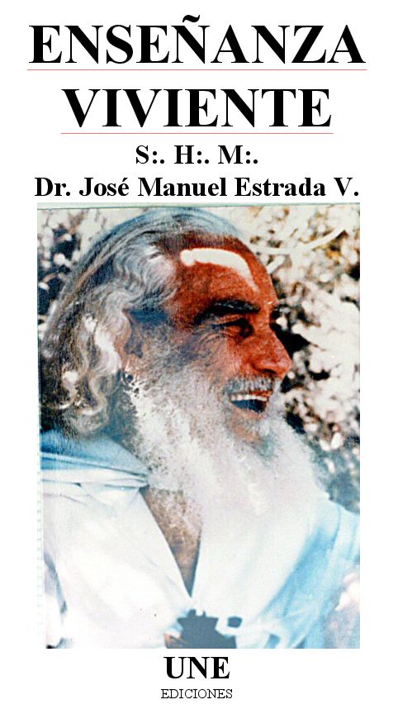
So then, the Elder Brother is the first educator. And the Maestre, in coming to America, the Maestre comes from the Old World to the New World. Old World, Europe, because it represents the Era of Pisces, the old era, which is in its last years, walking with a cane, supporting itself with atomic bombs, with weapons, importing food from America, from Africa. So, he came from the Old World towards the New World. What does that mean? That the Maestre brought the Rod of Power that was in Europe. He had to give it to a man from America so that America could begin to occupy its rightful place as the center of the Era of Aquarius; above all, he says, South America, from where the future apostles will come, that is, educators of Humanity. First, clarifying this time of crisis, which is not for the end of the World, the Universe, etc.
A world is ending, world does not mean the Earth, world means a lifestyle. In cities there are several worlds: there is the world of studies, the world of economics, the world of banks, the world of crime, the world of families, etc.; A lifestyle ends, a New World is born. America was called the New World not because it is a new continent, it is older than Europe, but it has to present the New Era, the New World.
Fine then, I want from our first apostle, messenger and educator of the Era, our Elder Brother, [Dr. Jose Manuel Estrada]. I want to read one of his lectures that appear in the book called A Living Lesson. He did not write the book, A Living Lesson. It is a compilation of conferences that were recorded of him in talks after the Ceremony, some communiqués that he sent in writing, and some letters that he answered. They were compiled to make this book, A Living Lesson, which as the title says, he in himself was a complete lesson: his gestures, his words, his example of life, his advice. His chastisements to the brotherhood that still have in their way of living and in their mind, a lot of materialism, even despite being disciples.
Fine then, here we have a writing or message from April 19, 1954, which the Elder Brother titled: “Our Realization and the Elder Brother.” He sometimes spoke in the third person, “the Elder Brother tells you…”. Thus, he says:
“The Elder Brother is among you again after his tour through two nations in Central America in order to further promote the Holy Mission, and I must tell you that our tour of the Sister Republic of El Salvador, and Honduras, was a great success. The Aquarian Seminary was established, a great triumph for the Aquarius Mission. My stay again in Mexico is to affirm and clarify our Mission here in Mexico City (in the capital of Mexico). When entering the Path of Initiation, one must have a secure state of consciousness—that is, be determined to follow the Path, without hesitation—ready to follow the Path of Light. We need to meditate on the teachings to then understand our Sacred Mission.”
Here we enter the Maestre's work to fulfill a mission. We are all missionaries, educators, on a greater or lesser scale, small apostles, or medium apostles, etc., for the Era. Apostle in the sense that I already explained, of educators of Humanity. After clarifying the transition of the Era, then teach what the postulates of the Era of Aquarius are. Fundamental postulate: peace, true peace, peace inside the head, not the signed peace that is always breached, but the peace that springs from conviction, from the heart, from faith. For this, to ensure a different humanity, the Maestre establishes the first task, “the Family Cell”, which has not been attended to or understood by the disciples.
First the cell... Educate the children of parents who are on the Path with the rules of the Initiatic Tradition, and not introducing coarse habits, vulgar words, aggressive educational methods, etc., but rather, the disciple has to be a spiritual educator. The Maestre gives the keys in that chapter of The Great Messages, which is called The Family Cell. It is the first thing that must be attended to before headquarters, institutes, restaurants, rather by paying attention to the family of the New Era. I would call it “The Holy Family” because there, dad and mom are educating their children as they should be. Like the Holy Family in Christianity, it speaks of the birth of the baby Jesus. As soon as he was born, three Masters came to him, three great Magi, Magisters, to teach the parents sacred family pedagogy. And thus, a messiah arose, a guide of Humanity, a founder of a civilization, because from a young age they took care that he not be contaminated by the environment and to maintain the purity of his spirit, to maintain the image and likeness of GOD, of his Being. That must be taken to the new family.
Fine, let’s continued with the writing of the Master:
“ The Mission of Aquarius…”

In the first years of the Era, it was called like this, it was not called the Universal Great Brotherhood but rather the Mission of Aquarius. What is the mission? To establish a united humanity, that is, a great universal brotherhood, not an institution but to work so that all Humanity is a brotherhood, a family, without walls, without divisions, without borders, without weapons, without antagonisms. It was later called the Mission of the Order of Aquarius, when the Maestre found disciples in Venezuela […] Mission of the Order of Aquarius. The mission of the Order of Aquarius is to create a Universal Brotherhood as an institution, to have the legal permissions of the Organization and adequate resources so that all Humanity is the true Great Universal Brotherhood. If it remains an isolated institution, it loses its universal character, a Fraternity among so many Fraternities. Fine.
“…The Aquarius Mission is a coordinated movement that has been establishing Study Centers that raise the level of minds and states of consciousness, but everyone must work unified because if each one wants to work according to their way of being and thinking, and distanced from the Central, they will be playing at Initiation - they are not in Initiation but playing, like children; and they believe themselves to be Initiates. –The teachings, the orders of the Elder Brother, although they may seem crazy, are orders that are based on a knowledge that the brothers who have not trodden the Path do not have.”
The brotherhood is beginning on the Path, Master Estrada is already an advanced Messenger. Therefore, his instructions are necessary to be complied with so as not to remain personally stagnant, in attachments, in appearances.
The Elder Brother continues:
“Many believe that following a religious path is the Initiatic Path, this is very different, totally different. The Initiatic Path is true balance, the path of activity that does not expect reward, neither in this world nor in the next.”
“I am going to behave well to earn Heaven, to go and be in the Divine World.” Then, you are already putting a price on it. “I behave well so that they will pay me.” No, you behave well because it is your duty as a member of society to behave well, without waiting for payment or rewards.
“Anyone who acts thinking of receiving a reward, is not on the Path of Initiation.”—he behaves well to get a grade, to show off to others; he is in the material world, like a veneer of spirituality. —If after entering the Path some reward is acquired, this does not mean that it will be so, no, one must enter the Path renouncing everything.”
In other words, a disciple can receive a gesture of gratitude, a hug, a gift, for having helped, but he is not looking for that; it is something that comes spontaneously from the one who received some benefit. But the disciple does not go around expecting to receive rewards.
“Those who feel Initiation, work on themselves…’
In other words, they recognize their flaws and dedicate themselves to correcting them by not criticizing others. A person who does not improve, what he does is criticize others so that they believe that he is the ‘big cocoa’ as they say in Venezuela, the superior of others.
“… they study to know their flaws and fight to correct them, and remove them—not leave a secret inside so that others do not notice— That is what every member of Aquarius, every spiritual brother, must do. Gossip is a flaw that must be corrected. Others don't like studying - well then, they must study, because that's their flaw – the mission of Christ needs activity...”
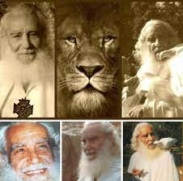
Otro requisito del verdadero discípulo…, actividad, y, de esta actividad viene el conocimiento. Cuando uno hace una actividad hacia la Sociedad, uno recibe conocimiento. Parece una recompensa, pero, uno no lo hace para recibir una recompensa, uno lo hace espontáneamente, generosamente, compartiendo lo que uno ha recibido con los demás, no se lo guarda para sí, para creerse superior, sino que comparte. Y, entonces, su mente se abre, se abre la intuición espiritual y recibe conocimiento que no está en los libros.
“That is why we must obey the orders of the Elder Brother…,”
His orders are for the good of all, not to impose himself and repress others, but on the contrary, he is giving them his hand to lead them along the Path of Liberation, so that they stop being the rational animal, the common man, and become men that manifest in their lives the image and likeness of the Divine.
“… in Central America they have respected and obeyed the orders of the Elder Brother in everything, even in the barracks — in Central America there was a member of the Order who was head of the military aviation in El Salvador; he took him to speak in the barracks. In El Salvador they already have the magazine “Aquarius” which is a beauty—a small nation, the smallest in America, six million inhabitants, giving examples to larger nations—if these people that are so grown and where there are such intelligent men act like this, they surpass others who do not have spiritual quality. We need to encourage, wake up those who are asleep, but those who do not want to work cannot be forced - the Path is not about recruiting people like in the army, the doors are open for those who freely will wish to take the Path - . I ask my brothers to investigate in your hearts, what is the true mission, the true purpose in the Era of Aquarius.”

Superior Course in Theurgy, By the Ven. Master T. A-O Domingo Días Porta
All Rights Reserved

