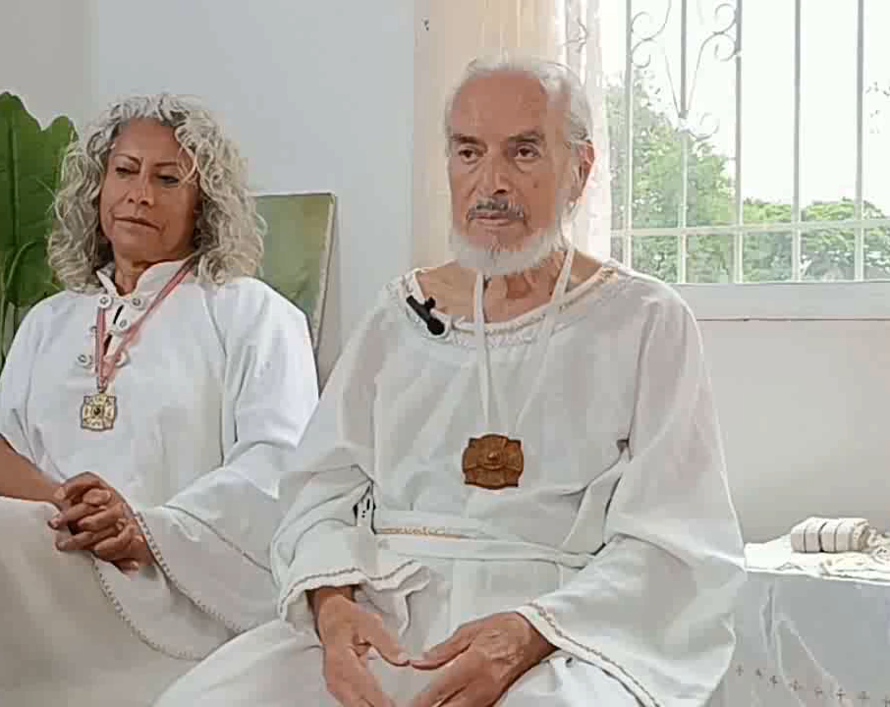
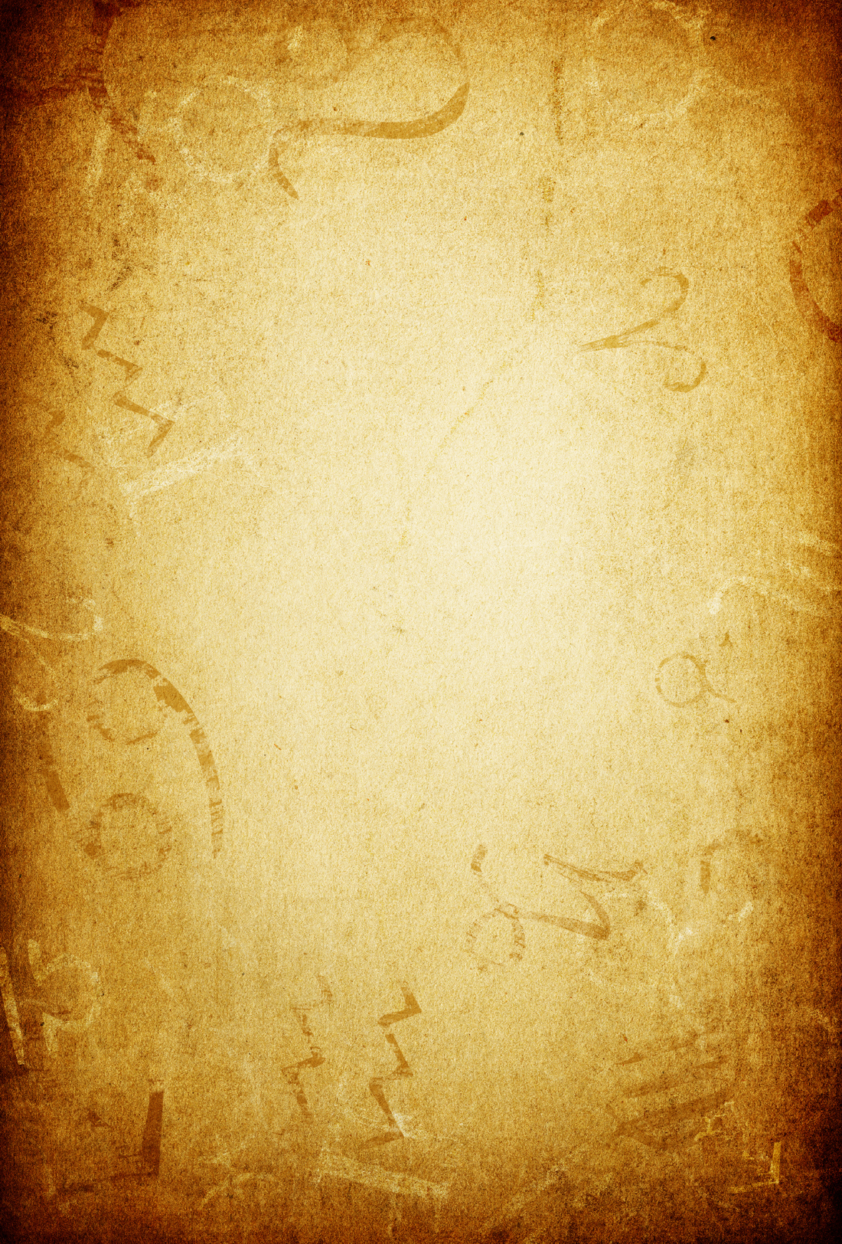
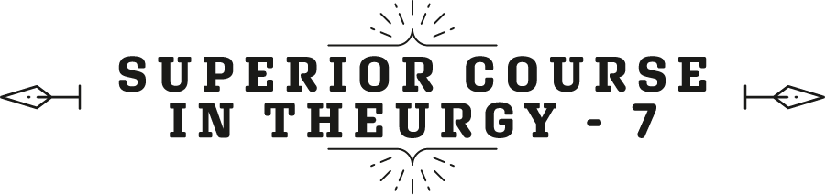

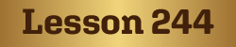
By the Ven. Master T. A-O Domingo Días Porta

W
e are in the Era of Aquarius, the era of knowledge, the era of Science. The Era of Pisces was the era of believing, “it's a mystery my friend, don't ask.” The priest told us when we went to catechism, “don't ask, it's a mystery, believe!” Just believe, it’s enough to just... And, in the Era of Aquarius, I am no longer satisfied. We want to know exactly what GOD is, what am I, what is this about, life, the world? As children we learn to investigate, to question in order to investigate, a methodical doubt. A scientist has a doubt, he goes to the laboratory and finds the answer. That is the methodical doubt. The doubt of the ignorant, he remains doubting all the time; "I don't... I don't know." He doesn't know how to use that...
Doubt is like arriving at a crossroads and stopping for a moment to see where the correct path will be, looking for the map and right away decide. He who reaches the crossroads and stays there for years and years is a cerebral moron, a fool. Doubt leads to knowledge if one takes action. We are in the Era of Knowledge. It is not that belief ends, but that belief has to be supported by sapience. “What is the Holy Trinity?” It's this, this, this, and this, explained well. When you understand it, it works […]. When you don't understand, well, no matter if you pray to the Trinity, nothing happens.
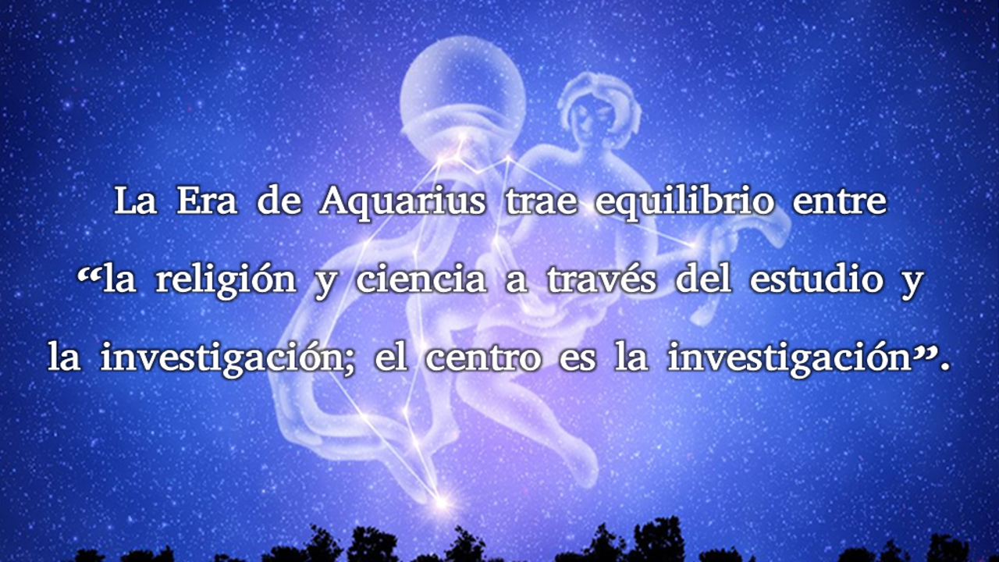
Doubt is like arriving at a crossroads and stopping for a moment to see where the correct path will be, looking for the map and right away decide. He who reaches the crossroads and stays there for years and years is a cerebral moron, a fool. Doubt leads to knowledge if one takes action. We are in the Era of Knowledge. It is not that belief ends, but that belief has to be supported by sapience. “What is the Holy Trinity?” It's this, this, this, and this, explained well. When you understand it, it works […]. When you don't understand, well, no matter if you pray to the Trinity, nothing happens.
GOD... GOD... what is it? Such a small word, two consonants and two vowels [DIOS in Spanish], Supposedly it encompasses something very big, truth [...] so many fights [...] they don't have the slightest idea. Those who have an idea of the truth, no longer fight like that, they share.
Parents who have not studied family pedagogy, what are they going to know how to educate their children. They are going to educate them as they were educated, without understanding that what each child brings is different from the other. One child is educated in one way and the other child in another way. because he or she brings another temperament, other tendencies. Don’t educate them like in a barracks, all the same, all soldiers. It is the symbol of the Holy Family. Respect what the child brings so that when he is an adult, he is a guide of Humanity, in his profession, in whatever, carpenter, bricklayer, doctor. But, as an apostle, with wisdom, not only the profession.
In the symbol of the Sacred family, in Christianity then, we have the... Three people, three wise men. Christianity began with magic, with three wise men, and in the manger or in the little house there were three people, the father, the mother, and the son. And then arrived, the shepherd boy with a sheep and a cow, three. And the three wise men brought three gifts to the parents. They came from three continents. One came from Africa, another from Europe, and another from Asia, from India; one on a camel, another on a horse, and another on an elephant, three. They were guided by the stars, Astrology. This is how Christianity began, with astrology, magic, and alchemy. They brought gold, myrrh, and incense, the three sacred sciences, to the parents. A baby does not need gold, frankincense, and myrrh.
To the parents, gold, Alchemy. “You are going to educate him. That child is not your son, he belongs to Humanity. He is an envoy from Heaven. You are going to respect him, do not show him bad habits, as parents usually do, and things that are not. You are going to teach him based on Magic.” And what came out? Well, a great Wizard. He turned water into wine, walked on water, cured a paralytic person without medicines or surgeries... [with] Words, etc. Magic was prohibited in the Era of Pisces because it was a materialistic time, and there was a danger that magic would be used for harm instead of good. And now in the Era of Aquarius, that is now taught.
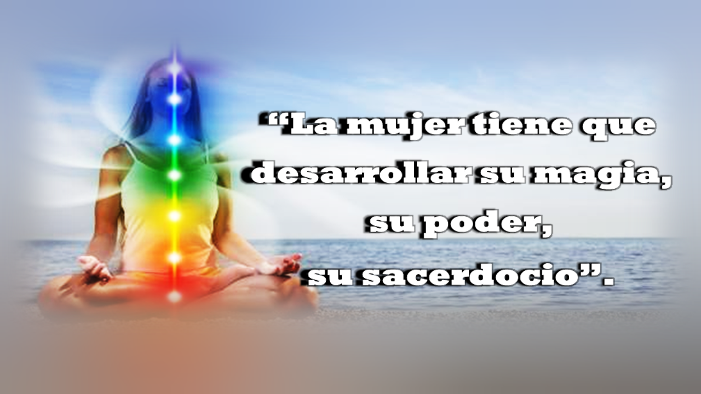
“You have white magic, you have cast a spell on me,” as the song says. A woman has her magic and a man his, but, very different, the feminine magic, very different from the masculine. The female priesthood is different. There are women, In the Catholic Church, who want to do the mass, they want to do what the man does. They put on pants, they put on shoulder pads, but they are not men, they can't. They would have to have surgery, and not even then. No, the woman has to develop her magic, her power, her priesthood. There are things shared between men and women, and things that are exclusive to men and exclusive to women, not because of ideologies but, nature has simply made us that way, and we must respect the laws of nature, the work of GOD.
The little children feel, the energy. When I go to mass, close to home, I see the little children who escape from their parents and approach the altar and walk around. They feel but do not have the words to say what they are seeing; they see and feel. And, the adult loses that, by turning outward, towards the material. The five senses become dense; the sixth sense does not exist. There are only five senses, “five fingers”, five laws. The sixth sense is nothing more than the development of the five senses. For example: clairvoyance, seeing clearly; clairaudience, hearing clearly; clair-taste, clair-smell, clair-feel.
The senses are atrophied, they must be cultivated. There is no sensory education. Painters do because they bring that sensitivity, they feel color, they live it, and they paint it. And, musicians and composers, the great composers have clairaudience; they turn the landscape into a musical composition, they turn their love into song, but they still lack, but they already have more sensitivity.
Those who use aromatherapy, healing through aroma, have that sensitivity, they help heal. What happens though, is that the patient does not have that sensitivity, they receive something, but not what they should receive. Chromotherapy, color healing; music therapy.
Be like children again, said Master Jesus; but not to be children again. Be “like” children again. What does “like children” mean? With that purity, that sensitivity, that nobility. The child has that, but he loses it because he has it unconsciously. He doesn't realize it, it is natural for him to be like that.
With the influence of adults, his spiritual sense is closed. The parents start first when one as a child, is contemplating... “Son, start doing something! Don't waste your time there! Grab the broom! Do your homework!” And they shut him in. Respect, he is meditating, he is playing with an elemental, with a spirit of Nature. So, the Holy Family, parents with sacred family pedagogy.
Gold, frankincense, and myrrh. Gold/Alchemy; Incense/Astrology; Myrrh/Magic. And of course, what came out of that child? A redeemer of Humanity, with such an education. Maestre de la Ferrière brings a teaching in this regard. It is called “The Family Cell”, in view of the fact that the family is in decline, that there is practically no family. Everyone goes their own way, and the family… Sometimes the Parents were like tyrants of their children, they beat, they prohibited, they punished them. We must recover the idea of the Holy Family.
The true yoga teachers are in India. How have they been educated? Since they were children, their parents transmitted to them the sacred traditions, everything; they took them to the temple to meditate, to pray, to do yoga. Well, of course, they’ll become Masters. Here there are no yoga teachers, there are teachers in physical education. Well, it's the beginning, that's fine, Kindergarten, primary school, yoga as physical culture, vegetarianism, a simple meditation. If yoga were taught as it should be, almost no one would go, they have to make it easy for them. And the day will come in the next generation when they will want to know more.
“Today I read a book by a yogi from India.”
“Ah, that's good, then, let's show you this.”
Yoga is not exclusive to India, but India was the last refuge of wisdom in times of persecution, fanaticism...bonfires, empires, and war; there it took refuge. The Mayans have Sujuy Tukul, which could be called “Yoga Maya”, so it is called Sujuy Tukul, “Essence of Thought”. Yoga Maya is based on postures of the mind, on attitudes, not on postures of the body, “asanas” of the mind. The first posture in Sujuy Tukul is the posture of joy..., and it begins with sadness. This is how the Mayans teach.
If you have shadows in your days, in your mind, in your being, sadness that you have been accumulating... Sadness is the starting point of joy. When you understand sadness, why am I sad? Why was I sad? Why? You analyze yourself; you don't blame the other, no, that's a bad habit. You blame yourself for what happens to you, and you realize that it's because you're silly, you got sad because you're being silly, and it makes you laugh, then, sadness becomes joy. That is Alchemy, turning lead into gold, low passions into high passions.
I asked the Mayan master, what about the second position...? Shush! With the first one you have for a while, when you master it, you will then know what the second one is. That is registered in oneself, all about wisdom. GOD is in oneself, “We are in his image and likeness”. As Saint Paul said, reach the perfect stature of Christ, the inner Christ.
Well, let's see what he... There is a teaching by Maester de la Ferrière in one of his books called Art in the New Era, a teaching that I believe that whoever grasps that key will truly become enlightened. The Maestre has been talking about some wise men that Humanity has had. He talks about Lao Tzu, a Chinese wise man, who taught the Tao. Tao means “The Path”, The Word. He wrote a text where it says, “The path that is The Path, is not the ordinary path; the word that is The Word, is not the ordinary word”, etc., and, the Maestre says thus – a quote that I take from a section on page 62 of Art in the New Era:
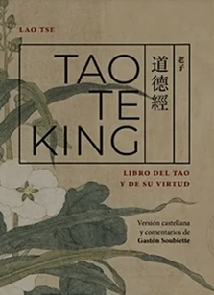
“The Tao, The Way, The Path; the Initiatic path that takes its name from the only work that Lao Tzu has written, the Tao Te Ching—that book […] the Way. It is said to be the middle path. The Way is certainly understood as to GOD himself. It is the only way, the only path, all the rest are weeds where one gets lost and moves away from the Path, from the Way.”
So, he wants to be an astrologer, “I want to be this, I want to be…”, so, he stayed there, he stagnated.
“Do not waste time because you will have to, one day, return to that only path that leads to the goal.”
In other words, the path is GOD, but GOD is supposed to be the goal. One day I will have the vision of GOD, His Omnipresence. But the Maestre says it is the way, “Do not leave for tomorrow what you can do today.” So, I made the comment, I put it like this: “… such a valuable key that the Maestre transmits leads me to this meditation: what does the path consist of? In the goal. Live each day capturing the divine omnipresence, at once, without wasting any more time, taking detours, with humility in the face of so much greatness.” As one makes the effort to see that, on the wall, on the ceiling, on plastic.
“Do not be blinded to the subtle reality hidden by the mental veil, mirage, and transitory appearances. Walk on the precious stones of perennial Wisdom, not on the quicksand of concepts, doubts, that chain the mind.”
So, in summary, what does the path consist of? On the goal. And then I say, “What does the goal consist of? The path". The goal that one wants to achieve is on the Path, it is in life. My goal is to be happy; happiness is here. It is not a person, it is not an object, it is an internal state.
“What is the goal? The way, in not leaving for tomorrow what you can do today, what you hope to see, achieve in the future. It is already at present, an instant, in the place where you walk. Yes, what you call GOD is in you and around you. It exists today and not only tomorrow. With such courage, with that faith, you will heal from the evils that weaken your will, your character, energy, the joy of being. First, you have to decipher that hieroglyph, D. I. O. S. [G.O.D.]—with points—, without sticking to the letter to get to the essence.”
That exercise of being with GOD at once, seeing the divine omnipresence. We have to meditate on the word GOD, not the word, but what the word contains. It's like the word happiness; the word happiness has nothing; it doesn't say anything. If I had something, saying happiness makes you want to fly, to jump, but the word does not define you. To define a word, you need a paragraph. So, it is said: What is happiness? It is always being joyous. So, what is joy? It is being content. Yes, what is content?! You haven't defined anything. Don't change one word for another.

The word is the cage that encloses the idea, the word DIOS, in Spanish, in English GOD, is a word, like a cage, and inside is the idea. What we want is to grab the idea, not the cage, the little bird that is inside. What does the word GOD imply? For us who have heard the word GOD since we were children, it is planted here [in the mind]. In India they say Brahma, but we have not grown up with the word Brahma, we grew up with the word GOD. That is the one that is planted in the garden of the mind and has germinated. It is grown, and we have to decipher it. The Maestre de la Ferrière wants it with periods: [in Spanish] D period, I period, O period, S period (D. I. O. S.) to imply that it is a topic of study and meditation. In the D, what does it contain? Then, grab a dictionary at the letter D to see what words can give you ideas of what is inside the cage; the letter I, the letter O, the letter S.
At least you now know the cage; you now know how to open it, but what interests you is being with GOD, embracing yourself, bringing out the divine that is in you. That is what interests you, not the word, not singing to the word or praying to it. Christ said, “The letter kills, the Spirit gives life”, because the religious people of the time always came out to him saying, “You do not comply with what the Bible says.” And He replied, “Do not cling to the letter, you become dogmatized, you become fanatics.
A Master of that quality is a living bible, he is above paper and ink; he has the true authority. Thus, seek the experience, once and for all, not tomorrow. “Tomorrow, when Enlightenment arrives”, enlighten yourself once and for all, because why tomorrow. What is the desire to live anguished, disoriented, confused, afraid?
So, in that teaching of the Maestre, that key that he gives there, that is a key that opens all the words, all the cages, we get rid of […]; that the crises, pollution, global warming, words to make us suffer. What kind of desire is that?

Superior Course in Theurgy, By the Ven. Master T. A-O Domingo Días Porta
All Rights Reserved

