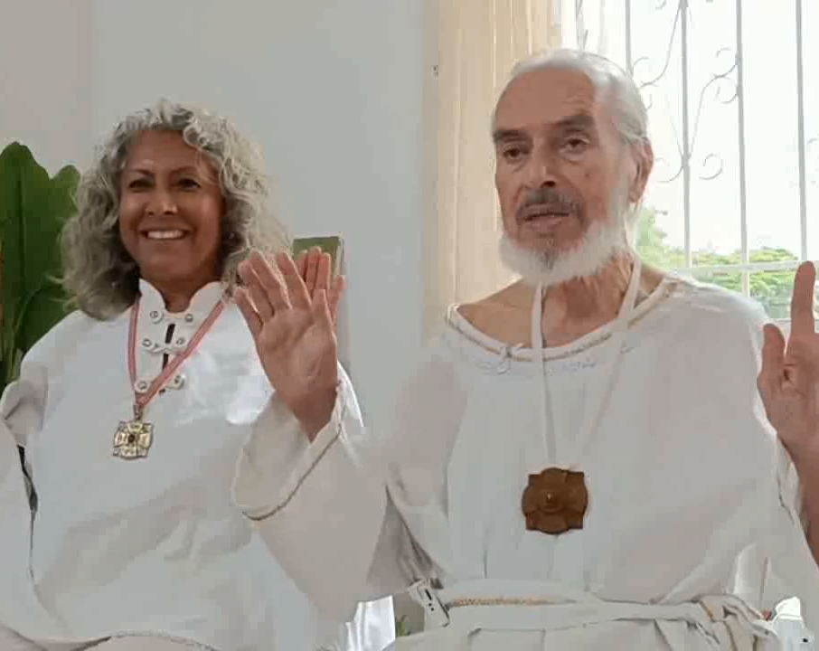

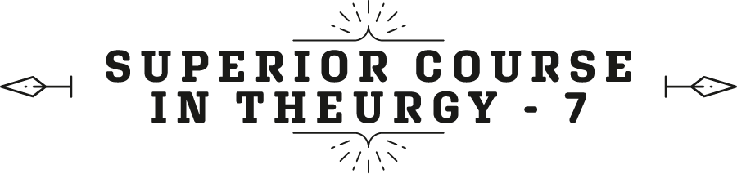


By the Ven. Master T. A-O Domingo Días Porta

M
exico City is one of the most polluted cities in the world. I, who have been there, see the people happy and healthy; they live their lives, they do not live with that anguish. This city is so polluted, yet they overcome the problem. Others, well, get out of there. They don't like that, but some have to adapt to reality, not escape. The example is given by the Masters. Master Jesus lived in a very difficult world for him, one of materialistic, vicious people, with an empire there, even in a house, as slaves, and he developed well. So well, that he reached the goal, ascended in body and soul, not only in soul, in body also. “Put your ear to the drum.” He ascended in body and soul and achieved it. How did He achieve this? By adapting to reality. What did he see in reality? That GOD was seeing him, GOD was with him, inside him.
We don’t have that. Faith had that power, that tiny word, (f – e), a vowel and a consonant [in Spanish]. And what did he say about faith? “He who has faith like a mustard seed—which is tiny—will move the mountain.” Not those [he points out] no one with faith will be able to move [...], but the mountains of inconveniences, of problems, of this, of... And what is that smaller faith? Faith in yourself, not in your name and surname, not in your profession, no, in your being, in your essence, in your image and likeness. When you have faith that GOD is in you, that faith opens the way for you. Not that you are going to have a great time partying, or that you are not going to have problems, difficulties, failures, but you act with your little flashlight of faith, illuminating everything. Thus, it says in Psalm 119, verse 105, “Your word is a lamp to my feet… and a beacon of light to my path.”
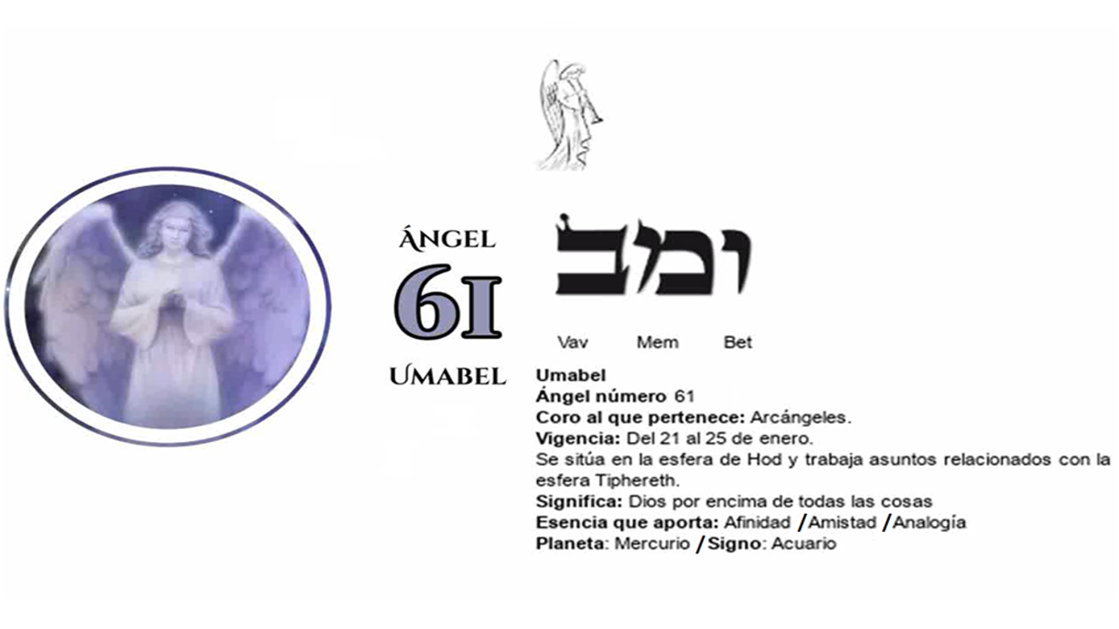
Your word, the sacred teaching, is: “lamp to my feet”, it means in every moment, in every step I take. And “beacon of light on my Path”: my future is illuminated by the Word. It is a lighthouse now, far away, pointing to where I need to go. So, in my immediate present, in my future, the true Word, what the Word keeps, the idea, the teaching.
In the parable of Christ there is a great teaching. The parable is a little bridge, “There once was a man whose name was such...” And, within the story is the teaching. So, it is not about focusing on the words in the story, but about trying to understand what the Master wants to convey, grasping the idea.
Question: —How can we work weekly with the three corresponding Names of God?
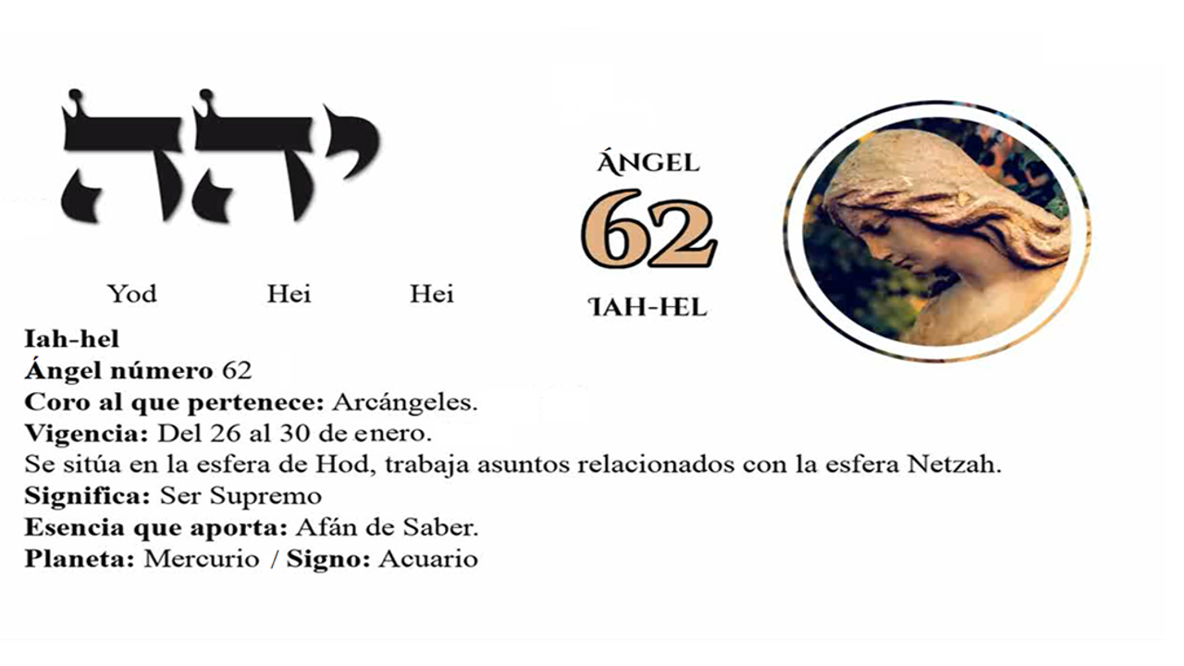
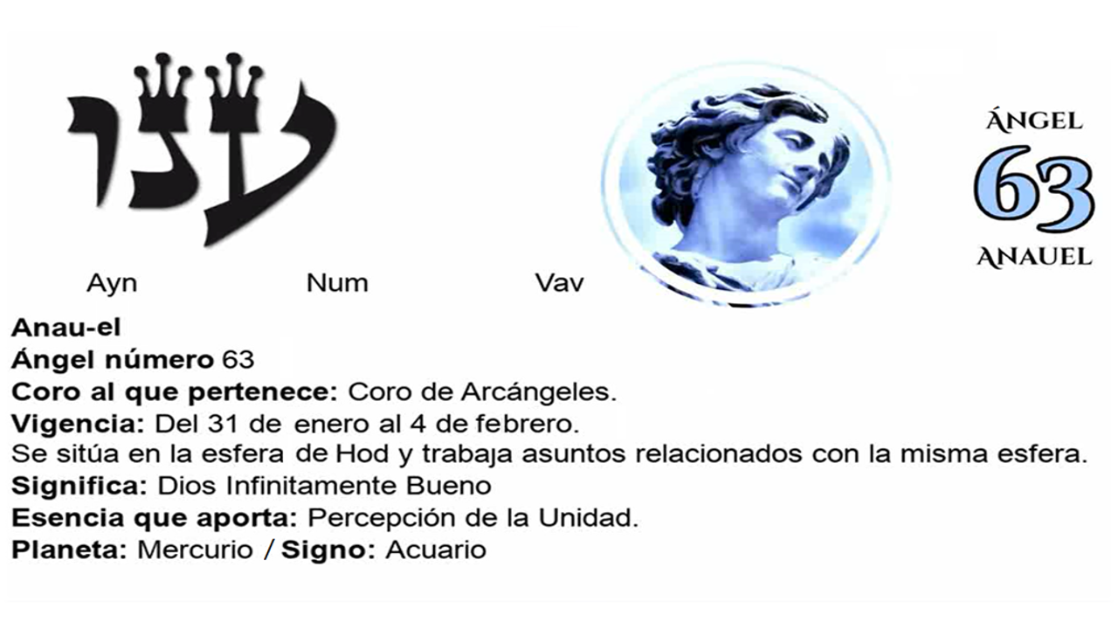
Answer: —Well, that is done in the Ceremony, the officiant makes the invocation, and the work is being done. The week is being worked for those who are on the Path, for those who ask for help, that force is vibrating. Now, those who study Kabbalah, then they study the 72 names of GOD, the three Angels. For example, today we had… Umabel, it is 61, Iah-hel is 62 and Anauel is 63. Take note then, Umabel: “God above all things”, is made up of three Kabbalistic letters which are Vav (ו), Mem (מ), Bet (ב), ימב. Umabel means “God above all things,” so it says in Psalm 5, verse 6, says: “…elevate and revere God above all things.” Love GOD, fall in love with GOD, the other loves derive from HIM, but first, love GOD above all things and your neighbor as yourself. That's Umabel, it has to do with that psalm.
The phrase that is pronounced is in Latin, but in Spanish [in English] it says: “May the name of the Lord be blessed today and forever.” That's in Psalm 112, verse 2. Then, we have Iah-hel [with I (Y)]. Iah-hel is not with G nor with J but with H; Iah-hel, because there are three letters, Yod (י), He (ה), He (ה) the ‘he’ is twice. From Yod, He, He, comes the name Iah-hel which means the Supreme Being and the connecting phrase says: “Look Lord, I love your commands, in your mercy vivify me.” Psalm 119, verse 150. All Psalms have 8 verses except Psalm 119 which has 150 verses.
Well, and the name 63 is an Archangel, Anauel, “Infinitely good God”, with three letters of the cabalistic alphabet. The He is repeated, and the connecting phrase says, “Serve the Lord with respect, rejoice cautiously.” Psalm 2, verse 11.
So, there are keys for you to meditate on during the week. On one occasion for example, the archangel Umabel is invoked from 11 in the morning to 11:20, that is, considering that the sun rises at six. If it rises at another time, the calculation must be made. Twenty minutes correspond to each Name, to each Name of GOD, to each of these servants of GOD. The first minute, the first twenty minutes to archangel number 1. So, to this one [Umabel], it’s turn is from 11 to 11:20. And in that hour, what can we receive? The friendship of a person, easy learning of Astrology and the physical sciences, consolation in matters of love, pleasant and profitable trips, protection against debauchery and passions against Nature.
Then, in those twenty minutes, begin the study of a science. Even if you spend two hours studying but do start at that time; according to Kabbalah. And so on, comfort, friendship, protection... pleasant trips; start the trip at that time, or, at least go to the travel agency.
Iah-hel, the number 62, of the seventy-two names of GOD, because these are not names of people, they are attributes. GOD delegates functions to his servants of the Celestial Hierarchy, of the Celestial Government. Thus, Umabel is the minister of the powers of GOD. Which powers of GOD? God above all things, that is administered by Umabel, that ministry.
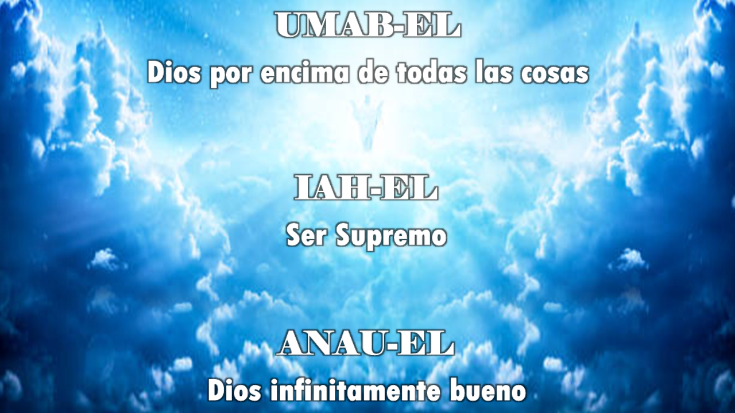
And Iah-hel more or less administers one function: “The Supreme Being”. What is the Supreme Being like? So, at that time, what does that mean, and, that archangel is going to inspire us. From 11:20 to 11:40 is Iah-hel’ s turn. What can it give us? Wisdom, the internal evidence of the truth within one. It helps those who want to withdraw from the World to philosophize, to meditate. So, those who want to go to the monastery, from 11:20 to 11:40 take the bus. Good marital understanding, tranquility and solitude, protects against scandals, luxuries, and divorces.
And Anauel, “Infinitely good God”. He is in charge of divine goodness, from 11:40 to 12:00 of the day. What can it give us? It takes the nations to Christianity, to true Christianity. It protects against accidents, preserves health, cures diseases, helps in business and banking practices, protects against madness, and helps to avoid making mistakes. That is part of that science of the 72 names of GOD, it is a small study that covers many things.
Another question: —Master, at the beginning you were mentioning something that I couldn't hear, that the priest does not pronounce the word Daleth, can you please clarify.
A. —Yes, he does pronounce the word Daleth, at the time of Communion, when the attendees ask for the word, the priest, immediately, in front of the altar, with his back to the audience, pronounces the word, makes the invocation, and pronounces the word: Daleth! / Door! And the doors open, and the Communion descends. So, he who knows how to receive Communion has receptive hands as if he were taking the host, but, it is an energy. He absorbs it, inhaling it, and feels that his being is flooded with that communion, with that blessing. The attendees have to do their part, they are not spectators, they are not passive, they are actively participating, giving strength to the priest, supporting him, being aware of each part of the ceremony.
Fine, that's clear.
Then, in the prophecies of the Apocalypse say: “The day will come when you will worship the Father in spirit and in truth.” Truly, the era of Wisdom has arrived, there is teaching, no more mysteries. And in spirit, direct communion, from the individual soul to the Universal Soul, without intermediaries. That does not mean that the Catholic communion should end […] people have their faith, and they have their beliefs, and it is a beautiful act, it is an act of magic as well. But those of us who bring the Era of Aquarius are leading the way, we are moving forward as standard bearers. We bring the spirit of the Era of Aquarius, without traditions ending, but traditions have to be updated with the era, with today's mentality that is different from five hundred years ago, a hundred years, a thousand years ago. Every tradition, every religion has to catch up, or on the contrary, it will end up alone.
The new generations want Knowledge, explanation, teaching, research. I was lucky that when I learned to read in kindergarten, I entered the first year, the first grade of primary school, and my father bought a youth encyclopedia: The Treasure of Youth, twenty volumes. So, when I came home from school, I would grab one of the volumes and read something. There was everything there, poetry, literature, history, geography, physics, chemistry. All in all, very beautiful. So, as a child I got used to studying, since I learned to read, it was no longer easy for people to tell me lies. For the first communion, we did catechism, on Saturdays, with a nun.
She also taught us things, and she warned us, when you are adults, this and this, don't get involved in this and this; she told us truths. I liked that because I had that concern, to understand, to know, to have things explained to me. At the age of eighteen I entered the Rosicrucian Order (AMORC), which sent lessons by correspondence, following that process of researching, studying, understanding the things of life and the being.
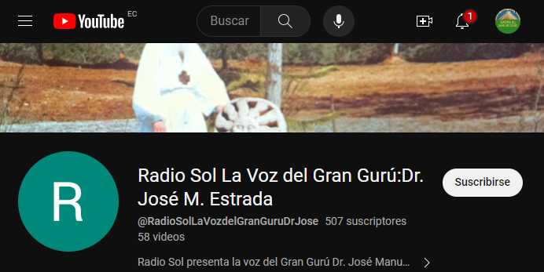
Well, I think we spent some time talking, a spiritual breakfast. I hope you enjoyed it, and soon we will publish... On Facebook I am publishing some teachings, I have a channel on my Facebook, which you can search. The teachings of the Elder Brother are there, which a brother from Mexico, Armando Real Rojas, is transcribing many of the Elder Brother's lectures. You can search for: Radio Sol, the voice of the Great Guru and a large number of recordings appear on YouTube, with very beautiful teachings from the Elder Brother, in detail. Why the stork? Where does that tradition come from? The Master explains. Why don't flocks of birds collide with each other when they are flying together? the Master explains.
And so, many things in life, living lessons that make us look more consciously at the things that surround us, to see that the Path is the goal, and the goal is the Path.
There is a cell phone that can communicate with the higher worlds, not the cell phone that you buy in stores, but the internal communication. It is the gift of the True Word, the sincere word, the word full of anguish, of searching, etc. trying to tune in. In a moment of silence, without rushing, when you are alone, let no one distract you, no one speak to you, close the door to your room, and in silence, says the Holy Scripture, communicate. […], the Master gives work to the disciple, the Master does not do the work for the disciple. The Master gives him the tool and the disciple will open furrows in the garden of his mind and sow the seed.
Thus, enter your inner silence and in that silence the voice will sound and rise up from below and the answer, the voice, will come down from above. The Voice In the Silence, not the voice of silence, as Blavatsky's book, The Voice of Silence, says, a very interesting book. The Elder Brother corrected that, “it is not the voice of silence, it is the voice in the silence.” The voice of silence is something that…Silence has no voice, precisely the word says it, silence. But, in silence there is sound, like the poet that I always mention, who climbed a mountain and when he reached the top, he sat on the edge of the abyss to contemplate the landscape and, when he returned home, he said, “There was so much silence, that even the slightest noise could be heard.” The Voice In the Silence.
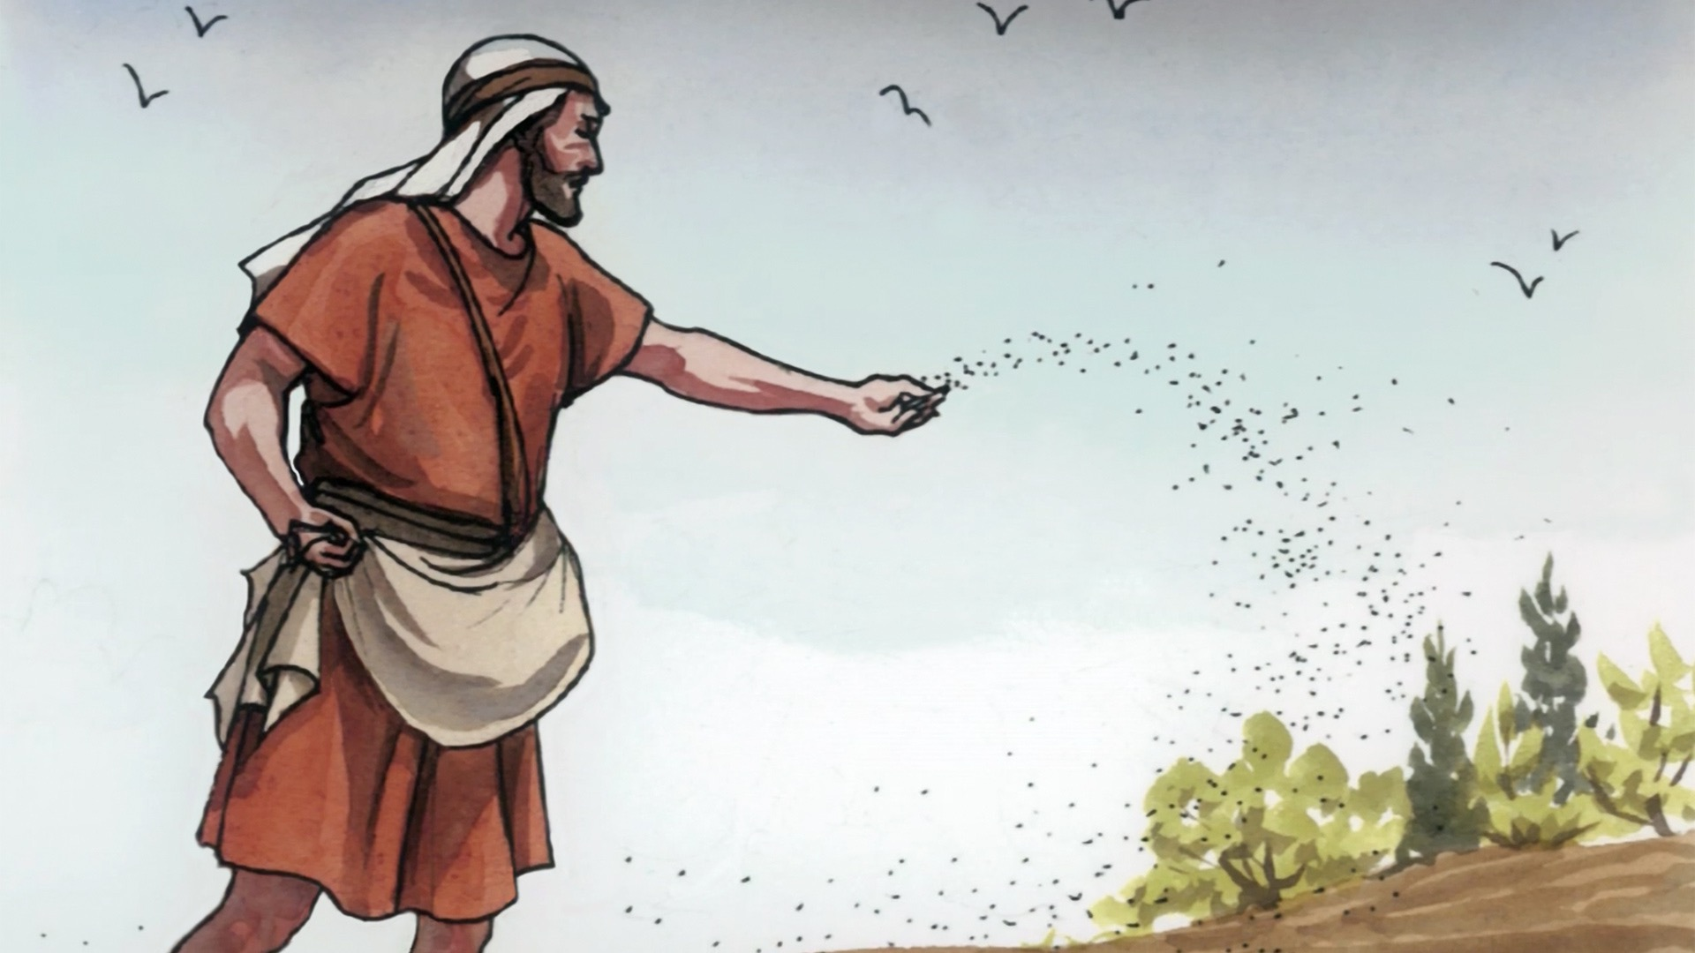
The parable of the sower, of Christ, is very beautiful and has a lot to do with the Path. Our mind is like a garden that is full of weeds and pests, because since we were children, they put things that are not right, are introduced into us. First, we have to clean the garden of the mind. The first meditations are meditations of purification, because if the good seed falls in a field full of weeds, it fails to germinate. Thus, clearing the mind of negative states, sadness, depression, confusion, wrong concepts, etc., we repair the garden, we add fertilizer and place the seed, the good seed, that of the sower, of the Master, he is the sower. He casts the seed to the sides. It can fall on a hard head, on an open mind, on a stone, on dry ground, on good ground, that is not his job, his job is to spread the seed.
Then comes the cultivator, who is more demanding with the crop. And then comes the harvester. So, the task of the Path, is to first cleanse oneself. Do not accuse others of what happens to you, because then you are not a disciple. The disciple blames himself for what happens to him. So-and-so offended me, why did he offend me? What did I do to make him offend me? What is my mistake? What is my fault? That is the correct attitude to start pulling out the weeds, habits, quirks, swear words, etc., that lower our energy. We are in a low vibration when entering the Path, and it will raise us.

Superior Course in Theurgy, By the Ven. Master T. A-O Domingo Días Porta
All Rights Reserved

