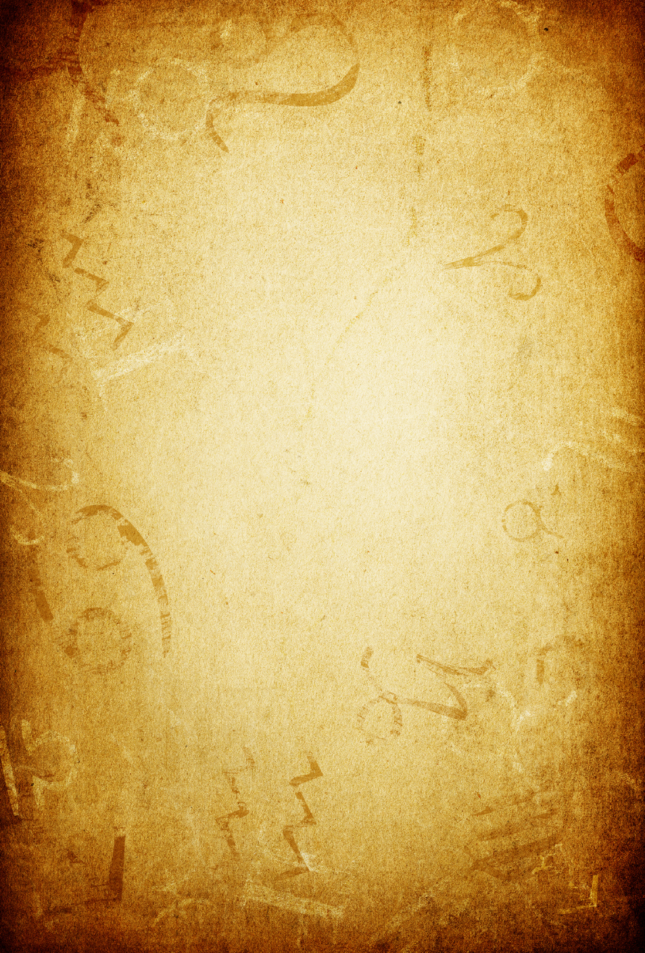
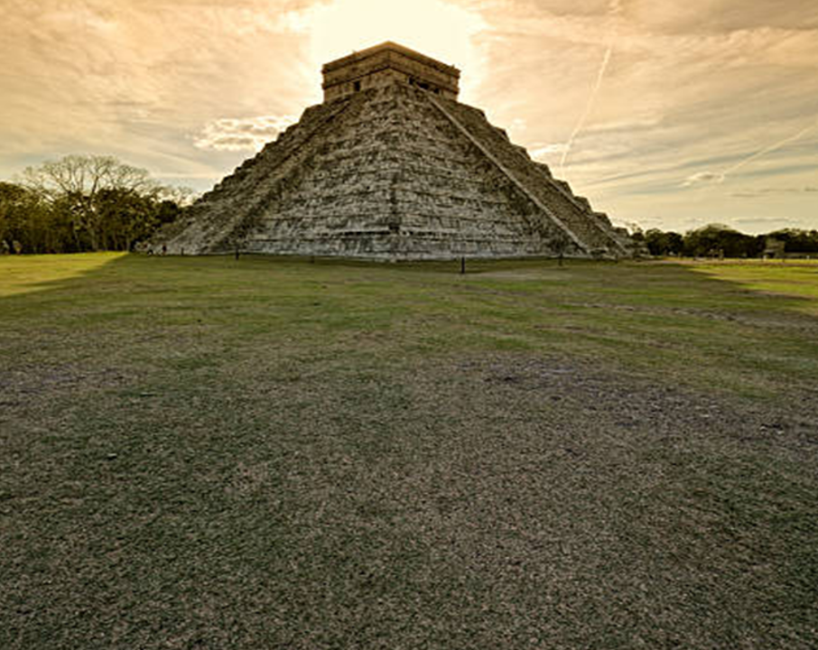
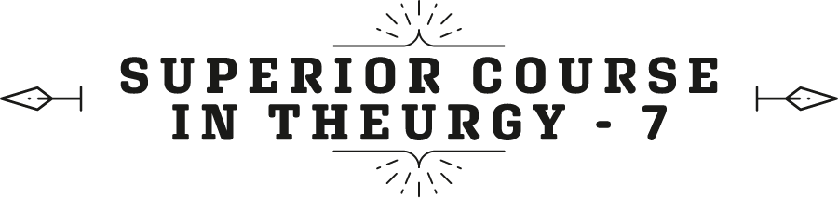

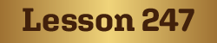
By the Ven. Master T. A-O Domingo Días Porta

L
et's talk about the Solstice. It begins in the spring, it begins in Aries, the month of Aries, thirty days of fire, the month of Taurus, thirty days of earth, and the month of Gemini, thirty days of air. Spring has fire, earth, and air; it's ninety days, the new sun. Then, today the crescent sun begins, increasingly hotter, hotter, it begins with Cancer, which is water. There are countries where the rainy season begins. Here we have rain all year round, but then it culminates in Leo, in the summer, and decays in Virgo, in earth. Thus, after fire, earth, and air, the water element is added; the four elements are completed. That is why it is the month of magic par excellence, the month of Cancer, because magic works with the moon, the sublunary. From the moon downward, with the astral light, is where the operation is done to be able to open to the Cosmos.
The atmosphere that surrounds the Earth, the stratosphere, and the magnetic field that the moon creates around the Earth, all of that can be a closed door or an open door. It depends on the person, if he is still obsessed with his things, he is trapped. No one will take him out, and if he manages to free himself, the door to the solar plane, to the light, opens.
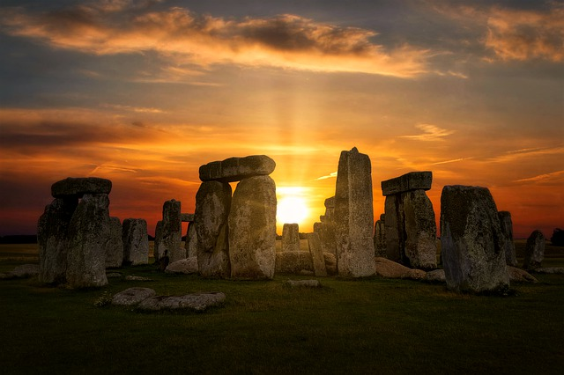
Fine then, today the Summer Solstice, is called the Gate of Men, and the opposite in December, the Winter Solstice, Capricorn, is called the Gate of the Gods. What does the Gate of Men mean in Cancer? That just as plants provide their fruits, humans who have prepared themselves bear fruit and the door is opened to ascend to higher levels of consciousness of the spirit. They are on Earth without being of the Earth, and they are in the World without being of the World. They know that they are passing through, that they cannot avoid it, and that everything they have, one day in the grave, they cannot take with them, not a coin, not even a credit card or... You cannot take it to the other side. To enter the other world, customs does not allow contraband to pass through; only what is allowed can be taken.
So, it is the month of High Magic. All over the world, those who know about this, do their rituals, their ceremonies. Some for selfish purposes, to make money, for this, for that; and then the law falls on them. And others to serve Humanity, to bring peace, well-being, health, solidarity, true love. In each season there are three months. The first month, the rise toward energy, for example of summer, now in Cancer, then it culminates in the month of Leo, and declines in the month of Virgo. Right now, we are at the beginning of summer, it is rising, rising, every day more heat, more light, the sun is getting closer. We reach the top in the month of Leo, fire, the fullness of the summer season. Then it gets cooler, autumn is coming, it is a little mixed with autumn; the last month describes that curve. Thus, in every season.
The same thing happens with the phases of the moon, the phases of the moon, the new moon... How long does the new moon last? A week, each phase lasts a week; there are twenty-eight days. The new moon for a week, the first three days, rising, exactly on the fourth day, the new moon culminates, then it starts to be illuminated, the new moon lessens and approaches the crescent [moon], then the crescent [moon] goes through three phases, then the full moon also goes through three phases that last a week, three days to rise, one day of culmination, and three days of declining, of descent. These are the signs in our lives. Childhood has that; a child starts out who can't walk, doesn't speak well, he's just starting out, then he's a perfect naughty child, running around, etc., Then he becomes a pre-teen; he no longer likes little toys so much and he wants a bicycle, etc. And then comes adolescence, and [the cycle starts] again.
Every age has three phases, according to the teaching of the Mestre. Each phase lasts seven years. At forty-nine (7 X 7 = 49) you have lived the first half of your life, the first half, a large cycle starts like that. Then, the second half begins, from forty-nine to ninety-eight years. Let's see if you make it. Almost everyone makes it halfway due to bad living.
Let's now talk about what the Maestre says of the solstice on page 25 of the Psychological Purpose number 9, which is called Medicine and Pseudo medicine. On page 25 there is an interesting teaching of the solstice from the point of view of Magic, Sacred Magic, High Magic, Theurgy. We are going to read a page more or less. The Maestre writes in a very synthesized way, and if we want to explain each paragraph, we would need ten, twenty pages. So, I'm going to break down what the Maestre says, starting on page 24, the last paragraph:
“The world is well organized and its balance rests precisely on these analogies...”
That, for example, the sign of Cancer is analogous to water, it is a cardinal sign; these are analogies. Like so-and-so, represents joy, the other represents sadness because of his way of being, the other represents responsibility, the other is irresponsible, etc. In this way, there are analogies. Each sign has a precious stone, a metal, a color, a sound, a scent, etc.
“The world is well organized”—from that point of view, not our world, our world is a mess, the human world—… “The world is well organized and its balance rests precisely on those analogies that make some things tied together to one another, beyond different domains.”—For example, Aries, red color, planet, Mars, cardinal sign, etc. So, the sign is coordinated with those analogies, with those correspondences. — “It is in this just title that Teutates, god of the Gauls, was venerated as the organizer of the world,” –the Gauls, in Ancient Europe, indigenous Europe, had that god, Teutates, he was the organizer of the World and anyone who creates disorder, will incur the law on him, not human courts but the Universal Law—"and he was the subject of a special festival on the first night of the New Year.”
The new year in ancient times was celebrated in winter because the sun in winter is weak, it is dead, and then, when winter ends and spring arrives, the new year celebration was held.
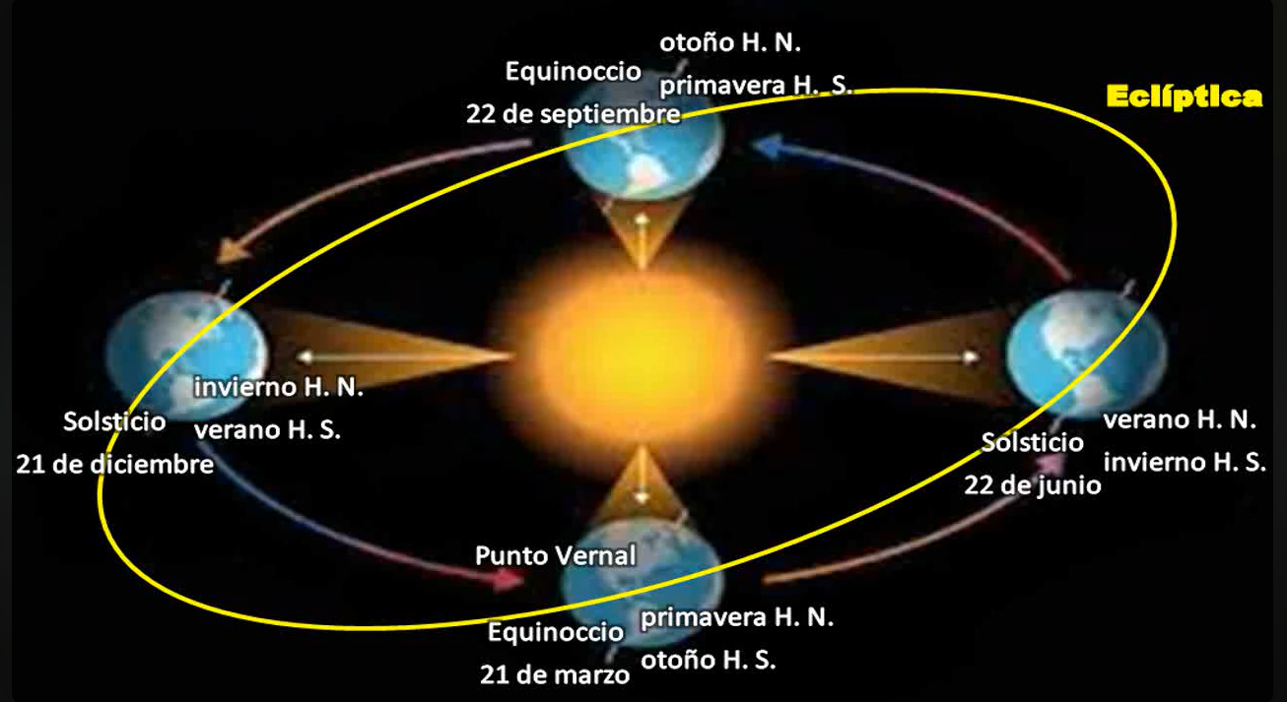
‘The Druids”—the Druids were one of the tribes that lived in Europe—… “The Druids had great knowledge of universal laws, and respected certain very important dates that were in this symbolism; thus the solstices (which indicate the longest day” — in this case the summer solstice — “and the longest night)” — in the case of the winter solstice; Capricorn in December— “with the equinoxes,” — the day lasts the same as the night, in March and September, in spring and autumn — “those dates have always been celebrated.” — In all cultures the four seasons have been celebrated, in the days of the beginning of the solstice and the days of the equinox. — The Sun, which in its apparent march marks those dates, was the object of festivity, but as a symbol of a profound esotericism...››
Knowing that the Sun went through these four phases in the year, festivals and tributes were made to it, and thanks were given because it brings spring, the return of heat, of life, of Light, the little plants begin to grow. In the summer the plants are already big, the fruits are sprouting; in the fall comes the harvest time, and in the winter the Earth rests. You cannot sow, you cannot harvest because the Earth rests. Thus, rituals of gratitude were performed to the Sun, but, as the Maestre says, the Sun “was the object of festivity.”
“… but as a symbol of a deep esotericism and not, as some have believed they see in those ceremonies: a cult of the Sun!”
It was not a cult of the Sun as a god, but rather it was a Thanksgiving to universal energy. If there were no sun, if the sun goes out, there is no life left on Earth, even if there is water, whatever there is, because the energy of the Earth comes from the Sun. The energy from metals, minerals, animals, from us, comes from the Sun. Thus, it is GOD's messenger for our solar system. All planets receive energy from the Sun, they have their life according to their distance from the Sun and their chemical composition, there is life on all the planets and on the moon, and on the other moons of the other planets.
“It’s just that it was likened to fire, an element that the Sun symbolizes and that traditional astrology places in the sky of the lion which represents the typical fiery element, but the idea of worshiping fire was never found in the ancients as such, but rather for what it initially represented.”
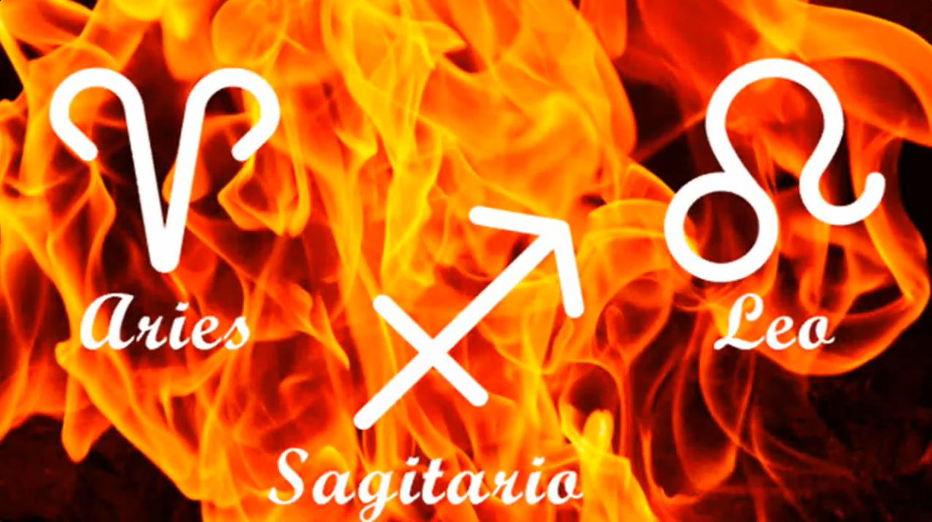
So, we have three fire signs, Aries, Leo, and Sagittarius; and it is called… The Maestre calls it the evolution of the elements. The fire of Aries is a child fire, it is a new sun, the beginning of the year, the beginning of life; it is a child fire, Aries people are like that, very enthusiastic, very impulsive. And here in Leo, it is a mature fire, it is already an adult; thus, that fire has the power to direct, be it a company, be it a gang of traffickers, criminals, be it in a country, be it in anything, in science; He puts himself in front, this fire, mature. And in Sagittarius it is an elder fire; it is pointing to the sky. What it seeks is to free itself from the Earth, to finish its course of studies at the Earth University to enter the next course. The courses are infinite in the Universe, we will never finish. Good.
“The Gauls”—in Ancient Europe—"lit a large fire on the summer solstice”—everyone gathered in the forest and made a large bonfire to work with the energy of the fire—“in honor of Belenus, who represented the Sun. That Celtic god can be likened to Apollo in the Greek tradition.”
Then, worship is paid to the one who presides over the fire. For example, we have the 72 names of GOD, 72 celestial spirits that are part of the government of GOD, divided into nine groups of eight. Nine archangels, nine angels, nine seraphim, nine powers, nine dominions, etc. So, each element has its celestial ruler and its terrestrial chief, let's say.
What are the spirits of fire? The salamanders which have a terrestrial leader, and that terrestrial leader obeys, let's say, the king, the emperor of fire, of Heaven. So, all this is study, it is not to be believed blindly. All of this has a lot of meaning to us, with our life. If it had nothing to do with our life, then we would not be interested in knowing that.
“It is based on those ceremonies that today’s Westerners still celebrate as the festivals called Saint John’s Fire.”
On June 24th . Why not the 21st but the 24th, the day of Saint John the Apostle? Why? Why is the day of Saint Jesus celebrated on December 24th, of Master Jesus? Why not on the 21st, which is the day of the solstice, why three days later? That has its study.
“Likewise, Christmas, which had been celebrated by the ancients on the winter solstice, was preserved until the 4th century, on December 22nd”—it was celebrated the day after the solstice. Pope Julius set the date as December 25th, but he changed the date. The festival of Saint John has also been moved to June 24th instead of the 22nd, its original date.” — but it has its reason— “That importance of the date…”
Because this is the sacred calendar, which we are talking about. The calendar that governs us today is a calendar that tells us nothing. We are in June, what does June mean? Nobody knows, but everyone is sure that we are in June. If it meant something to us, in June, one would fast every weekend, but no, June doesn't say anything. It comes from the ancient Roman Empire and was the month dedicated to Juno, to a celestial power, like a god, but today we don't have any Juno. Ah, so it doesn’t count!
But if we say: “we are in the month of Cancer.” Ah! Cancer, water sign, I'm going to bathe in a river, in a lagoon, on a beach, in the sea. I go to do this, that; cardinal sign, sign ruled by the moon, etc. I am going to do my practices according to my horoscope, where the moon is, what I have in Cancer, etc. One makes the most of saying that we are in the month of Cancer, the astrological calendar. The ancients had a similar calendar, which indicated the days, the dates on which they should make pilgrimages, great feasts, great fasts, this, that.
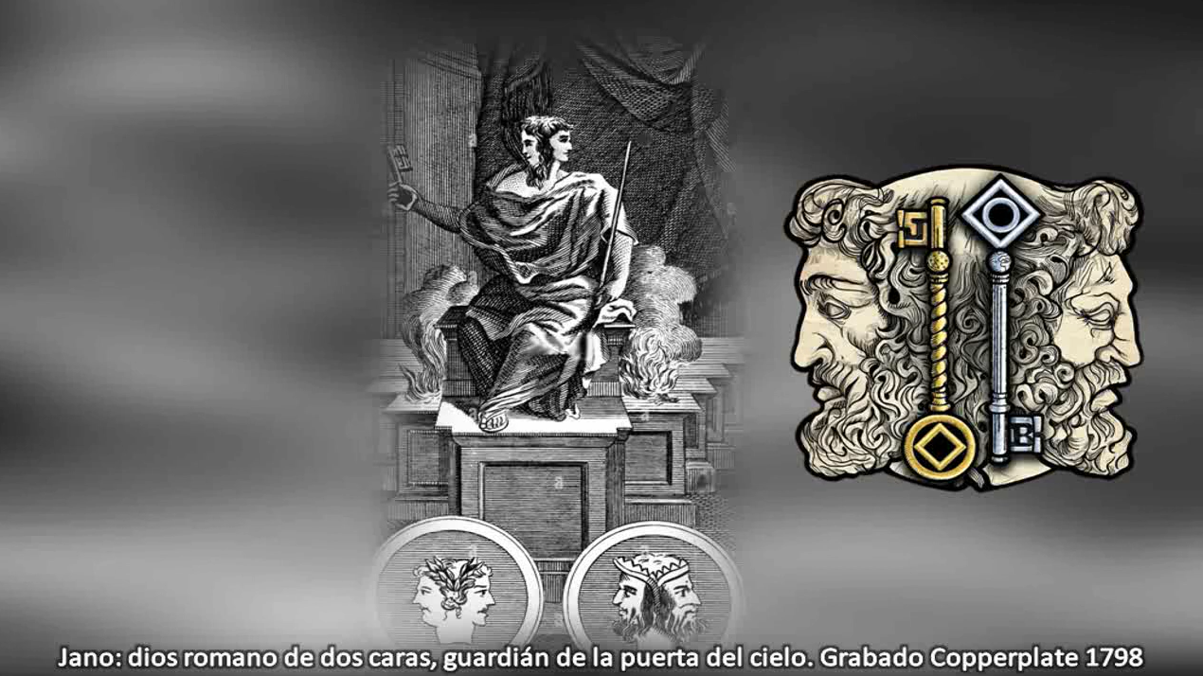
“This importance in dates is particularly symbolized by Janus, that god of Initiation into the mysteries, to whom a special cult was paid in all the countries occupied by the Romans and especially by the “collegia fabrorum” founded by Numa — a kind of initiatic colleges— (we have already seen in the fascicle of Psychological Purpose VI, the esoteric importance of its name) —The god of June has nothing to do with the God Juno. What is the God Juno? We will interpret it to our benefit now.
“Janus”—in Latin—"is the janitor who works and forms the annual cycle. The two keys he uses (one gold, the other silver) symbolize the great and small mysteries…”
The silver key, the Minor Initiation, the somatic scale. The golden key, the Major Initiation that passed through the Somatic Scale of Initiation, through the primary school of Initiation, enters the secondary school, the Aerosomic Scale; those are the Greater Mysteries.
“… they are like the two solstice doors…”
Thus, the solstice of Cancer, of the summer, is the door of the Lesser Mysteries, the Door of Men for […]. And [the solstice] of Capricorn is the door of the Greater Mysteries, the door of the beings of light, through which the Masters descend to the Earth, like the Master Jesus, born in Capricorn, the Maestre de la Ferrière; they represent that descent through the Door of the Gods, Capricorn. They are the two solstitial doors, one of ascent, the other of descent.
“… the two solstice gates that give access to the two paths, Janua Coeli” —Janus of Heaven— [the gates of Heaven] “and Janua Inferni” —Janus of the lower worlds [the gates of Hell] — “of which Christians have made Heaven and Hell. Indeed, it is the Devayana - in Sanskrit - and Pitriyana, the path of the gods and the path of the ancestors, known to the Hindus since ancient times.”
So, we have the Door of Men, the opportunity for an ascension, to make firm decisions to not get trapped in the world of appearances, and breaking gradually, not suddenly, that is not possible.
“It is known that the great ancient monuments were built according to a well-defined orientation—they were oriented to the cardinal points, they were oriented toward certain stars, because they were like batteries, they were charged with energy, terrestrial and celestial—and in relation to the solar positions, either with the entrance door facing the rays at the time of the spring equinox, or with terraces, pilasters, or stairs, always in relation to the star. In Egypt, the sun god Ra was undoubtedly the most popular. It is known that Amun, is also the sun god in order to even out the two Schools of Thebes and Memphis—that was in Ancient Egypt— It is especially in Tell el-Amarna, the royal city founded by Amenophis IV, where the ceremonies to the Sun were held.”
This, in Ancient Egypt, the Era of Taurus, but in the cult to the bull, the Apis ox, in Ancient Egypt. But, eras are for everyone, not just for those from there. It’s just that we have known about Ancient Egypt and the cult of the Apis ox, the bull. In India the cow was cultivated, not the bull, the Age of Taurus.
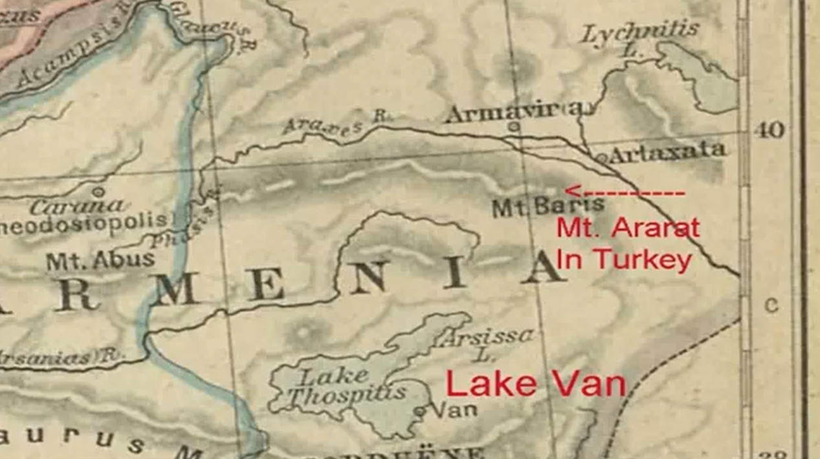
“It is said that it is in Syparis (or Sypara) the city of the Sun, where an Assyrian monarch placed the archives of the world before the flood” — in Sypara, the city of the Sun, there was the record of the history of Humanity before the flood—"According to Nicholas of Damascus, cited by Joseph, it is on Mount Baris that the Thebah would rest”—[…] wisdom—, “while according to ancient American writings, it is on a certain mountain named Olagmi that the remains of the human race, who escaped the flood, were found, and in which a temple was erected in honor of the Sun.”
That was in […]. Those who were saved from the flood, their remains were kept as a sanctuary […] with the testimonies they left of what they experienced before the flood, in Atlantis, the so-called Atlantis.
Well, this is how the Maestre continues. He talks about Mount Taishan in China, Teotihuacan in Mexico, etc., Showing then, that throughout the Earth, in an era favorable to Initiation, this wisdom of living in harmony with the solar rhythms, the lunar rhythms, cosmic rhythms this wisdom flourished. Not crazy like in today's cities, cities of sick people, polluted, paved cities [...] nature, inventing rhythms, who knows what kind of rhythms. Today's music lacks rhythm, it is noisy.
Well, I don't know if there are any questions about this, if not, let's move on to another topic related to the same.

Intervention by Sister María Guadalupe Abundis.
Well, good afternoon, it's already afternoon here. We were pleased once again to have our beloved Master Domingo Días Porta, whom we would like to have a long life so that we can continue growing by his side, even if we are not attached to him. Being under the aura of a Master can be at thousands of kilometers, by only following the instructions, but not just in theory, in words, but in body, in words and in mind.
So, right now, we are going to continue with a pre-Hispanic dance of the concheros or Aztecs, but I call it a “healing dance”. I have permission from the Aztec insignia from our general-chief Jesús León or his wife Victoria, whom, those in Mexico, already know him, and in other countries too because he accompanied us in some activities, even in Ecuador and Guatemala. The entire dance group accompanied us from Mexico and well, here I am as a first Sahumadora representative, which is my responsibility to work and dance.
Dancing with groups is not practicing dance, it is dancing to Mother Earth, dancing to Father Sun, dancing to the three hearts, dancing to the four directions, dancing for ourselves! Because we transmute that energy that comes from Heaven, and which is on Earth and that passes through our hearts.
The heart of Heaven gives us its healing, and we release it through the feet when we are dancing, and we give it to Mother Earth. Any illness, any ailment, any sadness, Mother Earth is in charge of purifying it. Yes, of transmuting it into fruits, into beautiful flowers, into everything that you know grows on Mother Earth.
Likewise, through our feet, our roots, we work absorbing the energy of the Earth. Transmuting everything through our body, removing all that pain, that sadness, that depression, stress, ballast, that we have carried for eons of years. Eons are millions of uncountable years. This is not of today, because in this life I have not done anything bad, but things are going badly for me. Why are things going badly for me? Well, because I have a past of eons of years, and which right now, I am purifying. How are we going to purify it? Well with our positive actions.
So, those positive actions are done in the present, here in the now. And how are we going to do them? With so many therapies that we have. One of them is dance, then there will be some songs. […] We raise it, we raise it, we raise it throughout our body, and it comes out through the orifice of our seventh chakra, which we say is not illuminated but works from time to time when we are very connected. So, we take out that dirt that we have, that disease and we deliver it to the Universe, to the Cosmos, to the Infinite, so that it dissolves and we […] become clean and pure like a crystal. And thus, we can do many therapies.
Today, we are going to continue with the conchera dance. But it is a dance for beginners. You will not find that in the media, that one is conditioned, as if arranged for children. So, since adults like to be taught like children, we are going to start as children, and we are going to end up floating. Jumping, floating, with the energy very high. So, we want you to accompany us at home, grab even a spoon or two spoons and make the music, or grab whatever but try to bring two instruments, one in each hand and we will go in unison, with your feet, with your hands, with the rhythm of the music.
Quietly there, let's do it, and we here, the group that we are in, are also going to dance like children, bringing an instrument. If we don't have an instrument, grab your maracas, your rattles, your feathers. Here I didn't bring feathers nor rattles, but imagine that you brought them, because you are going to go at that pace, so that the two cerebral hemispheres work in unison, okay? So, follow what you can, heal yourselves, jump, do whatever you want. In the end we will not hear you but, we will try to make the citation and after that, from the citation, we will enter into the songs, to the sacred songs, to the healing songs.
Well, Master, then, if you want to close now...

Dear listeners, brothers, sisters, in the four directions of space, a solstice greeting. Many blessings in this month when we are bearing fruit to harvest at the autumn equinox. Altogether, following the Path, the Initiatic Path that our Very Sublime Maestre Avatar opened to us after two thousand years of silence, let us stay on that Path, let us not waste this unique opportunity that few are taking advantage of. May the Light of Heaven and the Love of Earth bless you.
PASH!, IN LAK’ECH… A LAK’EN (I am you; you are me). Let us give thanks to the Giver of Life.

Superior Course in Theurgy, By the Ven. Master T. A-O Domingo Días Porta
All Rights Reserved

