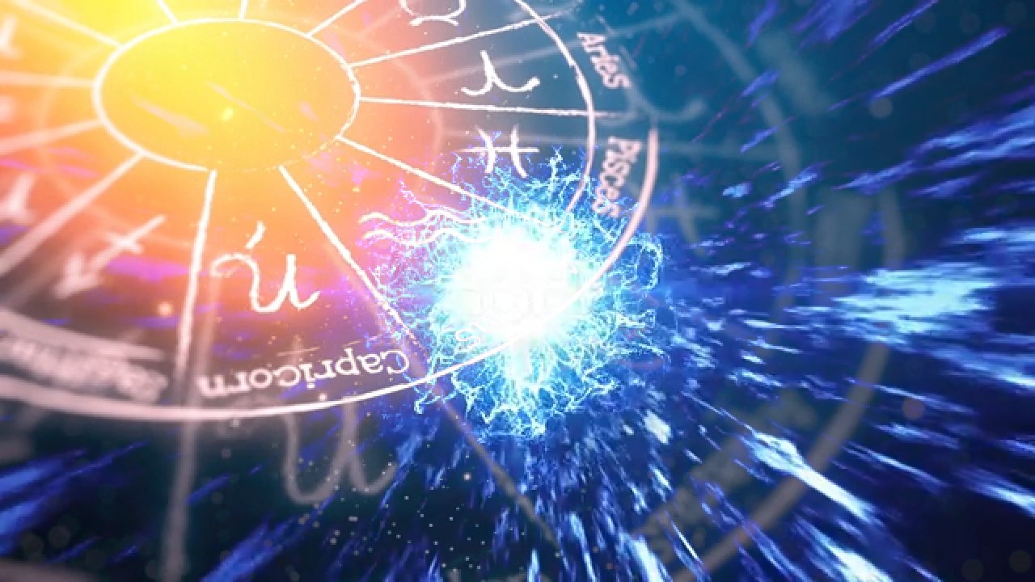
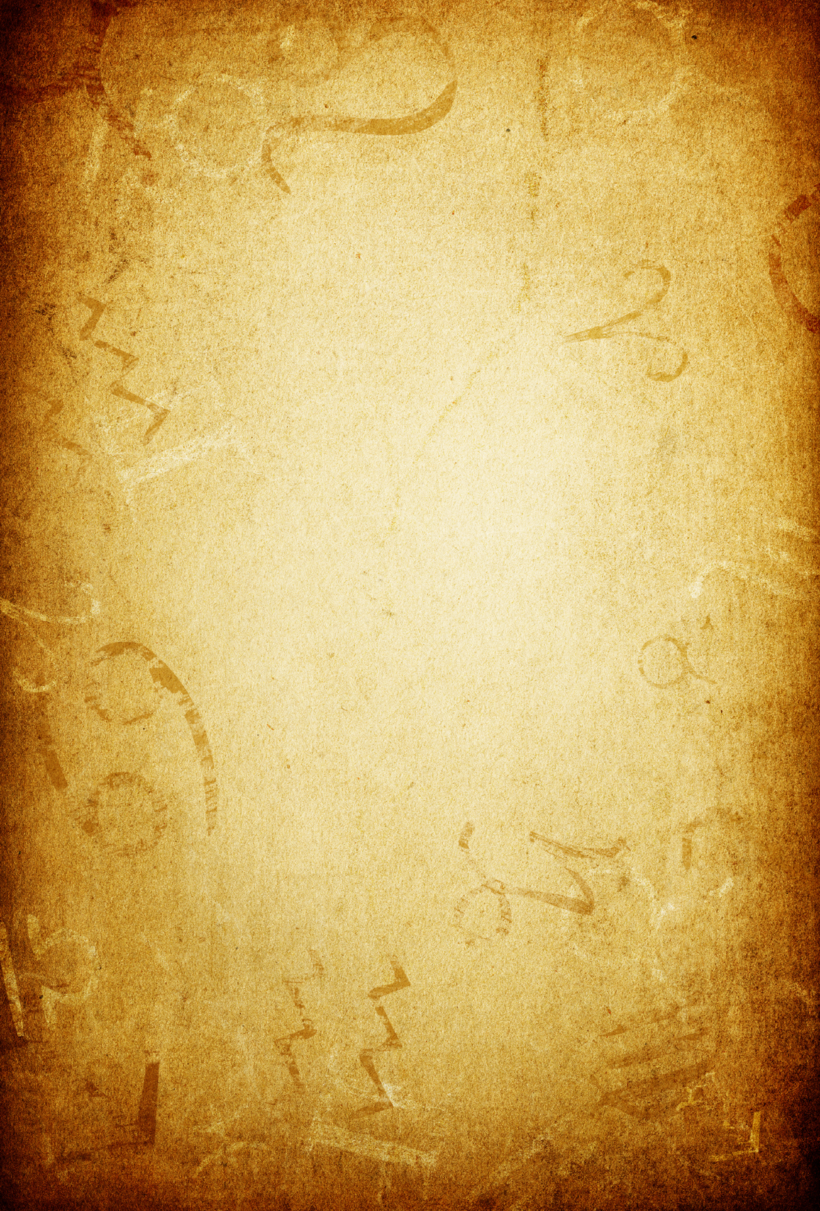
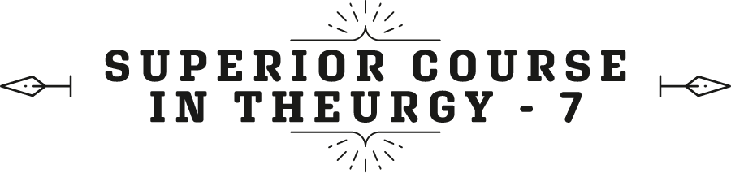


By the Ven. Master T. A-O Domingo Días Porta

W
ositive is being in harmony with the environment, and negative is being in harmony with oneself, yet having problems outside; unintentionally, one collides and then blames the other, whoever is closest, whatever it may be. But the positive person accepts the environment, adapts, does business in times of crisis, moves forward. The rest are in crisis… "There's nothing we can do"; the positive person doesn't give up.
Each zodiac sign has its ruling planet, called a regent. A planet governs the sign, it's not the other way around; the sign doesn't govern the planet, no, the planet rules the sign, it's the one in charge of that sign. What is the ruler of Aries? Mars, the god of war, of struggle, of action. So, we already have... how many keys do we have? Like four or five. Four keys: for each element, for the quadruplicity of the seasons, for the keyword, and the ruling sign.
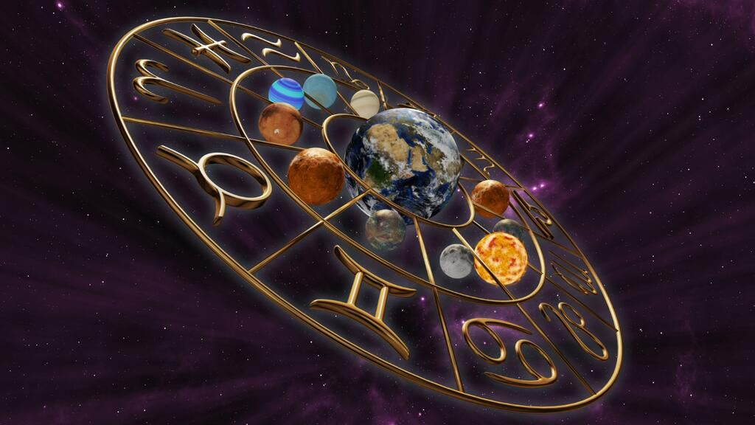
Then comes Taurus, what is the ruler of Taurus? Venus, the planet of love. Taurus, being an earth sign, is possessive love; "don't look that way, who are you looking at? It's mine, it belongs to me!" That's how Taurus is in feelings, depending on where Venus is, but more or less. Well, [Venus is] the planet of love, art, beauty, harmony. And then comes Gemini, ruled by Mercury, planet of intellect and mind, quick mind, because Mercury is the one closest to the Sun. It orbits the sun in eighty-eight days, it's the fastest. The Moon is also closer to Earth, but it orbits Earth in twenty-eight days, and you can see it passing through the signs.
Well, then, Cancer; ruled by... The ruler of Cancer is the Moon, a sign of dreamers, emotions, of water, and it's ruled by the Moon. They are very intuitive and very emotional. The moon affects them, a full moon, a waning moon, well, it depends on the horoscope. Then, Leo, the ruler of Leo is the Sun, the highest authority, our star, the center of the solar system. Those of Leo always stand out in whatever they do. Bolívar in war, and in thought; he was also a good thinker. Napoleon in war, but in astrological statistics we find Leos in all professions. There are doctors in all twelve signs, but the Leo doctor... hospital director, health minister, they go to the front spontaneously! They don't impose themselves, they have charisma, people recognize them, like the case of Bolívar.
So, that is the Sun, [they are] very lucid, have clear thinking, speak clearly, have the gift of speech. Most people don't speak well, they speak very fast, they stick words together, it seems... A linguist researcher said, “People speak dialects, they don't speak their language.” One speaks fast, that's their dialect, like the Maracuchos, sorry if there's a Maracucho here, the Carupaneros. Others stick the words together: you-are-bla-bla-bla... One doesn’t know what they're saying! Few have mastery of the language.
Then comes Virgo, the analyst, detail-oriented, Mercury, an analytical mind. Those of Gemini are writers, journalists, disseminators, professors, that is the Mercury of Gemini. The Mercury of Virgo is the detail-oriented one, who works on things like that, details, craftsmanship, miniatures, in the laboratory, etcetera; they are two different Mercuries. Libras with Venus, same as Taurus, but the Venus of Libra, as Libra is air, their feelings are spiritual, noble; they don't get jealous, envious, etcetera; they always seek balance. The air sign elevates the mind. Scorpio: Scorpio has two rulers, but for now, let's say it's Mars, Mars like Aries. The Mars of Aries pushes outward and the Mars of Scorpio, as I was telling you, is the internal struggle. Outside they seem very calm, but inside, they are in a struggle with themselves, their needs, their feelings.
Sagittarius... Jupiter, a planet of command. Leo, because of the sun, has authority, and in Sagittarius, authority comes from Jupiter. Jupiter is the planet that bestows authority whether in religion, science, or whatever they write or say; they speak with authority; they have a foundation. Then comes Capricorn: Saturn, the planet of justice, frugality, and law. Capricorns are frugal, as I was saying, they find a use for everything, they don't waste, they dislike extravagance, they are ecologists, and Saturn reinforces that control. Saturn is severe, it restricts. It's like a monk in a cave, anything similar to that: restrictive, thrifty, not wasteful. That's Saturn in Capricorn.
Aquarius, like Scorpio, has two planets, but for now, let's mention just one, which is the planet of...? Uranus, but that's a recent planet. The ruler of Aquarius, the ancient ruler is Saturn, but not the Saturn of Capricorn's justice, but the Saturn of wisdom, the sage who withdraws to meditate. Just like in Capricorn, seeking solitude to clarify their thoughts, to heal their emotions, etc.; that's the Saturn of Aquarius. So, Saturn is represented in ancient astrology in two ways. How is Saturn represented, for example, in Greek or Mayan mythology? The Saturn of wisdom, an old man with a long beard and hair... holding a book in his hands. And the other Saturn is represented as a skeleton with a scythe, representing death, austerity, etc.
And finally, Pisces also has two rulers, two planets that govern it; the ancient one is Jupiter, different from the one in Sagittarius. In Sagittarius, it has authority accompanied by fire, because Sagittarius is a fire sign. And in Pisces, a water sign, Jupiter is more mystical, with religious authority, philosophical relevance, etc. But the planets have much more significance, I'm giving you the ABCs, the simplest possible.
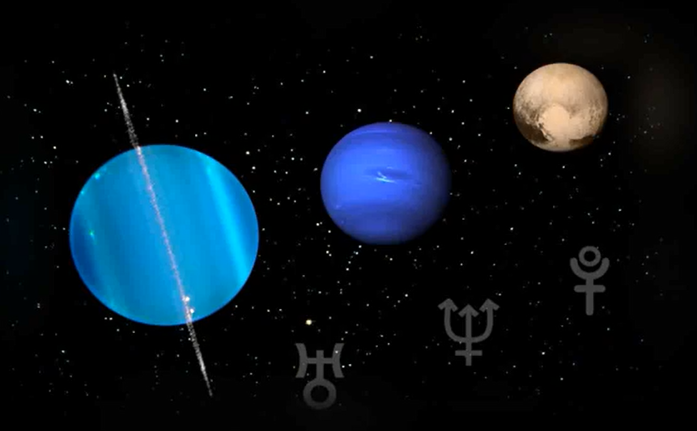
As there have been three planets discovered recently, starting from 1784, I believe Uranus was discovered first, then Neptune, and in 1930 Pluto was discovered, very recently. So, researchers have sought to assign these three planets to which sign they belong. There are scientific astrologers who dedicate themselves to research; it's a very advanced astrology. So, it was discovered that Uranus, Neptune, and Pluto bring new influences that were not present before: like science, space exploration, a spiritual mysticism that doesn't seek refuge indoors, in churches, in chapels, but rather seeks nature, etc. Pluto represents profound transformations. Pluto, the planet farthest from the Sun, the one furthest away, governs what is hidden. For example, oil hidden underground, it's said, is governed by Pluto, conspiracies, secrets, everything that is below or hidden or underground.
There are ancient civilizations that, by excavating, are now recently emerging. Several Mayan cities that were covered, seemed to be hills, were found recently. It appeared they were covered, for two thousand years, by earth. Pluto rules over that, everything hidden, and suddenly, it comes out, like oil, the oil rig. Thus, Pluto, according to those scientific astrologers, is said to rule over Scorpio, because Scorpio also hides what's happening with the person, doesn't reveal what's going on, hides. Ultimately, Pluto rules Scorpio.
Then comes Neptune. Neptune is the planet that brings that spirituality, that wants to go beyond being indoors, beyond little chapels, that wants to feel GOD 's presence in all things— not just within four walls— that contemplates the sky. And as the Lord's Prayer says, "who art in Heaven". And Neptune says, “How? In heaven? How? And what is GOD, what is that?” It's a spirituality with investigation, with meditation, not just blindly believing, but putting one's belief to the light to see why. Why do I believe this, why am I made to believe? Why? And that governs Pisces.
Pisces is a mystical sign and within Pisces there are two types: those of religiosity, like chapel-goers, temple-goers, theologians, etc.; and mysticism, like in nature. I am a Pisces, I resonate with Neptune, I like that spirituality in nature, contemplating the sky, investigating. I come from a Catholic family, so, why the Trinity? The Trinity, why Holy Week? I investigate and find that there are reasons that these are things that come from antiquity. In antiquity there was much spiritual wisdom, and in Christianity ancient things are preserved that come from two thousand years ago, and even earlier.
Well, now we have Uranus left. Uranus is the closest of the farthest [planets], after Saturn comes Uranus, then comes Neptune, and then Pluto, the farthest. I told you to study astronomy, there you can see the distances of the planets from the Sun. How far is Earth from the Sun? If there's any Earthling here, someone who lives on Earth, who knows where they live, not just with kilometers of roads. Yes, it's roughly 150,000,000 kilometers from here to the Sun. So, in a car going at 100 km/h, when would we arrive? 150,000,000 / 100 = 1,500,000 k/h. In a million and a half years, we would arrive. Easy, right? How many years?
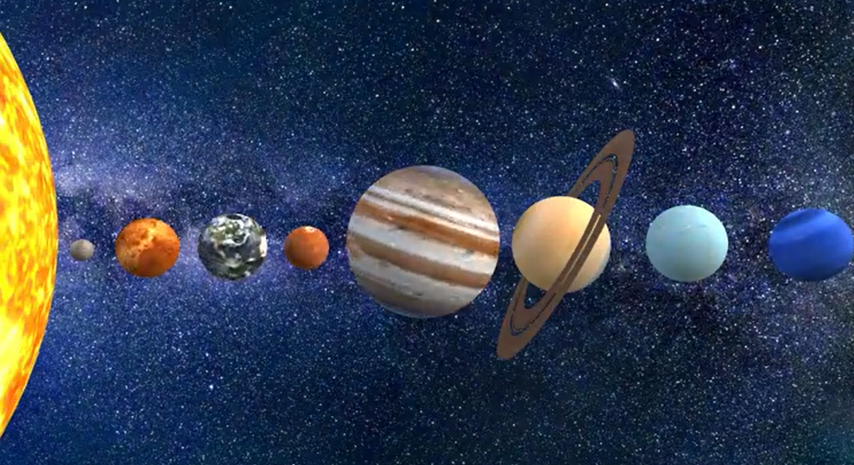
Fine, and so, the closest to the Sun is Mercury. NASA sent a probe years ago that passed by Venus, took photos of Venus, passed by Mercury and is getting closer to the Sun, and it's sending very interesting photos of the Sun. We have to keep up with that, don't stay stuck in the last century because you’ll get tangled up and won't understand what's happening now.
So, the order of the planets in distance from the Sun, who wants to say it? After the Sun, what comes? Mercury. After Mercury? Venus. After Venus? Earth, with the Moon. After Earth? Mars. Then... Jupiter, Saturn, Uranus, Neptune, and Pluto, the three new ones. Uranus, Neptune, and Pluto didn't influence when they hadn't been discovered; they started to influence when they were discovered, when the human mind connected. "There's a planet called Uranus," they started. Until a planet is discovered, it doesn't influence, there's no connection, one doesn't know. Did television influence before it was discovered, invented? It didn't influence, right? It didn't exist. The Internet too, before, there was no Internet, the Internet didn't influence; it's the same with the planets.
Astrology works because the mind is connected to cosmic energies from the planets, from the stars, the mind through the brain. The mind is not the brain, but it works with the brain, in us. There's a mind in plants, in minerals, in everything there's a mind, in the planets. We have the receiver-transmitter, which is the brain. It receives mental waves and emits waves, that's why telepathy is talked about. The thoughts one thinks don't stay in the brain, they come out. A mind that isn't disciplined, well, the wave comes out three meters, five meters; and a person with mental discipline, their thoughts go around the Earth. Like the case of Master Jesus, of Buddha, of highly evolved beings.
Well, those are the basic points we wanted to cover today and to stay up to date with astronomy, because everything discussed in astrology has a foundation in astronomy. If [the term] personality comes from Greek, what does “persona” mean in Greek? Mask, personality is the appearance. When someone goes out on the street, they groom themselves, they style their hair, etc., to make a good impression, but they arrive home in disarray. So, it's a theater we put on to look good, that's the personality, a mask. In Greek theater there were two types of theater. What was theater called in antiquity, in Greece, what were the two types of theater? Tragedy and Comedy.
Thus, when they performed tragedies, they wore a mask appropriate for tragedy, and when it was a comedy, they had happy, joyful faces. But that Greek theater represented what we humans are, that sometimes we act in comedy outside, and sometimes we act in tragedy; we become tragic. "My father died... and this and that," and the weeping, because they believe in death and make it a tragedy. And others act in comedy, they're always skipping down the street, singing, etc.
Fine then... That's not called personality, it's called individuality; individuality is one's own, not the theater one does in society, but rather how one truly is, how one thinks, how one sees life, whether one believes in death or not... That inner part, that's individuality, indi-vi-duality. What does indivi-duality mean? Personality means mask, appearance in society. Individuality, indivi = indivisible; indivisible in the world of duality. Where there's tragedy and comedy, inside one is sure of oneself, but when one goes outside, then they perform comedy or tragedy.
And that has to do with the horoscope, everything in your life, everything, everything is marked there. Everything that happens in a person's life is marked in the horoscope, and there are things that are marked in the horoscope and do not happen in the person's life, but everything that happens to them is marked there. And there are things that are marked, and the person doesn't get to develop them; they had an aptitude for mathematics and when they're old they discover it. "Oh, why didn't they tell me!"
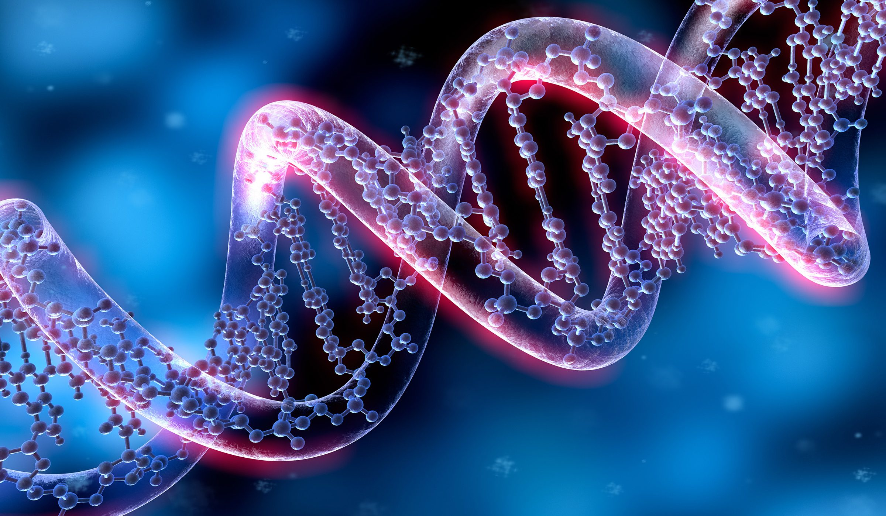
So, everything, everything, that is our life is registered there. That is our navigation map, our personal horoscope, and the genetic memory is also there, of our ancestors is also there. You take your horoscope and the horoscope of your parents, and you see what you have inherited from your parents. If you can get the horoscope of your grandparents, you calculate them and see, "Oh, I have the planet Neptune or Mars just like my great-grandfather in the same sign. So, then I have that in my genetic code." But we have in the genetic code our own inheritance, not from father or grandfather or great-grandfather or great-great-grandfather or anything, no, ours.
And in the genetic code we have the inheritance of GOD, but as it says in the Bible, that we are made in his image and likeness, we have an inheritance. I say, it can be activated, what is in the genetic code you cannot take out. So, a person can have the inheritance of the grandfather who was a scoundrel, and there it is, “I can take advantage of this scoundrel grandfather. No, I prefer my father's inheritance.” Everything is intertwined; our body is made from the measurement of our spirit, each body. There’s no tailor who sells it like that, in a series, you have to buy it in the store. When one is born, one goes to the tailor who makes us the personal suit, tailored to oneself. Everything is intertwined, the law of unity governs everything that exists. One is not alone, the person alone, one inherits from parents, grandparents, etcetera, the family tree.
One is influenced by Society. From childhood, parents instill things in us, ideas, customs, etcetera; in school they instill more things. One is not one, one is many. That's why an anthropologist wrote a book called Man and his Environment, and that's in the horoscope. If the environment is favorable or unfavorable, favorable in what, unfavorable in what.
Destiny is what happens to us in life. What does not happen to us was not our destiny. Then, they insist on doing something and it's not in their destiny. They knock their heads against the wall, and they don't achieve it. They insist on doing something and achieve it, because their whim, their will, coincided with their destiny. So, this thing about free will is subject to study. What it means, because most people do not have free will. Most are guided by propaganda, advertising, necessity, the education we received, customs, etcetera. At birth, we bring all possibilities, we bring a team for negative and positive. Negative, as I say, is an inner life, it's not bad, because people say negative as if it were something bad.
In electricity, there is a positive pole and a negative pole; it doesn't mean that the positive pole is good, and the negative one is bad. “Then we’ll remove it.” No, then there is no electricity. The positive pole is the one that sends electrons, and the negative one receives them upon contact, that's why there's a spark. So, the man is positive, and the women is negative, sexually, right? Because the man emits, and the woman receives. But the woman, for example, who is an educator, is giving and the male students who are receiving; they are the negatives. A female doctor is curing a patient, a man, she is the positive, and the man the negative, because he is receiving, and she is giving.
So, don't confuse positive and negative with good and bad. Good and bad is not a good way to study life, the things that happen. One must reflect better because we are discriminating when we say so-and-so is bad and the other is good; it's because we don't understand life.

Superior Course in Theurgy, By the Ven. Master T. A-O Domingo Días Porta
All Rights Reserved

