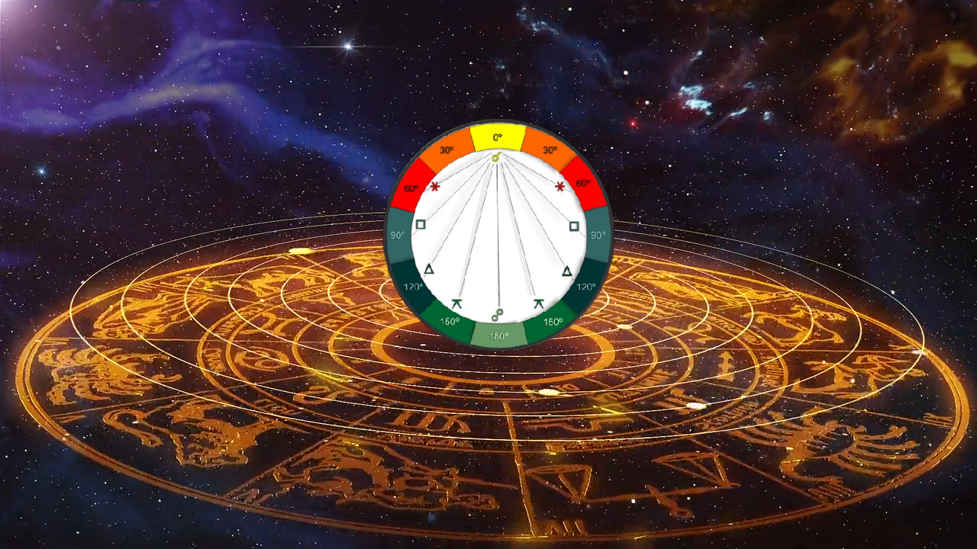
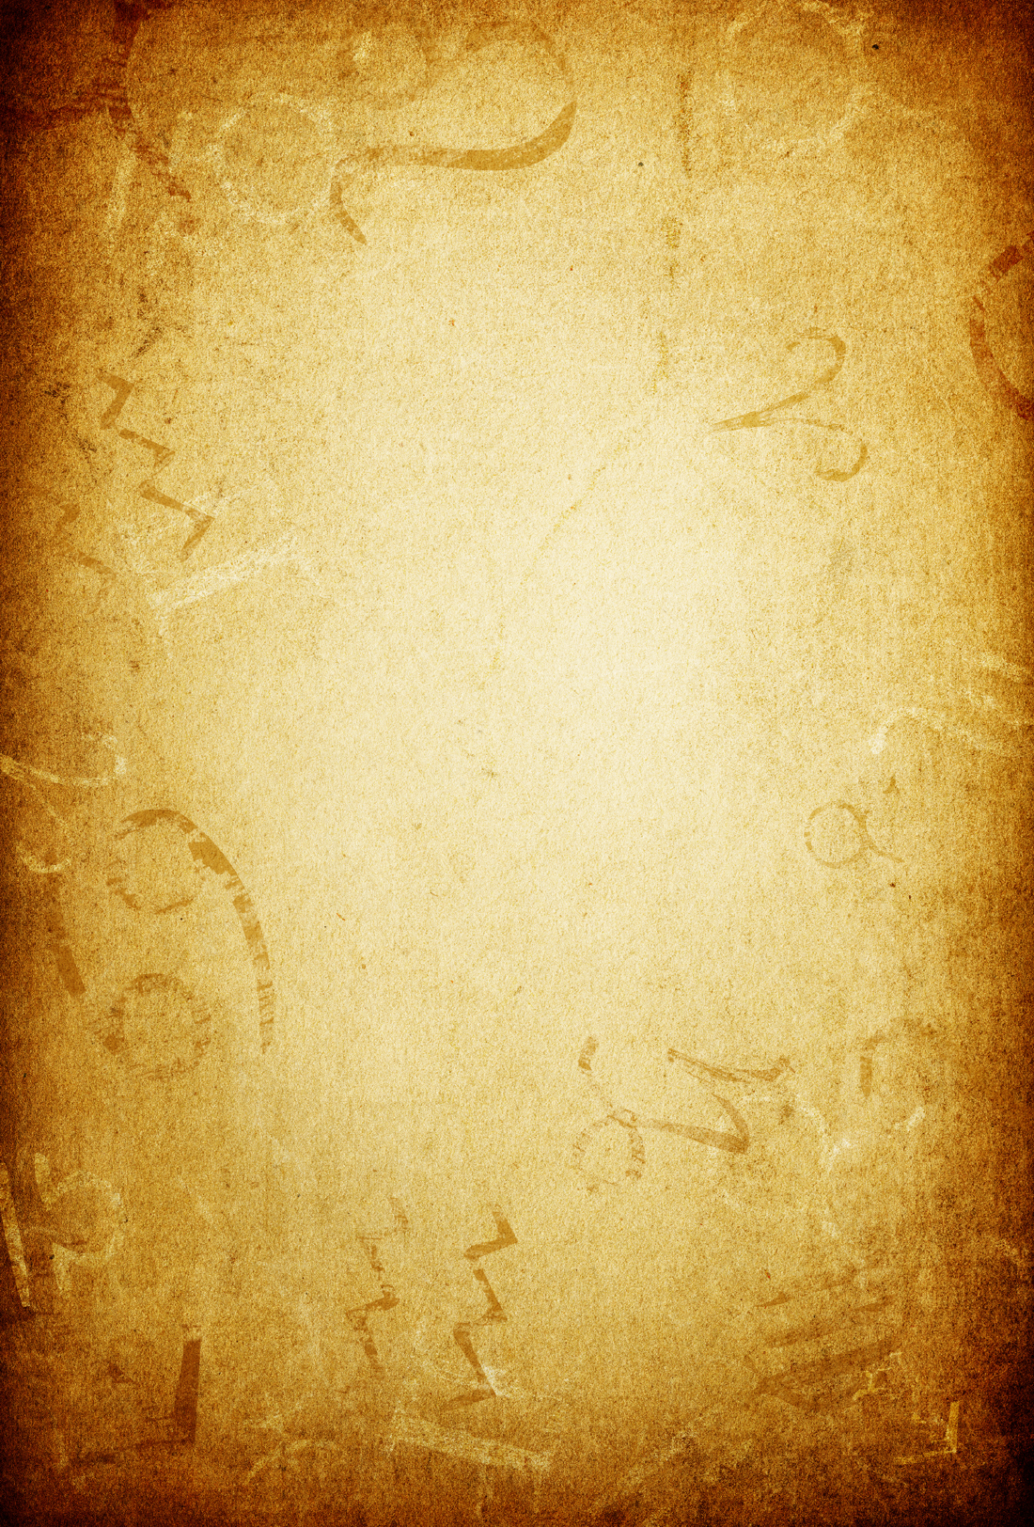
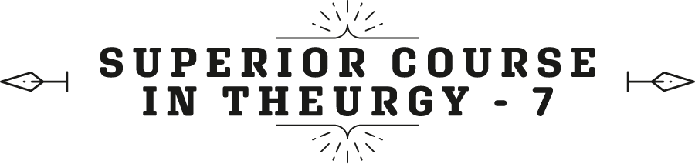



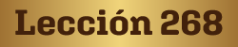
Ven. Master T. A-O Domingo Días Porta

“In the name of the Great Masters and Spiritual Guides of Humanity, in the name of our Maestre Dr. de la Ferrière, the founder, initiator of Era of Aquarius, in the name of Humanity, of its aspirations, this new humanity that is searching for the path too, and in the name of all of us, of our ideals, I declare our work open.”
Pash! In lak'ech (I am you)... A Lak' en (you are me). Let us give thanks to the Creator, Giver of Life.
We take a moment of silence to relax our mind, our body, put aside worries.
Intervention by Prof. María Guadalupe Abundis:
Then, for a moment we close our eyes, hands in our lap, spine straight.
Master Domingo: —Well, we begin, a minute of silence...

W
ell, let's see now, the Aspects. Do you know what aspects are? You already read it in the lesson I sent you. What are Aspects? There are certain distances in a person's horoscope that produce an effect, for example, right now we are in a full moon, yesterday was a full moon and today is also a full moon. What does that mean? That the moon is opposite the sun. When the Sun goes down in the afternoon, the Moon is rising. The Sun is going down beneath the Earth and the Moon is going up. That is the full moon, it is the opposite and that is why the sun illuminates the moon. On the new moon, the two walk together, the Sun and the Moon, of course, the moon is close to the Earth, but one sees them together. You cannot see the moon, it is a new moon, the sun does not illuminate it from the side of the earth.
Well, then, that distance, when it is a new moon, when the moon is on the side of the sun, is called a Conjunction, and the conjunction is written like this: 0° distance. The two are close together. Right now there is Jupiter and Neptune, they are close together, seen from Earth; of course, there is a lot of distance between them, but one sees them that way. Jupiter here and Neptune there. Neptune cannot be seen with the naked eye, Jupiter appears very bright in the early morning, and Neptune behind... They are in conjunction. When it is a full moon, it is an Opposition (180°), half of the circle. That is, right now the Sun is in Aries and the Moon is in Libra. They are opposite. Neptune and Jupiter are close together. From Earth one sees Jupiter, and Neptune is further back, in Pisces. Between those two, they are the extreme aspects, 180° is half of the zodiac, there are no longer larger aspects. The maximum distance between two planets is one hundred and eighty degrees.
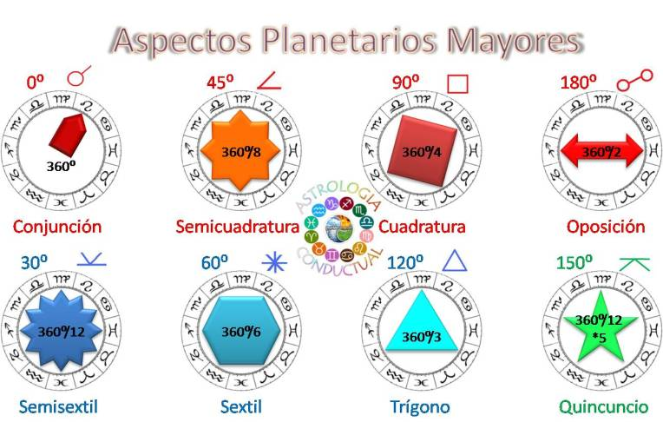
Well, after the Conjunction comes the Semi-sextile, it is written like this: it is worth 30°; The Semi-sextile is a horizontal line with like a V. The Sextile, a complete, 60°. But, between the Sextile and the Semi-sextile, there is an Aspect called Semisquare, half a square, 45°. When they are at ninety degrees, that is the Quadrature, (90°). Ninety degrees, for example, here I have the sun... 30, 60 and 90, When there is a planet here and the sun here, ninety degrees away, that is a very strong aspect, it brings struggles, it brings problems, etc. That is the complete square, which is worth 90°.

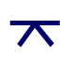
What Aspect follows, is there is a student of astrology? What aspect follows after the square? The Quincunx; how much is it worth? One hundred and fifty degrees (150°), and then comes the Opposition. There are minor aspects, but these are the important ones. So, if a person has a square between the sun and the moon, forty-five degrees away, that is an influence that brings problems, that may be health problems, for example, affecting the kidneys, etc. There is Medical Astrology and there we see the pathological aspect of the stars.
Well, we are missing the Houses now. The Houses are represented with Roman numerals, House I, House II, House III, etc.; House IV..., V—there are twelve Houses—, the sixth (VI), the seventh (VII), the eighth (VIII), the ninth (IX), the tenth (X), the eleventh (XI), the twelfth (XII).
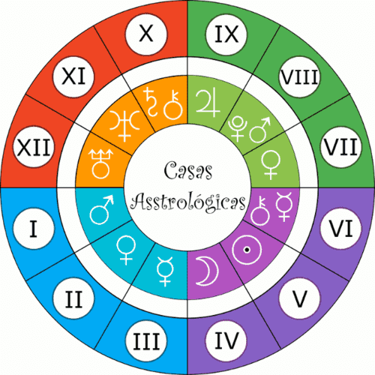
So, House I, Childhood, the home in childhood, the personality; that is, what one shows to people, “the mask,” it was called in Ancient Greece. The person when going out, gets ready, and everything. He is at home, and a mess, all disheveled, and barefoot, etc.
Well, House II would be Finances. House III are Short Trips, family, siblings. House IV is the Home in old age. House V is pleasures, amusements and consequences, children. House VII are Associations, including marriage. A doctor belongs to the Association of Doctors, a political party, all Associations are studied in House VII. House VIII is Finances, but different from House II. House II is the finances that one acquires through one's work, through one's efforts, and House VIII is inheritances, prizes in the Lottery, what one wins without effort. An inheritance: he won the Lottery, he invested in Bitcoin, a cryptocurrency. It is like saying, a stroke of luck, House VIII, and naturally, as it represents inheritances it also represents death.
What planet is in each house, then you see, you have Jupiter in the VIII House, good luck, you will have... You can play the lottery, roulette, whatever... and you will do well. Of course, that does not... You have to know what day you can, because it's not that the whole year is going to go well, that is another study of astrology, making predictions. You were born with Jupiter in House VIII in the sign of Taurus, so, every year in the month of Taurus, when the sun passes where you have Jupiter, there, you can invest. You have to see the planetary hours, there are hours in the day for each activity. But that is another study.
Well, then, we saw House VIII. House IX is Long Trips, House III is short trips, and the opposite, House IX, is long trips. Long, not in kilometers, but long is that you are going to move from Mérida to Tabay, and you stay and live there. That is a long trip, because it changes your environment, your relationships, your world. And a short trip in astrology means that you went from here to China, for fifteen days and returned. It didn't have much influence on you. You took some photos, went to a Chinese restaurant, etc. You had no changes. That's the idea of a long journey and a short journey in astrology. House X is the Social Position, if the person is going to stand out in the country, in the world, in his city, in the neighborhood where he lives, big or small. The social position, the profession too. And it is the age of youth, when the person is in full use of his faculties.
House XI is Friendships, the hopes, the ideals. And House XII, the opposite, the Enemies, the adversities, the loneliness. It may be that he goes to a monastery, it may be that he falls into prison. There you see, in House XII, what planet and what sign, and you see in what way he seeks solitude. He really likes to meditate, as well, then he is experiencing XII. The people who are in El Salvador, who are in jail, there... they have their House XII there, terrible.

Well, now we are going to see how to write, this is the alphabet, the ABC’s, and we are going to see the writing in astrology.
I think an Aspect was missing, the most favorable Aspect of all, is 120°. It is a Trine, one hundred and twenty degrees. It's the best aspect ever.
Once, I told Master Estrada, “Master, I have a trine here in...”
“No son, with the squares we move forward, it is a Spiritual Path, the squares are the struggles, the problems.
I told him, “Ah! here I have a square...”
“Don't talk to me about squares, my horoscope is full of squares... See you later!”
He left me wanting to know, but he made me understand that it's your horoscope, you study it. I study mine. Don't ask someone else, make an effort, leave laziness behind, don’t let someone else tell you. He didn't tell me that, but I understood what he wanted to tell me.
Well, then, for example, I have Mercury in a Grand Trine with the Moon and Pluto. Mercury in House X, the Moon in House V, and Pluto in House II. An astrologer sees that, he says, “You have a Grand Trine.” A Grand Trine is three planets that are the same distance away, 120°. I have... I have Mercury at 14° Pisces, the Moon at 14° Scorpio, and Pluto at 14° Cancer. There are one hundred and twenty degrees from here to here [from Mercury to the Moon] and one hundred and twenty degrees from here to here [from the Moon to Pluto]. If it were a single planet that was in trine..., it is a Trine, but when there are three planets, it is a Grand Trine, that is the best Aspect of all. In my case, it has made me travel the world carrying these teachings, through Europe, the Americas, etc.; and they are in water signs, all three are water signs.
From one fire sign to another fire sign, 120°; from one earth to another earth. They make a trine.
So, just like that, an astrologer presents this to you, and you start reading, because that is astrological writing. He says, “Ah!, Mercury in Pisces, in your House X, in the House of social position, of your destiny, of your profession, you have it in a water sign, what does it mean?” Then, he begins to decipher. There is no need to put words. That is the writing of Astrology. The astrologer already reads a detail of the person's life there.
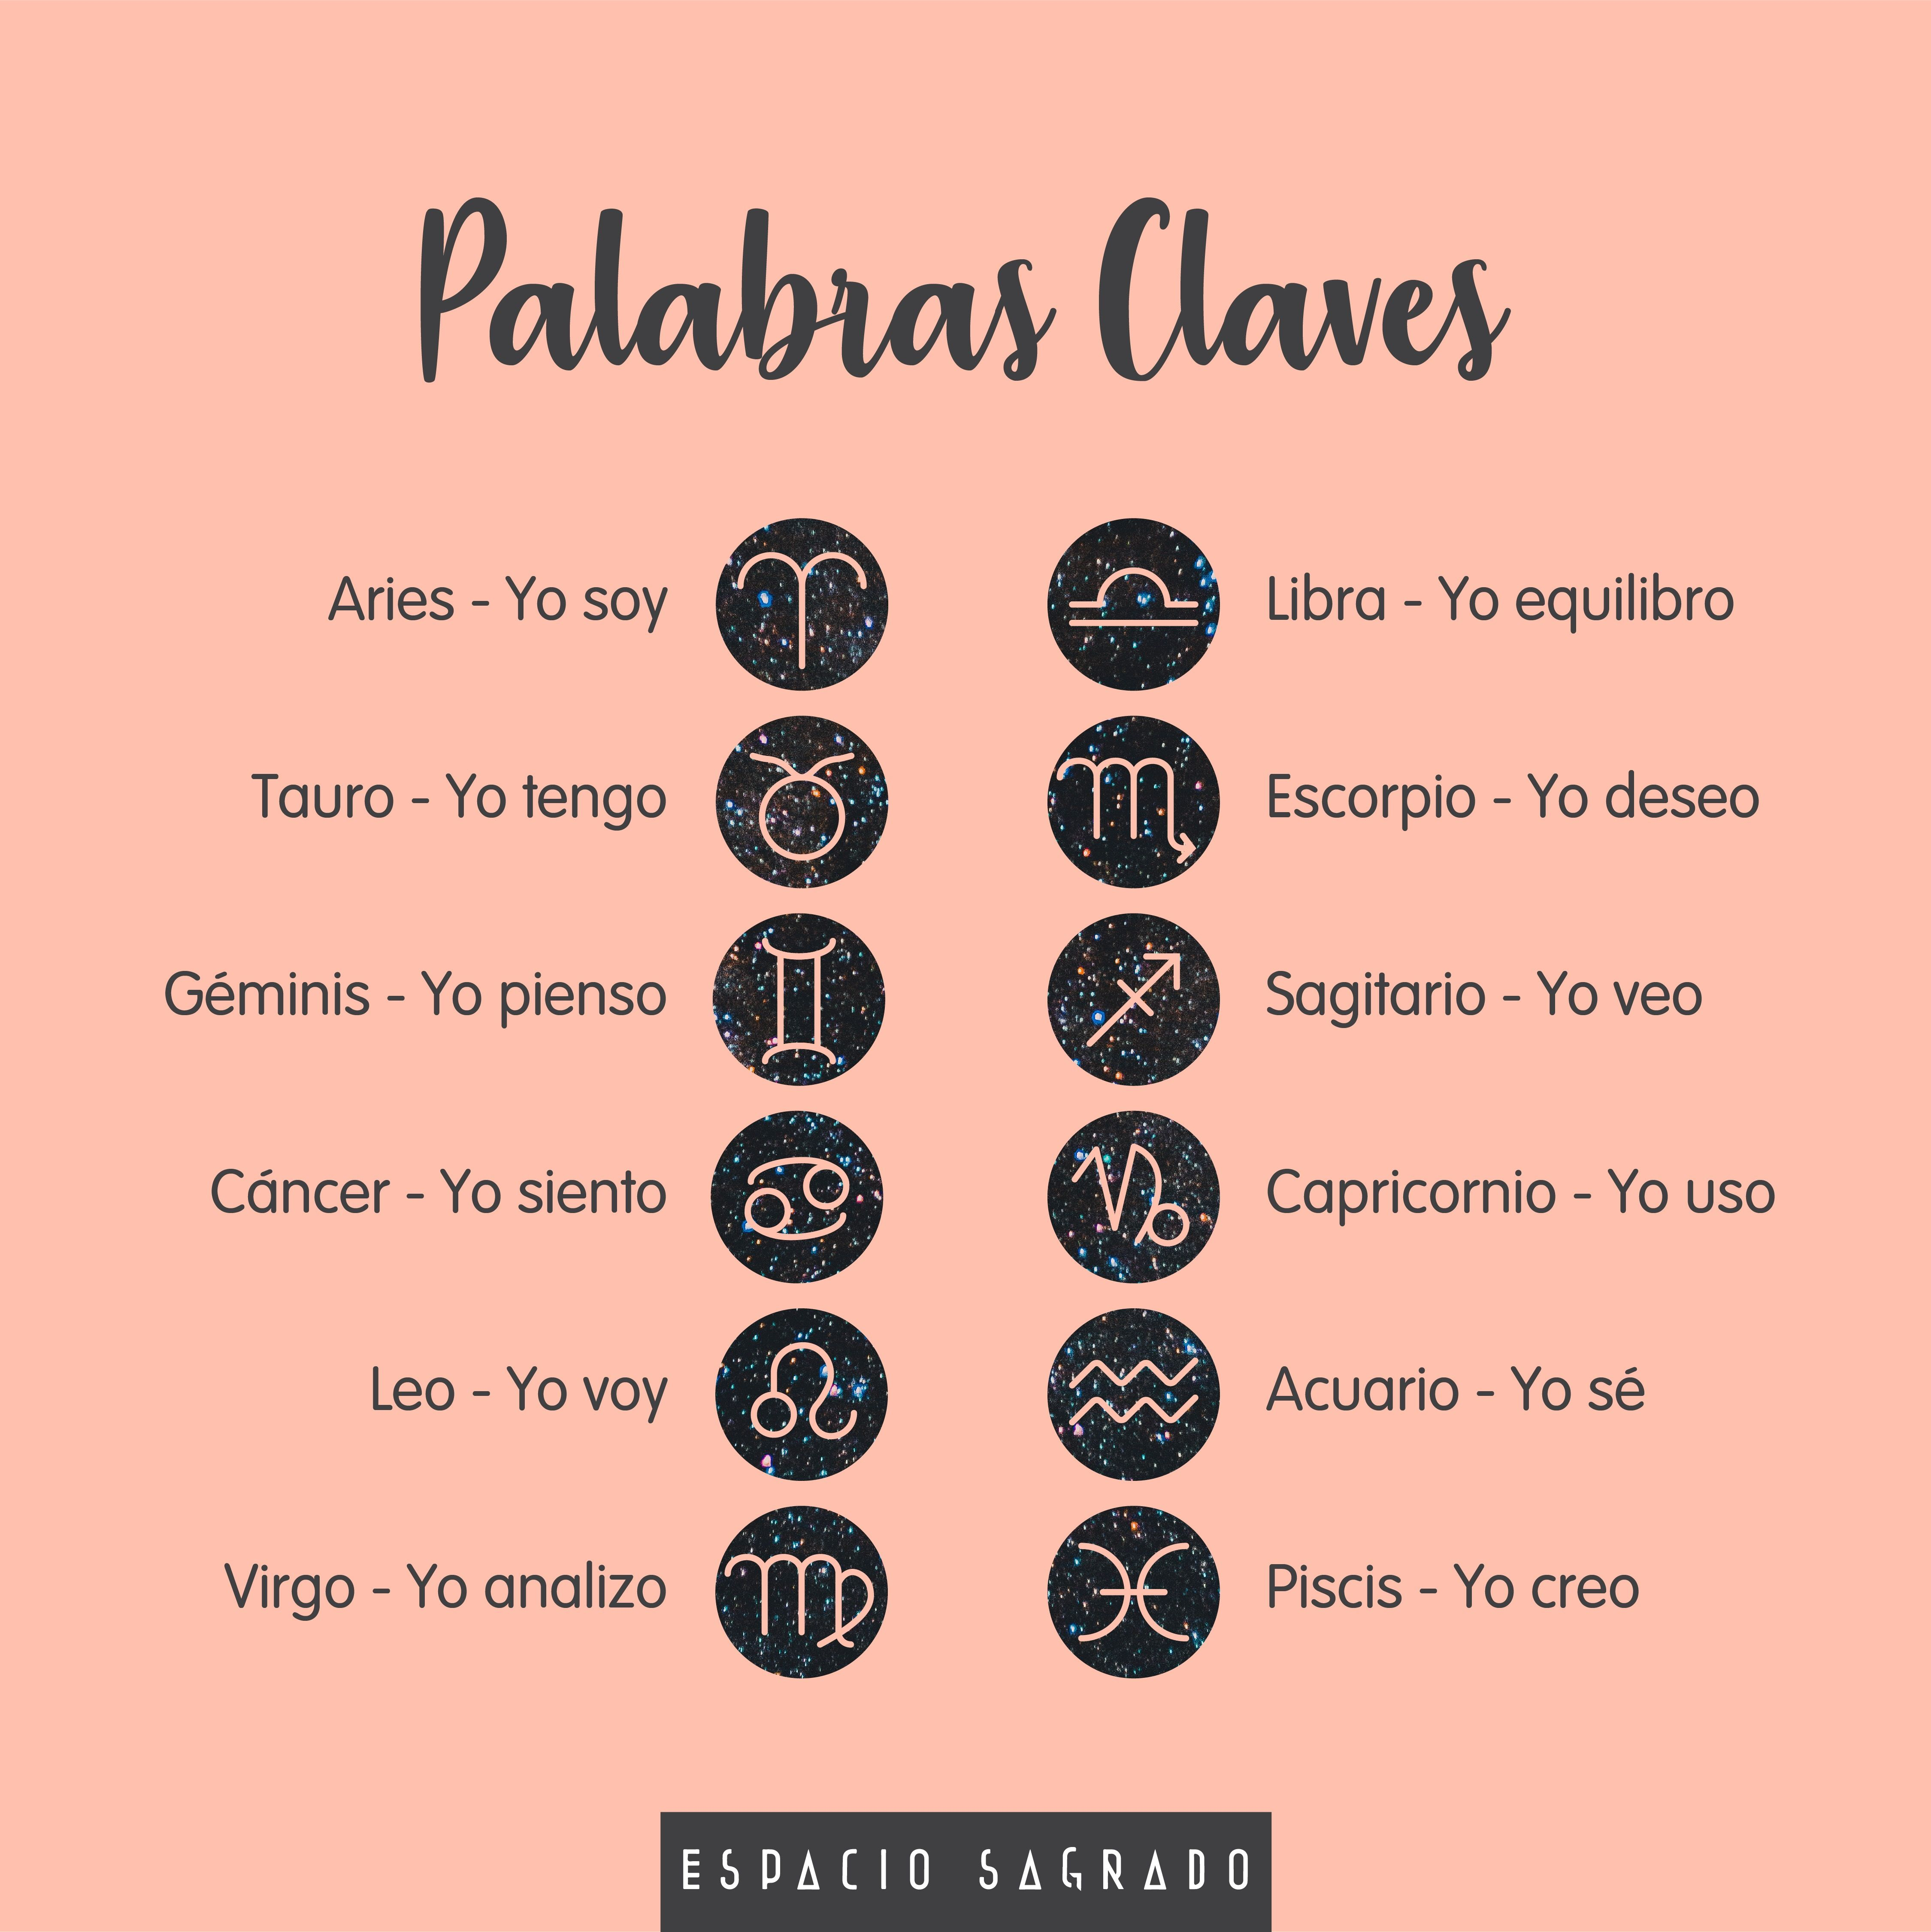
Well, that is, then, a way of writing in astrology, and one knows the keys, you already have the keys. What quality does the fire sign have? What attribute? What is their word, fire? Yes, impulsiveness, those of fire are impulsive. Aries, impulsive, Leo, and Sagittarius. The air ones? Intellectuals, they are the scholars: Libra, Gemini, and Aquarius. The water signs? Their word? Emotionality. Cancer, Pisces, and Scorpio. “They are the crybabies of the zodiac”, said an astrologer. Everything hits their little heart. And those of Earth, their keyword? Practicality, they are the practical ones, the ones who get to the point. They don't like to think about it, “let's go now, stop talking and making plans.” They get to the point.
Of course, each fire sign is different from the other fire sign, but all three have that similarity, that they are impulsive. Aries is impulsive about his affairs. What is the Aries word, the Aries keyword? I Am. So, “that's just who I am, no one is going to change me.” That's Aries. So, they are impulsive to show off, to put themselves in front. Those of Leo, what is the word of Leo? To Dare, and the other word? To Do... I Do. So, it is fire. Leos are impulsive for achievements. Bolívar, who was a Leo, impulsive to push for the independence of several countries. They defeated him and he came back again. He did not let others push him around. And Sagittarius, what is the word for Sagittarius? I see, to see. So, they are impulsive to investigate, to know, they are travelers, they want to know the World. for example, in science, etc.
Well, so, the sign gives us clues. Thus, I have Mercury in Pisces. Pisces, “I Believe”, it is a mystical sign, it is sentimental because it is water, etc. And you have a Trine with the Moon that is also sentimental, and with Pluto that rules the occult. So, you like the occult sciences, and you are sentimental, etc. And the astrologer discovers us, “No, no, it is better not to continue analyzing because he is knowing too much.”
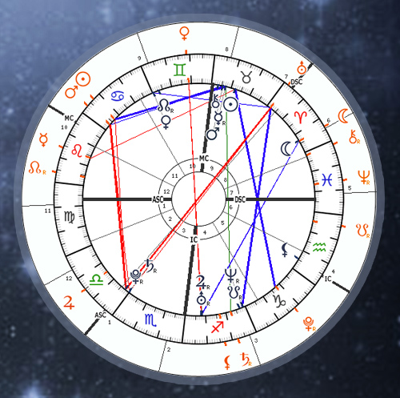
Of course, the idea is that you study, I sent you a link: astrology.com There you get the horoscope for free and a simple but very good interpretation. And if you want a deeper interpretation then you do have to pay; I think it's $20 Dls. But they calculate your horoscope, the disk, the zodiac, in an instant very well. And there are several teachings there about astrology, do you want to know them? Yes? Ah, then it says: Aries, and a description comes out; character, tendencies, this, that. There you can study each sign, each planet very well. That is free, what they charge is the careful study of the horoscope and other things that they put there, your lunar horoscope, etc., your birthday. Those are called Transits.
Transit, for example, what I put there from my horoscope are the Radical positions. Radical means from my birth horoscope, but my birthday this year, I see how the planets are, they are called Transits. How the Transits were on the day of my birthday, and I compare it with my birth horoscope, and there I realize what this year brings me. Knowing astrology, of course.
Well, that is the main alphabet, the ABCs of Astrology. There are even more, and that is the way to combine, to write, in the astrological language.
Well, then, review carefully what I have sent you. D0o not do like the bad students who, at the last minute, one day before the exam, stuff their head with the entire year of studies. That is impossible, they fail.
“You didn't send to those with the emblem the assignments,” Prof. María Guadalupe intervenes.
…because I'm not going to stop. Yes, I forgot to send the two lessons of the week to the emblem members, I'm going to send them now.
Prof. María Guadalupe: —They are being sent by e-mail, the Master sends by e-mail, and we exchange them in WhatsApp, but, since we did not receive them, we could not send them to you. But, anyway, you have everything by e-mail.
So, the mantra, for example, the o-eme [OM] mantra, in yoga it is said that the mantra has “villa”, it has a seed, a root. If you don't activate it, the seed, even if you say OM a thousand times, nothing happens. Because, as I tell you, within the word, the little cage, is the spirit, what OM contains, what GOD contains. There we do have to meditate, not on the word but on the power that is stored in the word. Happiness doesn't tell us anything, but it is the label we put on something that for many people is “the most” there can be in life. What is stored in the “happiness” cage? That is interesting.
Well, from the week forward we are going to keep track of their studies, their attendance, as if they were in university, or in primary or secondary school, whatever. One day a week, even if it is two or three hours of study. At ten in the morning before the Sun, go around to take the Vestment of Light, so that your aura is luminous and clean.

Good...
“In the name of the Sacred Traditions of Humanity, in the name of the Great Spiritual Guides of Humanity, in the name of this new Humanity seeking the Promised Land of the Era of Aquarius, in the name of our desires, of our ideals, of our searches, we close the work for this day, of the Universal Initiatic College.”
PASH! In lak'ech (I am you) A lak’ en (you are me) Let us give thanks to the Creator, the Giver of Life. So be it.

Superior Course in Theurgy, By the Ven. Master T. A-O Domingo Días Porta
All Rights Reserved

