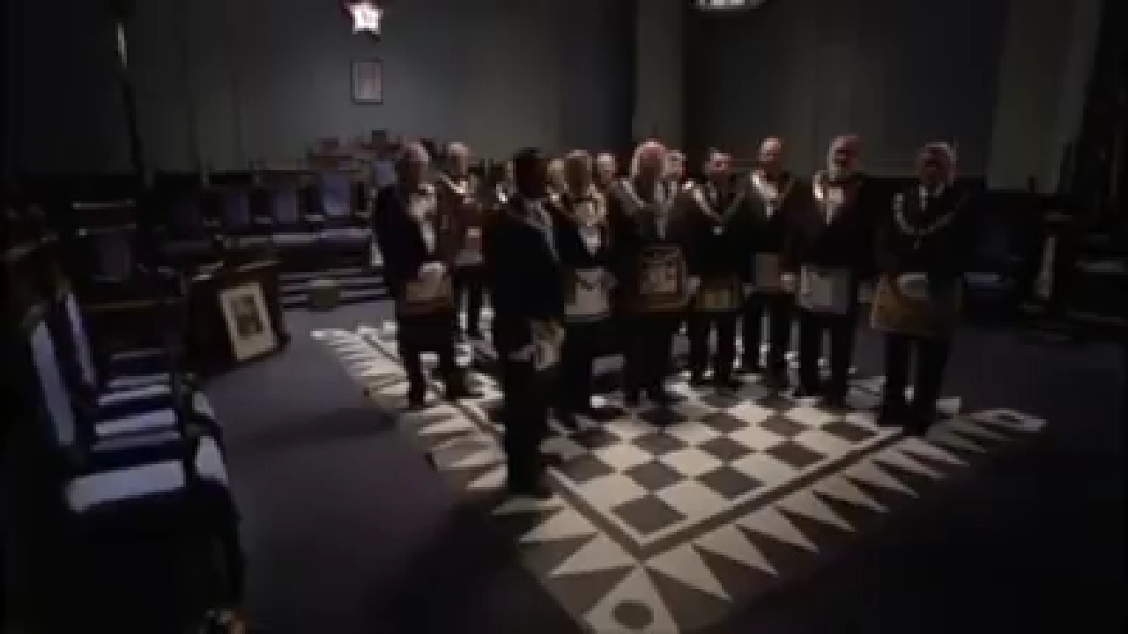
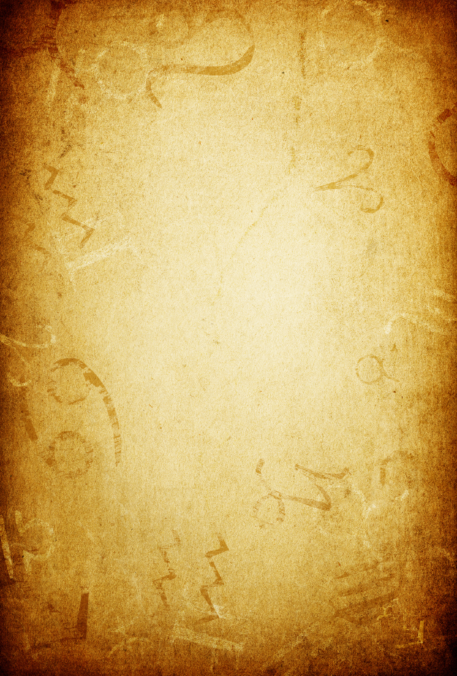
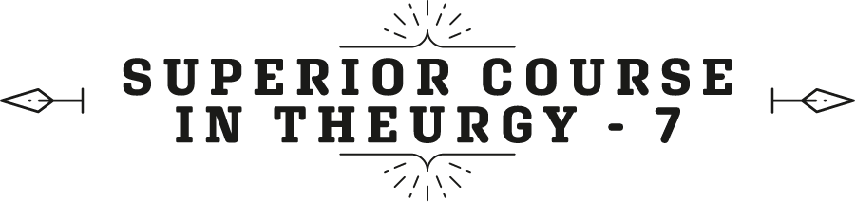



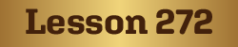
Ven. Master T. A-O Domingo Días Porta

S
o, the staff is wisdom, the Tree of Life. When Pharaoh said to Moses, “If you dominate my advisors”, who were astrologers, who were magicians, “if you defeat them, I will let the people of Israel leave for the Promised Land.” And then Moses' staff became a serpent. A serpent represents wisdom. They put a snake here for Cleopatra; they put a snake at the feet of all the virgins. It has a hidden value of wisdom. We can study it in Hebrew because the snake is wisdom. If not, the snake, what I do then, is that I get scared and I don't know what it means. If you want, we can also put it on right now to see... If you are interested, why a serpent is wisdom.
Well, in any case, the snakes of all of Pharaoh's advisors were on the floor, that is, on the conversation table. And Moses' snake, can you believe, ate all the snakes, that is, the knowledge that the rest had, he ate, got fat, and came back and turned into a rod again. This is when he was given permission for them to leave, because he had a level of wisdom above all of Pharaoh's advisors. The Pharaoh's level of knowledge, and the development of the Society knew one level of GOD, which was Elohim, but Moses knew other levels, other keys, other formulas superior to Elohim. Elohim is not just an expression of GOD; it is a quality. It is a manifestation, but there is another one that gives orders to Elohim. You have to know how that works, and it is Yod-He-Vav-He (יהוה).
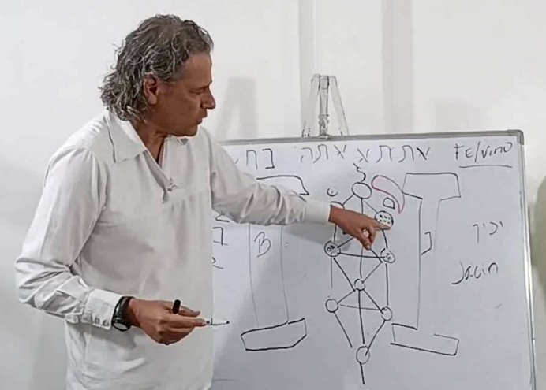
And there is another one above, but well, it is not today's topic. The topic is that when you have the wisdom of knowing the 72 names of God, the power is there to connect to Jakin, which is the column on the right side. It is the one that is connected with the source of the Eternal. Because the name of GOD of Yod – He – Vav – He on the Tree of Life is there. The first emanation of GOD is Kether and a tip of it touches above the right column Wisdom.
And this is the column of intellect, of intelligence. Intelligence has to be at the service of wisdom, because if not, the command that sends towards the world of manifestation and the kingdom of which we express ourselves, is distorted because it is the personal point of view but is not related to the universal principle. That is, it puts the stars above. Here is the Hei ה; Yod-Hei יה, and this is Vav-Hei וה, the Tree of Life; how it descends.
Thus Boaz. The correct use of my intelligence allows me to have what they call prophecy. It connects you to the world of emanation and then you are able to interpret it and say it with a language that reaches. Here it is made matter; that is prophecy. The same one that is—words in Hebrew— that is presented as: seer. Nabi is a psychic, or prophet, the one who sees and is able to communicate it, is ahead of time, and can see.
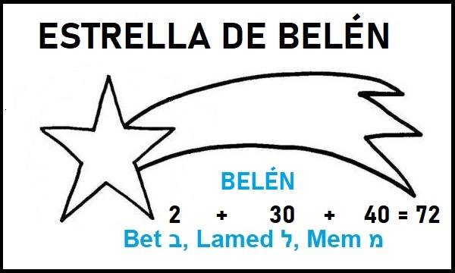
Fine. that 72, by the way, tells us something useful, because in a person under normal conditions, the heart beats 72 beats per minute and the Sun travels 1° of arc in 72 years. That is, the heart of the Earth, the heart of Heaven as some tradition says, but the bridge that unites them are the 72 names of GOD. And where can I see that? Also, in the flaming star used by the Jews. This is another symbol in Hebrew, the five-pointed star. And there are five points that the [Christian] Church also uses in the star of Bethlehem.
It is: Bet ב, Lamed ל, Mem מ. 2 – 30 – 40, Bethlehem, 72, the Star of Bethlehem.
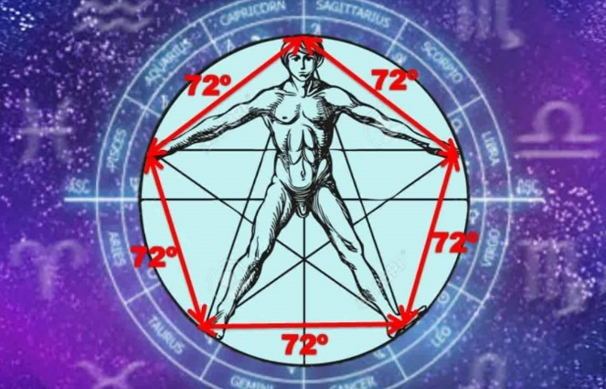
And there are 72, which represent him like this: the Man, with five points. Three and two on the legs are five, but between each point of the star there is 72°. 72, 72 here 72° and there is one, two, three, four, five... 72 x 5 = 360, the circle. Seventy-two.
And here is the Boaz, the power. And what does the other column have? Jakin, which says: “It will irradiate”, because the source that emanates from Kether which is the crown, the kingdom, the king, above this, above Kether everything is in the Tree of Life, the manifestation, the first expression of the manifestation of life, because above it is another name, Ein sof. Ein sof, without end, the Eternal. And here comes something interesting to see, Jakín, the column on the right side. It turns out that HE will irradiate, because in the name of Jakin there are two Yod, and the two letters that I have left are C and N. Those two letters in Hebrew, as you want to say something positive, affirmative, that there is that side, there it says YES, the other is NO. At Yes, it is like the warehouse where there is everything, you will get it there.
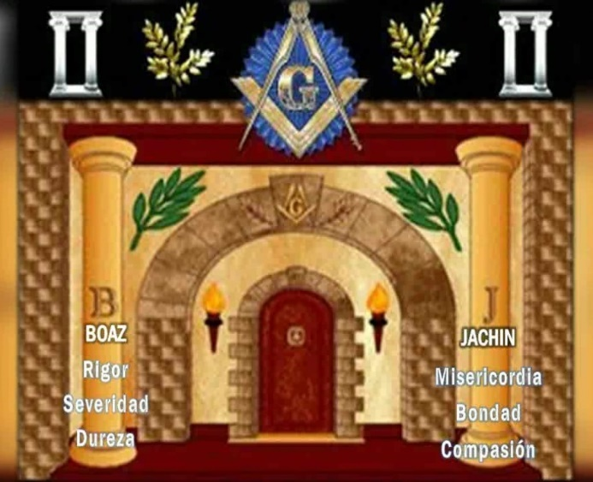
Those two letters yes (SI), and there are two letters left that are the Yod... And a while ago we saw that the only letter that has two Yod is the Aleph – GOD, that is why HE shines, that is why HE is light, that is why HE is wisdom. And, in this column on the right side that says that “he who overcomes, I will make him a pillar in my Father's temple”, he will climb on the right side because this is the side of mercy, of kindness, of compassion. The one on the left side is that of rigor. So, on the right side, which is the Jakin column and is the source where GOD manifests himself in an affirmative way, in balance, there is a word that is an acronym used by the [Christian] Church.
The early Church is very different from the Church today, because Jesus was a Jew, was born a Jew, lived as a Jew, and died as a Jew; Jesus the most known/unknown man. The Jesus that we have as a reference in the canon of the ecclesiastical institution, or the theological Jesus is not the Jesus who lived on Earth; they are traits, and the true Christian must first understand that they never called him Christ.
So, we have to remove the clip ot, in Hebrew it is said... Clip ot are the “shells”, those things that have adhered to us and we take them as true, but they are myths, and it is our duty to remove them to reach the truth, the essence, because we are believing in things that are not. Some have features, nuances of the main source, but we have to get to the source, not what was added over the centuries. Jesus' disciples were Jews, his apostles were Jews, and he spoke in Hebrew and some Aramaic. The translation passed into Greek, from Greek to Latin, from Latin it came to us. But throughout the translations, that has been deformed, more than by the translations, by the theological interests of the institutions.
Now, we have to know why that being, that Master, that rabbi, was a Kabbalah man, like Moses was, like Abraham was, a being One with the Father and not the exception alone. Any one of us can achieve it. That is why he said, “I do not come to abolish the Law, I come to fulfill it.” The Law is the TORAH. We have to go to the source and not to those things that over time have been part of... but we have to remove those things that were acquired by the interests of congregations in which I joined. But perhaps this is a thing that is not what it initially was, because it is the truth, it is the Eternal Truth, not an accommodating truth for one group or another; the Truth is one.
There are infinite points of view, there are multiple reasonings, but the Truth is only one. Wherever you have differences, it is because you or the person you are having a dialogue with, do not have the truth, they are points of view; but the truth is one. The true pilgrim in Eternal Wisdom must try to walk on stones. Stones, by the way, in the esoteric dictionary of Kabbalah, that you have to build stones, are also called the Hebrew letters. Floors on solid ground, no, on stones. Build the temple on stones. The Hebrew letters are called stones because symbolically they are the ones that last the most. Like our bones, they are the one that lasts the most, the rest is straw; these are relative truths. Some are not even clarified to us, we are given certain lights, but it is not clarified well.
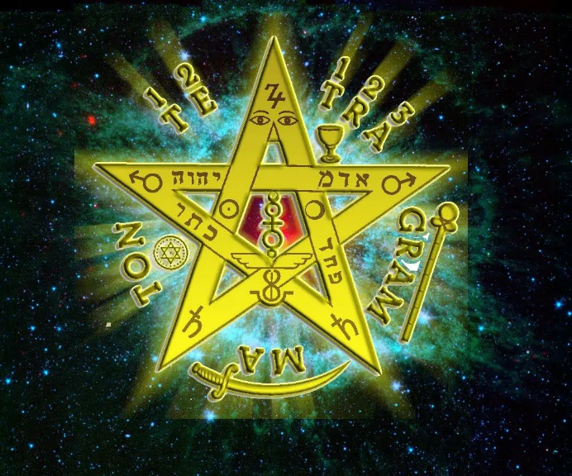
This is why the breastplate that Abraham carried had twelve stones. They were not stones, because he was not stupid to be carrying stones. He had engraved names of GOD, three four-letter names, the famous Tetragramaton. One of the names of GOD that he carried, if you are interested in what the... The breastplate was, that is, what he carried in his heart to face life are those three formulas. That's where the deformed derivations of talismans come from. because it has to do with the telí, the teslín, the protective veil. Then it was simplified to a stole, and from a stole it went to pectoral emblems, which are beautiful and interesting and are a reference for whether I know how to use them... But there are others much more powerful than that, which makes them look almost like child's play if we manage to penetrate into that pectoral, into that formula that even gave rise to the first books of astrology, such as the Sepher Yetzirah, the book of Creation.
And what about that Adam Kadmon, what is that? The Adam Elohim, the first Adam. Which, by the way, Adam is in this column. Adam... And in this one goes Aba, Eve. They are not a person, they are states of consciousness, they are manifestations. That's why we say that we are sparks of Adam, but we have to understand what that is; otherwise, we are left like in our rooms, with clutter that I call, ideas lost in our intellect, without understanding. Sometimes we chew them, but we can't pass them because it seems like we don't understand them. I keep it in the storage room to see if someone can clarify it for me, because sometimes I ask someone, and what they tell me, my soul says, “That doesn't convince me.” I think that what they told me is not right.
Well, here I was telling you that on the cross of Jesus there is a word known to everyone, or for some, I would say, known as INRI ינרי. In translations they say Jesus Christ of Nazareth King of the Jews. This Yod that is here, is the one that we were seeing a while ago, is the one that is here, the same as the name of GOD. There is Yod, it is this same one that also represents the J. It is I and at the same time it is J. So they named him Jesus Christ of Nazareth King of the Jews. That was four centuries after him, but initially it has a key. These two letters that are in the middle, N and R, if we put it in Spanish ene, e, erre, NER; we put the vowel. And NER means candle, that is, a candle, “the little candle”, because before there was no electricity or... Otherwise, they lit it, it was with oil and then with wax, with a little wick, they lit it there. That's NER, it means light; NER is light.
And whose light? (I had the two Yod left). Light of GOD because that letter is the one we have been seeing for a while. Two Yod, see? One and two. Light of the two Yod, light of GOD. Just as Jakin has, two Yod. YES (SI)... That is the statement. it is the source of truth, of wisdom, that is why Jakin radiates.
The early church... there were several groups, in Christianity. There were more than twenty movements after Jesus disincarnated, that followed Jesus, until in the end, the Catholic, apostolic, and Roman movement prevailed: the Roman Empire. But there were more than twenty movements that followed Jesus. That is why the Orthodox Church exists, which has two. It has its eagle, two heads, one that looks to the east and the other to the west. Those who were around, which was Palestine, Galilee, where the first bishops were, disciples of Jesus, they had all the teaching practices of Jesus. But to practice Jesus' teachings they had to comply with the commandments.
The commandments of Moses, because what I am going to tell you is still Jewish, one has to respect, for example, the Shabbat, the Sabbath. If not, it's fine, if you respect nine, nothing happened, you respect nine, but you, don’t follow the teaching of Jesus; you follow nine. Sunday came along, Sunday came for the Demiurge. When the Angelus entered Europe, as it grew a lot in Germany and then passed through all the Nordic countries, and until it reached the Roman Empire, they began to change it. Thus, they replaced it, because it was the majority. They replaced Saturday with Sunday. But Sunday is wrong, for those who want to study it. Every day has its power, but the most powerful is Saturday. For those who want to study why, they have to respect the Sabbath.
That can be taken, the interesting thing about why on Saturday. Very interesting, because on this topic, we do things only out of tradition rather than out of conviction. As we sometimes say, Sacred Initiatic Tradition, and it sounds very interesting, but what is sacred? And what is tradition, and what is initiation? That's as far as we go. I have to get to the secret of all the things we talk about, and if not, we are more or less. In Kabbalah, it is not more or less, it is exact. No matter what you think, believe, and everything is respectable, but the truth has to be one, not accommodating because this order or that order or that other order.
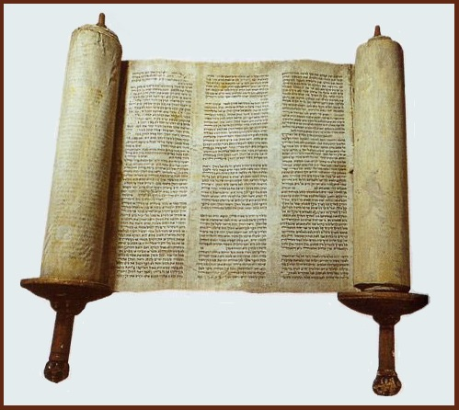
Because for an order, this is a red pen and for any order, it will be a red pen. Anyone who says otherwise that it is not a red marker, is surely wrong, because it is only one. This is white; for a Chinese or an atheist, this is white. Monday is Monday; for a Chinese, Monday is not Thursday, a day is the same for everyone. So, why, if we talk about these issues, how can it be different for this teacher and different for the other? Most likely, one of the two teachers or both teachers do not know the truth. No matter how beautifully they speak, because the truth has to be one, in this teacher and in that other, in any tradition. There cannot be two. If not, then we are contradicting in language, that GOD is one, but for us, He is like this. He cannot be different from the other or he does not know how to express it, or he does not understand it, or he is saying the wrong thing.
And the true pilgrim, the one who travels with light, you have to try to understand him and not repeat something that I am sure that in your soul you say things that you are not sure of. You are still in believing and not in knowing.
So, this INRI, I'm going to give it two more connotations to get into other symbols, so you can see where it comes from, what the tool is, how to use it. This thing that comes from here, look where it came from. Where did Moses receive the revelation of the books known as Torah or Law, Pentateuch / five books...
From where? Which mountain? On Mount Sinai. Anyone believes that it is a hill, all of Sinai, in Jerusalem, yet it is a small hill. In any other country, in any city, there are bigger hills. So, if it is higher, well, it should receive more wisdom. Or if you are on a plane, more wisdom. And it has nothing to do with that. Sinai in Hebrew is written like this Samekh ס, Yod י, Nun נ, Yod. י SI (נ) – NAI (יס). And again, we do the autopsy on the words, and we find that with these two letters N (נ) and S (ס), this is the I (י), between n and s, those two letters mean MIRACLE, those two letters translate into miracle in Hebrew. Miracle of what? Of the two Yod.
Those that we saw just now, the Yod of INRI, carry two Yod, and whose? From GOD, again; this letter Yod י. Yod, which means union, by the way, which has something to do with Yoga, because yoga/Yug. And Yod or yeghudi [יהודי], is union, is one.
With Kabbalah we can talk about any tradition because the Truth was revealed and then transmitted in all other languages. When they began to migrate according to culture and tradition, answers were given, but they keep some keys in their essence. With Kabbalah you can speak about any other language and on the contrary not, that is, of any tradition, because it comes from here where it emanated, and do you want me to tell you why? Not because of my whim, because I am nobody. Everything I am telling you, first, is remembering what your soul already knew. I am not telling you anything new. I am just putting it in order. As Christ himself said, with all his spiritual height he said, “I do not come to abolish the law—he did not change a period or a comma—... I come to make it fulfilled.” Him being such a high degree of initiation as a Kabbalist, He did not change one point. What He did was live it, He became the Verb made flesh.

Superior Course in Theurgy, By the Ven. Master T. A-O Domingo Días Porta
All Rights Reserved

