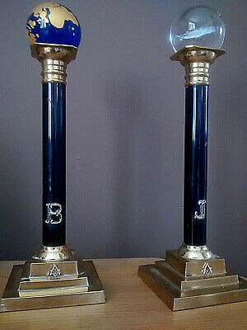
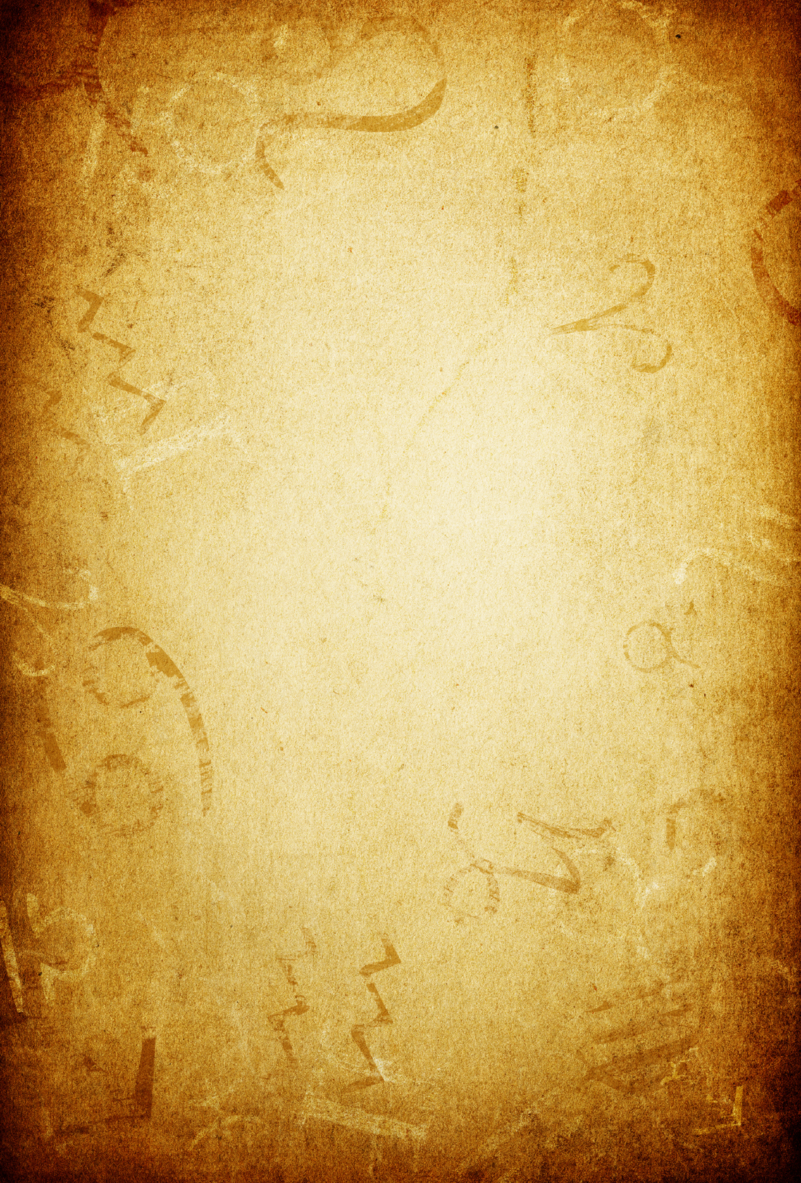
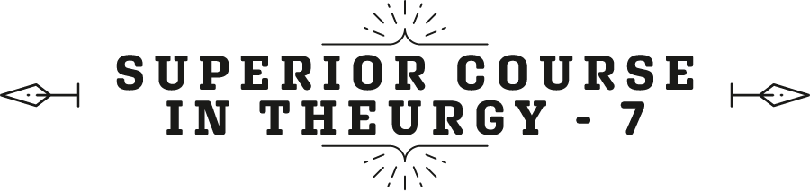



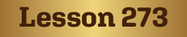
Ven. Master T. A-O Domingo Días Porta

M
oving on with some more of the symbols... These are from the columns, we are going to see the why of things, because the what does not illuminate us, but the why. In several texts it is mentioned that we rest on the seventh day; GOD created the world in six days and on the seventh he “sat down to rest.” They were not 24-hour days. No, when it says a day, it is a cycle, it is a period, but He took six to build until He reached man. The last thing that was created was man and then He sat down to rest. He didn’t rest as it’s thought, “He went to sleep”, no. A rabbi said, “He started having sex”, because everything began to be created and recreated. He already created everything, it is sustained and maintained, the species. How do we know that the sixth is Saturday and not Tuesday or Sunday? How do we know that on the seventh He sat down to rest? How do we know it’s the seventh? What is the seventh day?
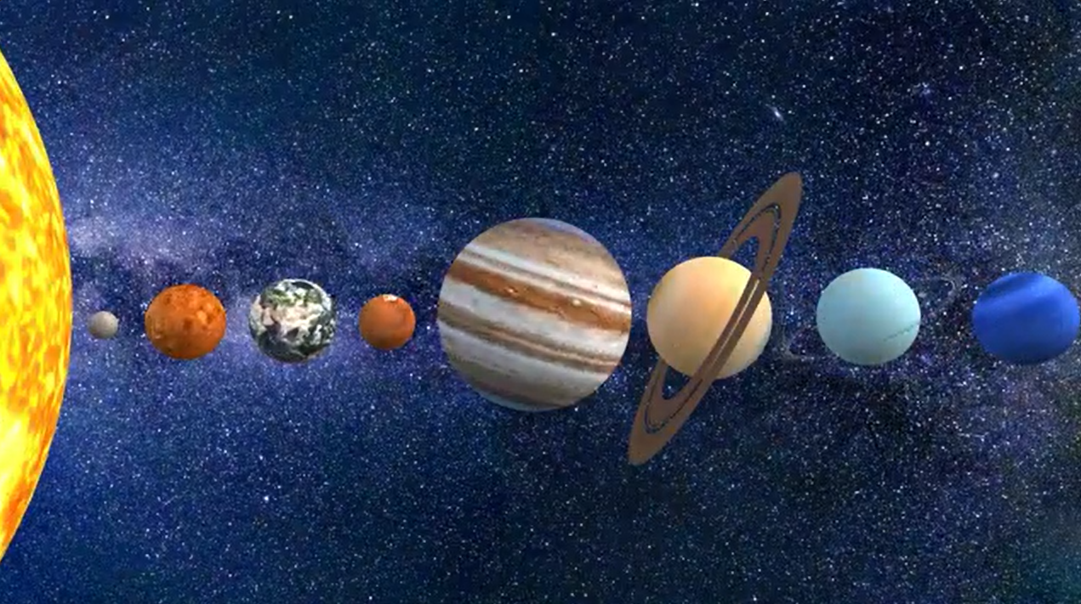
You surely know that the days have a vibrational correspondence with emanations of angels called planets. The souls of the planets are the angels, the essence. The presence is matter, speed, the residence; that is the body. But the refraction that comes from emanations, from celestial bodies more distant from them, including that of the sun, are energies that arrive and bounce back. That rebound gives it a special touch, due to the nature of its biochemical composition, and “those vibrations”… we call them: ah!, they are messengers.
Well then, each of those messengers has a correspondence with one day. Monday/moon; Tuesday/[Mars]... like that. Now then, studying Astronomy a little, we in the solar system, what was the first day? We live in the solar system, correct? This let's say, is the Sun, and we are expelled by the solar tangent, and we are left rotating by the Law of Universal Gravitation... different planets.
So, the first one, which is it? The Sun. The Sun is the first, then the others followed. The distance to it remained rotating at different speeds and they cooled down as the millions of years passed, and the so-called kingdoms began to emerge. First kingdom: Mineral Kingdom, from the mineral came the vegetable, from the vegetable came the animal, from the animal came the human, from the human the Fifth Universal Kingdom, the kingdom of Christ, Buddha, Krishna. A man among men, but not like all men; he is the Fifth Essence, the Crucible, the Ether, whatever you want to call it. It is the part of light called the oil. It is the oil, because you grab a container and it has water and oil, you mix it and those two liquid bodies mix, but they do not homogenize. A while after you mix them, what is going to happen? They separate. What is on top? The oil is the source of light, that is why it is anointed with light, that is where the light comes from, but not from the water.
Fine, then Sunday is the first day, let's count. Let's see, the second day, Monday, third day... fourth day, Wednesday. Fifth day?... Sixth day? Friday. But it turns out that in creation, the night was first and then became day. Yes? In other words, out of darkness comes light. The day for the Hebrews begins at sunset, not like our times, which is when the sun rises, or the day begins at one second past twelve. What time does the day start? According to Jewish mysticism, in that worldview, it was chaos, it was night, and it became day. “And there was day”, that is, made up of day and night, but it begins at sunset. Thus, Friday afternoon at sunset begins Shabbat, until Saturday at sunset, the seventh day. For Muslims it is Monday, that is why they put the moon in their mosque.
And unlike in astrology, complete astrology, so that the calculations are exact, many of which do not come out correct, neither numerology nor Kabbalah used in languages other than Hebrew, because the vibration is different. The calculations are being done with the same formula, but, in a different equation; It's not going to give you the right results. So, the Muslim calendar is lunar; The Christian calendar— not that of Jesus, that of Christianity— is solar. But there is an exact calendar that neither the Sun nor the Moon has. It unites the two and transcends them, because Genesis appears, when it creates the two luminaries in the sky that are the Sun and the Moon. From that moment on, all the calculations of the events to come will be taken into consideration by these two luminaries. If you take the pure moon, it has part of the truth; If you take it in the pure sun, part of the truth.
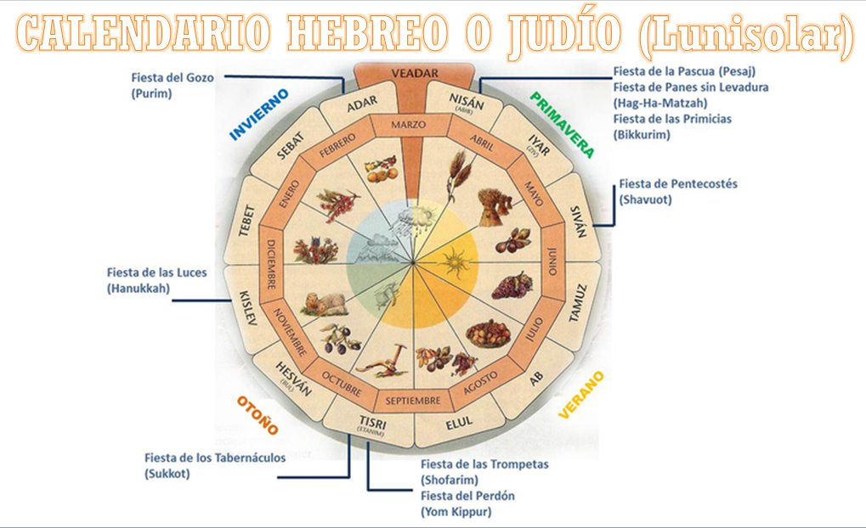
And the Jewish calendar, like the Buddhist calendar, is lunar-solar, uniting the two. And do you want me to give you an example how it works? When we do astrological calculations, they are [...] "Ah!, the Sun's birthday is on such a day, its birthday is today." Well, we will say that it is warm because you are only taking into account the position of the sun on the day you were born, but not the moon. Therefore, the important dates, the calendar [...] made in a perfect schedule. That is the algorithmic intelligence that the Jews contributed, the most advanced! The Christians knew nothing about it, four centuries later they separated and repeated the approximate dates, but they are not exact. Like Pesa - the day of Passover - and Holy Week, they already have it fixed and they introduced another myth, that of the death and resurrection of Jesus. That is not happening in heaven, the commemoration or celebration is not a cosmic event but a cultural, canonical, theological event. He did not even die that day nor was it like that, but rather it was based on a Jewish tradition that is based on the correct use of the Moon and the Sun.
So, when I have my birthday, it is true, the Sun is there that day, but it is not true that I am having my birthday on that day. At that time they say, at 3:15, you were born, you were born and on that day, there was a full moon, and it turns out that that day you are saying, is a waning moon and the vibration is already different. You have to know the exact equation so that the harmonic vibration that was flowing over my being is the same. If not, I have one part of the radiation, but I am missing the other and that has to do—with the influence they work—with my two brains: the left and the right, intuition/imagination, and reason/logic by the two columns of Solomon's temple. Each one controls neurologically, “input”, in us, which gives responses in a different way.
I hope I have briefly explained to you why Shabbat is the seventh day. It is simple to understand. There is more to add, but for now, I hope there is understanding.
In fact, the Shabbat... That is pronounced: Sha... (שבת) Shabbat, which means to relax, to rest, which is not resting, it is like the meditative state, that of contemplation, that of permanent observance. That is why it’s said, do not work, do not do. It is a day of receiving a special energy that is emanating from Heaven. We are passing in front of the store that has everything, and then I take the opportunity to receive that because tomorrow it will not be there. Tomorrow the baker is there, so yes I will have it, but only bread; I don't have everything. The day after tomorrow there is fruit, yes, but I don't have everything. The other day there will be vegetables, but I don't have everything. On Shabbat I have everything. And it is so important because we have to study it, understand it, and also demonstrate it, because Kabbalah is practical. It is mathematics, it is experience. It is not useful to fill our heads with concepts, ideas, but to prove that it is true, and you know because your body feels it. Even in commerce it says it. It is Friday afternoon and the body knows it. It is a commercial representation, but it is true.
Sit down to do this exercise starting today. Observe how you are on Monday, Tuesday, Wednesday, Thursday, Friday, Saturday, and Sunday, and you will see the difference in what you perceive on Saturday. In fact, the word itself is saying it, but we don't understand it because we wait like automatons. It's called a week, right? Semana [in Spanish] is the emanation, the week, like the spring [in Spanish to emanate]. And on Friday afternoon, what do they call it? Weekend, the emanation is over, it is... In English week end, the emanation is over, it is for contemplation, like a meditation, a prayer, a connection, an attunement. Saturday is different from Sunday, even on Sunday, you are half thinking that the week begins on Monday, but Saturday is like an echo.
Well, there it says Shabbath, but let's say that with the same words [letters], I write this word. It says: t... (תשובה) teshuva. Look at this, look, pay attention to this please. it has to do with Shabbat. With the same letters that I use to write Shabbat, that the letters... it is like a container, if I put here the energy of water, the energy of flour, the energy of yeast, and the energy of salt, what will I have there? A mass. This is the radiation of divine intelligences that pass through our brain sending neurological impulse through thought and then with action, which we don't understand how it works.
The letters... I'm going to talk to you about something more important than perhaps everything you have to talk about the Freemasons, which I haven't even covered a small part of.
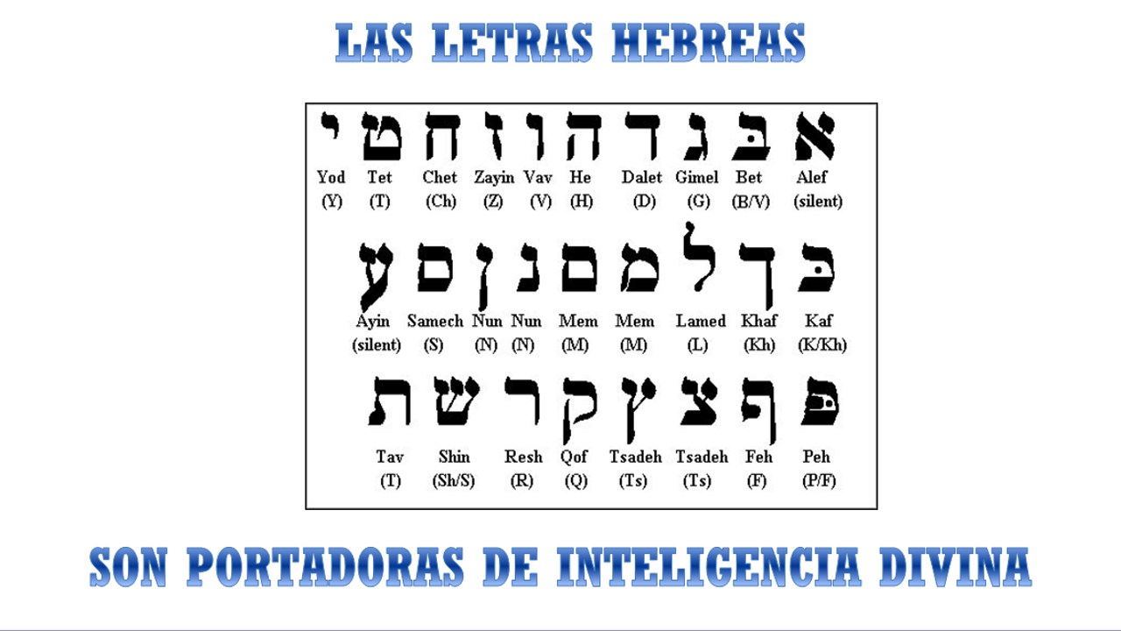
Thus, the letters are bearers of divine intelligence, they are radiations, the letters. Everything that exists is motivated by a letter, and letters were created first than any other body in the firmament. That is why Astrology derives from Kabbalah, and not the other way around, because things have been put to us which we are going to demonstrate to you here. It is not a question of what I think, what I believe, what they told me. That is not wisdom, that is an opinion, respectable of course. It is the opinion, and it may be logical, and it may be coherent, it may be sensible, but it is not true. And in Kabbalah it has to be “cabalistical”, it is to be complimentary, one with the ALL.
So, it turns out that the letters are the same... They are in there, look at them: the Shin ש, the Beth ב and the Tav ת; Shabbat. And there it says teshuva which is a very important word: correction, rectification! And that is the word that appears in the Bible, which was translated as sin. There is no such word sin in the Torah; you say teshuvah. I'm wrong, what should I do? Correct, rectify. It says, “take the good and leave the bad,” otherwise, let's say, colloquially speaking; as Jesus said: “It is teshuvah,” teshuv-he. Look what's going on here, look what's going on here ה, pay attention what's going on here. I'm wrong, I correct it; there is no sin. Sin leaves a negative charge, that I was wrong, that will be fifteen years, I continue... That has already happened, I have already rectified it, that no longer exists. That being that you are judging, that being died fifteen years ago. I was unfaithful or whatever it was, that was then. I had a penalty, I already paid the penalty in the penitentiary. If I violated a traffic law or a crime among men, I already went to prison, I already paid the penalty. Don't continue judging me for what happened twenty years ago. That being that you are judging is not this one, he has stayed behind.
Grief is a burden that recurs in you, leave that for the religious, but since we are in the [...] which we are going to correct... Before GOD I am in the Great Assembly, I am in his temple, I am in that university ; I already corrected. So, look, it turns out that teshuva, that the letters which remain are the Vav ו and the He ה, apart from this one that was here, do you see it? Which ones do I have left? the Vav and the He. And in the name of GOD is Yod, He, Vav, He (יהוה), “these two letters” (יה) remained. This is the world of emanation (יה) and the world of manifestation (וה); the sky and the earth; the invisible and the visible; the emanation, the manifestation. That's why it is now, Yahweh/GOD. And what is he telling me? Be careful, pay attention.
A little while ago, I drew the Tree of Life, I told you that here was Yod, here was He, that this was the 6 ו, this letter is worth 6 and is covering 6 Sephiras: 1, 2, 3, 4, 5, 6 It says: GOD created the 6, and here is the other He of the name of GOD Yod, He, Vav, He יהוה And what does it tell you? Teshuv-He, has the word of the verb teshuv which means to correct, rectify, return, return; where I left off, I rectified. So what is it telling you? To rectify this He ה of the world of manifestation, the world of His Kingdom, of Adonai, of the world in which we move, of this Vav-He וה and return to this, which is the Divine Court; rise up. Get out of this He! and return to this one, where you belong, the Garden of Eden.
I was left behind, from behind, Garden of Eden is written like this: gan-eden Álef, Dálet, Nun (אדנ) Garden of Eden. Be careful! Reading it in the opposite sense it says edengan, and it means “until I understood”, until I understood it. That is, I became enlightened. I understood what the Work of GOD is, that I am one with HIM. Ganeden/Garden of Eden. And do you know why it is called the Garden of Eden? It has much more but it is not today's class. Any of these topics is a workshop. Do you know why it is called Garden of Eden? Because in nature, in the wild, we find everything mixed, right? We go through nature and find everything mixed together. Unlike a garden, how does it work in a garden? That you see over there, and you liked this pink “offshoot ”, and you plant it and remove the weeds. And you liked that other “offshoot” and planted it.
You build your garden, you do not live in the weeds, mixing what does not suit you, what does not please you, what does not help you, what does not harmonize you. You keep the garden clean, you remove the weeds and keep the flowers with their perfume, their smells, and colors, that garden of Eden. But we also have to study what it is, how to write it. This is deeper, this is for a child's explanation, but it illustrates something more to us than what we would have accumulated since we were children.
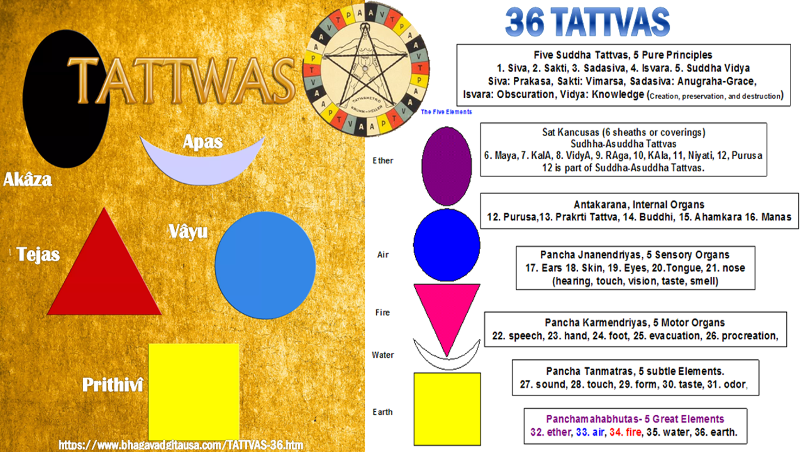
Well, moving forward for example with the 72... What is another contribution? Because each of these topics is so much more that it is impossible to cover it in such a short time, and there are other symbols missing that I want to touch on. Have you heard of the 36 tattvas in India? What are the 36 tattvas? In the Bible it seems that we are always protected by 36 Tzadikimes; Tzadikim, tzadik, is righteous, pure, holy. Beings that are always on the face of the Earth, at least thirty-six. That they are the ones who are setting the principles and virtues and values that the Society must maintain. They call them saints or pure, they are the references, they call them “the Masters”; Tzadik. What does it have to do with the Tree of Life.
With the name of this sefira... There it says Jesed חסד. This sefira is called Jesed, goodness, mercy. This letter ח is worth 8, the Het. The Samek is worth 60 and the Dálet is worth 4. How much does it add up? 8 + 6 = 68, + 4 = 72. That is, the domain of the 72 names of GOD, therefore, that is ruled by Jupiter. And Jupiter represents in Astrology, “the priesthood”, the Hierophant, the one who has the most power over the solar system, “the Tzadik”. Why is it called Sedec? It means Jupiter, Sedec. The same letters, changing the voice, say Tzadik, holy, pure. And he... Here goes a name of GOD יש, it means Ish. Who is it? It means ‘there is’. It has connected, that is where the source of wisdom is, this means Hochma, “Wisdom”, like this, “Intelligence”. She is nourished by the source of GOD.
And this יש, as a sum, is worth 10 י and 300 ש, how much did he give? 310. But in the sefira of Chesed there is another name of GOD, which is Álef א – Lámed ל (אל), and the Álef is worth 1 and the Lámed is worth 30. How much did he give? 31. And what is 31 in relation to 310? Because this column connects you with Wisdom, it ascended through the column on the right side, of mercy, of goodness. 310, in relation to 31; 31 is the tithe; 10% of 310. The source, [...].

Superior Course in Theurgy, By the Ven. Master T. A-O Domingo Días Porta
All Rights Reserved

