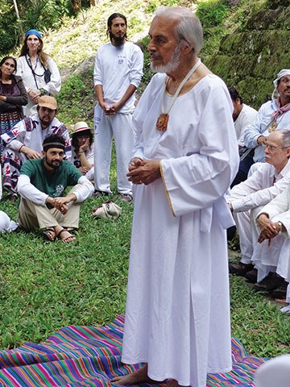
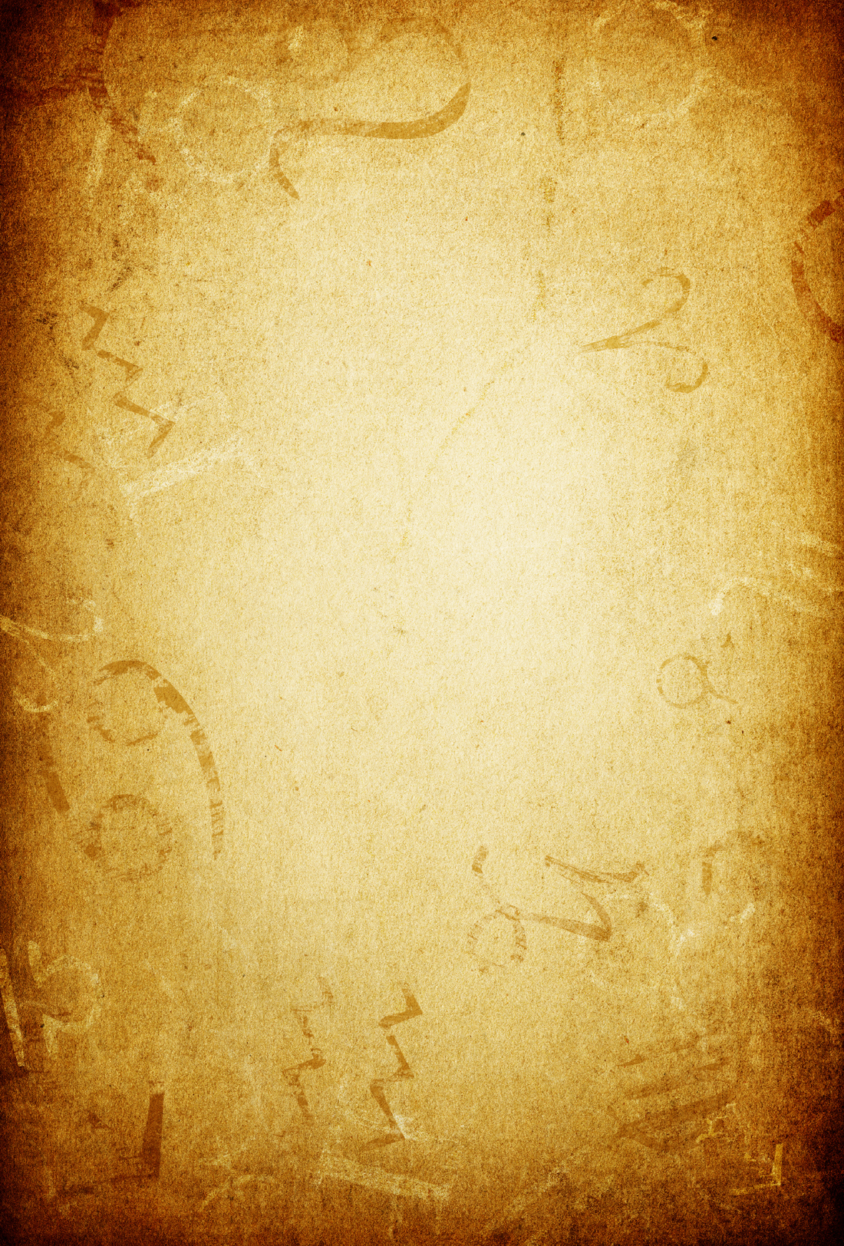
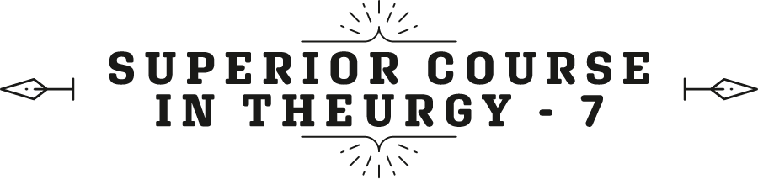

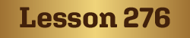
Ven. Master T. A-O Domingo Días Porta

W
elcome all dear brothers and sisters. The peace of heaven be with you, the true peace that is inner peace, serenity in the face of the events of life. The peace of the outside does not last long. We already know that life is a challenge, contrast, conflicts. It is the way that Great Cosmic University, which is the Earth, is based: on problems and solution of problems, such as in every educational system.
Well, sister Alicia Villagra from Paraguay asks, “Why do Theurgy classes begin in Cancer? And is there any consideration if one begins the class under the influence of another sign?”
A: Classes can begin at any time of the year. What begins in the month of Cancer, is the practice of Ceremonial Magic, Theurgy from the point of view of Ceremonial Magic, at the direct level of contact with Divinity. There are many types of magic ceremony for other material purposes, but Theurgy is directed directly to God. Thus, the month of magic is Cancer. The year of spiritual magic and natural magic begins in the month of Cancer and ends in the month of Capricorn. It lasts six months, and the other six months are studies, research, observing the results, the consequences of the work that was done in the practical part of the year. But it is not only the month of Cancer that corresponds to magic, but the entire summer season to the north, and winter to the south, those three months is the period of magic.
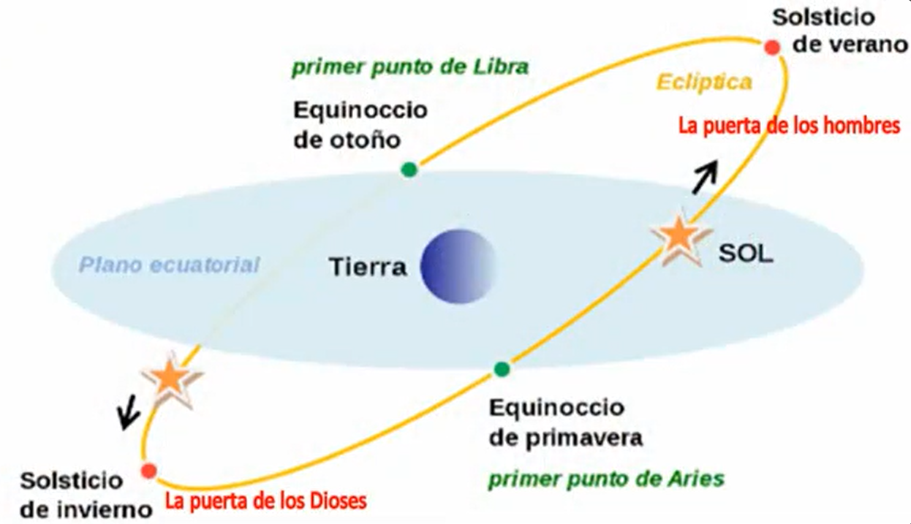
Those are already very deep studies, and something has been explained about it, which is called the summer solstice in the north. That is, on June 21 it is called the gate of men, when human beings can rise; it gives us a way out of the material world, an opportunity. And the winter solstice in December, is called the gate of the gods, when elevated entities descend upon Earth. As in the case of Christianity, when in that period of December is celebrated the star that shone in the heavens and then became the Star of Bethlehem. That is, he came down to Earth, he walked in the world, and then ascended in body and soul again to Heaven - in the Christian myth - but in all ancient traditions we find the same symbolism adapted to the time. Anyway, studies can begin at any time of the year, the appropriate period in the Initiatic schools, from December to June, six months is the period of studies. And the practice period is from Capricorn to Cancer.
The second question also from sister Alicia, "How do they relate and enhance in the Sun and the Moon in each class [house]?"
A: I guess it's not a ‘class’ but ‘house’. That depends on the horoscope of the person, according to the planetary dignity, if the sun is exalted, if it is in its domicile, if it is in fall or exile. Equally with the moon. You cannot do a general practice, but you have to individualize it according to the potential that each human being brings to birth.
Question, “Why are they divided into twelve, what is the meaning?"
A: —The twelve houses are divisions of the Earth; the twelve signs are divisions of the sky. The sky is divided into twelve constellations, astronomically, and in twelve signs, astrologically. And the Earth in astrology is divided into twelve houses. Not the geographical Earth, but from the human point of view. All human activities, all human work is distributed into twelve houses: Childhood, the profession ..., in short, health, etc., is distributed into twelve houses.
Third question: "What is our ancestral connection with the star Sun as beings of body, soul and spirit, reincarnating; And how can we enhance our personal evolution with your energy?
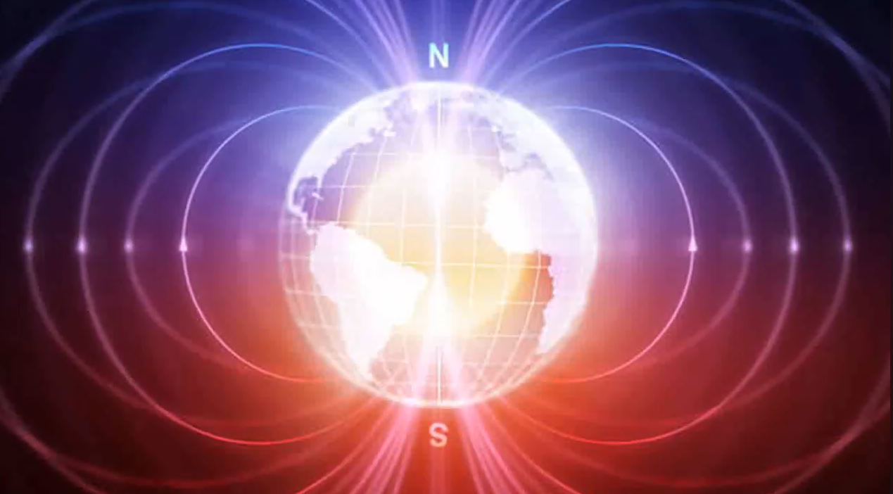
A: —Well, our connection with the Sun is that all the life on Earth, throughout the solar system comes from the star, our Sun; it is the fountain, our source. So, from the beginning the solar energy, in the case of the Earth, through the photons that are like seeds of the sun, when they reached the Earth, they became minerals, vegetables, animals, humans, and all the multiple forms of life on Earth. Not only in form, but in energies that circulate through Earth, such as terrestrial magnetism. There are lines of magnetism that run through the whole earth; electric power, not the electricity that we use, no, but the natural electricity that also circulates through the Earth. Electricity is the positive energy that radiates, and magnetism is the negative energy, which attracts or repels.
Thus, we are seeds of the sun, photons of the sun, which through the millions and billions of years of the life of the Earth were evolving. That is our relationship.
Q: "Beings of body, soul, and spirit."
A: —Well, that classification is the first elemental classification. The spirit is the essence, the vital part, which gives life to the organism, to thoughts, and so on. The body is the tool we use here on Earth. What is called the soul is the bridge that unites the spirit with matter, with the body, and that soul corresponds to the sphere of feelings, of emotions. There are feelings which are closer to the spirit, and feelings that vibrate more with the Earth, which are more passionate, possessive, jealous, and so on. And elevated feelings, because the soul vibrates more towards the side of the spirit.
Fine, then body, soul, and spirit because, it is the basic classification, but there are other increasingly subtle classifications. We can subdivide the body into cells, organs, tissues, into functions, such as the digestive system, the respiratory system, and so on. Likewise with the soul, the soul also has its strata, and the same with the spirit. The spirit includes the mind at all levels, from the practical mind, which allows us to survive on Earth through skills we have, of language, etc., and the superior mind, which makes us reflect on life, ask ourselves questions, seek personal growth, and so on.
Q: "How can we enhance our personal evolution with its energy?"
A: I suppose that she refers to the energy of the sun. That depends on the horoscope, where you have the sun. So, you combine the sun with the sign and with the house, and the aspects they form, and there you realize what is your path. The path is not the same for everyone; no, each according to their destiny, according to their location in life, according to their tendencies, their vocation, etc., is drawing a route on the road, in their destiny. Destiny is the forced part of life, and we have the part called free will, which almost nobody exercises. People then depend on the outside, on money, food, and so on. They are bound, but freedom can be cultivated, free will.
So, to take advantage of the position of the sun, the greater light we have in our horoscope, we must see all the connections that the sun has with the planets and with the signs, and other characteristics that are part of the study of astrology.
Another question by Alicia: "What other conscious practices, apart from the rites of the Sun and Asanas, do you recommend to clean the body, revert pathologies, improve our immunity, and reconnect to oneself?"
A: —Well, the practice of integral health. People have the idea that health refers to the physical body and disease of the physical body. No, health and disease cover all levels of the human being, from the spiritual, the mental, the feelings, the emotional, the physical, the social relationships, at home, at work, in friendship, as citizens, our responsibility before humanity, before the planet, before God, etc. All this encompasses health and disease. Most human beings are sick of one thing or another. Cities are sick cities, and that disease has been passed on to Nature. Thus, there is contamination not only in cities but in natural environments, on land, in the seas, in the air.
So, then, the ... for example, yoga therapy, ayurveda, which are natural medicine treatments but with a spiritual basis. Current natural medicine is materialistic, it only seeks remedies, but does not take into account meditation, prayer power, visualization capacity in the mind, positive thoughts, power thoughts. The mind is full of negative thoughts, fears, frustrations, anguish, it depends a lot on the outside world. They have no character, they have no will to overcome the circumstances, but are subjected to the world. They are like chained, let's say.
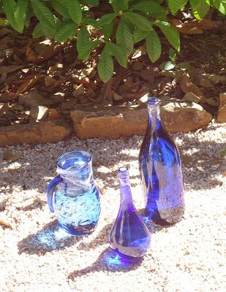
Q: "What do you think of the practice of solarizing the water we drink?"
A: "Well, I don't think about it, I do it every day." I put a glass pitcher in the sun for a few hours. I usually do this from ten in the morning to two in the afternoon when the sun is at its maximum splendor, irradiating and charging. The morning is positive for the sun, it is heating the Earth. After the sun is in the middle sky, which begins to fall, it is the negative part, the sun retreats its heat, its light, and is then used for a form of therapy in the morning, which charges vitality, charges energy, etc. And in the afternoon, to be rid with all the pathogenic elements, all the disorders of anguish, of infections, etc.
Then, you can also do this from eleven to one, for two hours, but after solarizing the water you have to put it in the shade, because if not, if you leave the water all day in the sun and every day, then green lama appears. And that is very interesting because that reveals how the life arises from the combination of the sun with water. That water that I use has been filtered, has been boiled, there are no microorganisms there, it is water, that is, hydrogen, oxygen, and the other minerals that water has. And yet, with the photons of the sun, a life appears. And you can do the experiment. Every day you can put a pitcher of water in the sun and see how it is filled with that green slime, how life is formed.
That reminds me that, in the Bible, at the beginning of the Bible, in Genesis, it says, "The Spirit of God floated on the waters." In this case, the Spirit of God can be represented by sunlight and water. It is a small experiment, then, which proves that key that appears there in the Bible, which is studied in the cabala. Religions do not decipher the symbolisms that are in the Bible. The Bible is not a religious book, it is a book of wisdom, of great wisdom.
Q: "What do you think of the diamond water?"
A: "No, I have not practiced it, but I think the most powerful thing is to work with solar energy. Crystals, diamonds, all those forms, magnetic stones, etc., all this comes from solar energy, from the photons of the sun condensed in those forms.
And the last question: "What diet do you recommend for the path of transformation that we travel?"
A: —The diet at the beginning, is what we have been teaching: Ovolactovegetarian, a transition from the custom of eating animal meat, to leave the meat behind. Therefore, we use the derivatives of the living animal such as milk, cheese, butter, eggs, and mainly yogurt. Animal derived, but they do not come from death, from the decomposition of a corpse but of the living animal. The stomach, I say that the stomach should not be a cemetery of animal corpses. It must be a site of cultivation of life, and vegetables are those that have evolutionary vital energy.
The meat of the animal, by killing it, has already been used, that low energy. People allege that the proteins are in the animal. But I ask them: where do the proteins of the bull, the elephant, of the giraffe, of the camel, come from if not from vegetables? Vegetables are rich in protein. All life forms are built with proteins, not only animal meat, and animal proteins, and the animal used them. By killing the animal, that protein ... they already lose vitality.
Well, that is the last question, about that there is much to deal with, but time is short. Let’s go then to the question of Sister Cecilia Martínez from Aguascalientes, in Mexico.
Q: —Master, in the different Initiatic traditions of the history of mankind, the teaching was given from Master to disciple, from lip to ear.
A: "Yes, it was, because at that time the majority of the population was illiterate; it was useless to write. There were no editorials, there were no bookstores, there were no libraries, there were not even schools to end illiteracy." The vast majority of the population did not know how to read or write. Then, the teaching was therefore passed on from lip to ear.
Literacy campaigns are very recent. Generally, before, 90 % of the population was illiterate, that's why the teaching of lip to ear was given, and when they could be written. When people began to read, to be interested, then, they began writing the teachings that were from lip to ear so as not to lose it, and so that they were not transformed because they were passed from lip to ear, from a master to a disciple. Then the Master disappeared from the Earth, and then the disciple passed to another disciple, and thus through the centuries. There is no assuredness then, that the words and concepts have not changed.
When writing it, there is already concrete evidence of the original teaching. However, sometimes there are doubts about it, both in the writings, like the Gospels of the Buddha and of the Master Jesus the Christ, etc. Sometimes there are doubts, like the translators have not translated correctly… anyway. But well, what has come to us is what corresponds to us and from there we must continue always, trying to go to the fountain. In Christianity, the fountain is the Gospels of Christ; it is what we have more directly relative to Christ. The apocryphal gospels, the gospels of the Essenes, etc., have already come out, which enrich us because that is living water of the original spring. From Buddhism, the writings of the Buddha; from Islam, the writings of the Prophet Muhammad, that is, the Quran, etc. In India, the Bhagavad Gita for example, of the Avatar of India, Krishna.
Well, the question continues: —... I suppose the secret chambers had that function during the time of the Elder Brother.
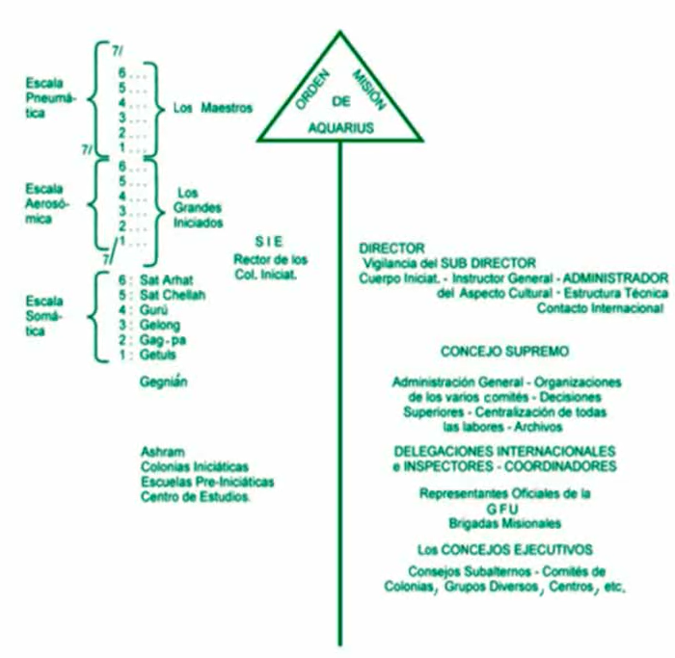
A: —No, the Secret Chamber was an attempt by the Elder Brother, Dr. José Manuel Estrada just like the internal ashram he founded in Coatepec, Veracruz, in Mexico, to open the Aerosomic Scale. But the people did not respond because it wasn’t the moment. The minds made a lot of effort with the simple fact of having a healthy diet, of practicing elementary yoga, a popular yoga which is now practiced everywhere, elementary astrology, horoscopes, without major results, and so on. We had to go through primary school that is the somatic scale of initiation. High Initiation has three levels: the somatic scale which has been transmitted thus far, generally dedicated to the physical body: healthy eating, breathing, relaxation, physical yoga, etc.
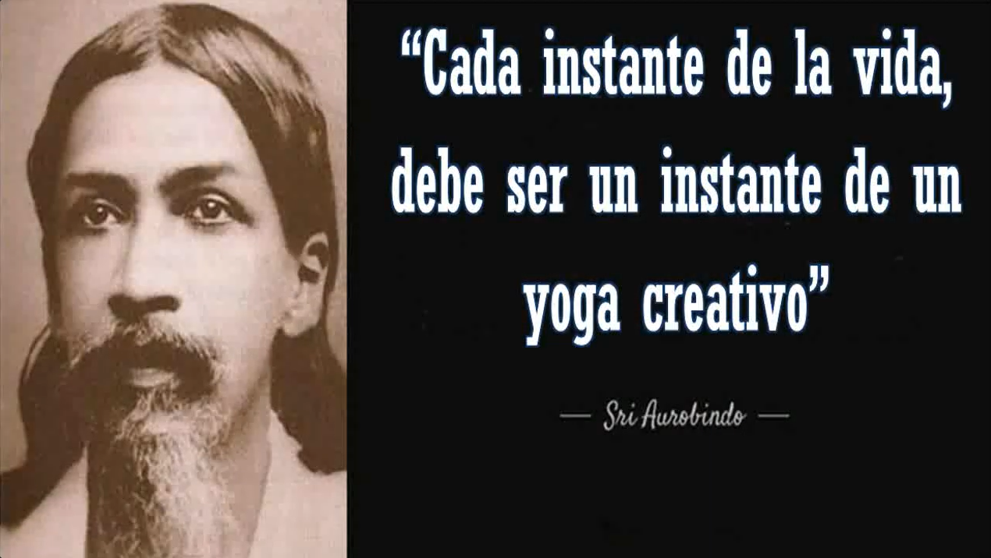
Then comes the Aerosomic Scale that is centered on the mind. Everything that happens to the body depends on the mind, originates in the mind. And the Pneumatic Scale, which is the superior scale, is already directed to the spiritual part, the divine part, the sublime part. This is equivalent to official education in most countries: primary school, secondary, and university. The primary school of Initiation would be the Somatic Scale, behaving well, taking care of health, practicing a bit of yoga, even if it’s twice per week. True yoga is practiced twenty -four hours a day, not sitting on the ground, but there are: eating yoga, conversation yoga, work yoga, think yoga, dance yoga, and so on. “Every moment of life”, said Sri Aurobindo, the philosopher of India, “must be an instant of a creative yoga.” Not the routine, not monotony, not every day the same, but putting flavor to life, salt, spiritual condiments, etc.
Fine, then comes the next question: "In the present, how can we get those teachings if we do not have a teacher nearby and communication is only given remotely?"
A: —Well, thus remotely, by the element of the era of the Aquarius, which is the air, the Internet has approached us all. Through the books, the books that come from the source, and the books of the great commentators, the great Masters who through the centuries have kept the flame going. Through the different spiritual lineages: in the East, Asia in the East, in The West called Europe, in Africa, in America ... America is North/South, it is not the East/West. Our line in America is different from the East/West line, as we see in the history of our civilization. So, those teachings, then, are already recorded, written. Today we cannot complain about information.
We have plenty of information today. The important thing in the disciple is the spiritual connection, not being attached to the Master all the time. The Master would get bored of being followed by some who are not teachers, who commit mischiefs and things, and do not understand, and they sometimes scold the Master and complain. That would be horrible for a Master, having that clique. No, the Master gives an hour in the day and then everyone to his path, to his destiny. They cannot all be locked in a monastery, in an equal routine for all, that is not possible.
Life is varied, just as there are varied plants, herbs, trees, thus human beings. It is like a jungle of all kinds, from bugs, to criminals, to delinquents, those who are looking to take the peoples to war, etc., and to higher, noble human beings who have learned how to drink from the fountain, who have learned to find themselves.
Well, those are therefore the comments on the questions we have received that we could deal a lot about what here is... what these questions contain. Then, the Maestre de la Ferriere, the Avatar of the Aquarius era, the first one that announced the Era of Aquarius in 1948, when the people expected the end of the world, he asked the disciples that when they did the meditation, they would connect with him, with the spirit of the Maestre, with the envoy from Heaven who had to present the postulates of the Aquarius era. Every two thousand years begins an astrological era, and an Instructor appears that brings the foundations for the era.
After the era, another Avatar follows for one more step of ascent in the spiritual evolution of humanity and, therefore, brings the new postulates that are added to the previous ones. The Master of these times does not rule out the teaching of the Masters of the past, but that they complement each other, enriching them. As in education, what one learns the first year in primary school is added to the second year, the first year is not ruled out. And in the University, the first year is enriched with the second year of the University, of the third year, etc.
Then, the Maestre de la Ferriere continues the sacred layout, the mystical layout, spiritual layout, which the great instructors of Humanity are weaving through time and through places. There is no place on Earth that is devoid of divine assistance, all on the continents, on the islands, in the jungle, in everything, all peoples have always been under the gaze of the Cosmic Mind, of Universal Intelligence to guide them in the evolution of humans, of animals, of plants, of minerals, of planets, of the galaxy, everything follows a constant movement.
Life, from one angle, is transitory, everything is transitory. Our childhood is gone, our youth is gone, our parents are gone, our children are gone to take their own path; everything passes, every day disappears; it is already history, it seems like a dream. That is the idea of ​​transience. But that is the word, let's say... elemental, there is a higher word which is transformation. Everything is transformed, physics itself says, "Nothing is created, nothing is destroyed, everything is transformed." Thus, in esoteric studies too, instead of transience we speak of transformation. The seed dies to become a small plant, the small plant stops being small and grows to be an adolescent plant. It grows and is a young tree. It grows and is an adult tree giving flowers and fruits. Old age comes and it becomes compost or wood to make houses, etc.
Well, we still have the question from Sister Frida Vissuet in California, in the United States, "Master, most of us were young and like sponges when we entered the Universal Great Brotherhood. Why didn't Master Estrada concentrate on lowering the ego and raise the being?”
A: Ah, why? Because of you, because of us, because we were stubborn, for not wanting to pay attention to what is really the Path, the death of the ego, so that the new creature, the true being could be born. No, each one defended his name, his last name, his prestige. "Well, do a little yoga then, and a little meditation there.” Elementary, to spend a little while believing that you were already flying through infinity, and so on. That is, when a Master takes disciples, he has to take them through primary school, little by little. He cannot stuff him with great teachings because his mind is accustomed to ordinary life, to what the television says, the newspaper, the films, customs, etc. That is the practical mind, the lower mind, the mind to survive, to lead our life, but the superior mind is asleep.
Thus, the Master has to go little by little fertilizing and watering the garden of the mind, so that they begin to awaken the higher faculties.
—... lower the ego and raise the being.
- Sister Frida, that is the job of each one. That is not the Master’s responsibility. The poor Master, who would have to lower the ego in everyone, they all would beat him. "No, I have my name and my last name, that's my right!" That is an inner work that meditation supports because it strengthens that inner life, but meditation is not to get away from life, it is to get into life. One meditates to act better and better in the world around oneself.
Well then, it is now her turn.
" I think that if you had reminded us again of who we really are and of our potential, we would all be at another level of consciousness.
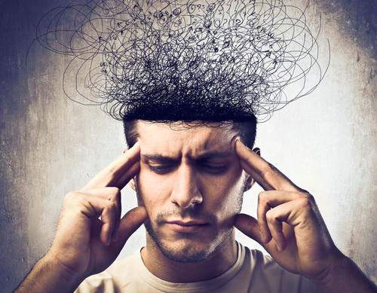
A: —Well, to be reminded every day, you can record in a CD, in a cassette, on the cell phone ... or put a card on head of the bed, so when you go to bed, you remember; and another card in the shoes when get up. Another card in the dining room, another in the bathroom, another inside the door of the house when leaving, and another card on the door of the street, another in the car, in the steering wheel, another glued in the soap, in the cutlery. And so on. And thus, you are constantly reminded.
But it is not a matter of memory or to remember. No, you already have the sacred words. It is a matter of wanting/to dare, wanting/to know, wanting/to silence, which is not to be mute but to enter oneself. To stop bad noises in the head, always thinking and thinking and thinking ... No, quiet the mind, because when you run around a lot in the mind, much dust rises, you get entangled in your way of thinking. Let all that dust settle so you can see what is stored within you, what gives you life. Life is like saying God. Life is eternal, life is life, life cannot die. A form can die, a house, a car, a body, but life, life continues. "Life is eternal and continuous." said Joaquín Trincada, the master of spiritism.
And here, she continues: —... for example, being constantly connected to our spirit, which is the same as God, the mind, the body, and the senses are at their maximum ...
A: "Well then, remain constantly connected and you will be at your best."
—..., in purity totally, satisfied with all desires, absence of desires, friendly with all, absolute truth, wisdom, tranquility, full of joy, sweetness in speaking, supreme magnanimity, brilliant, unidirectional, realizations of cosmic events, without fear, absence of divided consciousness ... ”
—Caramba sister, you arrived at the gold mine, there you have everything. You no longer need a teacher. Get on the way and guide others, teach them all that, how you did it.
Now she says, the question is, "Why didn't we focus on this connection before?"
"And why not now, I wonder. We are in the year LXXV of the Aquarius Era, and I see many stagnant disciples the same. When I travel, I find them the same as before. And I wonder why, why don't they concentrate? More than meditating, because meditating is to turn in orbit around the center that is meditation: halfway in the middle. And concentrating is going to the center. It is what is called in yoga, in India, the Samadhi, hitting the target. The symbol of Sagittarius is the animal man. There is the symbol, that is humanity derailed, the animal dominates. And the humanity that is overcoming and rising, the human part dominates and is pointing to heaven, to the heart of the galaxy, toward the Being.
"I am not the Being, and I am not the non-Being, I am." But it's not me, it's not my person, with name, surname, etc. It is a universal gift, it is in everything that exists, in everything. In everything: vegetables, animals, minerals, humans, on the walls, on the roofs, in the ground, in the rivers.
From time to time, I go to the river that is one block from home. And the river speaks to me, tells me those things. It says, “I am the river, but I am not the river, I am water that runs, and you call it River, but I can get out of the river. I evaporate and go to the sky, turn into a cloud. I can rain in the deserts. I can rain in the countryside, in the cities. The riverbed is a part of my work, a form of my work, but that does not limit me.” And so the river tells me, “You are the same.” You are not limited to the body. You can fly. You can rise. You can evaporate. You can rain. You can become a spacecraft. Do not remain locked in the skull. You are not simply a lined skeleton. There is something else in us.

Superior Course in Theurgy, By the Ven. Master T. A-O Domingo Días Porta
All Rights Reserved

