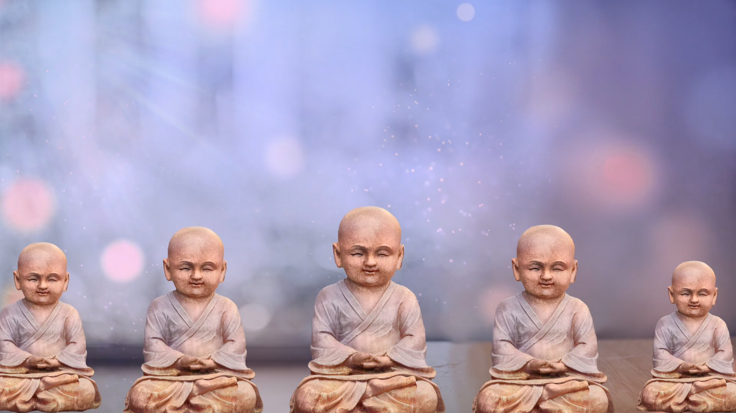






By the Ven. Master T. A-O Domingo Días Porta

W
ell, the purpose of doing this, as I said, is to prepare our mind. Do you understand? Taking a moment or a few moments to calm it makes our mind clearer so we can start speaking. I have here a presentation that I prepared for the course; I want to share it with you.
Well, first of all, welcome back. So let's go to the definition of karma, to get down to the subject at hand. We already have a general context of why we are going to talk about karma and interdependence, right? Why? Because we all want to be happy and avoid suffering. Thus, we need to know what causes happiness and what causes suffering, right? So, as I put it here [on the slide], the word karma is a Sanskrit word. The word karma is very well known. There is a lot of talk about karma today, even different ways of explaining it. But something very important to take into account here, is that karma means action, karma means action. In Tibetan we say le; le is literally: act, action.
In fact, the Tibetan word leka means: my work, my activity. Le, comes from le or karma. Karma, I repeat, means action. It is not at all incomprehensible, it is not at all hidden, it is not at all revealed, it is literally act, action. As I was saying, it is similar to Newton's law of motion of bodies.

However, it is important to tell you here that the complete word, which we translate into English as the Principle of Cause and Effect, is a principle: the Principle of Cause and Effect. So, together with the word vipaka, karma vipaka. Karma vipaka means cause and effect. It is the whole process of causes and conditions that produce different effects, or it would also be called action/consequence. So, for example, if I have these lozenges here, these Halls lozenges, and I drop them, they fall. This is not a reward or punishment, right? “Oh! What a reward!” A reward or a punishment, no. Reward or punishment implies that there is someone rewarding or punishing, keeping a list, how you behave. Karma is not a reward or punishment; it is simply action/consequence.
If I do, say, or think something in a virtuous or positive way, that will have a consequence, or in a negative way that will have a consequence. It is not a reward or a punishment, it is simply a consequence, right? It is not that someone is rewarding or punishing you, it is simply something...; it is a principle. Something also important is that karma..., karma is not destiny, karma is... It depends on how we understand destiny. Sometimes we understand destiny as if it were something that was already established. Whatever you do, that is your destiny! Karma is not like that, karma tells you, “If you change the cause, you will change the effect.”
If I have a box of matches, all the matches inside the box, all the matches, have the potential that if I take them out and rub them, they will light, they will ignite. However, if I wet the box of matches, the matches will remain there, but the potential to ignite by rubbing them will no longer be there, right?
So, if you change the cause, you change the effect; therefore, there is no written destiny that whatever you do will happen, according to karma, because karma is fluctuating, karma is constantly changing. If you, for example, right now —analyzing the teachings of karma— say, “Well, I don't have many economic resources, however, I know that generosity is the cause for having resources. With the little that I have, I'm going to be generous, with my time, with some words, with some food, with some money. Maybe I have very little.” I don't know, by practicing generosity you are changing karma. It's not that, well, this is my karma, and I can't do anything! No, that's a misunderstanding of karma.
Beings can... we can modify our actions, modify our karma. It's something very important. We have that power to modify it. Sometimes we want to modify it when it has matured. When it has matured, it is too late because it is already... It is like an egg, if we boil an egg and leave it boiling, and we want to take it out and have it still be raw after three minutes, no! It is too late; it has already matured in the causes and conditions for the egg to be cooked. So, now what we have to do is see what to do with the boiled egg that we have. And many times, we want to do it with karma, when it matures. The important thing is to do something before, and it is with the tendencies that we have in our mind.
Therefore, to clarify, the word karma means action. There is positive karma and negative karma; it is not just negative. People... "It is my karma, and it is negative." No, but how many of us stop to think... How many of us stop to think, the positive karma that we have, of having something to eat every day. That is the result of previous karma, of having been generous, of previous actions, having been generous, having to eat every day. That is what we may often take for granted, but many people do not have that. They do not have that cause, or they have to create it every day in a very hard way, right?
So, the word, the principle of cause and effect, karma vipaka, is action and the maturation of action. And that is what we are going to explore here, the definition that I want to make clear is this: karma is action; it is not reward or punishment, it is not destiny. Of course, if we leave karma latent there, well, it will eventually mature as something, right? It is not that it is destiny, it is that the cause is latent there to mature in the future as an effect.
Thus, by understanding karma as an action, it gives us the opportunity to say, I can change it, and that is extremely important, and it does not depend on someone else, it depends on me. I would like sometimes to remove negative karma from so many people, from us, or from people who have children, to remove it from their children. However, karma is... There are two types of karma, collective karma and individual karma, but both depend on the individual. So, the individual... As an individual, we have the ability, as people, to modify our actions, and therefore, the consequences. And that is what makes it very interesting, the study of karma, which tells us, I can do something with my current and future life; that is something crucial.
Virtuous karma or positive karma is one of them. Virtuous karma causes us to experience happiness or satisfaction. Non-virtuous or negative karma, as we also call it, causes us to experience suffering. And neutral or immovable karma comes from deep states of concentration in which there are practically no virtuous or non-virtuous actions. Most of us commit virtuous or non-virtuous actions in different degrees, that is, karma is not the same... Right now, I am going to explain the components for an action to be complete. That is, it is not the same for you... to kill, to run over someone by accident without intent and because they crossed your path, to go in a car, in the car and hit them, and to hit them with the car directly and with the intent of killing them. That is, the result of the action, the weight of the result is going to vary, because it depends on several factors. So, it is very important to take that into account.
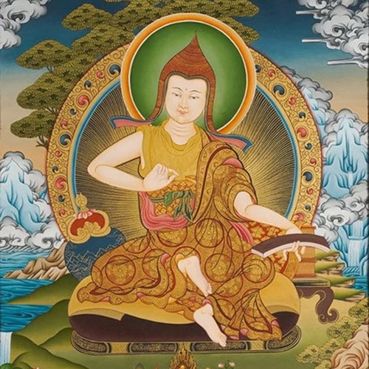
Therefore, when we talk about karma, we often talk about... The most important thing about karma is the intent. So, we have virtuous karma, which is positive karma, which comes from actions that are beneficial to us and to others, and that results in happiness. Non-virtuous karma or negative karma causes us to experience suffering for ourselves and for others. And neutral or immovable karma comes from very deep states of concentration in which the individual is practically just concentrated and there is neither virtue nor non-virtue. Finally, to advance on the Path, it is about avoiding negative karma and cultivating the positive channel; that is how we start.
Although, as the Great Master said, it seems that it was Chandrakirti, a great Indian Master; Chandrakirti said something very funny, he said, “To begin, we do that, we avoid non-virtue and cultivate virtue, however if we stay there, it is not enough. We have to transcend that and reach Enlightenment.” Not just cultivating the virtuous and avoiding the non-virtuous, but we have to go beyond that.
Question. It says: —How can a negative action that has an effect, a consequence, and is foreign in space and time, be improved by another good action? In this case, that it is not linked to the previous one.
Answer: —Well, something important here is that there are no actions that are foreign to each other, they are all interdependent. That is not to say: one is foreign, others are here, and others are here. Yes, what you mean is that an action done or performed perhaps years or let's say from the Buddhist point of view, lives ago!
The question continues: —How can we work with it at this moment, even if it is done or was done a long time ago?
Answer: Yes, it can be done; it can be done through the four forces or four powers of purification of karma. If the result of that action has already matured, then it has already matured. That is, there is nothing left to do, it has already matured, and so to speak, it has been settled. But there are many that have not matured, and many that we do not know that we have even done, that we do not even remember. That is why it is important to know the characteristics of karma, which we are going to talk about tomorrow. There are four of them and from that, we apply the practices, the four powers of purification. Among them are the ones I was telling you about a while ago, which is the hundred-syllable mantra of Vajrasattva and put it on your cell phone, or in your headphones, or listen to it. And as you repeat it, you will learn it. And there are a hundred syllables, and you say them at any time. Or you are on the subway, you are driving, you are traveling, and you recite the Vajrasattva mantra OM, and you are purifying.
So, as to whether your question is whether something can be done with previous actions, yes, because they are interconnected, otherwise if they weren’t... Chögyam Trungpa Rinpoche, a great Master, said, “The only reason we should think about the past, is to do something with it.” If we are only going to think about regretting, feeling bad, why are you thinking about the past? It is not useful because you are not doing anything. If we are going to do something with the past, that is why we think about it, we are going to purify negative actions from the past.
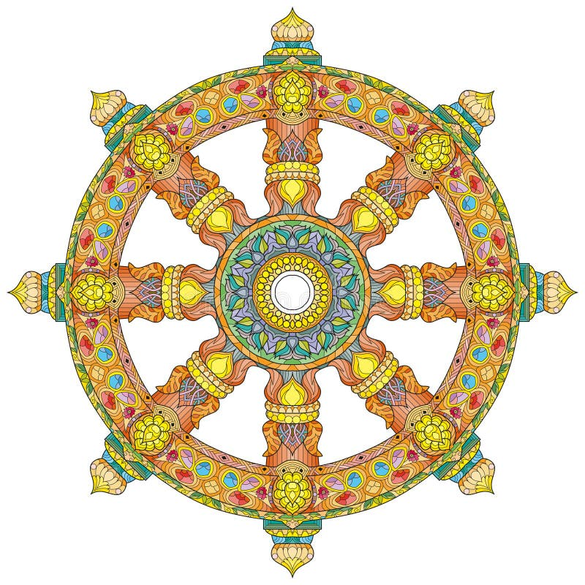
The last question. It says: —If karma is action —there is virtuous karma— what is dharma?
Answer: —Yes, sometimes, there is this interpretation that they say... I have heard that they say that karma is the negative and dharma is the positive. From the Buddhist point of view, no, that is a misinterpretation. Dharma, as I told you, dharma is all the teachings. And karma is included within the teachings of dharma. Dharma encompasses all the teachings, from meditation, the four noble truths, the two realities, impermanence, the precious human life, etc., etc., refuge in the three jewels, karma (the principle of cause and effect), all that is dharma, the whole spectrum of teachings. And within dharma there is a section that is karma, which explains actions, positive karma and negative karma, and how it is created, and how one can work with it. So, that would be the difference. Dharma is the whole teaching; karma is part of the teaching. Dharma basically means the teachings.
Very well. I have been very pleased to have this session with you. I appreciate the invitation of Master Domingo, and I also appreciate the invitation of his wife Lupita. I would like us to begin in the traditional way that we begin the courses, which is by quieting our mind, taking a few minutes to quiet our mind and establish our motivation. Why? Because our mind is like a field, a field in which we are going to sow seeds. So, when we sow seeds in this field, we first need to prepare it, like any field before doing... In agriculture, they burn the land, prepare it with the different types of fertilizers that the field needs.
Why? Because in this way, when sowing the seeds, if the field is prepared, there is a much greater probability that those seeds will bear fruit, bloom. Unlike if we throw them into a field that is not prepared, there are some that will always bloom, of course, but it is more feasible for most of them to bloom if we have the field prepared, right?
Thus, the same with our mind if we prepare it just a few minutes beforehand, doing a short meditation and then thinking about our motivation. Motivation is very important, motivation in simple terms means making it clear to ourselves, making it clear in our mind, what we are doing, and why we are doing it, and that gives a guideline, a much clearer direction to all our actions.
So, for this I am going to invite you to just for a few minutes, it is very simple, to sit with your back straight. Sit with your back straight, your hands can be on your knees, resting, chin slightly tilted down, if we can, to stretch the neck muscles a little. We can keep our eyes slightly half open without focusing on anything, nothing more... If you notice, it seems that I have them closed, however I let in a small beam of light, a little bit of light. If we get distracted, we can close them, no problem.
We are going to start, inhaling and exhaling three times through our nose...
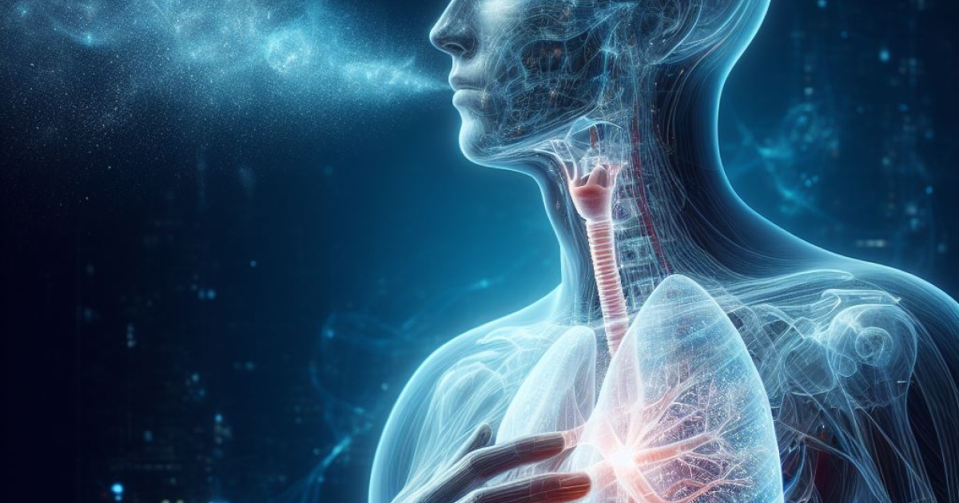
And now, we are going to concentrate on our breathing. We are going to do a very simple technique, which consists of inhaling through the nose. When we inhale, our abdomen expands as if it were a balloon, a balloon that fills with air, and when we exhale, our abdomen contracts as if the balloon were deflating. Then, we inhale, the balloon expands, our abdomen fills with air, and we exhale, our abdomen contracts and the balloon deflate. And our object of concentration, along with our breathing, is the movement of our abdomen. Let's concentrate on this for a few moments...
It doesn't matter if we get distracted, the important thing is that if we notice that we get distracted, we gently return our attention back to the breathing and the movement of the abdomen. It doesn't matter how many times we get distracted; the important thing is to notice and return again. If we don't get distracted, we continue observing the breathing and the movement...
[...] our attention on breathing, inhaling and exhaling naturally. We are like observers... we inhale, our abdomen expands; we exhale, our abdomen contracts, and the important thing is to observe it. Our object of attention is this movement. We concentrate on it for a few more minutes...
And now, we are going to inhale and exhale three times, again, through our nose naturally. We inhale deeply... We exhale...
And, we are going to take a few moments, we are going to concentrate for a few brief moments on our motivation. That, of course, is something personal and individual, but in these moments, what we are going to do is tell our mind what we are doing and why we are doing it. In this case, what are we doing? We are gathered here to share, listen, reflect, and meditate on the teachings of karma, on the principle of cause and effect. For what? To be able to first transcend our limitations. Second, to be able to develop our internal potential. And we do all this not only to obtain the personal benefit that comes with it all, but we try to expand it. We are here gathered together to be able to be of benefit to all the beings that surround us.
All beings of different types of existence want to be happy and stop suffering. So, what we do today can contribute to transforming our minds, to being better individuals. All this to be able to, not only avoid harming others, but to be able to benefit them as much as we can. So, let's think about this for a few moments. Let's try to let this thought, this motivation, enter us in a sincere way so that we can, due to cause and effect, generate a positive potential that will mature in the future, into something that will be of benefit to us and to others.
Let's take a few moments to reflect on this...
And now, gently, let's go back to our established motivation. Let's think for a few moments about four points that help us to strengthen this motivation; they are called the four unlimited or immeasurable thoughts.
The first is love, love, and we think... For a few moments we think that all beings can achieve happiness and the causes of happiness...
The second is compassion, in what we think about; that all beings can be free from suffering and the causes of suffering...
The third is joy or happiness. We think that all beings can never be separated from the great joy that is free from suffering...
The fourth is equanimity, empathy towards others; that all beings can dwell in equanimity without considering some as close and others as distant...
And, before concluding the motivation, I am going to make some small prayers of aspiration that simply verbalize all this that we have been reflecting on. We can listen and take advantage of this moment to strengthen the positive motivation before starting. Prayer...
And we return our attention, we stand up again, and we conclude the meditation.

Superior Course in Theurgy, By the Ven. Master T. A-O Domingo Días Porta
All Rights Reserved

