
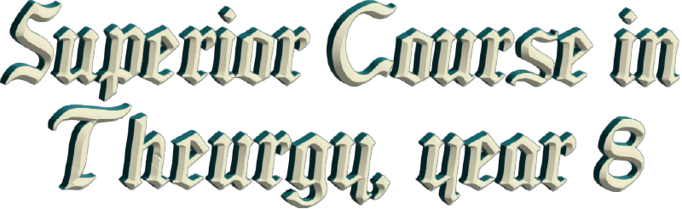
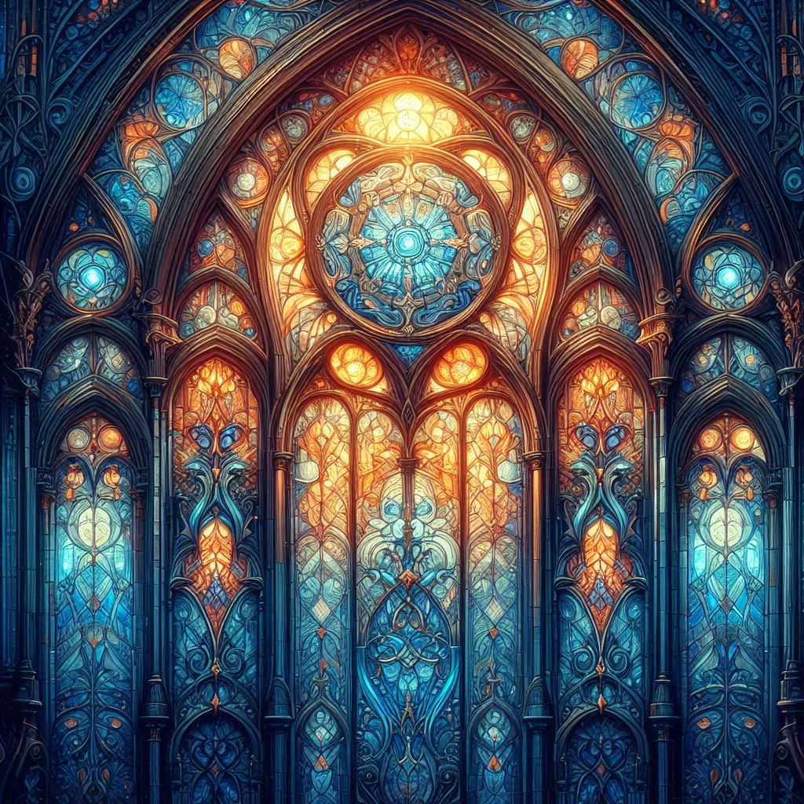

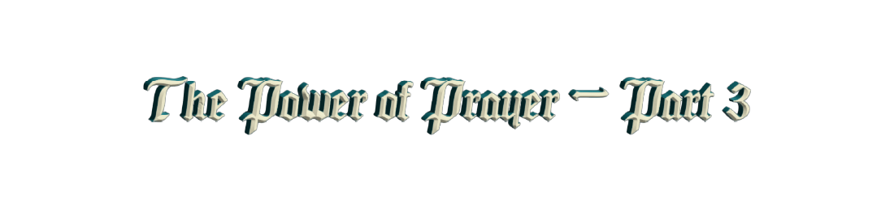

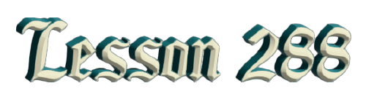
By the Ven. Master T. A-O Domingo Días Porta

W
hat are the recommendations to recover the original sound? Taking the Initiatic Path to learn about the Universal Initiatic Tradition. Study the origin of languages, search for the roots, the origin of life, understand that human beings did not begin on a continent, as they say now, that it began in Africa. No, the human being did not begin on any continent. Human beings began here on Earth, in the waters, in the ocean. That is why ancient tradition tells us about mermaids, and naturally, the “mermen”, humans with fish tails.
That is a hieroglyph that tells us that we begin in the ocean, and science does not understand that. However, science says that in the human body we have inheritance from fish, and the science of genetics tells us that ontogenesis repeats phylogenesis, that is, the development of the human being in the mother's womb repeats all the stages that life has gone through since its origin here on Earth. So, it goes through the stages of mineral, vegetable, fish. There is a stage in which the fetus or the pre-fetus swims in the waters of the womb, swimming like a fish.

Thus, in this way, we recover the original sound, because the original sound depends on understanding. To recover the original sound, we need understanding, and for understanding, to understand, we need knowledge. To understand a person we need to know them, if we don't know them, how are we going to understand them? So, the Maestre de La Ferrière in his writings, in his books, gives us keys to knowledge so that we can apply it in life and not to keep it in the brain but to live the knowledge. There then is the power of sound, it springs from understanding.
Well, we will talk about that later, give other orientations, because that is very important since we are sonorous beings. We are sonorous beings, we use sound, words, poetry, music, song, etc. We have to build the Era of Aquarius on other foundations, the law of polarity applied to sociology. For example, in Europe we went through the Middle Ages, which was very religious. Then came the Humanist Renaissance, then came the Industrial Revolution, which was mechanistic. Then came the new technology and now comes the other polarity. So, from this civilization that ends in mechanization, the Era of Aquarius goes to humanism, but not to a humanism like that of Europe, which was literary, philosophical humanism, no, an existential humanism. The Maestre says, a humanism of the Era of Aquarius.
Understanding what human, what the human is, the correct understanding of what is to be human, what does the human consist of. Are we animals, one more animal species in this world? Or do we have something...? Today there are many searches and much confusion. People confuse success with money; they confuse love with sex; they confuse health with medicines. But ideas closer to the truth are already circulating. That word that is so manipulated, the truth, the word truth has the original sound that leads us to the idea of what truth is. In this case the Universal Truth, not the truth of a science, not the truth of a religion, not the truth of a philosophy, but the Universal Truth, the meaning of all this.
Question from the public: —For the cosmic antennae, with the windows of my room... [Orientation of the altar].
Response from the Master: —Yes, in the Cosmic Ceremony, for the tuning or antennae, we place the altar where the light enters, where the sun enters. If there is a window, because sometimes the east in the room faces the bathroom, then, it is not a good vibration, we look for the light.
Intervention of Sister. Ma. Guadalupe: —But, if we are outside, where there are no walls, we should put the little altar or our face towards the east. So, don’t worry if there is a window facing north or south, you put your little altar there, you do antennae there.
Master: —Fine, the Cosmic Ceremony as it has been done until now, is designed to be done indoors, but it can be done outdoors with certain precautions.
Well then, another question: —What is the name of the book and the author that you mentioned about the alphabet? In French it is called l’Alphabet, like in English, alphabet, with PH. The author is called René Palaysi, with Y, Palaysi: l’ Alphabet. It says, “The alphabet, mystical code of the language and philosophy of the ancestors.” It was published in 1945 in Paris. Yes, in French, very interesting, very synthetic, a small book but with a lot of content, very beautiful.
Well then, now the other questions. Let’s see, here is another, another one arrived. It says here: —Dear Master, you have transmitted to us some sounds and prayers in the original languages, such as the prayer of the 33 Taus, the Tamtum Ergo and other sounds that you recommend in your book of the Heavens of Quetzalcoatl. Could you tell us how we can search for and pronounce other sounds and prayers?

Answer: —Go to the cultures that live in nature, the indigenous cultures; go to Mexico, to the Huichol, who have the sounds. In the United States, go to the Hopi, and other cultures, but the Hopi in their silence keep the original sound. Silence... To grasp the sound we have to enter into silence. Mrs. Blavatsky wrote a book called The Voice of Silence. The Elder Brother says that is a mistake. It is not the voice of silence, it is the voice in silence. The voice of silence... Silence has no voice, that is why it is called silence. But the voice in silence... When one enters into silence, one hears its sound, its internal song.
And thus, go with the Mayans, in Central America and Mexico, go to the Amazon, to South America, go with the descendants of the Incas. To those people who have remained outside of moral contamination, of the diseases of civilization, of the violence of wars. They are more connected to the origin, to the source of life.
Well, then these are the questions that were pending.
Question: —What is the shortest path to transcend karma? From Fabio.
Answer: The shortest path is about ten reincarnations more or less, in a single incarnation... Stop rushing, we are in the era of speed but in these things you have to go slowly. As the saying goes, “if you are in a hurry, go slower.” It is not about knowing a lot, but about being, to achieve being, what we are. “Hallowed be thy name!” says the prayer of Our Father, hallowed be thy name! How can the name of GOD be hallowed? How can one hallow the name of GOD? Because that name in itself is already holy. What does that mean? That you pronounce the name of GOD with respect, not saying GOD as if it were the name of a person, but with his attributes: Eternal, Infinite, Almighty, etc. GOD, then by using those sounds you place yourself in a different vibration.
This is the first rule to sanctify the name of GOD: the correct pronunciation, so that it is not a word that offends like, “Why does GOD allow this?” That is an offense. And the second rule for you to sanctify the name of GOD: is your conduct, your character, your vocabulary, your way of seeing life, your response to problems; there you measure yourself, to see if you are low or high in vibration.
The quickest way to advance in Initiation is “know yourself…” That is what they said in the Initiatic colleges, in ancient times. At the entrance they said, “Wayfarer, know yourself and you will know the Truth.” It is not about knowing the physical part, the body; one is not the body. The body is the space suit that they gave us to be on Earth. When one goes to the moon, one puts on another suit, adapted to the moon, but one is not the body. If you focus on the body, on appearance, then you are not knowing yourself, you know the vehicle because you move through the body; you know the dwelling because you live in the body, but you are not that. The Masters of Humanity have always taught that in one way or another.
Of course, the body is not a machine, the body is full of the Spirit, it is full of the essence. That is why one says, “My foot hurts”, and not the body hurts. The body’s foot hurts! No, my foot hurts, my head hurts, because one identifies with the body. The same happens with the car, you identify with the car, and you say, “I ran out of gas...” Not you, it's the car. “I had a flat tire, I had a blowout” Is how we say in Venezuela. Not you, but you identify with things. “I have a leak in the house”, you don't have leaks, it's the house. So, to disidentify, it is said, to cut things off, to understand in another way.
Question: —When people say that a drunk is “drunk,” it also isn’t true that he is a drunk either?
Answer: No, the body is drunk, but it is not that the body is drunk, but that the owner of the body harms the body. The body gets sick not because of the body, but because of the owner. The poor body suffers the consequences, but it is still the work of GOD; all forms are the work of GOD.

Superior Course in Theurgy, By the Ven. Master T. A-O Domingo Días Porta
All Rights Reserved

