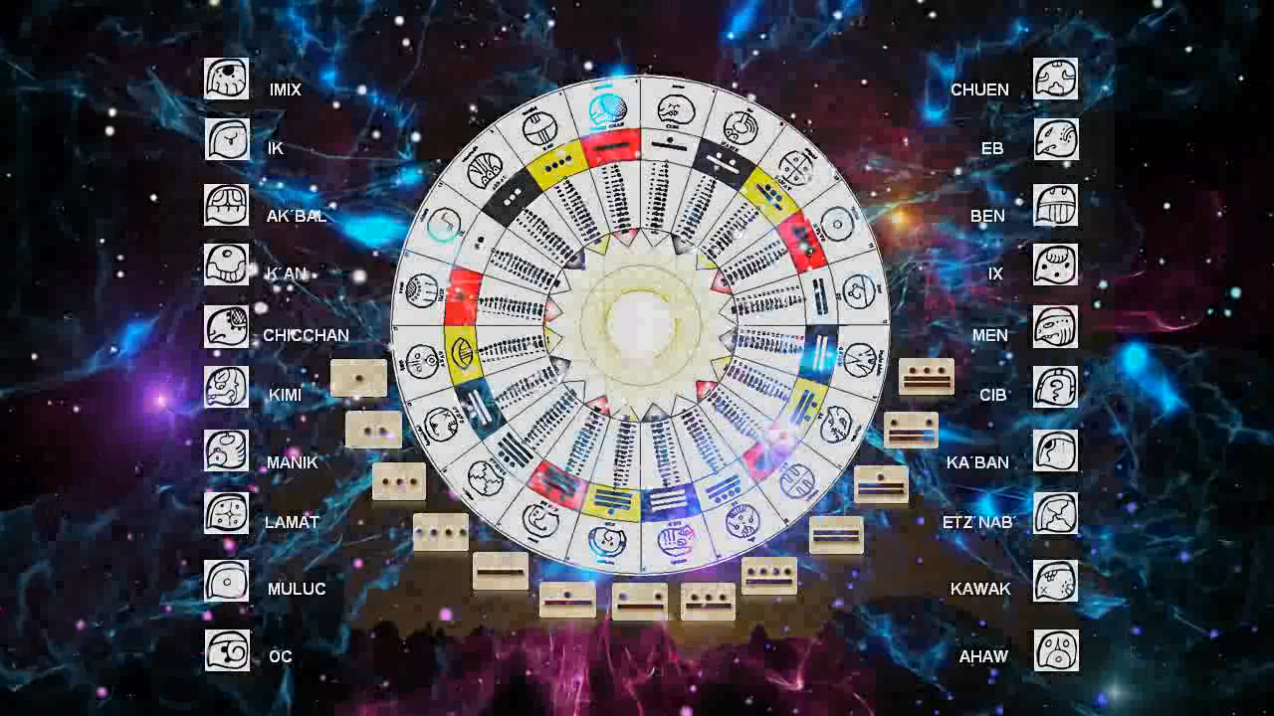
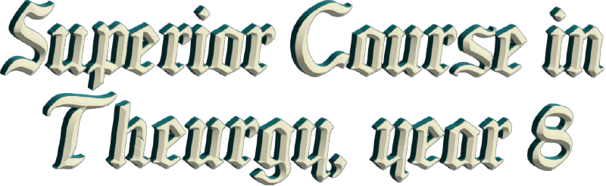
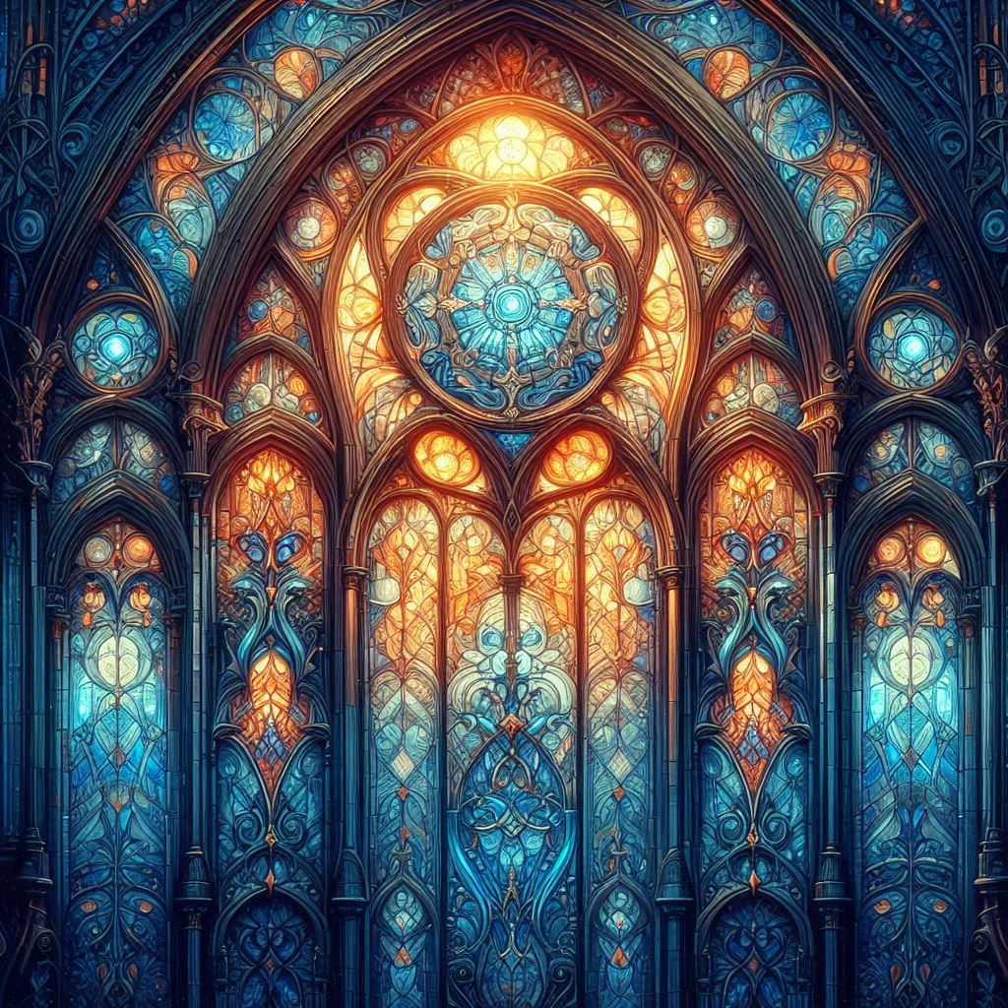

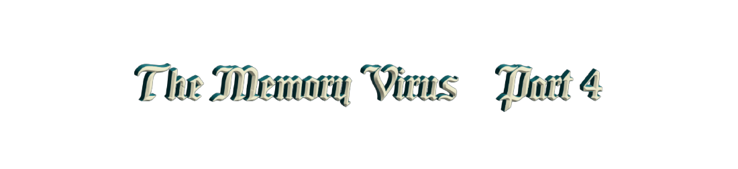

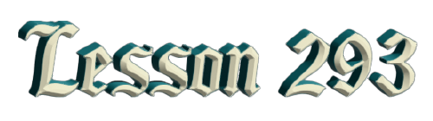
By By Brother Pedro González

Ven. Master T. A-O Domingo Días Porta

L
ook at everything we are hearing, that implies a whole new mental structure, a whole change, a whole review of what we have done, what we are doing, and what we want to do. I don't know what your priorities are, but personally, I have been in a constant search, and it continues, prepared, and I think that for the first time in my life I found... Because I am living it. It's that... it occurs to me, I am living this, I am living a totally natural frequency, which is the frequency of the Earth, it is the frequency that connects me with galactic information, which is telepathic. In other words, I know things from within, because they come to me, they come to me just as they can come to each and every one of you. I am not following anyone, I am following my own dimensional double, my own inner being, as it is, as you will be when you begin to handle these four-dimensional tools.
And I am talking about the first level. We already saw the twenty seals and the thirteen tones, but look, I have the ninety-four [...] and I still need more, to add more, and more, and more, and more, and more, and more, and more, and more, and more; it never ends. And you learn one thing and another and another comes out, and you realize about life, and you are... you see the results. These days... I am going to tell you about a synchronicity that I had that is the part of telepathy. I found myself in the subway in Mexico City thinking, what do I do with this decision that I am going to make? It is a decision that I am going to make that is going to distance me a little from my spiritual work that I am doing. What do I do, do I stop or continue, do I wait or continue? The response was instantaneous. Going down the stairs, there was an announcement that said "wait." Okay, "bye," I have to wait, there it is. The information comes to you through sound, a musical note, a look, some numbers, a message as it came to me, so obvious: What do I do, do I decide or wait?
Bam!, I waited. What?, I waited. Ah!, I said, well, it's clear, like water. That's how it's happening, the information in the fourth dimension is instantaneous, because it's time. And if we're managing the frequency of time... It's like you, you're doing yoga, you're not going to receive the effect in two weeks, you're feeling it there. I do this pose, I do Paschimotasana, and I feel that my spleen and my liver are working better. Oh!, what's the reason for that? Well, the effect of the pose, it's immediate, it doesn't take that long.
Well, in the same way, the management of time is immediate, and the information that you require, that you're using at that moment, occurs instantly, because you're using the telepathic language that is synchronicity. Everything that is synchronic is telepathic, although many times we don't manage all the language that is at the final level. There is a level that is synchro-galactic yoga and holographic yoga. Imagine! When I saw that, I said “joy!” I thought I had learned yoga. No, I’m just starting, galactic synchro yoga, “galactic synchro”, synchronicity with yoga. The synchronization that yoga can have with those mental states, is mental yoga that synchronizes all the time, at every instant.
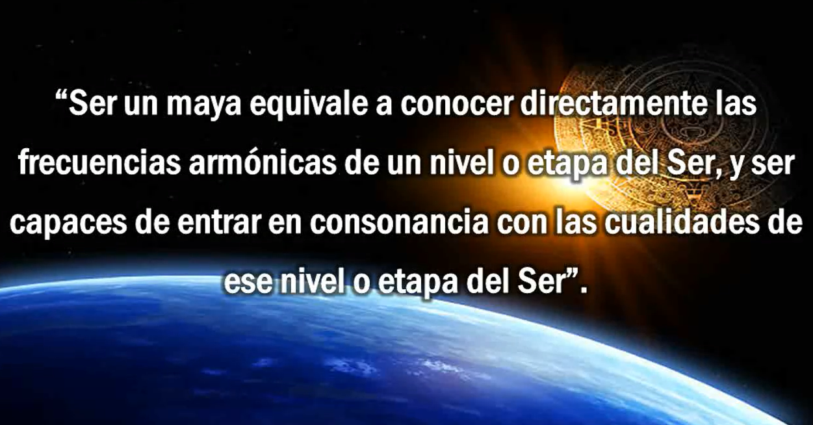
And holographic yoga, well, I’ll tell you about it later, but all that implies, well, knowing the languages well, the numerical languages, which is the grammar that we are handling. This is the first level that we are seeing, Dreamspell. Unfortunately, we are not interacting in person, which would have been more interesting because I can then have a banner and things to explain, and tell you, and everything. But I will send them to you anyway, if you have any questions, you call me or send me a message and I will gladly answer you because that is my mission, that is:
“... the ability to maintain direct communication —I am repeating—, to continue establishing and expanding the perception of the ALL. It is the conscious achievement of the harmony that is the object of [...]. The intelligence that manages to reach this stage is called maya, diviner of the energy [...] maya. Being a maya is equivalent to directly knowing the harmonic frequencies of a level or stage of the Being and being able to enter into consonance with the qualities of that level or stage of the Being.”
Our being begins to evolve truly. We begin to accelerate our evolutionary process. I have no interest in telling you these things for another purpose. Do you know what my true purpose is? It is that individually we cannot make the quantum leap, it has to be collective. When I discover that, I say “jooy!”, everything I was doing, working hard, and hard, and hard, and hard... No, it has to be collective! The Earth is one, but the cells of the Earth are all of us. It cannot be a cell that escaped, zip! He did a Samadhi and left. No, that is not so. It is a change to another dimension where we are managing time, and time, when we start to manage it, is infinite, it is eternal. Therefore, do not limit yourself.
“The galactic telescope and the music of the spheres, with the Tzolkin or calendar, the Mayans managed to codify for us what is called resonant transduction.”
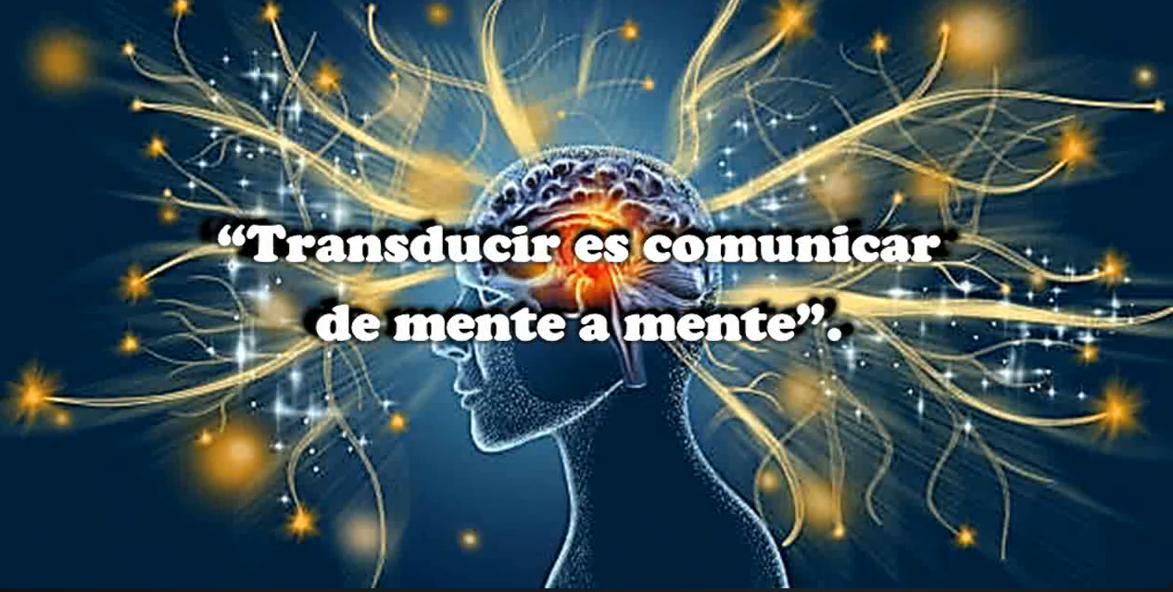
What am I doing right now? Transducing... trans...ducing is to communicate from mind to mind because the knowledge that was previously done by word of mouth, is no longer, because knowledge also evolves. And in this case, as knowledge also evolves, it is now placed from mind to mind, that is, a transduction. When we said to José Argüelles in Chile, who was there for forty-nine days, how are we going to communicate this? [...] Ah!, what a friend, how will it be... [...] and we learned it, we learned it. Thus, it enters your cells, it takes possession of your cells, it takes possession [...] of your senses, it takes possession of your emotions, it takes possession of your mind, it takes possession of your time; it becomes totally impregnated in you, always! Because this becomes impregnated with a form of resonance, the resonance is there, in the form of transduction.
“Resonant transduction, that is, the ability to understand information energy and apply this knowledge by passing directly from one existing, existential condition to another and consequently from one star system to another.”
What am I doing? You will say, “Oh! You […] an hour, an hour and a half of talking.” In the morning I was talking for about an hour, next Saturday and on Sunday, I have to give a ten-hour workshop on Saturday and a seven-hour workshop on Sunday. No, I don’t get tired. Do you know why? Because the form of transduction is energetic. To the extent that I am doing the transduction, I am charging myself with energy, more, more, more! So, it is a feedback, energy reaches you and you send me energy; thus, we are getting feedback with that energy.
That is what is learned with the 13/20, with the 13/20 frequency. It is like translating the language of energy every time it passes through a receiver/transmitter. That is in a direct form from one existential condition to another, that is, my existential condition transmits to another existential condition because I am another you, and you are another me. And as an Earth Wizard, that was what we were taught and what we learned, the one hundred and forty-four Earth Wizards, so that in order to graduate, when Argüelles arrived, he said, “How are we going to know that we are really Earth Wizards? Ah, well, simple, when you are able to create a rainbow.”
“Wow! A rainbow, but we are in the middle of spring, it is not raining, and the sky is super clear.” it was almost impossible. But what happened? One day before graduating, we all went out to walk, to sing, to dance, to enjoy that day because we were leaving the next day, after forty-nine days. And what happened? It got dark, it was already ten at night, and in Chile it gets dark late, at ten at night it was starting to get dark, and we were dancing. And when we started to notice, several of us fell to our knees crying: the first rainbow! And then... a second rainbow; we managed to make a Rainbow.
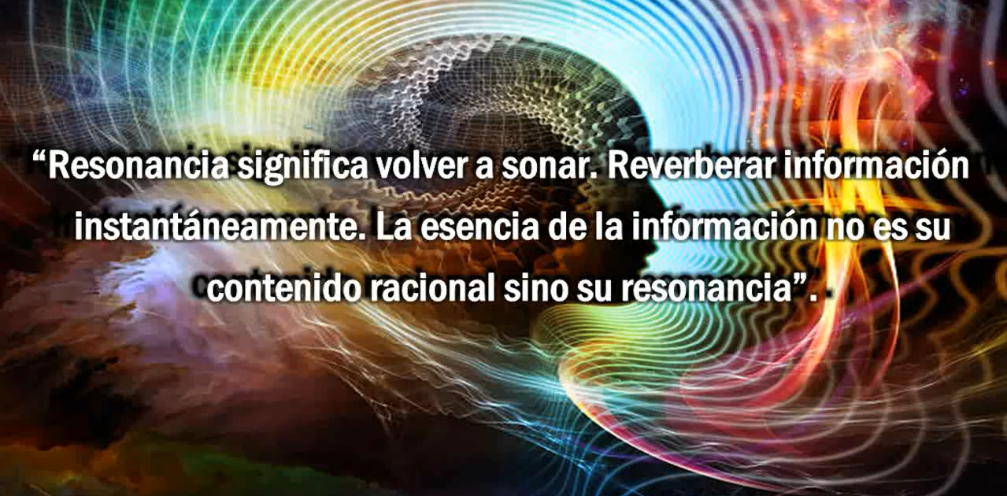
And you may say: “Oh, so what!” The rainbow is the covenant of GOD, we made the Rainbow… So, we really graduated as Earth Wizards. And that is what we are doing, charging ourselves with more and more energy, recharging our batteries. Yes, then, resonance means to resonate again. To reverberate information instantly, the essence of the information is not its rational content but its resonance. When someone tells me, “Oh, but I am not prepared” or “I am not going to understand.” It is good that you do not understand. And if you have not understood anything, wonderful! Why? Because it is better not to understand with reasoning and analysis with which we are accustomed to knowing things. It is better to perceive them, to let them enter our mind and our heart, and there they will do the work that is really needed. That is as simple as us [...] when we resonate. We resonate and the essence of the information remains, if not the resonance remains in us, and the resonance remains in you. I'm sure that sooner or later you will become super interested in this, some sooner rather than later, and others may take a little longer, but each and every one of you will train in that resonance, because it is cosmic. It is energy, we are handling cosmic energy resonating through the connection we have from mind to mind.
“When we talk about resonance, we also talk about frequency: the level of vibration of a frequency maintained for more than one cycle and tone. A sustained frequency can be said to be harmony, which is the synchronization of two or more tones of the five senses through producing unique tones. Focusing the lenses just as with a harp, information from different levels or octaves is transmitted. This is what Pythagoras called the Music of the Spheres: resonance. The Mayan civilization was based on the principle of harmonic resonance where what is intended is the universalization of consciousness within a gradual evolution. Obviously, it is different in nature and purpose from a civilization like ours which is based on the acquisition of material goods and the defense of the territory.”
Venezuela has the unique opportunity to have a government come to power that obstructed a number of things but allowed, through this material obstruction, to realize our true reality and get out of that apparent reality in which we lived. It makes sense, things don't happen by chance, they happen by synchronicity, and synchronicity is very powerful, and it happens by resonance. So, you are receiving resonance, synchronicity, through a situation that you are living that is not everything that we would like, right? But that is what there is.
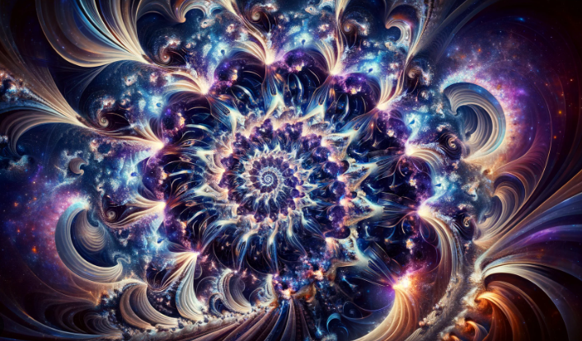
“The harmonic function of the number, called fractal principle, describes the capacity of a number to remain proportionally constant. It is through the proportion that the whole can be reconstructed and at the same time be resonant at different octaves. These fractals form a synchronization beam that we will talk about later.”
Which is precisely... the fractal. We are fractals, we, fractals of a WHOLE, that fractal of a WHOLE is... well, whatever you want to call it, Divinity, God, Energy... I don't know, whatever you want to say. So... you were receiving information, perhaps, as I was saying, you did not fully grasp the meaning of the words, but you did grasp the essence, which is resonance. Children up to the age of seven live in the fourth dimension, that is why they are happy; every day they are happy because they live in the fourth dimension, that is why they are happy. All children are happy because they live in the fourth dimension, and they handle the 13/20 frequency: all children.
Ah!, then we as adults, begin to tell them that they have to prepare themselves because they have to have a career to earn money, and buy a car, and have a house, and get married, and well..., a lot of things. But we don't tell them, "Hey, you have to prepare yourself because you have to know yourself internally, you have to [...] your mind. You have to restructure it and not be like the mind that we lead, you have to get out of this 12/60 frequency that is only mechanical-materialistic. You have to enter a more natural frequency so that your body can live happily and not get sick.” No, we don't tell them anything like that, you have to be more self-reflective, go more towards your depth, towards your inner part.

They connect very easily with their dimensional double; they see it! My son saw it.
“Hey dad, I was meditating and another Pedrito comes out! His name is Pedro Manuel, and another Pedrito comes out and starts dancing.” —
"And what is that Pedrito like?”
“Well, he looks like me, he’s exactly like me.”
It’s his dimensional double and he saw it with the greatest ease, without having to study anything, without having to tune in. He saw it, it’s his nature, and those children already have that intention and that intensity, [...] you have to... Ah!, you have to... before they are seven years old, so that when they reach seven years old you can guide them to know all this information and put it into practice.
This doesn’t mean that you tell them: “No!, the mechano-materialistic world is already [...]”, no, no, no, or in decline. You manage your spiritual world, and you manage your material world that is doing all the work. Ah!, perfect, then it’s fine. And you start to educate him, and you start to educate him in a function with a galactic vision, with a cosmic vision.
The Mayans had a very interesting vision about evolutionary development; they knew that there was no bad or good, that they were energies. Then they told you, "Well, if you use your energy to do harm, your evolutionary process stops; if you use it to do good, that is, to help someone, your evolutionary process is moving. If you use it for yourself to develop, your evolutionary process is moving, but if you use it for something that is not correct [...] karma, that is to say good and bad. You cannot classify, that is a concept that we have in our mind that we were taught: bad – good, black – white. It is the biphasic mind, that is what we all move with, a biphasic mind, when our mind should be analogical.
Thousands of possibilities!! Like the Sanskrit language: you say Ananda, you are saying Paradise, Heaven, beautiful, beauty, holiness... X, a thousand things in one word. So, Heaven and Paradise you live on Earth, and when we disincarnate, we leave this physical body, it is our space suit!
Do you remember the clothes you were wearing yesterday? No, you grabbed them and put them in the laundry basket and left them there, you don't even remember, they were washed, and you put on clean clothes. Likewise, when you die, you leave this body. Ah! This body is no longer useful to me, ready, now I am with my body without limits, with my body of merkaba, of energy.” Until I decide to take another physical body and then say, “Ah, I am going to take another physical body. Now I am going to do this, now I am going to do that or the other, to experiment.” And there you are evolving. Ah, but if you do it consciously then you are already moving forward.
I am not going to have a body of suffering because that is going to limit me in my evolutionary process. I am going to have a body that gives me balance, and if it gives me balance, I can then harmonize myself with some frequency that allows me to evolve by accelerating the evolutionary process [...] You consciously choose, “I come now like this.” And you realize, you come with your mind clean, pure, and empty, and then, it is easier to activate your conscience.
Consciousness... You don't have to be conscious, it is done. You simply have to activate it, because consciousness expands more, and more,... and more. That is, GOD lives in that expansive consciousness, and we also live with that expansive consciousness, to the extent that we are expanding it more, and more, and more, then we are going to evolve more and more. For that, we have to have the knowledge of our mind, and that is what we do not know. Then, if we do not know our mind, we cannot manage our ego, and the ego takes over, do you see? To do what it wants, and then you live a life based on ego.
And people don't realize, they think that this is life, "No, this is life, here I live almost happily"... or "I survive." No, no, you don't have to survive you have to live; you don't even have to live, you have to exist as a human being, and then existence becomes a collective existence where unification is the process that leads us to this unified consciousness. We unify your consciousness with your own consciousness. When we both unify our consciousness, our consciousness grows. We lose our personality, which is the ego, it doesn't matter, but we emerge in an individuality; we destroy our individuality, it doesn't matter, but we emerge in our universality.
And in that sense, it is why we are, "I am another you, you are another me." We are a collective consciousness. So, you are going to ask me, "Why is he my same mind? It is his mind." When you acquire your mind, you realize you have the same thoughts as him. “Ah, change the nuance a little bit, because of your life experience.” It’s the same, we all think exactly the same. “Ah no, I think differently.” What’s the difference? “Ah, I had more education.” No, but that’s a process of experience, it’s not that you think differently. Maybe, for [...] you think with a better intellectual level. Or, maybe that’s a difference, but the consciousness is the same. So, when we have that, then unification comes.
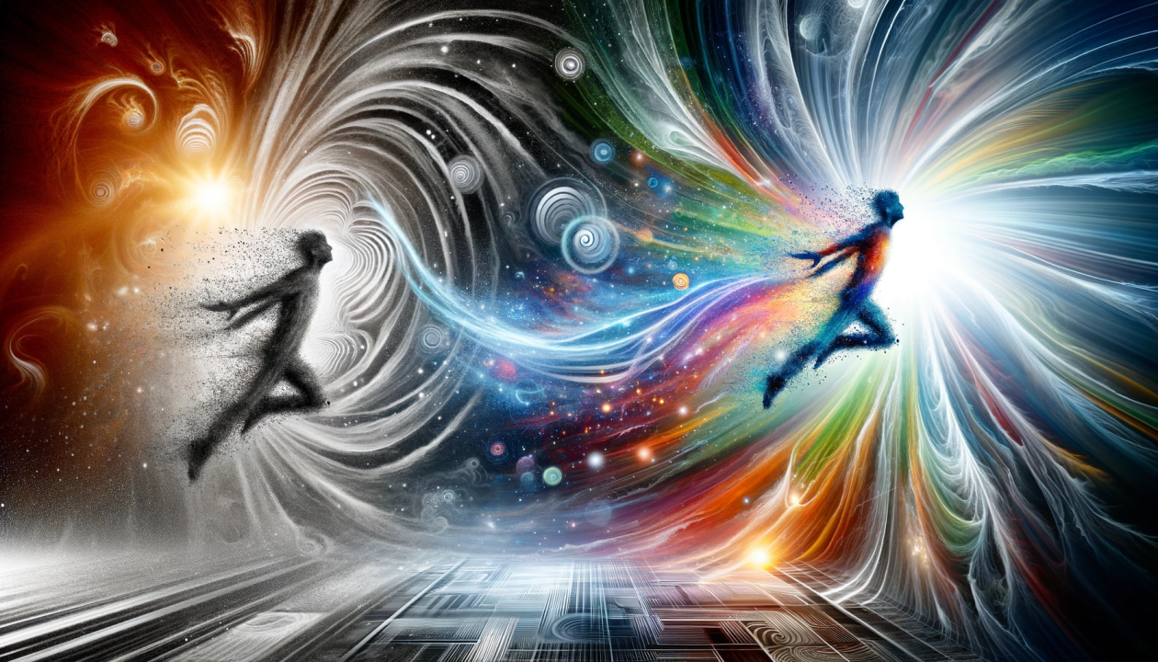
And how is the Earth going to make its quantum leap? Well, with a unified cell which is us. We, as a unified part of the Earth, make the quantum leap to a fifth dimension, which is the dimension of light. That is how we are, that is what we are going towards, and that is what we are. It is either sweet or salty. You cannot say, “Well, I am going to mix sweet with salt.” It will taste a little strange. Look, the 12/60 frequency is what keeps us chained. I would say to you, “Do you want me to chain you with just one hand?” You have to chain both hands. “I will free one of you. Yes, I will free you from one of the chains, but I am going to tie you with just one hand.” What would you say? “No, free me completely!!! Take the chains off of both hands, more than one.” Something similar is the meaning of our frequencies.
The 12/60 frequency is a mechanical-materialistic frequency, it is a frequency of slavery. The 13/20 frequency is a frequency of liberation. Now... Don't be confused, don't say, "Well, now, I'll sell everything I have, give away everything I [...] and I'll go live the 13/20 frequency." No! Wait, it's not like that, you are going through a process of change. Every day, you are understanding more, and more, more, and more... And you don't need to leave anything. You realize that now, with what you have, it's enough. You don't need more, because what we apparently required is not true, it belongs to an imagination of our mind.
Our artificial reality has made us ask and ask more and more and consume more and more. No, we have to see our reality that is not apparent. We lived in an apparent reality, now it is a genuine and authentic reality of each one of you. I cannot tell you, this is the reality, because that is my reality. Your reality is the one you began to live. When you live your own reality, it is combined with my own reality and they unite, because it is an egalitarian reality, but you have to live it with my own reality. Now I can unify it with Pedro's, but you decide. Now I can unify it with another sister, now I can unify it with another person, but it is free will, their will to decide. We are going to unify this and that, the car together, to make the Earth ascend, among all of us, one person alone cannot.
If we are going to push a car, just one, and it is uphill, it will cost us. Ah, but if thirty or forty of us came, we will push up the car quickly. So, similarly, we have to use a 13/20 frequency, which is the natural frequency of the Earth, which is the frequency that we forgot and lost. You recover your memory! Or do you want to recover your memory halfway? "No, I am only going to recover a little bit." No, you have to recover your memory in its entirety, completely. And that is where the state of decision comes in. I cannot share the frequency 12/60 and the frequency 13/20. No, the frequency 12/60 is discarded and you live: thus, the fullness of what you have, of what you live, of what is happening, but you then realize it. As long as you live in the frequency 12/60 you do not realize it! You think that this is what it is, that this is your reality. Use the frequency 13/20 in its entirety.
That's the change! That's why we didn't advance in our evolutionary process no matter how much we... I tried very hard, four or five hours..., six, seven, or eight hours of yoga, meditation, fasting, cleansing, abstinence, everything, and I didn't advance, and I didn’t advance. What am I doing wrong? What? I behave wonderfully with people and everything, what am I doing, what am I doing wrong, what am I doing wrong? Well, I didn't do anything wrong, I just lived in the 12/60 frequency, and I never realized it.
When this frequency appears I see, immediately, the same instant that the frequency appears. I remember. "Ah! Hey, that's why...I used to do yoga, and not now, in past lives.Ah! I who [...], I used to meditate, of course, that's why I love meditation! Oh, but now I'm realizing, now I'm remembering." These memories... there are so many, they come back to me, and they come back through the 13/20 frequency. Thus, that process must be unique, you cannot handle their frequencies, because they are not compatible. It is as if you were to mix oil with milk, it would taste horrible, it could not, they do not mix. So, these two frequencies do not mix. They even repel each other, because one is genuine, authentic, true, and the other is outdated and artificial. It is based on a quantitative calendar and the other is based on a qualitative synchronization.
So, what do you want? The quantitative or the qualitative? We see that the quantitative did not work. The qualitative begins to work with us because they are inherent qualities of what you have as a seal and as a tone. I am a yellow magnetic human; I have the power of influence; I have the power of free will; I always liked to attract wisdom and do my will.
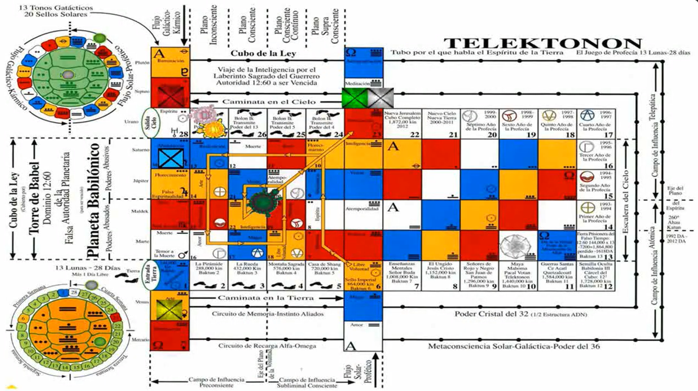
Thus, everything is working so that things happen in a sense of reality, of true reality. No [...] what are they going to do? The simplest thing in the world, look, this information was put into games. And when I asked him, hey, why in games? It is a way of learning. If you start to study this, forget it! It will seem, well, unattainable, [...] it is handled. But if you do it by playing, the knowledge enters more and more, and you understand, "Oh, now I get it! Now I realize what is happening!" Because you are doing it [...] For example: I told you at the beginning that José Argüelles showed me the Telektonón, he said, “This was sent to me by Pakal Votan.”
“Oh, don't tell me! What do you mean he sent it to you?"
“No, no, no, and [...] in the early morning to make my move in the Telektonón which is the second level, after the Dreamspell.”
And, as I began to play, the dreams I tell you about began, the revelations. And they continue every time I see it; they come more, and more, and more, and more, and more, and more, and more, and more, and more. They don't stop, just now when I was in the fraternity, someone came and said to me, “Are you Pedro?”
“Yes.”
“Ah, I'm listening to you with the Red Master, it's another Master of the Fraternity.”
“Ah, that's good.” I said, “It’s good.”
“I like it a lot, this information makes me feel…”
“Hey, it's good that you're taking it. Go ahead.”
And you're not carrying it out, but only the information that I'm transmitting to you. Now, I give you the 20 seals and the 13 tones and I tell you: every day there is a seal and there is a tone. Meditate on that seal and on that tone. Meditate on it, a minute if you want. You don't have to see, you don't have to do it for hours, just look at the seal and look at the tone. Boom! the connection is made, and you'll realize [...].
For example, let's suppose today... Let's not suppose, today is [...] Harmonious Skywalker, okay? What is the energy that moves today? The energy of [...] spirituality moves, the energy of revelation moves, the energy of prophecy moves, the energy of leadership moves. And what was the first thing I did in the morning, at seven in the morning? At six in the morning when I got up, I went to the Fraternity to see if I could transmit this from there, and put up a display for you. The tone is the harmonic tone, it is the tone of command.
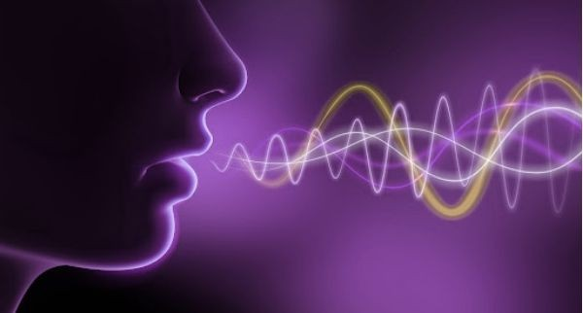
I arrived at the fraternity and, “Hey, I’m coming to the Cosmic Ceremony,”
He says, “No, it’s at ten.”
“Oh, it’s eight.”
“It’s not at eight, because it’s two hours difference with Caracas.”
“No, it’s at ten.”
“So then?”
“Well, come at ten.”
“No, I can’t come, I have a backpack, and I want to ask you to put up a banner to explain what’s going on at today’s workshop.” And he wouldn’t let me in. Ah!, today is the tone of command, that is, I have to command things.
“Hey, come down and open the door for me please.” And he came down and opened the door for me, because I was handling today’s tone, which is command, and I was handling the information of the Skywalker, the spiritual part. He felt spiritually, that he had to open up, and he couldn’t leave me outside; he came and came down, and opened it.
So, you handle the... That’s an example, right? Like the one I put up where I saw “wait”, well, that’s part of what we’re going to see. It’s, ‘come’ the seal and ‘come’ the tone of today. Today the seal… For example, tomorrow is going to be “Magician”. Tomorrow is a day of enchantment, of magic, of meditation, of time without time, and Rhythmic is double power. What can you do? If you are asking for something, tomorrow you will surely get it, because you are going to use the magic of the Magician. If you are going to undertake some movement, some trip or some business, whatever it is, it will give you results, because there is magic. But you already know it, today is the Rhythmic Magician, it is directed by its double power, then, you shape it. You ask for it, we are going to give it to you! The energy goes down; you are using the energy.’
I am saying this in a material sense, so that I can be understood, but you can do it in another sense. Today I want to realize myself as a woman, as a person. Today I want to heal myself from this, and you ask for it. The seal brings an energy extracted from the sunspots. You attract a communication, and when you meditate, it will enter you, the seal and the tone. You will vibrate with the tone at that frequency. It's that simple, just look. How long will that take you? Not even three minutes, and every day you do that, and I will send you a little more. Well, now here's this more, and here's another little bit more. And you'll say, “Hey Pedro, this and that, and the other thing is happening to me, and I'm happy, I'm content! Look, I'm... Well, I want another workshop.”
Because that's how it is. I'm constantly giving workshops, and here there are a lot of people who taught this about 13 moons, but they weren't magicians of the Earth. So, well... —I taught, there's no way around it. I already taught a small group and I'm leaving now. —No, I told him we have to give seminars for Earth wizards, why? To convert more Earth wizards. —Wow! I like the idea. And people want to be an Earth wizard, just like you, you decided to be an Earth wizard because you are receiving information from an Earth wizard. There is a direct transmission. That is what I want, that you, through the information that is coming to you, keep doing it. You don't have to follow Pedro at all, you have to follow yourselves. How are you going to follow yourselves? Well, by practicing, like a game, and there you are assimilating the information, remembering. Every day you remember more, and more, and more. —“Wow, this man was right, now I remember this, I remember that.” And you are going to find yourself with situations of remembrance because your memories, [...] little by little.
Time has [...] instantly, frequencies start vibrating [...], which is the 13/20 frequency. We were taught the fear of death, we were taught... We are a society of fear, as long as we are in a society of fear, everything is forbidden. When I was young... I did things like yoga practices, swallowing a bandage, three meters... I did things. “That is forbidden”, doing mantras... “That is forbidden”. It is forbidden for people who do not dare to discover themselves. Let us remove all fears, there is [...] nothing; you will find yourself. When you find yourself, you will find your partner, and your partner will teach you love, and more love, and more love. And the counterpart of love is fear and [...], forget [...] and get rid of fear. We are then ready and prepared for a change.
There will be a change of consciousness and a mental change. There will be a lot of things that you will see and that will horrify you of what you were, of what you were, “Well yes, I was that, but I am not anymore, I have already removed the fear and all that, that has already disappeared.” When there is no fear, everything comes. And love is energy and information. Those three things happen like that. Love is a science. It is not an emotion, forget it, there is no precaution. Ah! You go directly to the objective, which is to find yourself, through a good frequency, which is the 13/20 frequency. You do not have to be careful about anything.
I have had, together with my wife, beautiful and wonderful experiences of telepathic issues, of listening to inner voices internally. Who is it? I am Pedro, oh. Why are you going to be afraid of yourself? “Oh, no; no, no, no, it is that no... I had never had this experience.” Well, if you want information, well here it is. You cannot be afraid of yourself.
So, there is no caution about anything; there is a sense of living in happiness [...]; it is bringing Heaven to Earth; bring Heaven to Earth and you will see that nothing will happen.
Well, I think we are finished then because it is already raining here, and it is making a lot of noise and it will not be heard very well.

Superior Course in Theurgy, By the Ven. Master T. A-O Domingo Días Porta
All Rights Reserved

