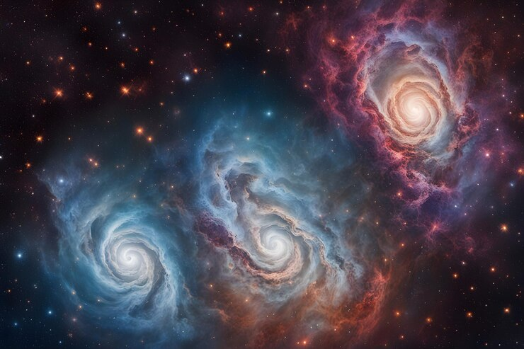
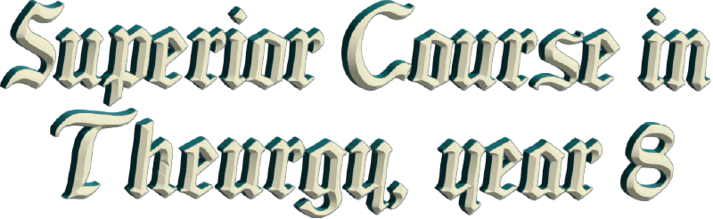
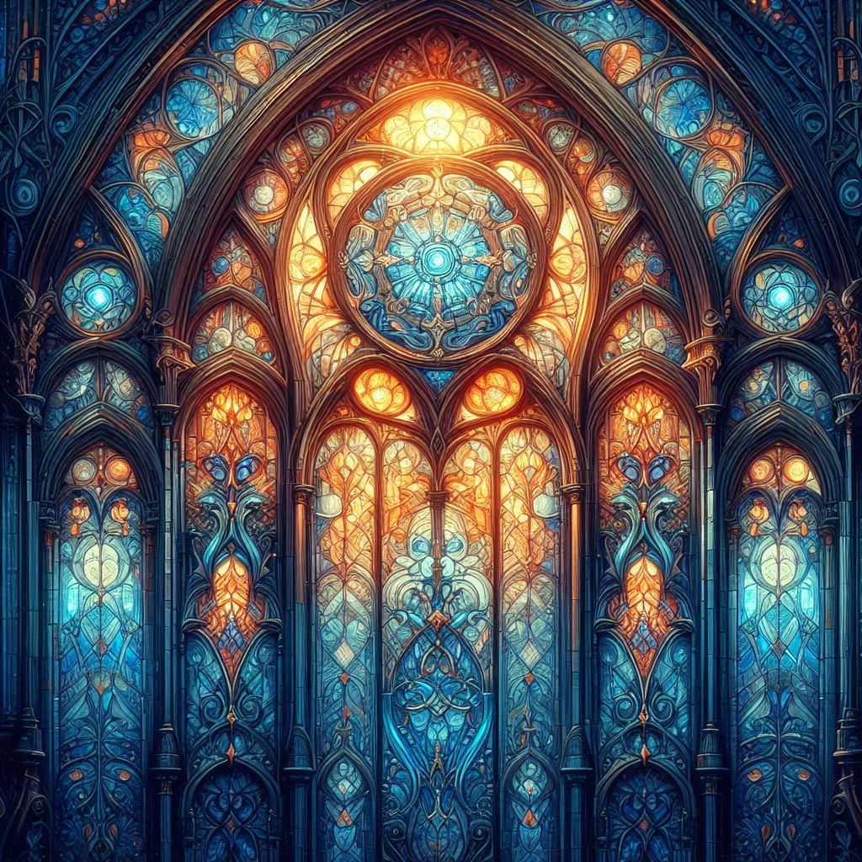

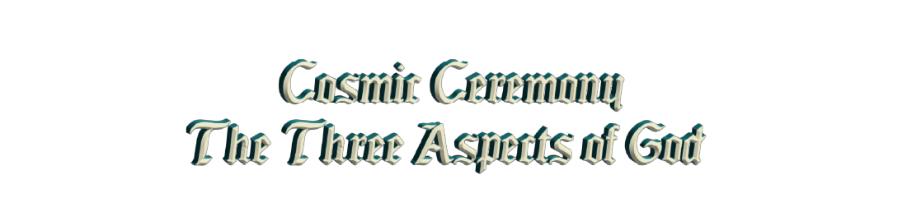

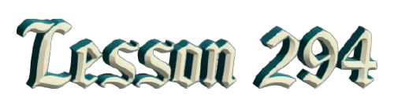
By Ven. Master T. A-O Domingo Días Porta

D
Don't pray too much, prayer is quality, not quantity. Just by praying for an hour, doesn't mean that GOD has to... No! There has to be purity of mind, intention, spirit. Prayer, even if it's just a word, reaches Heaven. The Ceremony is called "Cosmic" because each part of the ceremony corresponds to a planet, and there you vibrate with the energy of each planet. The planets are spirits, they are entities; they are not a bit of earth going around, but light is there, they are the seven archangels.
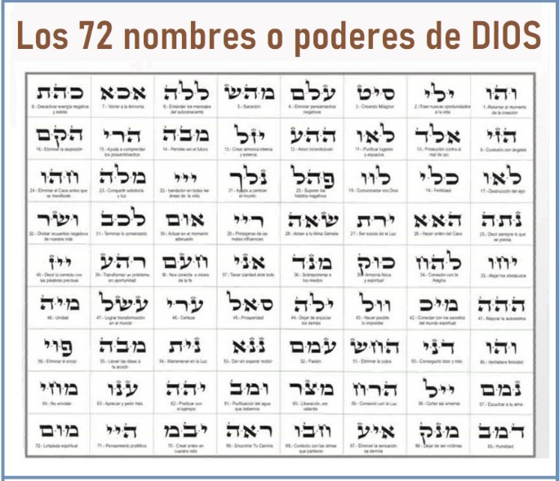
Also, Cosmic Ceremony because it is based on Nature or open (by a window) so that the sunlight enters, not closed in a... And cosmic also because we must elevate our mind towards the infinite, towards Heaven. As I explained to you yesterday, that the Wisdom of GOD is written there, it is the Gospel of GOD, the fifth Gospel, which we must study. So, your participation is to be attentive, not to be distracted, not to turn around, not to converse, but with an elevated mind following the parts of the ceremony. As it is a Theurgy ceremony, the Work of GOD, then the ceremony begins directly connecting with GOD. With a prayer that is said in French, the Prayer of the 33 Taus. 33 Taus means that the phrase of the prayer begins with the letter T. It is pronounced in French because it has a rhythm like a mantra, translated into Spanish it would no longer have that force.
That prayer comes from the time of the Druids, of the Masters in Europe when the people lived in nature. They were indigenous people, they did not have large cities, the communities lived in the forests, just like here, our indigenous people. So, the Druids were the masters, the Celts were a people from a certain part of Europe, and the Druids were the wise ones, the Masters. And this prayer, then, has been preserved in French to maintain that rhythm. That prayer is almost like a mantra. Those who do not know French, then visualize that you are elevating yourselves to GOD and visualize the Attributes of GOD. GOD has 72 names, that is, 72 powers: Merciful, Generous, Kind, Sublime, in short... That should be studied. Later we will see the 72 names of GOD, according to the Hebrew tradition that comes from Ancient Egypt: 72 attributes.
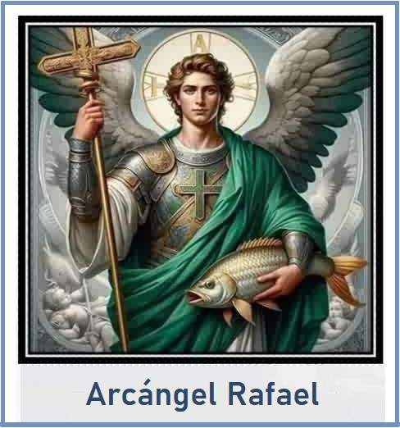
There are 72 hierarchies of Heaven. The Government of GOD has 72 Choirs, well, 72 members of the Celestial Choirs. The Choirs are nine choirs, nine archangels, nine angels, nine seraphim, nine cherubim, nine potentates, nine dominions. There are nine choirs, each choir has eight members. There are eight archangels, eight angels: therefore, 9 x 8 = 72. Each archangel and each one of them, the name they have is one of the powers of GOD, one of the names of GOD. Just as Archangel Raphael is not Raphael, the common name in Hebrew (Rāp̄āʾēl) Rafel, Rafel means: “Medicine of GOD”. This archangel handles GOD’s gift of spiritual medicine, which Christ used with the assistance of Archangel Raphael.
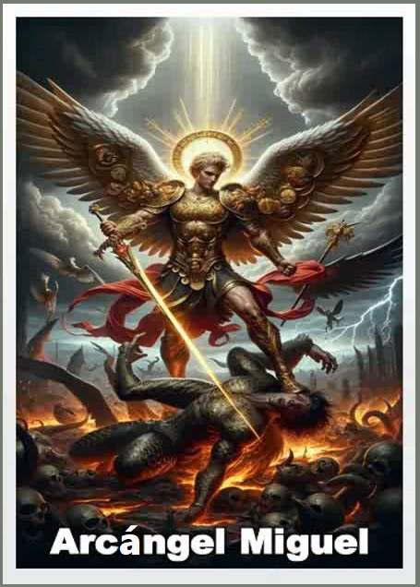
Archangel Michael, [Mī-khā-'Ēl] protector against evil, has a sword, vanquishing evil. So, it is not a person's name, Archangel Raphael, Michael, Zadquiel, etc., They are attributes of GOD, like saying, Minister of Agriculture; it is not the name of the person, it is a power that he has, a function. Well, we will see that later, so, let's start.
As Master Jesus said, "The day will come when you will worship the Father in Spirit and in Truth." Thus, we connect directly, and in Communion, just like in the Catholic mass, we ask for The Word for Communion and the priest gives The Word.
The Word is what establishes Communion in the Eara of Aquarius [...]. It is no longer necessary to feel the bread, the host, we have already completed that stage of two thousand years and now we enter the new "dispensation", as the Bible says. In the New Era, which is of the air, we communicate through the air: telephone, television, airplanes, the era of water. The Era of Pisces from Christ onwards, was communication by sea, maritime transport, naval empires, battles at sea, discoveries by sea. Not today, we are in the era of air; it is obvious! That is why the communion is direct, without the Eucharistic species. Of course, to participate in the ceremony you have to study what spiritual magic is in order to do it more consciously.
Just like the Catholic Mass, the Catholic Mass, the whole process is to prepare for Communion. When one receives the host, the Mass ends. It closes, because that is the idea, to arrive at Communion. And in the Cosmic Ceremony, the same. After Communion we do the song of gratitude, in Latin. It is a Gregorian chant, the Tantum Ergo, and it closes; the lights go out, the books are closed, the ceremony is over, giving thanks. So, it is based on knowledge, each part of the ceremony corresponds to a planet.
The first part, which is said in French, the Prayer of the 33 Taus or 33 phrases that begin with the letter T. TOI qui est feu= YOU who are fire; TOI qui est Lumiere= YOU who are light; Toi qui est flamme= YOU who are flame... That creates a rhythm, but if you translate it into Spanish, it doesn't sound the same: YOU who are flame, YOU who are light, YOU who are fire. It doesn't sound the same as: Toi qui est feu, Toi qui est Lumiere, no. The sounds in French come from the Druid language; the language of the Druids, of the Celts, which is a language like Latin, a sacred language.
Well, if you have any questions about the ceremony or the elements, the symbols... Everything is studied in the ceremony, the movements of the celebrant, etc. The Catholic mass used to be done facing the altar with the back to the public, now they do it facing the public. But traditionally it is done first towards the sky, up high, because the public has no spiritual power. It has to be towards there, and from time to time it is directed to the public to send, depending on the part of the ceremony, a blessing, a force, a light. Well, I don't know if you have any questions, any doubts, any concerns.
Yes, each person can have an oratory in their house, a little corner where they concentrate their spiritual energy. There they say their prayers when they wake up, before going to bed they give thanks, and then, that generates energy. For example, you walk through the dining room and your stomach jumps, because there is an energy of nourishment there. You walk through the kitchen, and you feel like igniting and doing something. You go to the living room, and you feel like turning on the television. Each part of the house has a power, an energy. You enter the bedroom, and you feel like lying down for a while, relaxing. And the oratory elevates our soul. When you walk through that little corner, even if it's just a bow, that generates a power. Most houses generally don't have that now. They had their chapel before; it was customary in the family to have a place with the saints, the image of Christ, and they prayed.
Now houses are materialistic, the spirit has been thrown out, no longer... Before the garden was inside the house, now they have thrown it outside, it is a hindrance to the house; and before, the garden gave purity to the house, the flowers, the birds, the butterflies; not, now... And sometimes they take away the garden to put the machine, the car there, to park the car; there is no garden anymore... or it is abandoned. So, that spiritual culture is missing.
Well, to participate better in the ceremony, in the second quarter we are going to do the practices: what the ceremony consists of what it is based on, any ceremony. All the ceremonies that are done today come from very long ago, in ancient times there was knowledge. Today people go to the Catholic mass or evangelical services without culture, without preparation; therefore, they do not participate well. Although I see that people are already more prepared than before. When I go to mass in the little church near-by, I see that the people who attend know the prayers well and support the priest. So, they have been... people are more informed now. Something has been lost and something has been gained.
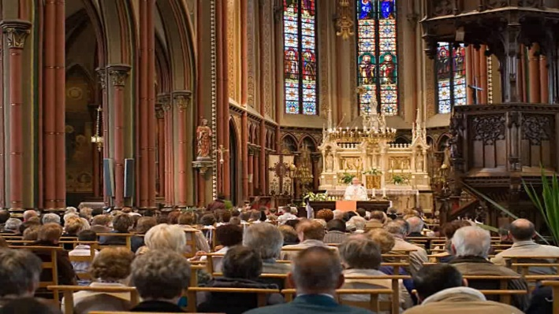
The Catholic Mass has a power, I have seen it when I go to Mass and observe. One of the powers it has is collective prayer; there are 100-200 people, all praying together, that generates a great spiritual energy. And the service itself... As one who already knows who sees what the priest is doing and realizes the steps that the priest is taking at that moment. Just like one here, when one takes off the pilgrim emblem and puts on the stole, the talisman, one is no longer the person, one is an instrument of GOD.
Priest means “mediator between Heaven and Earth”, an instrument. And when one finishes, one takes off the talisman and becomes again the pilgrim, the human being walking through life. And the priest in the Catholic Church does more or less... Some priests do it very well, others don't put much effort into it, but the priest who has studied and has meditated and everything, knows how to position himself as a spiritual instrument. And with the evangelists, well, what I have experienced it in Caracas. When I lived in Caracas, my godfather became an evangelist and he invited me to the services, and I saw that the pastor really concentrated well when he prayed.
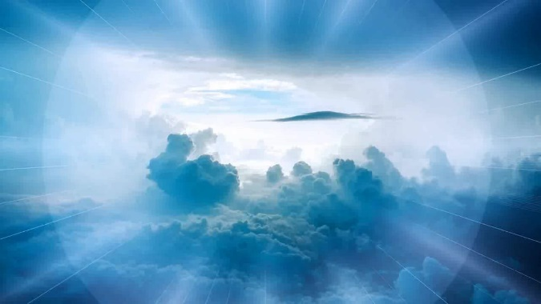
And thus, in any religion, the one who studies and understands, receives a light. GOD is not the property of any religion or of any person, He is for everyone; for sinners, for saints, for the elderly, for children, for beggars; He is not the private property of anyone.
One has to study first the word, the origin of the word, demiurge, which comes from Greek. it means “maker of worlds.” GOD in his stage of creator. Because GOD is not only creator, because some say: since GOD created the world, he has nothing more to do, because he has already created. But he is not only creator, he is also a sustainer, and he is a transformer or destroyer; he creates a world and that world one day disappears. GOD has three facets 3 x 3 stages: he creates, conserves, and transforms or destroys. In India it is called Brahma, Vishnu, and Shiva. Brahma the creative aspect of GOD. Vishnu, which is like saying, the Christ, the one who comes to conserve, to protect the Work of GOD, the Theurgist.
And Shiva, the one who destroys one civilization so that another may come. That is, he destroys childhood so that adolescence may come, he is transformation. People say “destroyer,” but he is a transformer, he transforms. One goes from one age to another, one is transformed. One no longer speaks like a child, one no longer speaks like a baby, one no longer walks like a baby, one no longer crawls, one is transformed. The baby, now..., that is already dead; I am not even interested in what I did as a baby, etc.
So, the Demiurge is the aspect of the Creator, of Brahma, in the religion of India. In the Christian religion it is GOD the Creator, “In the beginning GOD created the worlds, the beings,” says in the Bible, in Genesis. But before, “The spirit of GOD floated upon the waters.” That is another state, that has another name, GOD has another function there. It is like the human being, the human being... [First] Son, then Dad, then grandfather, then great-grandfather, but it is the same person.
And so, GOD, is in one thing, he is in another, and he is in another. He is in tigers, he is in birds, he is in butterflies, he is everywhere; he is in oneself, but in different functions. Thus, the prayer to the Demiurge is used in the aspect of the Creator God. So, the Prayer says, “Oh! Demiurge, ècoute moi...” “Oh! Demiurge, listen to me…” And so, the prayer goes, sliding, “YOU who are light, YOU who are fire, YOU who are flame.”
So, when one receives the priestly ordination, one receives a mystical name, a secret name, but only for oneself, which is what one uses in the ceremony; one introduces oneself with one's secret name.
Well, there are several things: when one pronounces the mantra to open the ceremony, one pronounces the mantra OM TAT SAT. Om tat sat, is like saying Father, Son, and Holy Spirit, but with mantra, with the sound of power. Father, Son, and Holy Spirit does not have that force as when one says OM TAT SAT! It is The Verb, that reverberates in the spiritual world.
So, the Universal Prayer says, the prayer to the Demiurge, it says, “Oh! Demiurge, ècoute moi…” “Oh!, Demiurge, listen to me.” Now, from the beginning of the ceremony one connects with GOD, with his power of creation. ‘Eternal Demiurge, Infinite Demiurge” —undoubtedly, we are talking about GOD— “Unique Demiurge (one God), Strength, Justice, Love.” These are attributes of GOD, they are names of GOD, but they are powers of GOD, “Help me. YOU who are flame, YOU who are fire, YOU who are light, protect me.” One enunciates the powers of GOD, and one connects with GOD by saying protect me, help me, listen to me. One creates a little bridge; it is not the God lost over there, and one the poor mortal here. No, a communion is created by saying this.
“YOU spiritual and eternal substance, Perfect Being, ungenerated” —has not been generated, has not been created, has always existed, is beyond time— “immutable (always the same), who are without beginning, without middle and without end, and who eternally engenders Himself.” He is not static, he is constantly in his infinity. HE is discovering things about HIMSELF because as Master Estrada said, “GOD is infinite in himself.” HE is discovering things about himself at every moment, because HE is infinite in himself. HE is not bored, “I know myself well, now…” No! He is in a constant adventure, himself discovering himself…
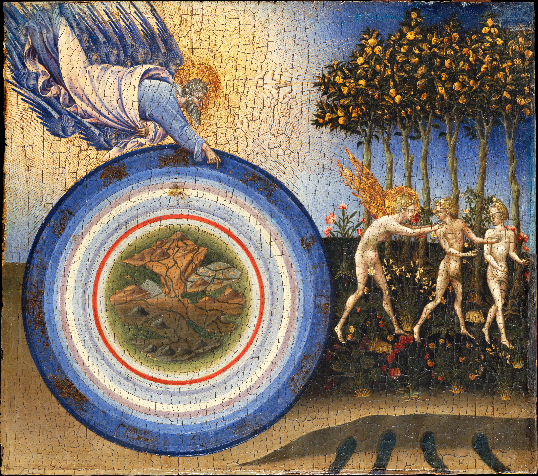
“YOU, sublime architect” —because as creator, he builds worlds, universes, galaxies, atoms, beings— “who by the effect of your will, bring the entire Universe out of nothing.” Before there was nothing and then... In the desert, when it rains, plants appear, and there was nothing there. So, Creation, which is relative, because when one studies, we are no longer told that it is Creation. How do you call it? Manifestation: it manifests. One day the Earth will disappear and one day the Earth will reincarnate again; it manifests and it unmanifests. It is said in India: the night of GOD, “the night of Brahma.”
When the Universe disappears, it enters into rest. The new day arrives, then, the day of GOD, what was there manifests itself. The Universe that disappeared, it was kept in GOD’s archive, his little trunk, and when the dawn of GOD arrives, then HE brings everything out again. Then, everything that has been stored comes out, the little animals, human beings, the stars again, because there is an eternity.
So, nothing can be destroyed, it is transformed. What we do at night, in a small way, eight hours sleeping, is done in the Universe countless times. Billions, trillions, quadrillions of years; the night of GOD is vast. And the day of GOD arrives, billions, trillions, quadrillions of manifestations that the Universe lasts. A time that does not fit in the human mind because it is the time of GOD. HE is eternal. His time does not have hours, minutes, but when HE enters to create, then the law of time is established, the law of space, for the worlds, for the beings.
“YOU are the axis of the Cosmos and the pole of the Cosmos.” GOD is the north pole, the south pole, and the axis that unites the poles. North Pole, South Pole means day-night, spring-autumn, winter-summer, etc. They are the poles of life. But HE creates these poles, and at the same time, he has the axis that keeps them together. They are not separated. On Earth we have the North Pole and the South Pole of the Earth, and we have a continent that unites the two poles, which is America. America goes from the North Pole to the South Pole, the other continents do not. Only Asia reaches the North Pole, but it does not reach the South Pole. The only continent that unites is... And the Earth, inside, has the axis, the magnetic axis that unites the two poles, which is the backbone of the Earth.
It says, “YOU, the original and permanent cause of all things.” So, when one studies, “Ah! I know that YOU created...” YOU are the cause of the weeds, YOU are the cause of the storm, YOU are everything; HE is the great culprit of everything that happens, GOD. So I say to GOD, “Hey, YOU are guilty of,” and HE laughs. “YOU are the Lord, the Master and stabilizer of the worlds.” HE maintains the universal balance, so that the Earth does not collide with another planet, etc. There is a power of GOD that keeps everything in its place; the Earth has its orbit, Mars has its orbit, each one in its place.
“YOU are the Master of the entities of the three worlds.” HE is our educator, our Teacher, the Supreme Master. Master Jesus came in the name of GOD; he was a human teacher who represented the Great Universal Master. We can say the same about Buddha, the prophet Mohammed, in short, about Quetzalcoatl in America.
“YOU are the inexhaustible source or fountain of life and intelligence.” That gives one faith, it gives one strength to know that death is not death. Thus, you no longer have that thing stuck in your head, “I could die, my father could die, someone could die…” No, because one knows that GOD is the creator of life. No religion says that GOD created death; so, death does not exist from the spiritual point of view. It does not exist, but rather an idea that has been put into people through ignorance, through not studying the science of GOD. Well, so it continues... “I am Yourself.” There comes a moment... “Je suis Toi meme.” One discovers GOD in oneself, and if He is everywhere, He is in me.
So, I have feelings, that comes from GOD; I have thoughts, that comes from GOD; I have desires, that come from GOD. Yet one is contaminated by the world of appearances, and desires becomes a negative desire, let's say, for liquor, for this, for having money. But when one is purified, the desire becomes a sacred desire, a desire for others, that there be peace in the world, that there be no more war, that this, that diseases end, etc.
“I see you everywhere, I feel you in all places. Your verb is the harmony of the worlds and the heavens. YOU are everything; YOU are life, YOU are death; YOU are the void, YOU are the plentitude; YOU are the darkness, YOU are the light; YOU are the silence, YOU are the sound. You are above, below, to the right, to the left, from the center to the periphery; YOU envelop the infinite, and the infinite is full of YOU; YOU embrace and contain everything; YOU are the ALL that is ONE. Oh! Demiurge, Oh! Marvelous Silence.” At that moment one becomes silent to feel all of that.
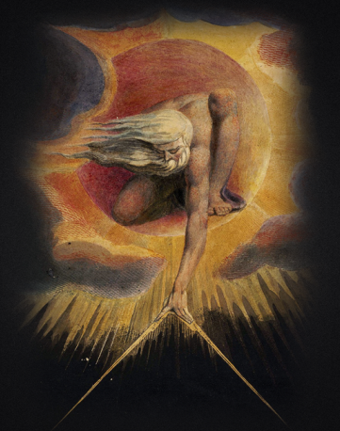
Then, the word demiurge, when Christianity came, they denied it. They said about ancient religions, “No, that is paganism, that is not useful.” So, the word demiurge was taken negatively, the word... Whatever they found, from the ancient religions, “No, not that! That is sin, that is from the devil, not that.” And then the word demiurge was attributed to what Christ said, ‘the king of this world, the god of this world is not the true god.’ People worship power, money, possessions; that is the god of this world. It is not a man who is out there, He is inside one, just as the true God is inside one. People have many false gods: pleasure, money, this, that. That is the king who rules this world, until what is asked for in the prayer of the Our Father comes.
How do you say it? “Thy kingdom come”, but GOD says, ‘No, I am not going to give you that kingdom right now, because you are going to contaminate it. You are going to dirty it, you are going to start your war and your fight.’ So, for GOD to say, ‘I can give it to you because you are my children and I would like to see you happy, but you have to meet certain requirements then.’ For GOD to put the Kingdom on Earth you have to live in peace, you have to do this, this, this.”

Superior Course in Theurgy, By the Ven. Master T. A-O Domingo Días Porta
All Rights Reserved

