
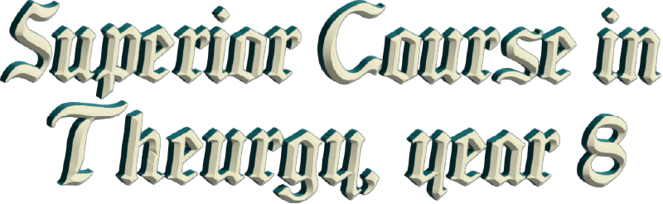
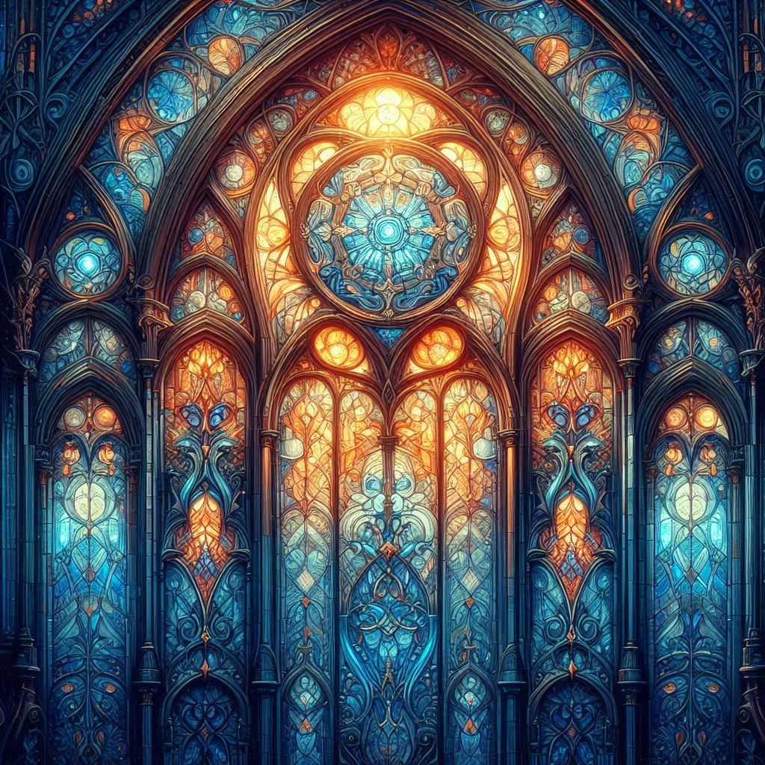




By Ven. Master T. A-O Domingo Días Porta

T
he power is within us, everything, the ancient principle says, “The universe is mental, everything is mind.” Everything depends on here, not on the outside. It doesn’t depend on the bank… it depends on how you use money; it depends on here. And thus, health, “No, I’m healthy, I can stand drunkenness and so on.” Yes, but… wait a few years. As they say, “I’ll wait for you on the way down.” And there are people who gamble with their lives and that’s very sad, isn’t it? For a silly thing for… There are beggars who are respectable.
When I was in primary school in Maracay, there was a... On the way from school, from home to school through the square, there was always a beggar there, with a little white dog that belonged to him, begging for alms or sleeping off his drunkenness. My classmates wanted to - when he was asleep - kick him, bother him, and run away. But the dog didn't allow it; he defended him.
"He's a drunk!" my classmates would say.
“No” I would say, “No, he's a good man.”
"How do you know he's good?"
“Because the dog protects him, he goes hungry with him. If he were a bad man, the dog would have already left him.” "What was I doing there?"
But he was a good man who shared what they gave him for food, what he got, with the dog. And I saw, I saw his face. I've never forgotten it. I would like to be a painter, how his eyes shone; he was good.
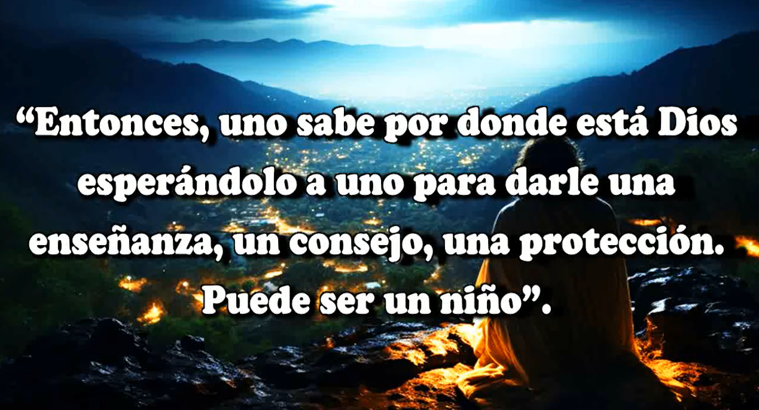
One time, he begged a woman for alms, “Shameless, drunk, why should I give you money so you can go and get drunk, degenerate.” And he looked at her like that... he looked at the sky, he smiled. While she gave him a barrage of insults, he smiled, as if to say, “Yes, it's okay, I'm a drunk, but...” I say... As a child, I thought, could it be that God put him in my path so that I would know what drunkenness is? He's a teacher; he's teaching me what I shouldn't do. He sacrifices himself for me. So I saw him like that, like a teacher. That's why I never forgot him! Here I have him: the man with his cute little white dog. There was wisdom there. So, one doesn't know where God is waiting for one to give a lesson, advice, protection; it could be a child.
Once when I lived in Guadalajara, when I was a guru. I dressed in white, I had a long beard, long hair. In the square a child came up to me and said, “Hey, are you God?”
I told him, “No, I am a son of God.”
The child ran out, “Mom, he is not God, he is a son of God.” He betrayed the mother who sent him to ask! “Mom, he is not God, he is a son of God.” The child served as an intermediary, so that the mother would not expose herself to me. Why didn’t she go out and ask? No, she sends the son to get a scolding, a slap on the head, right? And the child, of course, then learned that there is a son of God. When he is an adult… Well, yes, that was in 1970 or so, 47 years ago. That child is already grown; he would’ve been seven years old, so he is fifty-four years old. That child would remember as an adult, “A man that I saw that my mother thought was God, and that he was a son of God. “What is that about, a son of God?” He would surely seek a spiritual path... or become a priest. Who knows, a monk, with that memory! it would serve as support for him.
Like the drunkard, the drunk beggar, well for me it was a moral lesson. I never drank liquor. At Christmas and New Year my father would insist, “A little glass of punch, cream, a little glass.” Yes, okay.” I liked cream punch. At that time parties were held at home, so in my house when there was a little party, they would give us a little glass of cream. And I liked it because I like thick drinks, milkshakes. When I prepare everything, I put Cerelac in it, so it is thick. If I make coffee I put Cerelac in it, and ever since I was a child I got used to it. That is why I liked cream punch, not because of the liquor. I grew up and I never drank cream punch or anything else. Then, my father... Since I became a vegetarian, I eat papaya, orange juice, and fruit juice that I accept with fondness.
So, life is a school. GOD created the Earth as a university. We came out of light, we came out of GOD, and we lost the light so that we could learn to study. Because at the beginning, when Humanity was created, it is like when one is at home, as a child. When one is a child, one is on a scholarship, one receives free clothes, free shoes, free food, free lodging, free housing, everything. And when one comes of age, well, “Son, from now on, your scholarship is over, you have to help your family, you have to work, you can study but you also have to work.” So, when I was twelve, I learned to bind notebooks, and I earned a little money. And when I was fifteen I had my first job at Avensa, an airline that existed before, not as an aviator, but in the office. When I was fifteen, I learned to earn a living, to struggle.
Thus, Humanity was like that at the beginning, a childlike humanity. And in that paradise, they didn't have to sow or work or anything. They gathered fruits, they ate, everything was guaranteed. They didn't need a house; they slept under a palm tree, in a cave, they didn't need shoes. The Earthly Paradise was not a little Italian garden, it was a jungle. There were all kinds of bugs, there were tigers, deer, snakes, everything. But everyone was at peace. I say, what would it be like? A vegetarian tiger, what would that be like? Nobody ate anyone in Paradise, there was no killing, there was no...
But the time came when Humanity was already reasoning and had doubts, and GOD said, “The time has come to send you to school; get out of Paradise. Now you are going to earn everything with the sweat of your brow.” You are no longer going to pick fruit. You have to sow, you have to study, so that you are no longer a child who receives everything, but rather a worthy son of GOD, who realizes that life is sacrifice. It is struggle, it is study, preparation, it is strength, to become like GOD, because GOD gives up himself. HE gives himself over, gives, gives, gives, gives and never remains a beggar. He gives, gives, and has enough to continue giving for all eternity. He gives the universe, gives matter, spirit, gives everything that occurs to Him. The more one gives, the more one has. How curious that is.
Therefore, the first rule of Buddha is generosity. The other rules come by themselves. Not that... “I will fulfill the commandments because my church forces me to.” No, that is not obligatory; it has to come naturally to you. It is not because the Master said be generous, I’m going to be generous and without much desire to... No, it has to come naturally to you. You have to understand that life is about giving, giving, giving and the one who gives receives. In commerce, a good merchant sells cheap and receives money, becomes rich, and does not take advantage, does not deceive the public, is generous. He has to charge because he has to pay for what he sells, and has to earn a living, but he earns it honestly. Commerce is part of culture, religion, science, art, agriculture, all of that, masonry; all of that is human culture; that is giving. The mason gives and receives, he has the right to receive.
Knowledge, how does it come? From those who investigate, those who study. We arrive at science through scientists. Science has now advanced a lot, but before it was a small science. But thanks to that first science, we now have a greater science. So, in every period, science adjusts to the spiritual evolution of humanity. Religion is the same; religion has dogmas because people are not prepared to study that...
“The dogma of the Holy Trinity!”
“But what does it consist of?”
“It is a mystery, it is a dogma, it has to be fulfilled if you want to be a good Christian.”
“Well, fine, I will comply.”
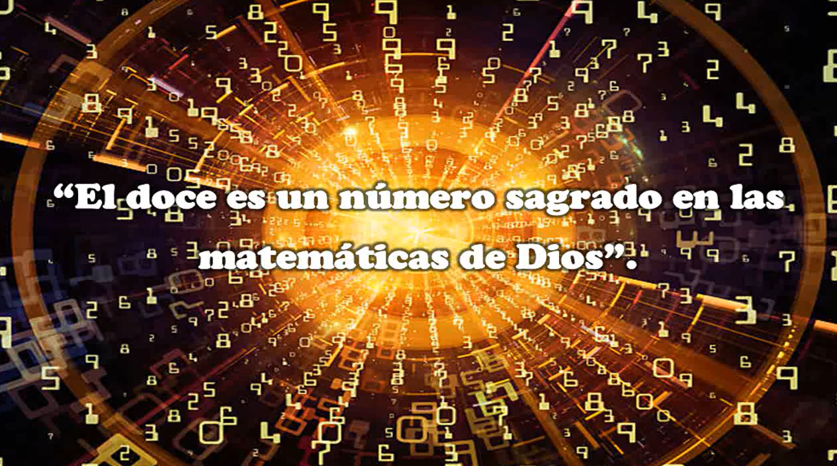
There comes a time when humanity becomes cultured, then religion has to explain, “Look, the Holy Trinity is this and this.” the Mayans said of the pyramids, that it is a trinity on all four sides: three, a triangle here, a triangle there. Thus, there are twelve, because there are twelve months in the year, twelve are the disciples, etc. 12 is a sacred number of GOD's mathematics. And so on. Then religion becomes a school, it is no longer "a mass and then the temple is closed". No, after the mass... "Well, now you are going to stay with me... You are going to study the dogma..." Which one? Of the Virgin Mary, of virginity, what it consists of. Virginity is not a physical state, it is a mental state. A woman can have children and be a virgin, because her mind is pure. And another woman doesn’t have children, and there is nothing virginal about her. And so on.
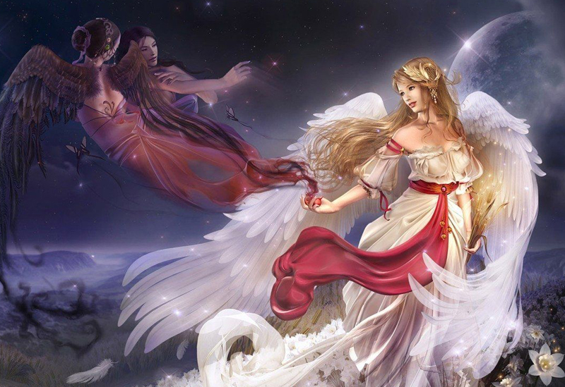
And for this and for this, and virginity this and such. The sign of Virgo in the Zodiac. Virgo, the virgin, is in the sky, the writing of GOD. It consists of this and this and this. Well, the study of the Science of God. The virgin of the Zodiac has a fish tail, what does that mean? The origin of life; life began in water. In the Bible it says, “In the beginning the Spirit of GOD floated over the waters.” What waters were those? The virgin waters of Creation... What did the spirit of GOD floating on top consist of, what was that like? Well, then it’s taught. It is no longer the priest, the mass is over, he is no longer the priest, now he is the professor of the mysteries of GOD. It is no longer dogma, people already understand that it is a law; virginity is here, in the spirit, they cultivate virginity.
Fornication is like gluttony; gluttony is eating, but it is eating in a way that you are going to get sick. Food is supposed to give health. And so it happens with fornication, with... That is in the mind. The one who desires a woman in his mind, has already sinned. He has not touched her or anything, but he has already sinned, because everything is in the mind. In your mind there is a thought of sexual abuse, of exploitation. If you act like that, you are going to push the woman into prostitution, etc. So, that is the...
Ephesians, what does it mean?
—It is a town. —
And why, of what? Why does that town appear here?
—Ah, I don't know. —
It is an epistle, a letter from Saint Paul to the community of the Ephesians, a people who lived in Ephesus, a Greek city, where the apostle founded a brotherhood, a group. There was an Initiatic school, an Initiatic college. And Paul, Paul was an intellectual, in studies. He was one of the few who knew how to write and read and... The other apostles... The Gospel of St. Matthew... The Gospel according to St. Matthew, that was written about 150 years after Christ. St. Matthew no longer existed but the disciples of St. Matthew preserved the teaching of St. Matthew that he gave and then they put it in writing. The time had come when it could be written. The Gospel according to St. John, according to… that is why (...)
With sex... A myth has been made out of sex due to this lack of culture, as if it were the great thing, this overeating... Chapter 5. The mind, the mind gives the measure. If there were a thermometer to measure the mind, that one would put it here [on the forehead] “Oh, what a scoundrel!” He is so well dressed and perfumed, and everything, has titles, and is a scoundrel! How barbaric! It’s pure appearance, a facade, seems like a palace and inside everything is in ruins. But that... that thermometer doesn't exist, so how do you do it? As Master Jesus said, "You will know them by their fruits." By their way of speaking, by what they do in the world, by their attitudes, by the way they treat others, by their idea of life, by... All of that serves to measure what is inside.
Thus, it would be a very complete measure, he is not only good, he is bad; no, he is bad at work, but he is very good at heart; he is bad at eating, but he is good at this, in sports, etc. There are several measures, and one takes an average. He had five points in such a thing, ten points in such, such, such... Average: 12 points. Well, he passed the year. Barely, with little pushes, right? Now then, here Saint Paul says in his letter to the Ephesians, he says, "Be imitators of GOD...” Tell me that’s some advice, right? To imitate GOD.
What is GOD like? He is generous; HE does not put things to enrich himself and take home. HE does not have a palace, His palace is the Universe. HE does not want to have walls, He does not like them. HE IS free, free, He wants to flow, flow, flow. He is a traveler, He is a monk, He is a farmer, He is an engineer... He has everything, He does not like a single thing. As he is eternal, He lives millions of years, "I dedicate a million years to being an engineer, another million years, I am a farmer, another million... "Imitators of GOD", be imitators of GOD. With that, there is enough for a while, right? And then, He adds even more things but for that, one has to have knowledge, to imitate... What is it like to imitate GOD? I will have to get on a cloud, because as they paint Him, GOD, in the cloud, you fall. Because you do not have a spiritual body, you only have a carnal body.
Well, then, it says, “Be imitators of GOD as beloved children.” How beautiful, “beloved children.” GOD loves us with all our mistakes and faults and everything, like a father loves his son, even if he is spoiled, and naughty and everything, and like a mother. We count on GOD’s love, and that will give us a guarantee, a security. You can walk calmly down the street. I count on GOD’s love, GOD’s love is power.
“And live in love as Christ loved you and gave himself up for us.” Love is sacrifice, “Live in love as Christ loved you.” How do you imagine Christ loving people? Kissing them, hugging them, etc., but no, true love, divine love. “...as Christ loved you and gave himself up for us.” He gave himself out of love, not because he was forced to because GOD was watching over him, no, generously. He gave himself up for us as an oblation. Do you know what an oblation is? “As an oblation…”. The host is an offering, the body of Christ and the blood of Christ are there. And a priest once said, “It is not a symbol, it is true that the body of Christ and the blood of Christ are here, it is true!” In the host. When he said that, I began to meditate and study. How is it that the body of Christ and the blood of Christ are in the host, and I discovered many things, and I proved that it is true.
“As an offering and a victim of a sweet aroma.” As an offering and a victim of a sweet aroma, like a perfume. When He gave Himself up, a wonderful aroma went up toward Heaven, the angels arrived, it generated a wave, a vibration, a music.
So, it is verses 1 and 2. Then comes the third, the Trinity. Fornication! After he spoke so nice, he inserts such a harsh word. “Fornication, any impurity or covetousness, do not mention it among yourselves...” The Master mentions it, but he says to them, “Do not speak about it or even mention it.” Of course, you are not going to do it, but not even in words. Do not speak about it, forget about it, because when you speak the mind is already vibrating, “fornication, fornication”. Pull that weed out of the garden of the mind. “Fornication and any impurity or covetousness, do not mention it among yourselves, as is proper for saints...” It is a teaching of Theurgy, to support the Work of GOD, not to go against it “... the same as crudeness, foolishness, or vulgarity, things that are not good but instead, let there be thanksgiving.”
Instead of those things that are not right, do rather acts of thanksgiving, acts that come from words, which are seeds of the mind. I am going to share the bread, I am going to share this, I am going to... My joy, I am going to share it. These are actions of words, of powers that are in the mind that one is going to bring out, and not put in harmful words, from a vocabulary of power. “...For you may be sure of this, that anyone who is a fornicator or impure, or covetous (which is like being an idolater) has no inheritance in the Kingdom of Christ and of GOD.” In other words, you will simply die, as Christ said, “... he died and was buried.”
He had fun! He did what he wanted and there he stayed, as a soul in pain, taking care of his body, taking care of his wealth, because his soul is dense, heavy, because of everything he thought and did, his soul cannot rise. That’s as far as we’ve read. And there it ends: “... because you must understand that no fornicator, or impure, or covetous person...” It is like being an idolater, take note, failing GOD, the idolater fails GOD, goes against the Work of GOD, against Theurgy.
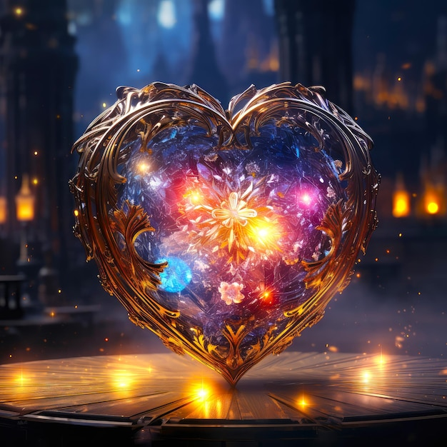
It is not sexual magic, what there is, is love magic. There is no magic in sex, sex is a physical matter for the reproduction of the species and to release energy; the man releases into the woman what he has left there, like urinating, let's say, he releases, he calls it pleasure. On the other hand, love magic does, then sex takes on another character, the magic of love; food takes on another character. Talking about sexual magic is like the magic of food, the magic of urinating, the magic of defecating, magic... No, not that’s not it! Those are physical functions, which can be given a spiritual character, but it is not that the magic is there.
So, the person has magic, his food is based on magic, on the Work of GOD. I feed on peace, which does not depend on killing animals. "I do not kill! I buy the meat." Yes, but you pay for someone else to kill, you are an accomplice to the crime, etc. So, yes, there is magic on the table, but it is not the magic of the food, the magic of the kitchen. It is the person who cooks, has the sense of the sacred, as it says here, not to be idolaters. Don't put the word or anything then, cook with prayer, with pleasure with..., not because they are obliged to earn a living, but because it is a priesthood. The kitchen becomes a priesthood of health, but it is not the magic of the kitchen, no, no. You have to put a candle here and a saint there, no, no, you are the one who generates white magic or black magic with your thinking, with your vocabulary, with your life.
So there is an error, and well..., but people fall into that, of looking for a man to do sexual magic, looking for a woman to do... That is not, that is not the idea, that... What would Saint Paul say? No, you have to study the postulates of magic. There is a book called Elementary Treatise on Occult Sciences, in there are the sacred laws, the occult science, the science of GOD that was hidden because people were not interested in it. You could now change the name to, “Science toward the light”, “Elementary Treatise on Science toward the light”.
Master Jesus would say, “The day will come when everything that is hidden will be brought to light, and all the mysteries will be revealed.” That is in the Gospel of Saint John, “Everything that is hidden will be…” The occult sciences will be brought to light In the printing presses, in the publishing houses, and they are in the bookstores; they have already been brought to light. It was hidden in the heart of civilization, and suddenly, it is no longer prohibited, it can now be read, and all the mysteries will be revealed. The mystery of genetics is being revealed, the mystery of biology, the mystery of the planets, of the stars. GOD opened the doors.
What would Saint Peter say, “Lord, do not open the doors, people will misuse them.”
“No, no, the time has come, for the atom, open up.”
“No, no, they are going to make atomic bombs,”
“it doesn’t matter, there is that risk, but the time has come for the mystery of the atom to come out…” of this, of that!
GOD is now throwing everywhere, food for the spirits, everywhere. The Tibetan lamas are already teaching what was forbidden in Tibet; it was just for them, now for the whole world. I have a complete library of books from Tibet. The Kabbalists, the time has come to bring Kabbalah to light. Before it was secret, forbidden, now it is in classes. It is on the Internet, teaching Kabbalah, the 72 names of GOD, etc., everything. All the mysteries will be revealed. Master Jesus prophesied it, and the prophecy is being fulfilled.
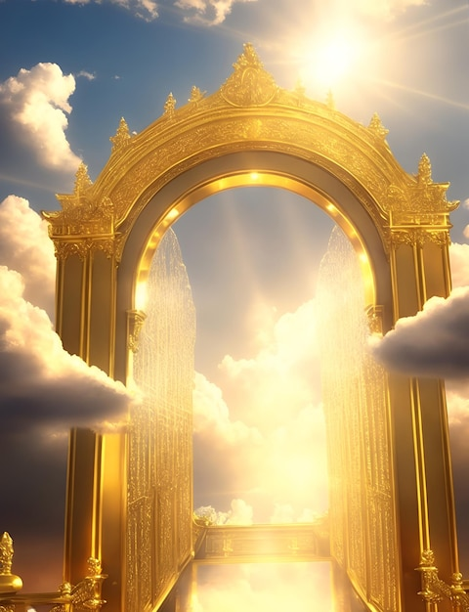
“And the one will come, the one who succeeds me, who will open the doors of the Kingdom.” The Maestre de La Ferrière came with the rules of the Old World to the New World. From the old world, which was the Era of Pisces, the power was held by Europe, he came from Europe and gave the power to a man from America so that America is now the center, no longer Europe, the old world is already... dependent. Right now the power is in the United States in America, the political power is there, the money, the weapons, everything. And Europe... "whatever the United States says," because America rules. Then it is South America's turn, which is the polarity, positive and negative, and the bridge, the Holy Trinity, Central America.
But the power, when South America wakes up, then the power of North America will be cleansed, because it oversteps its bounds, because the South is not responding. There they meet now at the Summit of the Americas, what to do with immigration. Everyone wants to go to the United States, because the colony is still here, “Whatever Europe says, whatever they say...” Waiting for foreign investors to come, to come to awaken us because we were accustomed to the colony. “Whatever the king of Spain says, whatever he says, we don't know.” But when the South wakes up, then, the power of the North will say, “Wow, what we were missing!”
The wise men are already preparing, those who are in the Amazon and in the Andes, when the time comes... They have already spoken on television, they were invited to the United States, to Europe, but the Great Council of Wise Men of America, when they raise their voice, everyone will be like that... “Whatever the Great Council says.” But here we have them, and people are thinking, "No, the wise men of Europe, those of India, the yoga of India, European astrology.” No, it is here! A Tibetan lama told me, “We know more than you about what is hidden here in America, and the people here don't know about it, and they welcome us as if we were the saviors when the secret is here.” In Tibet they knew what is in America.

Superior Course in Theurgy, By the Ven. Master T. A-O Domingo Días Porta
All Rights Reserved

