






By Ven. Master T. A-O Domingo Días Porta

L
et's get rid of the Latin [idea], we don't belong to the Roman Empire, we don't speak Latin here, that's from the Colony. We've gotten into this idea of Latin America, Hispanic America. I use the word Amerrikúa because the word America didn't come from Europe, the word America is a Mayan word. Because they say, “No— in primary school— no, Amerigo Vespucci gave it the name.” A European had to come, because we were so stupid that we didn't even know what a continent was; that's how they pushed on us, the Colony, a colonized mentality. No, look at the maps that he signed, Alberic Vespucci, look at the maps, you can see them on the Internet, Alberic Vespucci.
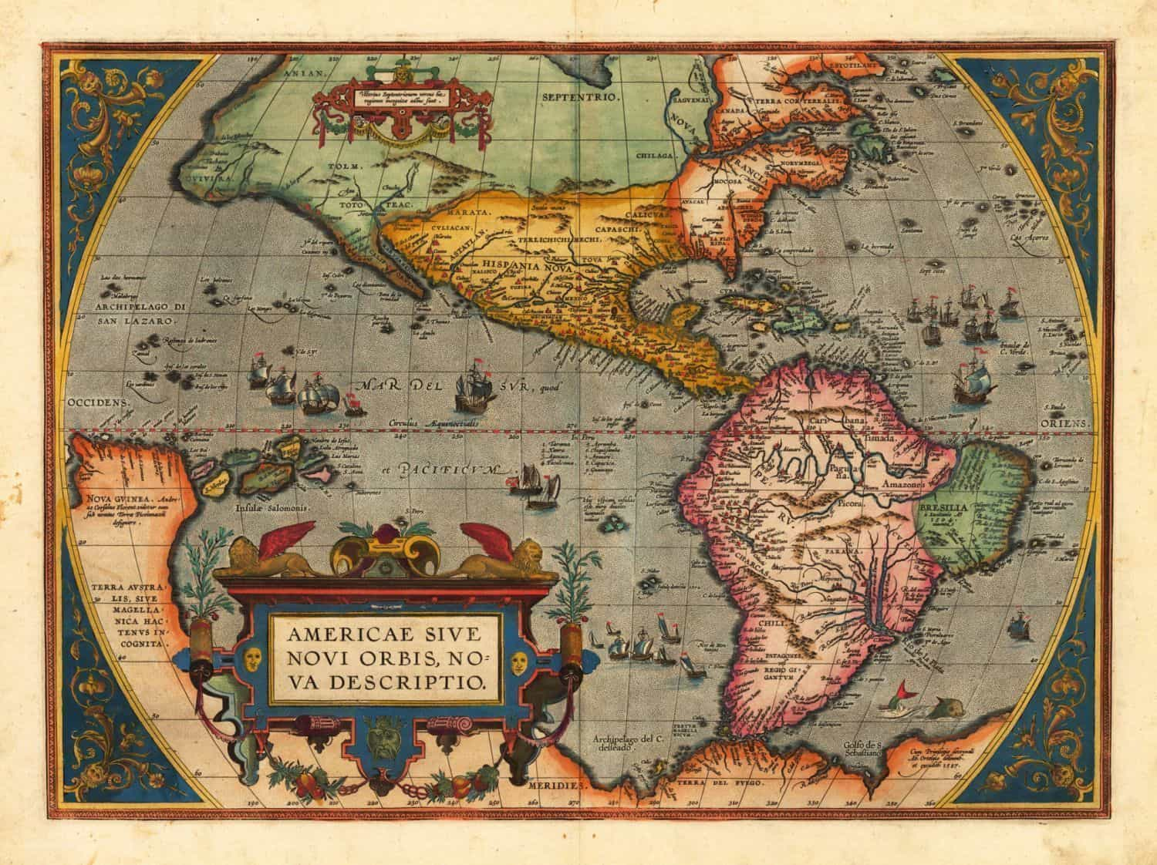
On the last map he put Amerigo Vespucci because the word America was circulated. [...] “Since I was the first to make the map of that continent, then, I put Amerigo, on the last map.” But on the other maps, it was Alberic Vespucci. Who heard, where did that word come from? From Nicaragua. One of the Spaniards asked an indigenous person in Nicaragua, “Where does the gold come from, where do you get it from?” And he said: “Amerrikúa... Amerrikúa.” What is Amerrikúa? The whole land, from the snow over there, to the snow over there, Amerrikúa. What does Amerrikúa mean? The realm of the winds, the land of the winds. Because Amerrikúa is the only continent on the whole Earth that unites the four cardinal points.
Amerrikúa goes from the North Pole to the South Pole. There is no other continent like that. And too the east, it has the Atlantic Ocean, and to the west, it has the Pacific Ocean, the two largest oceans on Earth. The other continents do not, they either have the Atlantic or the Pacific. Thus, it is the continent of unity, the continent of the future. When Humanity is one family, when borders are gone, this land has the power to establish that unity, because here there have never been great world wars or anything. That is from over there, from Europe. They call them world wars, and they are European wars, to get rid of the blame, and so, “no, we are all to blame.” No, there have never been world wars here. Not the Russians, the Germans, nor the French have come here. It is not up to us to fight them.
They trespassed, they imposed themselves. Well, what can we do? It is the will of destiny, the more we resist, the worse it will be for us; better to... There was a reason destiny wanted this. Why? So that when the time comes, this will be the continent that will unite the others: those who are separated. Because here there are white, black, yellow, and red people; all races meet here.
That is North America, Central America and South America. Comments Sister Guadalupe.
And the Caribbean islands. Finishes the Master.
Intervention of Sister Ma. Guadalupe:
Master, look, going back to what... And what Netsa also spoke to us about fornication, and everything that was in the Bible, and also about sexual magic that he talks about, and the clarification that you tell us, well... I understand that sex is there for a reason, right? For a reason, not just to engender children as you said. Well, it is a way of releasing energy, but not only does the man release it, the woman does too and transmutes it. And transmutes, and transmutes it to such a degree that one can have a well-directed orgasm without being in that pornographic mind but... I believe that one can connect with divinity; I feel that. However, what happens? In the way that you are implying that it is only to beget children and to...
Master: —No, I have not said that only...
Well, and to have discharges as you say, which is like a man discharging what is not useful. Well, I do not see it that way. However, I ask you, as when a person, or people, all people, with this birth control that we have, there is a time that we say, “I am only going to have four children or two or three and I am going to have surgery. I am not going to have children anymore.” Then, what happens to those people, how to enjoy that sexual energy? Let's not call it sexual magic, let's not call it... whatever, it is a sexual energy.
How can we enjoy it if it's just going to be for a release... And fornicating, we understand it to be... Well, if I have my partner, right, with whom I can have sexual relations, then being with another person, at the same time... That's fornicating. Or as he says, having my mind dirty, of wanting someone. But not if I like him where I can say, “Look, that boy, how cute, how handsome, how well-groomed, that this...” But, if I'm thinking that I'm going to have sex with him, or I'm going to find a way…. that's when I think that one is already fornicating in one’s mind. You see?
Master: —Look, that is... The problem is in the word...
Those of us who have already had surgery, Master, argues Sister Guadalupe.
Yes, that is, that's enough, the question is too long, answers the Master. Look, the problem is in the word sex, that word is contaminated, it is dirty, right? As Saint Paul says: “In the mind he fornicated.” The word sex was damaged. Let's say, they discharge. When someone has a strong desire to urinate, when they urinate, it is a pleasure to discharge. When one is constipated, when one cannot, when one manages... Oh!, what a relief, what a pleasure, what... And so on, it is discharge, discharge.
One must understand, that is why Theurgy clarifies many things, without speaking of sex and all those things that people are now obsessed with. Let’s clarify that GOD discharges, gives, gives, gives. Generosity says Buddha, first point, generosity; from there come all the virtues. When you give yourself up you give of yourself. So, you can feel pleasure even if you are alone, when you discharge prayers, ideas. In such a country there is a problem, there is a famine. As you say, “there is a famine”. So I discharge thoughts of abundance of food. And after you do that, you read in the news, “The whole country sent 1000 tons of food to that famine there.”
“Oh, my thought helped, the next day the ship left loaded.” And that strengthens you.
So, yes, just as we talk so obsessively about sex, we should talk about food, about the stomach. Talking all day about “the stomach, the stomach girl!” We have to share the pleasure of food, sit together, that... and this, and this, and go on, go on, go on.” And the pleasure of the lungs, breathing, why only sex? I mean, so much concern for one detail. One organ among many. No, the lungs, the breath, because GOD, when he blew into the little clay figure, he transmitted the divine gift. It was not only oxygen, when he blew, there went GOD, all the gifts of GOD. And the little clay figure came out walking, a little doll, a creation.
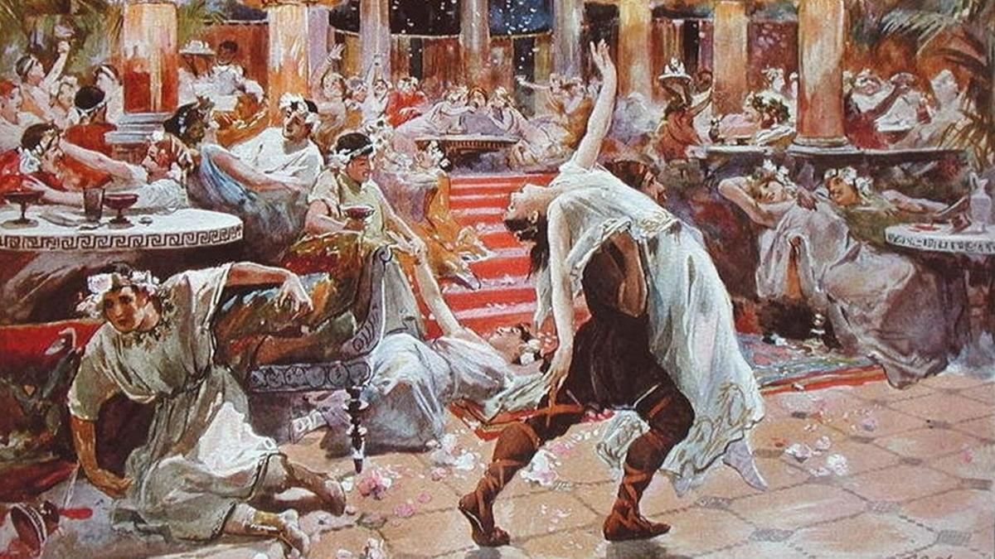
So, there is a secret in the breath, we should be talking about that, about breathing, instead of that obsession. Why? Because it has become a business. I have seen shops... sex shops! Shops selling sexual things, this, that, in short, I see many things. Some are obsessed, others are not. Others talk about art, philosophy, about... And why did that tumor come out? Because there was pus inside, misunderstanding, discrimination against women, this, that, prostitution. And it is good that the tumor comes out. What would the doctor say? “It is good that we already know what he has, because the disease has come out.” That tumor has come out, because the secret of life is there, and people do not understand that. “No, not the secret of life. Pleasure, discharge, discharge, the desire that I have, the hunger that I have, discharge.” From there comes gluttony.
“I'm hungry, I'm going to swallow whatever I can.” What did the Roman emperors do at their banquets? They had a slave who made them vomit so they could keep eating... And he made them vomit so they could keep eating. Pleasure, pleasure, “This is so tasty, so tasty!” And out it went! When it’s eating, it's fine, but once it becomes a vice—virtue becomes a vice— then it degenerates, the soul becomes dense, they remain there as a soul in pain.
Prostitution is now called, sex workers. They are there for the man to discharge. It doesn't matter if there is no love or anything, unload, come, and the other comes, and the other comes. But yes, he pays. And there is the owner of the brothel collecting her share. Unload, unload. If it is about that, well, prostitution takes care of that. There is no need for commitment, to have children, for nothing, just pure pleasure. That is what someone proposes... I saw in a news story, a philosopher from I don't know where, I think he is Spanish, that there should be no family, no marriage. That is from the Catholic Church, to remove that. Let the woman live her life and the man live his life. Let the woman do what she wants and have sex with whoever. That is like going to eat, like going to a restaurant and then going to another restaurant, and the other, and the other. And the man the same, from here to there and there.
But not a family, if they have children, the government should take care of them, the state, there should be some shelters for children. But women are not obliged, if they do not want to have children, they should not have them, he says. What outrage, a philosopher! Where is he leading the people! If he were a guide, he cannot be a guide, it is over, humanity disappears, people no longer have children but pure sex, sex..., magic. How barbaric.
That energy has three levels. The physical energy of sex is an energy that is in the body. You can use that energy in any other way. Start doing sports, climb a hill, sweat, run, this... And the physical part runs out. The emotional part, through friendship, friends, children, bringing presents to children, everything; you discharge the part of love. And the mental part, which is the most difficult, when it gets in there, they do not hear arguments, they do not hear anything. "No, it is that this, and this, and this, and you...". And that is the one that needs to be worked on, that is the most difficult. The physical is easy to remove, the physical part, the energy that people now call sex, the emotional part too.
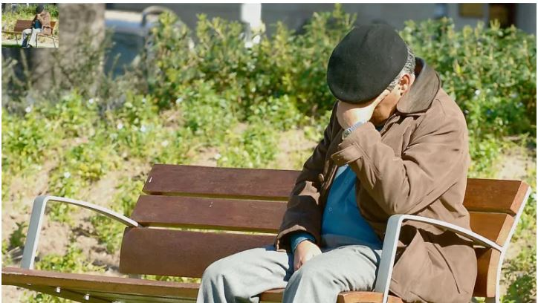
Going with grandpa; grandparents are now abandoned, before, grandparents were... I remember when I was a child, what joy, and the children with the grandparents; and the ones that the grandparents would visit, and that we would visit the grandparents. Now they put them in the nursing home, and they forget... They get in the way, the old people are... What they do is produce expenses, at that point it happens. I remember when I was a child, the uncles, the uncles, the uncles were family, it was joyful too, when Uncle Carlos arrived... We were eight brothers, surrounding Uncle Carlos and he would play pranks on us, and we would enjoy ourselves. He would make us bend down and put our hands here [between our legs] and he would pull us and make us go around; and we would make a line. “Now my turn, uncle!”… And thus, the other uncle, Uncle Eduardo with his mechanics and things that he taught us... It was a microcosm, it was a small world, the family. It was nice.
Now it doesn't exist, the family is already in decline. Before it was the television for the family, when television came, the whole family and the neighbors gathered together. Photos have appeared on Facebook, lots of neighborhood children, all of them, asking permission to watch TV. Now, each one has a television in their bedroom, there is no longer a family or neighbors. Each one with their cell phone, each one with their computer, individualism to the maximum, the individual, not the family, the individual. Their car, their this, their that. So, now I hear that "I'm living with my boyfriend," not with my husband, the boyfriend. The one who didn't see and that's why he does that, because he didn't see. [A play on the word “novio” boyfriend, and “no vio” didn’t see.]
Because a family should be, and there is control, birth control, a medicine, and there is no danger; having a child is a ‘danger’. It’s not a gift, no, it's a ‘danger’. Before, the family was large, now just one child, two children, at most three children, two children. Two children, the old pair die, and the institutions remain, the population doesn't increase. One child... It is decreasing... There is concern in China about this, because Chinese communism prohibited having more than one child. There is a large population and there is a risk of hunger, so the country is now full of old people with pensions.
So, young people have to work to pay their pension, etc., because there is no substitute anymore. If there were two, they substitute, the population remains the same number, but they did not give permission to have two children. Whoever wants to, can have three, but then he has to pay a tax if he wants to have the third. When man puts his hands in the laws of GOD... disaster. The disaster, is terrible. Control of thought, religion is prohibited, only Marxism, this, that. When man puts his hands in the things of God... disaster.
A government of a single party... Parties are prohibited, only a single party! Tyranny, how barbaric. And they do it in the name of Humanity, it is not for your good. I was in the Soviet Union, I saw the disaster, how barbaric, how painful; a people supporting the whim of a few imposing themselves on the majority. Why don't they set up free elections so that...! When they had elections in the Soviet Union, in the end communism ended. All the countries that the Soviet Union controlled, communists, forgot; they no longer wanted to know about dictatorships, about... The idea is good, but as Saint Paul says, the idea is tainted in the mind. There should not be a few rich and many poor. Everyone should be rich. Communism arrives and everyone is poor; there are no rich people anymore, everyone is poor. The expropriated, abandoned companies, you have to return them because...
A government has to put shoe stores, restaurants and areperas [tortilla shops]. A government has to manage the largest company, which is the country. Leave the rest to its citizens. Let them put factories, companies, whatever. It is the secret of the United States [USA] which is ahead in the world; freedom of everything, enterprise of thought, of whatever. And the government, with its taxes, sends men to space, investigates the atom, has everything they want. And everyone wants to go to the United States. I don't see people who want to go to China, Cuba, Nicaragua. Why don’t they go through Nicaragua to go to the United States, they don't stay there.
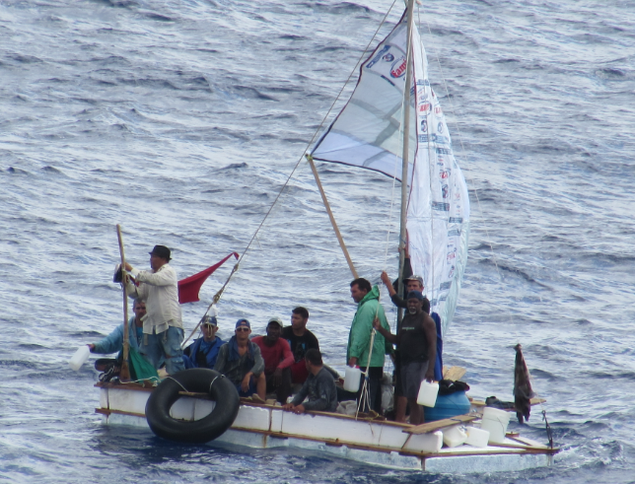
In Cuba... nobody. They take a small boat to leave. Those from Cuba go in a small boat, in small boats, in life preservers, out; they cross the Darien jungle, there in Panama, that terrible jungle, the Cubans, to go to the United States; it is a magnet. And there came a time when Venezuela, someone wanted to unite, Venezuela, a magnet. Here they came... A small United States, in the south; but not for work but for oil. We relied on oil from Venezuela; it became famous, the bolivar was worth more than the dollar, but for oil. The United States for work, everyone working, struggling, studying. They take away our oil... Oh, poor country! Third world country, deflated, there... Poorly managed oil and no longer worth as much as before. It came to be sold cheaper than what it cost to produce oil, at 20 USD per barrel, and oil costs 25 to 30 USD.
So, a Saudi Venezuela hurt us, because we didn't worry about developing the country, because we already had enough, to steal too, to get corrupted, for whatever. And they came from all over the world, and everyone wanted... to make money. Since we were educated in the Colony like that, to depend on outsiders, well, Italians, Germans had to come, to set up factories, companies, and we became employees, the habit. Here there is a psychologist that I know, María del Pilar Quintero, she wrote the book Psychology of the Colonized, about that bad habit that we have of depending. Let the foreign investors come, let them come, let them bring things. We sell iron cheaply and then we import it converted into cars, into... They continue to exploit us as in the Colony and we remain very happy.
Yes, we are already exporting iron, and we export gold, and we export this; we fool ourselves. The mentality, psychology of the colonized. I told the professor, “Look, I am making your book known.”
“Oh, that’s great, because my book hardly sold.”
Now, people don’t like to know that. She worked at the university, she taught classes when I taught classes too. And I talked to them about MAIS, about the cultures of America, many saw me like that [with strangeness] but she understood me, and others didn’t.
I went to school at the university because I was the odd one out. When I studied at the university, it was communist [the university]. The motto was to study and fight, the professors were communist, the students —the majority, not all—the students were communists. To graduate they had to have gone to the guerrilla, which was in the east, in the mountains of the east. The motto was to study and fight, and that did a lot of damage. And I was the only one who talked about peace, who talked about esotericism, who talked about... But I...
Students from a class called me and said, “Our professor didn’t come, come and talk to us about the strange things you know; talk to us about the stars, the end of the world, this…” And I would keep them amused.
Then the professor came and said to me… “And why do you talk about that? It’s not in the class.”
“In Venezuela there is academic freedom, the professor must learn from the students’ concerns if they are interested in a certain point and one can teach it…”
And so, sometimes my students told me the same thing, “Professor, don’t talk to us about that, that’s in the books. Talk about the things you know.”
And I would give them courses. And the subjects? Well, look in book such and such, and such book, and in the library there are the books. That ended.
When did the communist university end? When they discovered that the guerrillas were paid by the government. They were surrounded, the guerrillas were in the mountains, they couldn't go down because the army was below, and the army was instructed to let those who went to the guerrillas pass, and when they had done their part with the guerrillas, yes, it's fine, they could go out, they didn't stop them, they would go out. They were under control. They found out about it, they met, an assembly of all the students, the political parties... out of the university! We are going to do politics without political parties, no more obligation to go to the guerrillas, it’s over.
And one time the communist professors called me, "Come here"—because that was when I was a student.
“Come here Domingo.”
“Aha, yes, here I am.”

“Forgive us, we were wrong, you were right.”
I said. “And what bug bit you, what happened to you?”
“We are reading Lobsang Rampa.”
Reading novels by an apparent Tibetan, who was not Tibetan, he was a Canadian, who had never been to Tibet. And I once asked a Tibetan lama, “What about Lobsang Rampa?”
“It seems that he has never been to Tibet, everything he says is a lie, that is not true... That ‘my life with the cat’, that this, that, are all his fabrications.”
But, nevertheless, it reached many people, and they became interested in... And these communist professors, who study Marxist doctrine and this...!, Lobsang Rampa's little novels changed them. I told them, “No, what you have, what you have seen, is the facade, you have not yet entered inside.” But the facade made them change, Lobsang Rampa's little novels. Others were hooked by Carlos Castaneda with what he wrote. Now that was more verifiable; they were not fantasies. Freedom, freedom... Where the human spirit flourishes, is in freedom not imposition. Not dogmas or threats of inquisition of... Nor bonfires or anything. Freedom, freedom, and the spirit flourishes.
And religions are going down that path, why? Because now the priests who are now the young , who become priests, already bring another spirit. Because they have studied since they were children and are accustomed to studying. So they feel obligated to study the religious mysteries and teach that. This pope is making many changes, a revolution there, and he has people who are against him, even cardinals are against him, because they are used to the old way. Since he is from here, from America, he is ventilating the Europeans, he is telling them things... that they did not understand.
I read somewhere... A chef from Finland. A chef from Finland went to I don't know what country in Asia... Thailand, one of those countries, and he met a Venezuelan girl. "And what is this about Venezuela?" And she explained to him, "this, this...", and she showed him a book, and he looked it up on the Internet. In the end, they ended up being a couple. He came to Venezuela - he is in Caracas - he said, “No, I'm staying in Venezuela, this wonderful country, these open people. You talk to a stranger and the stranger talks to you, tells you whatever you ask him, about this, about that... That's not customary there in Europe, that... It's very cold, it's very difficult for a person to open up to a stranger.”
“No, here I... I'm staying here, this is wonderful, the Catatumbo, Angel Falls, this... And the people... the people!” It was on a news program about the Finnish person. And the people here say, "No... Europe," and they want to go there thinking it’s the best. And the Europeans, why do they come? To look for the shamans of the Amazon. There in Puerto Maldonado in Peru, planes arrive every day with Europeans, looking for those from the jungle, tired of their civilization, of their coldness, of their mechanical life, machines, machines everywhere, robotized. They want to feel a little freedom of the spirit, of nature. The shamans of the Amazon are the teachers of the Europeans.
When I was with the shaman Bolívar, some Dutch people came to him looking for a shaman, a group of Dutch tourists. And the shaman told us, “Wait a moment, I'll take care of them.” And he took them to the churuata; there he gave them ayahuasca. And after about two hours, some of them came out. And they came out like this, the Dutch, like this, tall and robust, making themselves... And the shaman saw them and laughed. “I gave them only just a little bit, and they feel like they are in Heaven. And now when they get to Holland, they will say that they are shamans, and they will set up their business there, ‘urban shamanism’, to collect of course.” says the shaman. They laughed because he hears the stories, he did not speak Spanish, his son translated for us, he told us about the tourists.
Because he had... He made a deal with the taxi driver, the only taxi driver in Puerto Ayacucho, who went to the airport. When the tourists got off, then the taxi driver, —“Shamans, shamans?”
“Yes, yes, us, shaman, shaman.”
“Get in, I’ll take you.”
And he made three, four trips, taking fifteen, twenty tourists looking for a shaman. Or sometimes tourists would arrive at the airport, “Shaman, shaman!” and the taxi driver would come out, “Yes, me, with me.” And then the piggy bank would be divided between the shaman and the taxi driver. “So much for you, so much for me.” They pay gladly, because they are looking for freedom, tied to work, to commitments. And people here think it’s the good life; and people from there want to come here.

Superior Course in Theurgy, By the Ven. Master T. A-O Domingo Días Porta
All Rights Reserved

