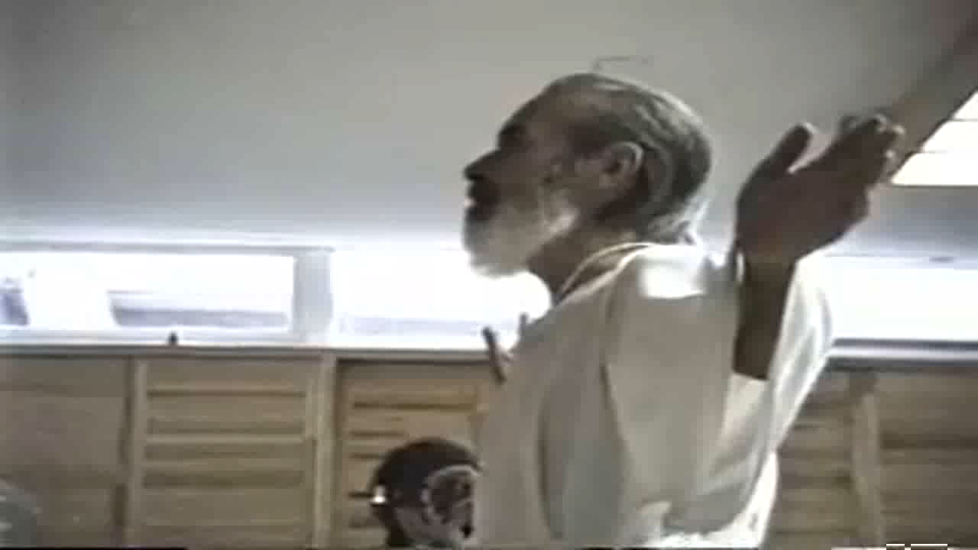
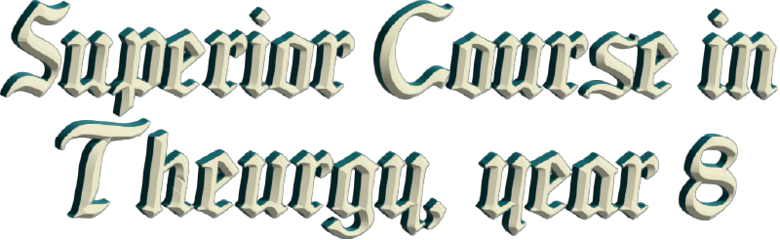
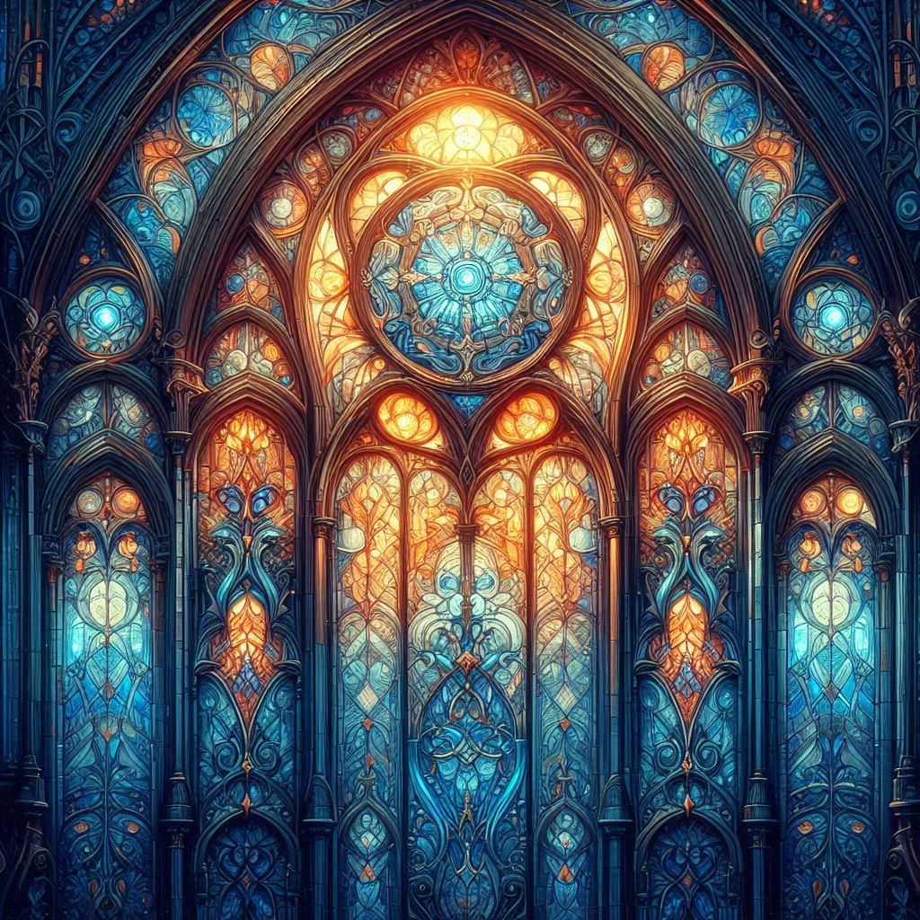

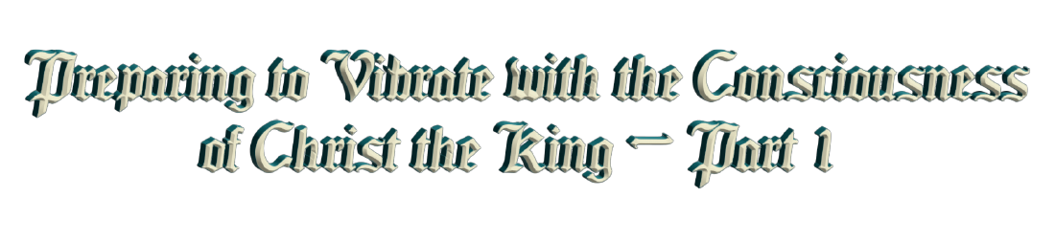

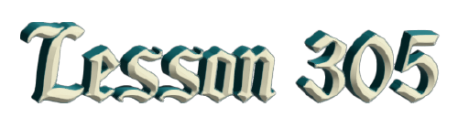
By Ven. Master T. A-O Domingo Días Porta

W
hat is the purpose of the Cosmic Ceremony? First, to give Communion. Communion is done directly, in spirit, without species. Like in the Catholic Church, the host is used, consecrated with wine or water. That corresponds to the Era of Pisces […] ended in 1948, the two thousand years of the Era of Pisces, while the Sun was transiting through that constellation […].
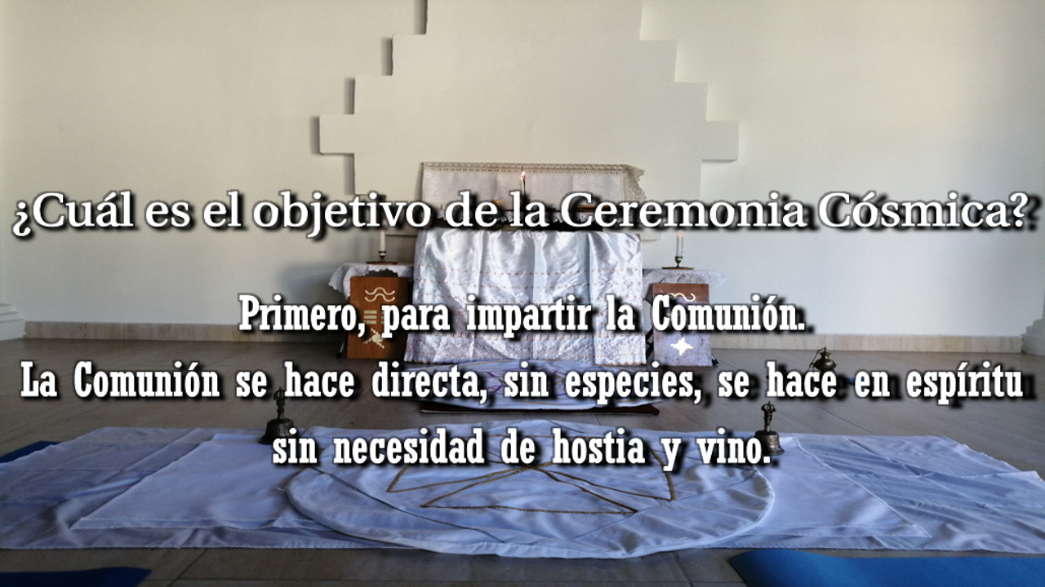
The symbolism of Pisces and the opposite sign Virgo is that Communion was used like this, directly with […] material. Pisces is water or wine, and Virgo, the zodiacal Virgin, has an ear of wheat, thus, bread and wine; and in another sense, bread and fish (for Pisces). In the Last Supper there was bread, a broken loaf and two fish, that’s all there was, the symbolism then.
It was not a material supper for the body, rather it was a spiritual supper. The Last Supper is full of symbols. In the Era of Aquarius, what is it like? Air and Fire. Thus, Communion is done directly, in spirit, without the need for the host and the wine.
Why is that? Because Humanity, when changing a civilization, the mind takes a step forward. So, the Era of Pisces was the era of believing. People had no concerns, they did not ask, and if they asked, they were told, “That is a mystery, it cannot be explained.” But in the Era of Aquarius, which is the Era of Knowledge, of science, the mysteries must be explained, according to the prophecies of the Apocalypse.
When the prayers are from different traditions, there are formulas that we use in Latin, which come from ancient spiritual magic, which the officiant uses in Latin. The Tantum Ergo is a Gregorian chant from the Middle Ages where the return of Christ is invoked. Thus, it is appropriate for the Era of Aquarius, which brings the return, no longer of the crucified Christ, but of Christ the King. The Christ King is not a person who is going to be the king of the world, but rather, the Christ consciousness is going to be born in human beings. In many human beings the Christ will reign when people vibrate with that state of spiritual consciousness that we call the Christ King.
Christ is a word that needs to be studied. It is very old, much older than Master Jesus. The word Christ comes from Greece, Crestus, “the anointed one” and represents a lineage, a lineage of great Masters of Humanity, not only of Jesus. In the Bible they only mention Melchizedek, a Christ much older than Jesus. And Master Jesus also mentions him, as he appears in the Gospels, and he is in the Old Testament as well. But there were others, other Christs. Just like in Buddhism, the well-known Buddha, Siddartha Gautama, is the last one, the twenty-fifth Buddha. Before that, there were twenty-four. Many Buddhas were from here, from America. But here we do not use the word Buddha; [we use] Quetzalcoatl, we say... Huiracocha in our languages.
For example, water is spread in the four directions. A protective sphere of water is created so that the entities of light descend, the pure entities. In a contaminated environment, those entities have moved away. So, we have to create an appropriate field for their descent. Incense is also spread in the four directions for communication with the entities. In short, the four elements are used: earth, air, fire, and water, to work with the fifth element, the quintessence, the Spirit. You can study that, it is explained in one of the books of our Master, the founder, Dr. de la Ferrière. In The Great Messages it is explained what this ceremony is.
And he says that incense comes from Buddhism, and fire, candles, come from Zoroastrianism. Zoroaster was a Master before Master Jesus. That religion developed, Zoroastrianism, both in the Middle East and in Europe.
Well, we pray the Our Father until the middle; we don't ask for bread and so on, because that second part corresponds to the state that Humanity was in two thousand years ago. Now we use the second part, a micro prayer of the New Era that our Master, the Elder Brother, wrote, expressing the state of Humanity today. We no longer ask for bread, we ask for other things, more human and more spiritual. We already have enough bread, food, and those who are hungry, well start to sow, and not throw the seeds in the trash, which is to waste the work of GOD.
After eating, we collect the seeds, and we sow them. If not, we throw them into the river so that they live their destiny; the river will leave them somewhere. Or [leave them] in a park or in a garden, the important thing is not to sterilize, not to destroy life.
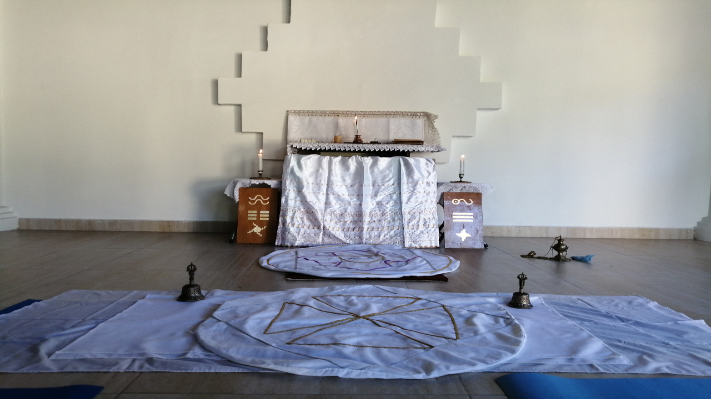
We use... a fire over here and another here, because that represents the two columns: the column of Aquarius- Wisdom and the column of Leo- Love. Between Wisdom and Love, the ritual is performed with knowledge and love. Not the love of songs and all that, but true love, the love of Christ, which is more sacrifice than pleasure. That is a study that the Era of Aquarius brings, the art and science of feelings. Much has been played with that, and it is time to take seriously what that represents.
Well, I ask myself the question, because nobody asks.
What else? Communion, well, I have already explained it, it is direct, in spirit. When “communion” is announced, everyone puts their hands to receive the energy, which is the important thing, spiritual energy. You visualize that you are entering into communion, “common union”. A union of our individual soul with the Universal Soul, with the divine, without the need for the host. You can continue using the host because, as in the Catholic religion, the symbolism of that is very beautiful, the body and blood of Christ, the host. But those of us who bring the New Era, well, we bring direct communion.
At the beginning, when starting the ceremony, the Bible is read at random. One slides the finger [on the pages] and where one feels that one should stop, there one stops. Then a few verses are read to see what the message there is. Today the message of the sword came out, with which they killed... It is not talking about war but there is a teaching there. The sword is the backbone. In the Yoga of Initiation, it gives the power to cut the chains of ignorance, of illness, etc., when we awaken the inner fire, kundalini, in Yoga.
And each one in his home, at seven in the morning, on workdays, can say at least the Universal Prayer, to enter into the chain that we have throughout the Earth. [It is] a spiritual chain, to clean the moral contamination, above all, the contamination of the water, the air, etc., comes from moral contamination. It is immoral to throw away garbage. They don’t care if they contaminate or destroy the forests.
Thus, one has to bring ethics, the ethics of the Era, the universal morality that the Era brings. A morality based on study, not on prejudices or customs. What most characterizes the disciple and the Master on the spiritual path is ethics, the code of conduct, knowledge is secondary. The important thing is to live in harmony with the laws established for Humanity, beyond the ten commandments and all that, there is a code of ethics for these times.
Our Maestre, the founder and messenger of the Era of Aquarius, Dr. de la Ferrière, wrote a series of pamphlets, thirty-six, which he called “Psychological Purposes”, thirty-six psychological purposes. These psychological purposes are equivalent to what was previously called commandments, “The 7 Virtues” ..., etc.
For Humanity, then, which is launching itself into the conquest of space and the atom, ten commandments are very few. Then, thirty-six psychological purposes, not commandments in the religious sense, but for the psychology of the New Civilization, thirty-six key points. What is the first purpose? Each pamphlet, each little book contains within those pages—there are about sixty pages— a precept. In Psychological Purpose #1, there within those pages, the disciple who is a researcher reads it, studies it, observes it... and finds it there; within the first purpose. And thus with the others.
The important thing then, is not to read it, the important thing is to bring it to life. Knowledge that is not brought to life takes up unnecessary space in the brain. All knowledge must be brought to life, to one’s conduct, to the way of seeing life of thinking, of relating to others, etc. So, a Master observes the disciples to see if they are following the norms, or if they are just one more, getting tangled up... well, fighting, getting into debt, etc. So now, the Master already knows, he places each disciple, “Not this one”. At least, he should come to... to take up space. This other one, who already shows that he is a candidate [...]
Reading what the Master of La Ferrière has written about the Cosmic Ceremony, he gives it the title The Cosmic Mass. Well... in two previous sessions the Maestre had already dedicated the first page to it. So, we are going to continue linking with the last thing we read, he says:

“The cosmic mass, like all masses or ceremonies of this kind, can only be celebrated by person of male gender, not for reasons of superiority but of polarity. This is a topic that is too long to explain in this brief exposition. The Antennae...”
The Antennae is what everyone does at home, at seven in the morning and on Sundays at ten, praying and making contact with the Cosmic Ceremony. We do not call it antennae but “tuning in.” Tuning into the vibratory frequency, the power of prayer, to unite with the people who are praying the same prayer; this can be done by a man or a woman, a child, or an elderly person.
Now there are women who want priestly ordination before the Catholic Church. There are groups of women who are asking for it, who also want to do the Ceremony; they want to go to war, they want to handle weapons, they want to become men, how strange that is! Instead of women cultivating the feminine power, they want masculine power; everything that he […]. He wears tennis shoes, give me shoes! He wears trousers, give me the trousers! They put on a moustache, a moustache too!
—And men are the opposite, they want to be women.” —comments Sister Guadalupe.
They are women, they have feminine power; the feminine priesthood is different from the masculine one. That is why women are not in a temple, their center is the home, it is love. Why don’t they fight for that? Why don’t they study in antiquity, the priestesses that existed in antiquity? What did they do? They weren’t copying men, they would have to change then, have surgery too, to see what men have; that is strange. There has to be a true feminist movement and not a competition with men. That is not the idea. Women can be an engineer, whatever, president, but in their feminine condition. President of a country with feminine power, not with the tricks that men do to stay in power, with demagogy and all that. They have to have a sincere word.
Well, we have already read the introduction, what we explained, the chain. Until now it has been done by holding hands, but as a result of the pandemic, this contact is avoided. So, I prefer better that we put our hands crossed over the heart. The X is a symbol of multiplication, once we are in line, we form the chain, but rather spiritually.
Sister Guadalupe asks: —Master, and when they say that in the second degree, we are no longer women but... We are no longer the masculine pole, we no longer have the polarity, or that we have already become... They no longer call us [female version in Spanish] Reverend Gagpa but [male version in Spanish] Reverend Gagpa... Doesn't that indicate that the Master is also giving a teaching there for everyone?
Yes, I suppose that women have understood what that means. Doubt must be methodical doubt, which Descartes taught in his work Methodic Doubt. How is that? That a doubt that is not methodical, when a person has a doubt, he spends his whole life doubting. He remains at the crossroads, is not able to take a path because he does not know how to use the brain, it seems that he is brainless. When doubt is methodical as Descartes taught, which is the basis of science, one has a doubt, immediately one looks for the solution, the answer. One is not going to stay there standing still, because for that, one has a brain that is the vehicle of the mind.
That teaching that when a woman receives the second degree, she is not called the female pronoun [in Spanish] of the second degree, but the male pronoun [in Spanish] of the second degree, it is assumed that the woman has investigated and studied. I am not going to apply that.
Sister Guadalupe asks: —And isn't that why, and because the Maestre also came with his wife who had the dalmatic, with the emblem, when she came here?
Master. —Not with a dalmatic.
Sister Guadalupe. —With the... well, with the cape, and with his emblem, the same, made of wood, like himself, presenting that the woman could be equal to the man. And also, elsewhere, they call us [the male version in Spanish] Reverend Gag-pa. Isn't that why in some schools of Initiation that also come from the Sublime Maestre, they are already giving degrees to women, of sixth dignity or sixth degree? Because I think that they too...
Master. —Well, we are talking about the ceremony.
Sister Guadalupe. —Yes Master, about the Ceremony.
Master. — Let’s leave the theme about women be.
Sister Guadalupe. —No, but it is about the Ceremony, because it is what I see and many women see it, and many men see it...
Master. —Women can copy the Catholic mass, and record, and stand at the altar, and that; they can do it, but that has no power. Likewise, they can do this ceremony that the Maestre says is for the good of the masculine, and what they are doing is theater, because it is not the female’s place, and she is not a man. So, she looks more like a “clown”. All that is supposed to have been studied, I have studied it. That the Maestre came with his wife, with a cape, is a very old subject already.
Sister Guadalupe. —Yes, well that is why perhaps many institutions that derive from the Maestre do that, and they do not know it, right? They have to listen to you so that they learn that they are like clowns...

Master. —After seventy-five years that is already more than known. I am rereading this because there are many brothers who do not study, they are in the Era of Pisces, they are in belief. I have to be recapitulating so that people become aware.
Many... I have asked some disciples, “And are you doing the antennae every day, the tuning in?”
“It's that I don't have time.”
“What, a seven-minute prayer and you don't have time? To pray seven minutes, then get up seven minutes earlier!”
What they don't have is the will, and they blame the poor time.
What do you mean you don't have time? The God of time gives you twenty-four hours every day. I have never met a person who only received eighteen hours a day. If not, check your watch or your cell phone to see that you received twenty-four hours. What do you mean you don't have time? That is a lie, a falsehood to cover up the lack of will, energy and character. What you have is a lack of [sic.] time management. You have a time leak because of your mental state of fools, and then you blame poor time.
“That time is faster now, that there is nothing but” ... There are twenty-four hours, follow the clock to see that it marks twenty-four hours. If the day were shorter, then twelve at night would then be six in the morning, and the clocks would have to be corrected, or get new clocks. But no, clocks mark twenty-four hours, and the day has twenty-four hours.
What there is, is life in materialistic cities, where there is a time leak. That is, time in traffic. So don't waste time. You don't take advantage of time while in traffic, that’s all. “While standing in line, in the office, in a bank, I waste time.” You waste it because you want to. While there, you can talk, study, so many things that you can do in a line, in a queue.
Well then...
“The preparatory ceremony begins —that is, the introduction that we made— when the priest or the guide of the antennae —when a group of people gathers, even if the Master is not there, to do the antennae or syntonization, in the absence of the priest— calls the assistants with three rings of bells; who, forgetting their worries or worldly matters, direct their bare feet to the portal of the sanctuary, and with recollection and peace, take their places. With the lights of the altar lit in odd numbers, the priest or the guide proceeds to the incensing, blessing the incense with a sacred formula.”
Now then, the Sanctuary. Each person in their home should have a little corner that is the oratory, equivalent to a sanctuary. A corner where they meditate, where they pray, where they practice yoga, etc. Thus, that little corner is filled with that energy. A magnetic field is created that protects the home and those who live there, in that house. And that energy, if it is attended to every day, radiates into the environment, towards the neighboring houses, and little by little the people in the neighborhood become interested. The energy reaches them, and they begin to awaken spiritually. And those who want to pray also, even if they are not told anything, they get the wave, the energy.
And then those who practice that every day, then try to form a study center in their home with the neighbors to share knowledge, about health, about whatever, to remove mental laziness. In that way they are true disciples; they are taking the message to others. The apostolate of the Era of Aquarius is not a devotional apostolate [...] The apostolate of the Era of Aquarius is a pedagogical, active apostolate, to bring useful teachings to families.
Well, the incensing is done, first, to clean the vibrations of the place and create the aroma, a mystical aroma: sandalwood, roses, which helps elevate the mind. If we put incense for black bean or... I don't know what, what it does is that our stomach will jump, and it will... Therefore, we put in an appropriate incense so that one feels the mysticism, so that the brain calms down.
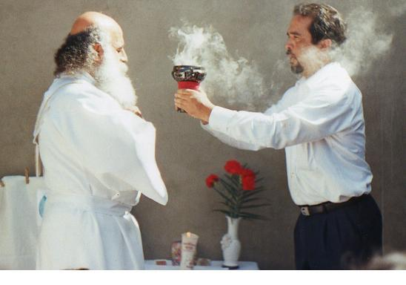
That is good to do. For example, to clean the aura— we have an energy field around the body which is the aura— with an incense stick one can clean it, because that aura is contaminated, when you go out into the street it is impregnated. It is in an energy field that we have around the body, when you go out into the street it is impregnated with gasoline smoke, with so many things, with bad thoughts. One cleans oneself, with a stick, as if it were a broom, sweeping the aura and throwing it on the legs, on everything, on our arms, over here... And one gathers the little pile of garbage in front of us and makes a cross on them with the incense stick so that the harmful energy dissolves. And then one draws a circle so that it is transformed, and the energy is recycled, and it becomes positive.
And then, one harmonizes one's aura, from below as if one were combing the aura, with the incense stick; I am filling it with harmony, peace, health, bliss, beauty, etc. At night, before going to bed, as one comes from the street, the aura is cleaned. If not, once a week. Saturday is the day of cleaning and Sunday is the day of consecration. So, on Saturday, one cleans one's house, from the back, from the back of the house, with the incense stick as if it were a broom, taking out the trash. One visualizes that the trash goes out. Trash is negative energy: fights, arguments, sadness, etc., goes out. One takes it to the front door; one goes out to the street and gives it to the Sun so that it dissolves. That is on Saturday, in the morning, [...] or at noon.
And on Sunday, one consecrates the house where one lives, from the front door, with the Sun. When the Sun comes out it brings that light, which is the light of GOD, and it consecrates the living room, the dining room, the kitchen until reaching the back. All with prayer, not mechanically. The incense does nothing of that, rather one says, “I am perfuming my home with the aroma of peace, of health, of happiness etc.” And thus, they go. And when one gets to the bed, also trace a circle on the bed, in the kitchen, in the dining room, in the bathroom, and so on.
That is part of the ceremonial magic that people today, go after. Seeing that it is not enough to have a lock and a key, an alarm for [...] the house, but those who come to the house are the ones who are doing harm, not the thieves. The house does not seem like a home, it feels cold, sad, because there is not that hygiene, that ethics, that they should have.
Well, then it says: ... the incensing… then bless the altar, the columns… the same, with the incense a prayer is said.

Superior Course in Theurgy, By the Ven. Master T. A-O Domingo Días Porta
All Rights Reserved

