
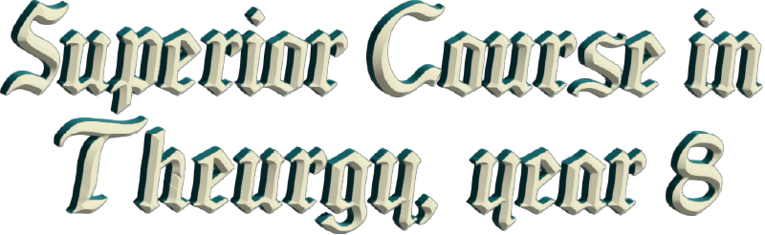
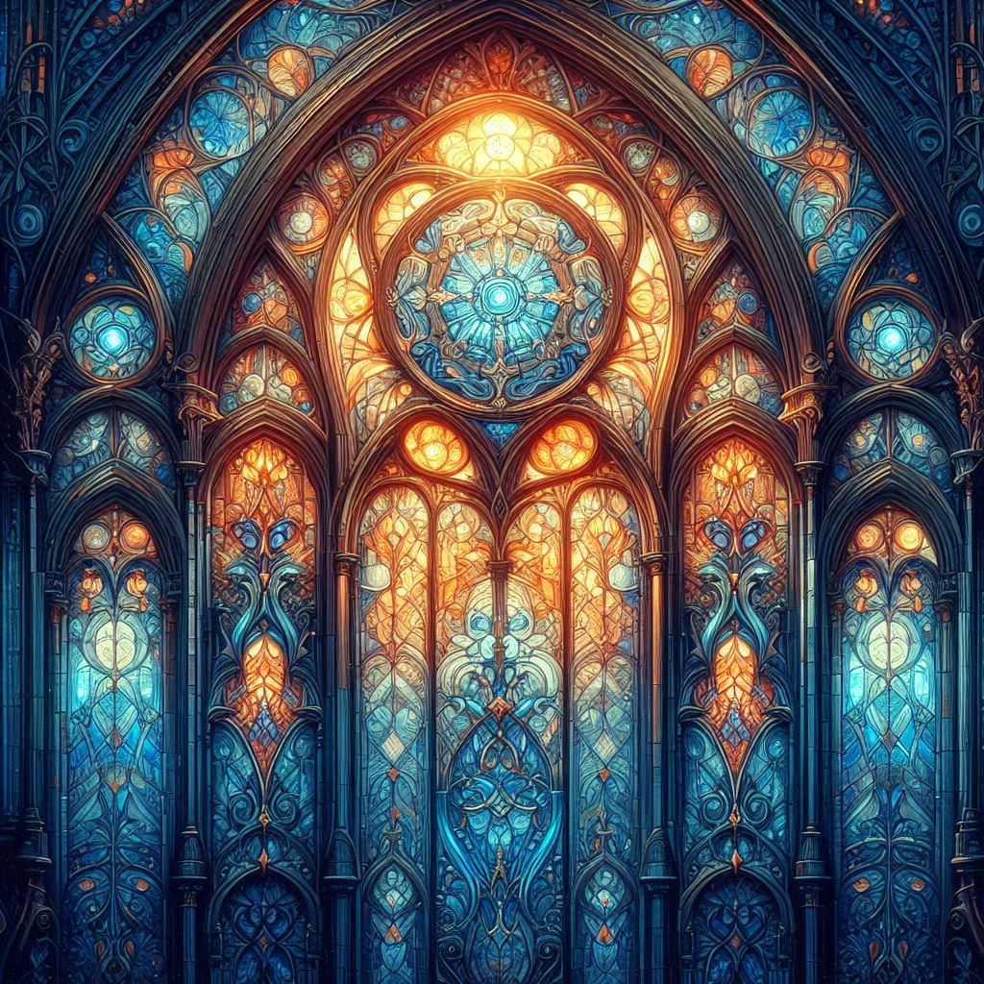



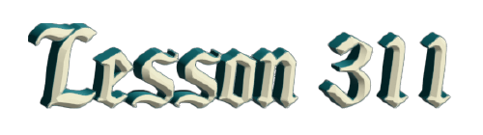
By Ven. Master T. A-O Domingo Días Porta

“Peace to all beings on all planes. ‘In lak’ech - I am you...Al’ Lak’ en - you are me.’ And we give thanks to the Author of life, the Creator, the Eternal Spirit.”
M
ore than a conference, it's a dialogue. I always try to play ping-pong with ideas. I say, have them ask me questions, I answer, and that way I see what concerns they have, what interests them, what worries them. First, I want to say that what distinguishes us from other movements, from other groups, isn't astrology. There are many people who teach astrology, who study it, who... Better than us, better astrologers; they dedicate themselves exclusively to that. Ours is not a yoga school. There are many teaching yoga classes everywhere, perhaps specialized in that. We aren't a holistic school either. What distinguishes us as a group, as they say, a brotherhood, a spiritual family, is the recognition of the coming of the avatar of the Era of Aquarius, the Most Sublime Maestre Doctor Serge Raynaud de la Ferrière.
That characterizes us and is our specialty, our emphasis: that humanity finally understands the coming of a great Instructor for the world. Not to crucify him and then worship him, and all that; no, but to absorb his teachings, which are nourishment for the spirit. Our daily bread in the Christian world is the Bread of Wisdom. But it's not only the bread of wisdom. As in Christian communion, we speak of blood, what is the blood of a Christ? Christ isn't Jesus' last name; it's a title: Jesus the Christ, John the doctor, Anthony the engineer.
So, Christ is a Great Master. What is the blood of a Great Master? What is a doctor's bread for the sick? Medicine. And what is a doctor's blood, his vocation? Why does he dedicate himself to this? For love of Humanity, to heal them. And so, the blood of Christ is love, love for Humanity to heal it from spiritual, mental, and emotional illnesses; everything that produces suffering, conflict, estrangement, divisions, and so on. The doctor of souls, the great Masters of Humanity bring the sacred medicine, that spiritual multivitamin.
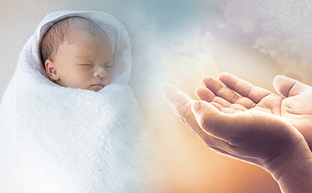
But what characterizes us is not so that we believe ourselves to be a group superior to others, separate from others, no, but to carry out an apostolate, to share with all people of religions, science, the arts, politics, whatever, that bread of wisdom and that nectar of love. Plus the breath of life, because the air has something very sacred about it. According to the Bible, as it tells us in Christianity, God made the little clay figure and blew into it, and when he breathed into its nostrils, it became a living soul. This means that he didn't just inject oxygen into it; he infused part of his essence into the human creature, and every human being has that divine spark within them.
What is spoken of in religions, we bring the teaching of the Avatar so that it doesn't remain in memory and mere talk. But rather, to live in accordance with the spiritual dignity that human beings must have to emerge from the condition of rational animals. Reason at the service of the body, of survival, of food for the body, rest for the body, health for the body. Not remaining there but reaching that which the creator of all that exists breathed into the soul of that prehistoric humanity in the earliest times, when we managed to emerge from the ocean onto dry land. These things take a long time to explain.
So, the recognition we give and the obedience we give to the messenger of the Era of Aquarius is to practice his teachings and share them with all beings, without distinction of any kind, without discrimination. I say we no longer speak of apostolate because the word "apostle" has been given a religious meaning, but rather we are in a different era. When a Great Master comes while present on Earth, which is only a few years— a Master cannot bear to be in such a violent, sick, and disturbed world— that is the messianic stage or of the Avatar. When that Great Master completes his public mission, he disappears. Then comes the apostolic stage, which we, especially here in Mexico, witnessed in the presence of our Most Sublime Elder Brother, Dr. José Manuel Estrada, the First Disciple of Master de la Ferrière.
He fulfilled his apostolate, trying to raise—especially in Mexico where he spent most of his mission— trying to raise the state of consciousness of the secular world in which we lived at that time. When he concluded his presence on Earth, the apostolic period ends, and the difficult work of the disciples begins: the re-education of humanity. We are now in the stage of educators. Studying the scientific basis of the re-education of humanity, spiritual and esoteric pedagogy, and the philosophy of the education of humanity, to lift it from the prostration in which it finds itself.
It is a goal that Maestre de la Ferrière, as a messenger of these new times, proposes: "The Re-education of Humanity" in the social aspect. Our goal is to go to families to guide them so that they may be truly happy and healthy and understand life and educate their children with that wisdom. And on the individual level, the Maestre brings the formation of the disciples so that they may be those educators who go to universities, homes, government houses, etc.
The Messiah from India, walked around with his flute, but the flute is really a symbol. The 7-holed flute represents the 7 chakras, and with singing, he activated the energy of the chakras, the nadis, and of prana, with music. Because each chakra has its own musical note. The flute vibrates with the lungs, with the element of air; you have to blow it. The drum vibrates with the heart; the heart is a drum, day and night... thump! thump! thump! thump! thump!... The heart is an African drum; it never stops; and the maracas mark the dance; they represent the feet, which are also sacred things. Master Jesus washed the disciples' feet. There's a lesson there; it's not just about believing, and, oh, how beautiful! No, there's a lesson there.
Okay, then, you have the platform (music)...
And from the human voice came string instruments. We have the vocal cords, but the human voice represents the yearning of the spirit, the divine gift that is in every human being that tries to emerge, yet customs and commitments don't allow the soul, the spirit, to emerge. But it is represented then, in the vocal cords, and that's why the chants were once sacred. The Gregorian chants, the chants of the Tibetan lamas, of the Buddhists, etc. All of this is the mysticism of the soul, of what is permanent in the human being, that which never dies. That's why art is a form of yoga; it unites us to the mystery of Creation.

The Maestre in Art in the New Era cites painting, poetry, literature, song, architecture, but from an esoteric-spiritual angle, with an Initiatic sense. It's not about painting little pictures to hang on the wall; no, it's about painting your soul so that your feelings are harmonious, beautiful, not ugly, and do not provoke conflict. Colors- the psychology of colors, chromotherapy- the psychology of aromas, of perfumes, aromatherapy. There's a perfume called "love me a lot, follow me always", and people use it with that idea, reflecting the recognition that there is something in aromas.

So, aromas, sounds, colors, flavors, and touch—the five senses don't deceive; the misuse of the senses is what deceives. The mind deceives, misuses the senses, and then complains and becomes disappointed, out of foolishness. But the senses are there to capture the presence of the divine in everything that exists, the omnipresence. But the senses aren't sought for that; they're instruments; they give art its place as a spiritual discipline. So, everyone should have their box of crayons, their sketchbook, even if they make a mess. The important thing is to feel the color, the shape, circle, square. Its not about being a painter, but to experiment with light, with the eyes. Colors are refractions of light; also, experiment with sounds, and so on.
As Master Jesus said, "He will come like lightning in the night." A very short time.
"No, I want to see him to record him, to take his picture.”
No, that's not him. He's not an actor, he's not a television singer. He comes to do a very serious work, and they shouldn't be taking pictures or applauding him; he's a redeemer, a liberator. But you have to understand what a redeemer is. A redeemer doesn't redeem anyone; he gives, to those who want, the tools to free themselves. Whoever wants it, the redeemer gives them a pick, a shovel, a hoe, seeds, fertilizer, to see what they can do.
"No, I want you to redeem me, Lord."
No, don't be lazy. The Kingdom of Heaven is not entered by scoundrels, but by those who sacrifice their lives, dedicated to the Sacred Path as the most important thing.
And so, the liberator doesn't free anyone; he gives the means to the disciples, to those who want it, to free their being from the material prison. You don't want to do it, so you can take a picture of the tool; that doesn't achieve anything. Hanging it on the wall, lighting incense, a candle, that doesn't work. But cultivate your garden, your mind, which is full of pests and weeds. First, cleanse, purify yourself, and once the garden of the soul is clean, sow the good seed, and it won't be extinguished by weeds, or destroyed by pests, health, fears, worries, all those things we already know.
And thus the Maestre came. Then, he left a succession, an inheritance. At this moment, I represent the Avatar, in what corresponds to me, according to the path I have followed. I had the experience with the Maestre when I was twenty years old, in Caracas, without knowing him. I saw a photo, and when I saw the photo, I said, “Christ, but it can't be a photo of Christ.” Two thousand years ago there were no photos, but I recognized him. So, I have proof, evidence, and I can demonstrate what the Maestre is. I had many dreams about him, I accompanied him on his travels in dreams.
I told the Elder Brother, and the Elder Brother said to me, “Look at this letter.”
I read the letter, what I had told the Elder Brother, “I dreamed about the Maestre in such a place”.
And in the letter the Maestre said, “Estrada, I was in such a place and this and this happened to me.”
So, I had internal experiences, and I feel I have an authority, not to command or impose myself, but to represent the Messenger in what I have grasped: the program he brings to humanity in these times. A humanity that goes to school, to university, that develops science, that flies into space, that delves into atoms, that creates artificial intelligence. But this humanity that is awakening its mind—there is a program brought by the Avatar, the Messenger, for whoever wants it. But that's not mandatory, and that's what we try to represent in our Order. I called it the Sovereign Solar Order of Chichen Itza. I gave it a Mayan name instead of the Order of Aquarius.
Aquarius is a Latin word, from Europe, from the Era of Pisces, so people think Aquarius is a fishbowl. No, Aquarius, the sign of the zodiac, isn't of water, it's of air. And you have to understand what Aquarius means in the sky, the celestial water bearer. Thus, positioning oneself correctly and using the tools of that messenger, who is, as Master Jesus said, the sower, the parable of the Sower, sowing the seed wherever it falls. Whoever cultivates, if he doesn't cultivate, his land becomes arid, and the seed dries up. If he lacks the will, he stops cultivating and fertilizing, but that's not the sower's problem. He provides the means for anyone who wants to elevate their being and their life to what we have called in Christianity, the Kingdom of Heaven.
"Where is the Kingdom of Heaven?" asked a disciple. I would ask you, in which star is the Kingdom of Heaven? What did Master Jesus say? "The Kingdom of Heaven is within you." There are no Christians here unfortunately. You don’t study the teaching. You go blindly and… The Kingdom of Heaven is within you. Everyone can be the king in their own little kingdom of their life. And you can be a good king, or a tyrannical king, getting drunk, getting sick, getting anxious, or a noble, exalted king. That's how I feel. I'm the king of my little kingdom, the little piece of life I've been given, my little garden, and I try to do the best I can.
And so, there are many things to clarify, but that takes time. How does an engineer begin? To become an engineer, at university, how do you start? 2 plus 2 equals 4. In kindergarten, in elementary school, that's where it begins. And so, at the Spiritual University, first get rid of your vices, get rid of your anxieties. The Elder Brother, the First Apostle of the Era said, “Just as you must stop smoking, you must stop bothering your neighbor, your family.” Don't throw at them that nicotine of shouting and insults, bad words. Just as you stop drinking alcohol, you have to do this and this, just as you stop eating meat, this and this, the moral, the ethical part.
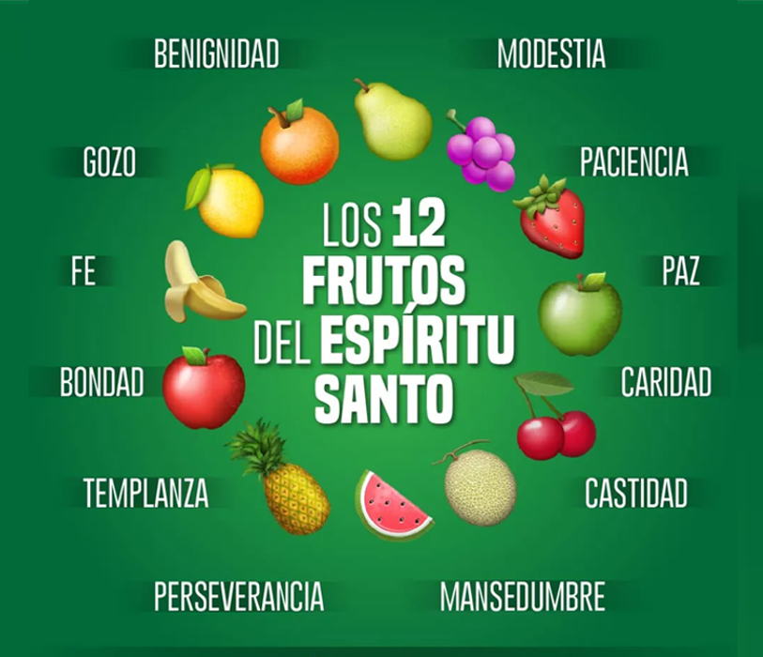
We have the seven gifts of the Holy Spirit. The Christians have that, but who practices it? What is the first gift of the Holy Spirit if there is a Christian here? Wisdom. What Christian cares about bringing wisdom to their life? Not to their brain, to their life, living wisdom. Second, gift of the Spirit... there are seven. From those seven gifts, seven seeds, come twelve fruits of the Holy Spirit. But what Christian studies that? “It is enough to believe, my son, no, do not ask.” Then they remain spiritually illiterate, they achieve nothing, unfortunately. Devotion must be accompanied by knowledge, belief accompanied by sapience.
It says in the Psalms: "Your word is a lamp at my feet and a beacon of light on my path" on my Road. Your word is a lamp at my feet, the teaching of wisdom. What is a lamp at my feet? In your daily life, try to do it with the greatest awareness and knowledge. And a beacon of light on my path, to prepare your future. The beacon of light guides the ship, where it should go in the future so that it doesn't crash against the rocks. Work on your present, your day-to-day life, with wisdom. And thus you prepare your future, making the wisdom of Heaven a beacon of light so that you don't crash into inconveniences, failures. So that you know how to swim on top... like the surfer, you float above the inconveniences, the storms of life. The little fish know how to do it too.
Nature is the sacred book of GOD, it is Nature, says Maestre de la Ferrière in the Psychological Purpose number 10, Nature is GOD manifested. When you see a little tree, try to look there. What is that thing that people call God and don't know what it is? How is the Divine in the little tree, in the blade of grass, in the little ant that sometimes gets stepped on without respecting that soul that has its right to life? Nature is GOD manifested. GOD opening His sacred book, His existential bible. Every day we are turning the page; every day is a page that brings us wisdom. How does it bring us wisdom? With your encounters, your disagreements, with your friends, with your coworkers, with what you see on the street; everything is speaking to you. Don't speak like a robot but open your five senses and you will see how your soul enters another level above ordinary life.
GOD has never left Humanity abandoned to the elements. He always sends a guide, a prophet, a saint, a mystic, a messenger. No people have ever been alone. Do you have the history of Humanity? Not the history of war, or politics, or dictators, or kings. But the history of the peoples, and you will see that there has always been someone who went to the mountains to meditate and returned with nourishment for the spirit.
Five senses, there is no sixth sense, five senses. The sixth sense is clairvoyance, seeing clearly; clairaudience, hearing clearly; clairsmell, clairtaste, clairtactile. Use the senses like a detective searching for GOD. “Aha, I surprised you in the scent of flowers, there You are, you don't fool me; I surprised you in the colors of fruits.” That's what [the sense of smell] is for. The five, four limbs, and the head, we have five limbs. And this [the nose] is the one that should preside over the senses.
Question: —What should the couple's love be like in Initiation?
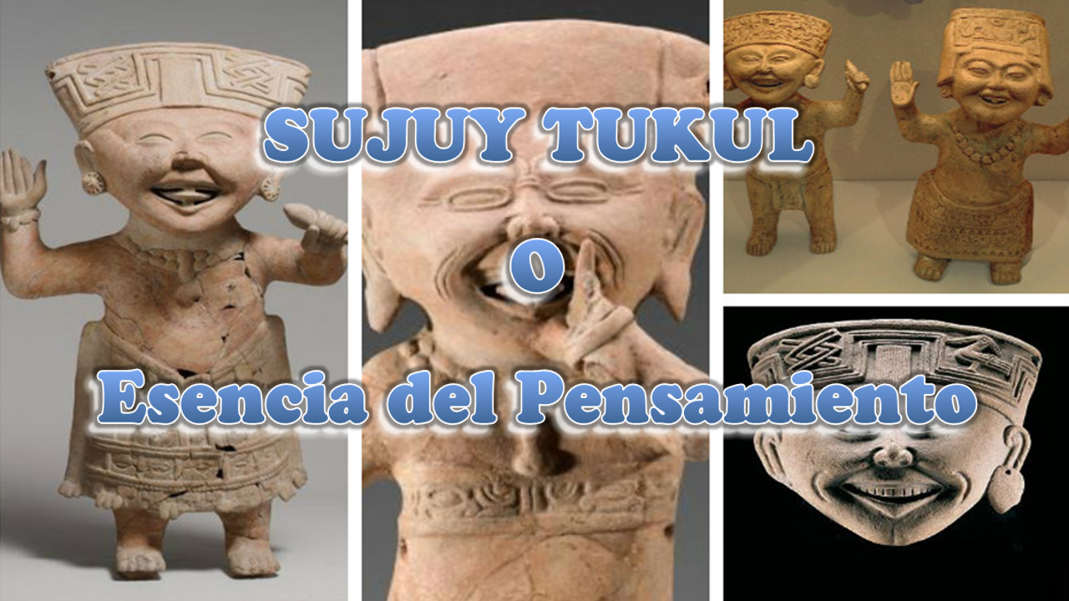
A: —Well, it's always the "how"; the answer is a technique, not a few words. How do you drive a car? Well, you first have to learn to brake before accelerating; you have to learn to start the engine, you have to... Step by step, right? So, always the question "how". When people ask me how to be happy, it has its technology, its gymnastics; it's not simply: smile every day! No, that's not it; people don't know how to smile every day. By the way, Mayan yoga is called Sujuy Tukul, which means "Essence of Thought." The first posture of yoga Maya—which is the Mathesis of Psychology— the first posture is joy, it's the basic posture.
And joy is born from what? From sadness. In Yoga Maya, psychological yoga, when you're sad, observe what makes you sad. Why do you react that way to what makes you sad? Look at your face in the mirror, so sad. “Oh, I don't like that.” And analyzing, analyzing, sadness turns into joy, and then, "How foolish I was. I'm not going to let myself get sad anymore. I'm going to keep my energy high." That's spiritual alchemy, transforming the dense into the subtle, lead into gold, carving the rough stone to make it a philosopher's stone. Your roughness, your errors, everything, work on it, don't feel bad, accept your flaws to work on them and they will become virtues.
Fine, so, how to be...? How did you say it? How to live the love of a couple in marriage?
That has its technology, right? Because love has its challenges, its storms. You have to see how uneven the relationship is. Not everything in a couple matches up. There are things that don't sit well, because each person has a heritage from different parents, was raised in a different environment, etc. So it's natural for there to be friction. But then you have to apply the Mayan technique, turning what brings us arguments into an encounter, which is where it begins. How is it turned...? Then at that moment, one begins to awaken a strategy to control oneself.
The true disciple and traveler in Initiation never blames anyone but themselves. If they get angry because they were told a lie, then they don't criticize the liar, because rather they criticize themselves. "Why did I get angry? Why? Why do I fall for that? That provocation? Why am I weak?" That's the task, and never blame someone else, because then you fold your arms. Since the other is the guilty one, what do I do? Then you don't grow. But that implies a technology, working on oneself, that's the technique, of transforming the rough into the delicate.
So, love, the word love, I say, because it's so small, people don't understand it well, and then conflicts arise. The songs on the radio and television, that's singing about an illusion. How does the song say? "Your eyes... Your teeth like pearls and..." It's singing to anatomy.
The woman can say, "Sing to me, don't sing to the body, that will wrinkle soon, sing to my soul. If you don't see my soul and what you see is my body, I'll give it to you, when I go to the grave. I'll give you my body. I want someone who loves me, my Being, my essence.”
And a man could say the same, right?
“Oh! I love you so much, your athletic body, what a champion!”
“No, don't love me for that, get to know me internally.”
The hardest thing is to know yourself, that's very difficult, because people identify with their body. If I ask you, 'Who are you?' and you tell me, 'I'm 1.80 m tall, weigh 50 kg, well... a skinny, Mexican. I still don't know who you are; you haven't told me anything. It's just external things, the embellishments you put on, a name, a surname, a way of dressing, exercising. But you're not that. You're in your body, but you're not the body. You're in the car, but you're not the car.
But there are people who say, “I ran out of gas.”
I tell them, “No, not you, the car. You're not the car. Why do you think you're the car? Why do you identify yourself like that?”
And that's what happens with the body.
"I need new brakes."
Not you, the car.
So, people think you're just your first and last name. No, that's not... A name is a whim of your parents; a last name is a social issue so they can collect taxes, the police can search for you, etc.; for social organization. But you're not your first and last name. It's not that it doesn't have meaning, of course it has its meaning, but you're not that.

Superior Course in Theurgy, By the Ven. Master T. A-O Domingo Días Porta
All Rights Reserved

