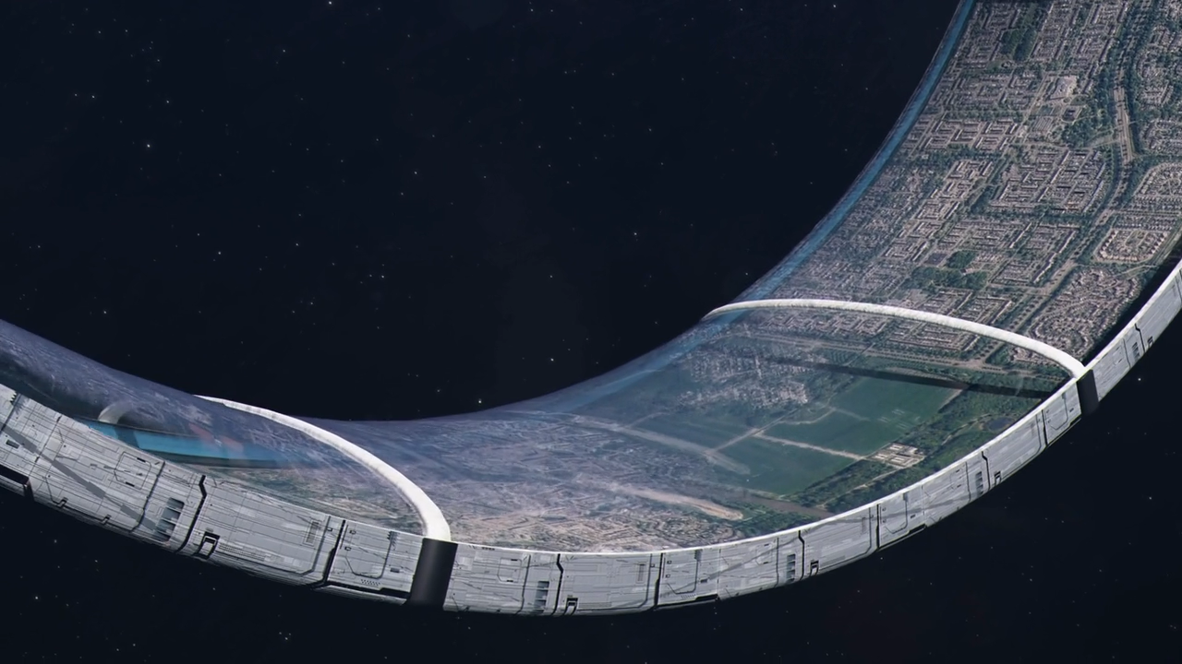
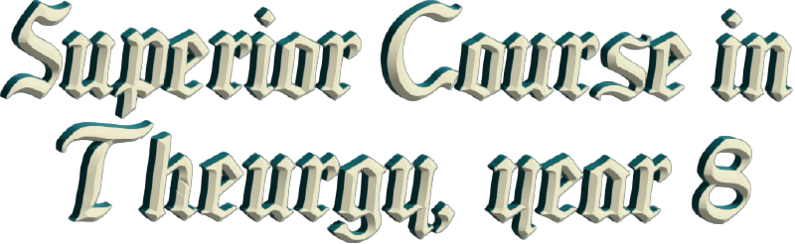




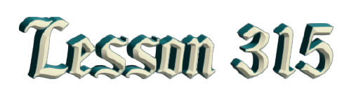
By Ven. Master T. A-O Domingo Días Porta

T
hen the number of members increased, and then they wanted to establish another lodge. I was no longer in Mérida, I was here in Mexico, and they agreed to name it "Human Duties" [...] the Human Rights Lodge became "Human Duties," heeding that call. And thus, we could all be aware of our human duties, personally, as a family, socially, in the workplace. As citizens, as members of humanity, we have duties, not to be indifferent to what happens in another part of the world, even if it's just sending a good thought, a prayer, a good wish; it's a way of contributing, of resolving problems.
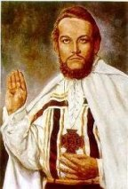
So, I tell you, when I’ve spoken in other places, get out of the pool of problems so you can enter the garden of solutions. Don't think about problems, think about solutions. "What a problem, there's still war!" No, how would I solve the war? How can I contribute? What solution can I provide that's within my reach? That's why, in a meeting, the peace greeting... The peace greeting is a mantra if the word is pronounced correctly. By saying "Peace!", we radiate waves of peace wherever needed. But by doing the mudra of peace, as you already know how to do, right hand, thumb contracted, the will directed toward oneself, not imposing yourself on others, like those who greet wanting to impose themselves. Toward oneself, controlling the four foundations of life. And with the attitude, the mandala: mantra, mudra, and mandala, your whole being radiating peace, correctly.
But some people greet like this, no, it’s like this [shows the correct form]. In Venezuela, there was someone who had been a soldier, and he would go to the activities and say, "Peace, brother!" [with his hand on his forehead, like a military salute]. I would tell him, no, it's not done like that. And there was one who was always in a hurry, and he would say: "Peace, brother... Peace!" [to the side, back, in motion] And I would stop him, [...] the body, for a few seconds, “Turn around, don’t be in such a rush.” Because poorly done, the idea of peace, the word of peace, contributes nothing, then, it's not yoga. The yoga of life is sacred.
I ask students, “How often do you practice yoga a week?”
“Two, three times…”
Look, you're not doing yoga, you're doing some physical workout.
“So, how much?”
Twenty-four hours a day!... stay in Yoga, in Union; eat-yoga, talk-yoga, walk-yoga, sleep-yoga, etc. Always stay in harmony, yoga is not just body postures but postures towards life.
So, the Avatar of the Era of Aquarius, our Maestre Dr. Serge Raynaud de la Ferrière, wrote in his yoga book, "Mathesis of Psychology" “The yoga for the New Era is postures toward life.” Not postures lying on a mat, but in the street, at home, at work, wherever, the correct posture. And that resembles Yoga Maya, which the Mayan elder Don Félix Pon Chuc told us about. When I asked him about Yoga Maya, he told me, "No, the word yoga isn't Mayan.” There's a discipline of human, individual, and social improvement called Sujuy Tukul, which means "Essence of Thought." In other words, a Mathesis of Psychology, not ordinary, university psychology, but transcendental psychology. Elevating our mind, not relying on memory, reason, in short... everything, imagination.
These are elemental faculties; there are transcendental faculties. Well, I say Yoga Maya, but then he corrected me: Sujuy Tukul. The first posture has to be joy, not bending the knees, but joy, because it’s a posture, a transcendental psychology. Joy comes first. I asked him, “What is the second?”
“No, we Mayans give the first spoonful and whoever receives it has to find the second on their own.”
Yug works with joy, and you’ll then find out. The Mayans never tell you everything, they release little pieces.
So, GOD, experimenting... I realized that the seed of joy is sadness, like, what you won't take to your stomach, is emptiness. So one has to observe sadness, what it consists of, and observe oneself, what makes me happy. Why do I drag my feet, put my shoulders together, lower my head to my body? But you’re putting on a show, that's it... —And why do you do...?
“It's because the other person offended me.”
And you let yourself be offended by the other person? You're weak-willed, can’t you control your sensitivity? Look at yourself in the mirror when you're sad, so you can see and you're not going to like bringing out the truth. They're going to laugh at you [...]. And sadness took a step before good, when you swept the dirtiness of sadness, the glow of joy appeared.
And that, I understood that any negative state, if it’s compared, it gives way to the positive state. And that is alchemy, turning the lead of base passions into the gold of sublime passions, turning the "rough stone" of ignorance into the "philosopher's stone of wisdom", that is, carving the rough stone and extracting the diamond beneath it.
So, our life is our school; there we get the tasks. There goes some sadnesses for you to work on; depression, anguish, an illness, let's see if you're capable. Or you are weak of character, dependent on another to cure you, another to bring you joy; then you are useless, a hindrance to Society.
We are, then, at the beginning of the Era of Aquarius. We are still in transition, the Era of Pisces still rules, but everywhere there are flutters of the New Era. There are small groups searching, searching, improving themselves. Be it in their religion, their science, their way of eating, etc., paragons of the New Era. The seeds stored in the Spirit's yearnings are already germinating in the undergrowth.
But there are still more than two thousand years left. We are just beginning. We are pioneers, and future generations will thank us for the effort we are making in this difficult environment, which is also a challenge. And when there is challenge our will is tempered, our character is strengthened. When one is […] and things go right, the character is weakened, is neglected, is abandoned, but thanks to problems and difficulties, our ability to solve problems develops.
The Elder Brother asked, at a university, “You who are students of science and [...], who know so much, define what a problem is.”
“It is a difficulty, an obstacle, an impediment.
And he would say, “No, nothing of the sort. You learned from elementary school that a problem is something that has a solution.”
And I remembered that when we were in elementary school, they gave us math problems, and we went home to find solutions. A problem is something that has a solution. A bad student complains, "They gave me so many problems, I don't have time, and it's hard for me, I get tired." But that is a bad student.
And anyone who complains about life, about their problems, is a bad human being; they are weak, they have some character disorder. So, don't give importance to problems, look for a solution, even if it's a temporary solution, in the meantime, to get through the situation, but never stagnate. Every difficulty in life is a challenge to your character, your intelligence, your feelings, your health. Life is a gymnasium to strengthen the muscles of our spirit, which the pioneers of the Era of Aquarius must have that character. To Know--To Want. Wanting in the sense of will: "I want... to be happy." Anyone who says, "I would like to be happy, but..." has no will, is clumsy. Because "I would like" implies a ‘but’, an impediment. As soon as they say, "I want", they advance in this difficulty, "I want to be happy, no matter what others do."
So, it's To Know-To Want. The Maestre de la Ferrière, the Avatar of the Era says, "Love in the Era of Aquarius is of no interest." That's what the Master of the Era of Pisces taught us, how love should be. In the two thousand years that have passed, Christians are supposed to know how to love, they have no problems, love is marvelous. In the Era of Aquarius, well, that's of no interest anymore; what matters is science, what matters is human development.
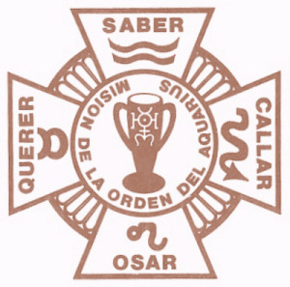
So, the sign of Aquarius, its key word is To Know. So, it’s not about love, but "knowing how to love." If you haven't studied the art of love, the philosophy of love, the science of love, the mysticism of love, don't get involved in that, because you'll "put your foot in your mouth", and then blame the other person, because you’re a bad student. "The science of human relations" must be taught from elementary school to university. The most important good thing one brings, has no course. They graduate from the university and commit ererors. They graduate disoriented and don't know what to do. They only received a profession; it's not the University, it's the Specialty. They came out specialized. Because [they’re...] the university.
I know the real University, it's in the Amazon. There you have to know [...] how to climb mountains, climb trees, farm, build your own home, understand the traditions of your culture, participate in rituals; you become a universal man, a universal woman. But in the city, they don't know anything about that; they give us cheaper things, they give little pills to the sick etc.
When we have the cosmic cathedral, open to the sky, we will go and talk to the sun, the river, the birds, the rain, participating in the work of the Creator, who is not lost in infinity, He is here.
The Elder Brother, in a recorded lecture, said, "Look, my disciples say that GOD is everywhere. I tell you, GOD is not everywhere, that's not true, "GOD IS everywhere." And there is a difference between being somewhere and being. Being somewhere implies a location. I can't say I am everywhere; I am here [...] on such a street, at such a number, in such a room. One cannot be everywhere, but one can be everywhere. Yes, I am the same here as there, wherever I go; I am everywhere.
The Elder Brother, in a recorded lecture, said, "Look, my disciples say that GOD is everywhere. I tell you, GOD is not everywhere, that's not true, "GOD IS everywhere." And there is a difference between being somewhere and being. Being somewhere implies a location. I can't say I am everywhere; I am here [...] on such a street, at such a number, in such a room. One cannot be everywhere, but one can be everywhere. Yes, I am the same here as there, wherever I go; I am everywhere.
Domingo Días Porta, which was the name that was given to me, I'm the same everywhere. But what am I? The first name, the whim of my parents, the last name for social organization, knowing how to distinguish those who have the same name and what the difference is. But that doesn't identify us, just by saying the name. I ask someone: "And who are you?" And they give me the first and last name... "No, I still don't know who you are."
"I'm 1.60 meters tall."
"I still don't know who you are."
"I weigh 160 kilos."
"I don't know who you are."
"I'm Mexican."
"I don't know who you are, you haven't told me anything.”
Like in astronomy, the Sun: such and such dimension, at such and such a distance from Earth, center of the solar system. You haven't told me anything yet.
I go to the astrologer, and he tells me, “The Sun is authority, it is wisdom.”
Ah, that does identify the Sun. In our, where we live, in our area, there we call it "urbanization", there are two astronomers. One asked me to give him astrology classes, and I gave them to him. And the other one came later and asked me for something, and I gave it to him. But every time I gave him the class, he would respond to my words and talk to me about astronomy.
"No, that sign, that constellation has this and that."
I told him, “Look, you who are in astronomy, gives us the size, the instant, the composition, the speed, etc., but that doesn't identify the stars. On the other hand, astrologers tell us about the personality, the character, of each star, of each constellation. And for human beings, that's what interests us, because when you are born, they put a seal on you, what they call the horoscope, the birth chart, it's marked on your spirit.”

With the first breath, at birth, one ingests cosmic energy, not just oxygen, depending on the planet's position. Then, that energy is imprinted, first in the lungs, in the pulmonary alveoli. It passes to the heart, the second seal, the heart rate, which elevates the vibrations of the Cosmos. Third, the brain; three seals, three. And that does identify. So, among astrologers, when two astrologers introduce themselves, one says, "I am the sun in Aries, the ascendant in Cancer, and the moon in such and such." And the other answers the same, and they get to know each other. "Ah! Very well." They understand each other now, because they reveal themselves in their inner lives. From there, of course, other details emerge, but it is the calling card between astrologers. It says much more than giving them a first and last name.
Well, I see a difference when I arrived in Mexico compared to when I arrived here [Guadalajara], where there was little presence, little organization. I went out into the streets and saw the situation of the people. I observed their faces, their way of walking, so many street stalls selling food seasoned with smoke, with pollution. I thought there must be a lot of depressed people, walking with their heads down, looking at the ground because of the pollution. No, I saw them walking energetically; a child was walking as if dancing, and how people survive in this chaos. And I realized they have two powers that protect them, which come from ancient times. They call them Iztaccíhuatl and Popocatépetl, two snow-capped peaks.
And I confirmed it. One night, there was a very strong wind in the street, and someone who had his stall got up, and his little plastic chair, his stool, was blown away by the wind, towards, into the traffic. And someone said, "It's a ghost, its's enchanted, the chair, don't touch it." Everyone screamed, Lupita put her foot on the stool, and she got it back.
So, I say, that comes from Iztaccíhuatl or Popocatépetl to sweep away the contaminated air. I don't know if that happens every night, but there is a protection there. And here, I was greeted with a chant in Sanskrit to the Supreme Guru, to the Creator, with song and music from our ancestral culture, which is not the past, which is alive. I have seen throughout America, our culture has not died, none of it. And that of the Incas, which was an era there in […], disappeared; the legacy left by that civilization is alive. Everywhere in America, they did not give up; they retreated, a strategic retreat of survival, of languages, of culture, of traditions, of families, not of defeat; and these are moral reserves of Humanity.
And Maestre de la Ferrière gives us a message; in the fifth message, he speaks of the Sumos Initiates, in Central America. Yes, they are in Nicaragua, in this area of Central America, on a mountain, the Sumos Initiates. There [...] from Central America, "Oh yes! The Sumos, the Indigenous Sumos." But the Maestre calls them the Sumos Initiates. I think it's... Why does the Maestre know, and we in America don't know about here, about our own? We know more about other lands.
The Templars of Chichen Itza, says the Maestre in the Fifth Message. Who knows about that? I went to Guatemala and discovered, at a water fountain, the pact that existed between the Templars who came from Europe, in secret, and their meeting with the Mayan sages. And the Templars of Europe said, “You, work for us Templars, so that they don't erase you from life.” So, the Maestre names them: The Templars of Chichen Itza.
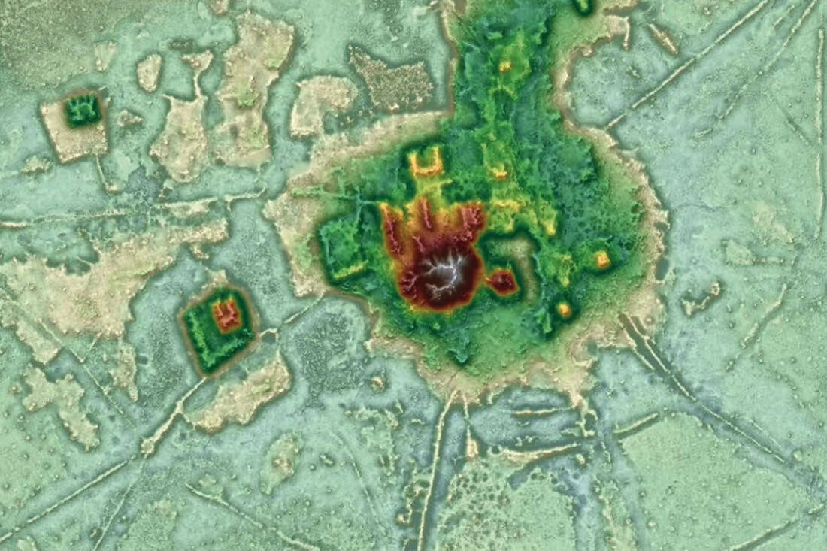
The Wari Runa, in the Andes, says the Maestre... We don't know about that. Who knows about the Holy City of the Amazon, about the great cultures? Today they are discovering remains of civilizations under the Amazon rainforest, ancient civilizations.
So, the colonized, the mestizos who came from Europe to America, to Indian America, are slowly opening their eyes. In Peru, when I [...] in Peru, I said... Flights came from Europe and the United States to the Amazon rainforest, looking for shamans to cure them of their routine, their depression, their fatigue from excessive civilization, living in nature, living... clean air. And the shamans took pleasure in curing the civilized. Boasting, with their constant wars, tyrannies, etc., and cleansing those groups who came from the north. They sent cleansing to their people; they performed special rituals for that. In Chichén Itzá, every March 21st, people from all over the world go there, to commune with Mayan wisdom. So, these are announcements of an awakening; the pyramids are being activated.
Well, many topics to discuss, but I'm happy to be among you, to see you again, to know that you are firmly on the Path that is everyday life. Each one at their respective point. Some are just starting out, others are halfway. And so, everything has value, and the people who walk everywhere, in the streets of every city, are also on the Path, they are in their struggle. The day will come when they will have an encounter that will define their lives.
So, I want to give you the right to speak so that you can ask me questions. I've come to take the temperature, to see how far along Mexico has come in general in the work for the Era, with those who have been given the responsibility of moving forward in this work, who may be standard-bearers, those who have remained steadfast and have carried out the work for Society. The Maestre says, our goal is the re-education of humanity, and those in our group of disciples must go to the media, universities, government buildings, etc. To spread the message of the Era, and the principles the Era brings, the new commandments, the new spirit, the way to conduct oneself in these times of change. That is the work of the disciples, the re-education of humanity, starting with re-educating oneself first, teaching by example.

Superior Course in Theurgy, By the Ven. Master T. A-O Domingo Días Porta
All Rights Reserved

