
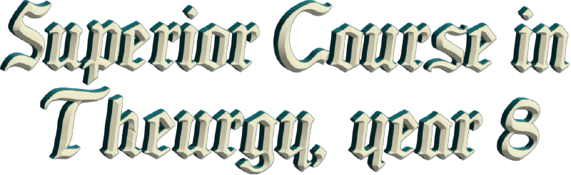
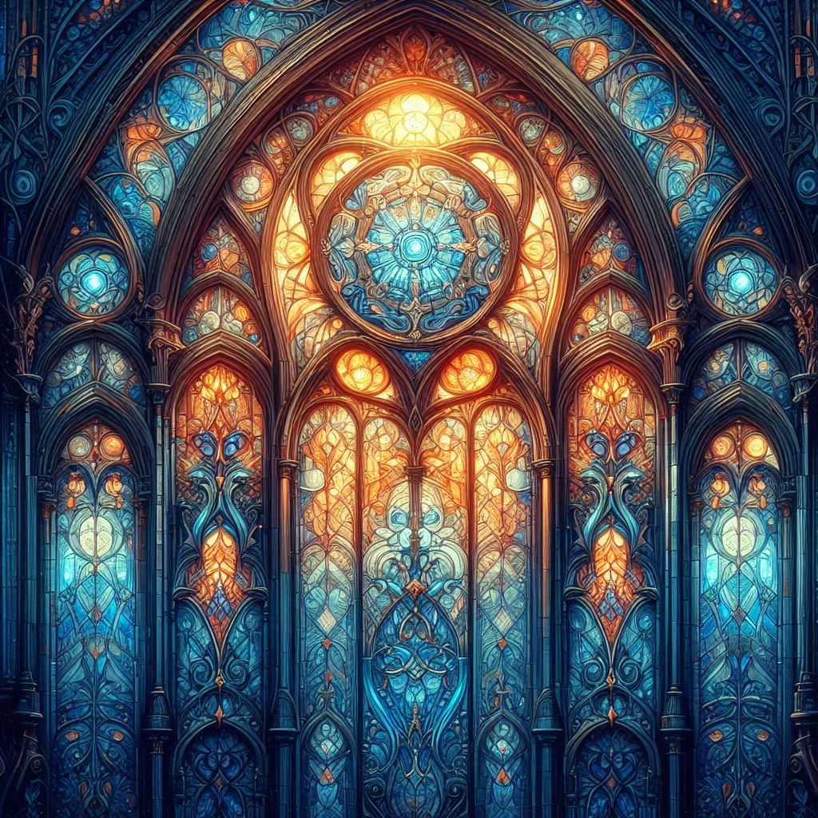



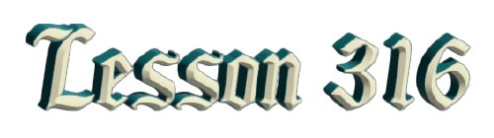
By Ven. Master T. A-O Domingo Días Porta

M
aster Domingo Días Porta: —Here we have a question.
Question from the audience. —Is Mexico advancing spiritually to advance economically?
Master Domingo's response: —That depends. Sometimes, when the economy is going badly, people look for ways to improve themselves, to face problems. Problems are challenges, and the right thing to do, is to seek solutions and not cry over a problem. When the economy is going well, sometimes there are people who become materialistic, fall into consumerism, into buying and selling, they get caught up in sales, discounts; they give more importance to that than to their spiritual culture; so, I would say it "depends". I use the word "depend" for many things, so as not to get involved [...] how it is applied. Money and how the lack of money affects health and poor health, that depends on each person, on their human quality.
Q —I would like you to tell us about the secrets of MAIS that "Negro Mateo" gave you.
A —Yes, that was in 1950, 51, 52, when after the internal experience that I had, I went to see the Elder Brother. He had the degree of Gag-pa, the Dignity of Gag-pa. On Sundays, he held the Cosmic Ceremony, and that... —the explanation of why with the 2nd Degree... But that's not the point— . After the Cosmic Ceremony, he directed the Study Center, and we went out to the hall. Then there were several points that were discussed, and he gave the right to speak, then he would do a compilation. He would finish the point... everything, of what was said, words of Elder Brother, he would summarize what brother So-and-so said... "But you have to observe..." And he would add his point; he would add the summary and everything.
And "Negro Mateo" would go to that Study Center, whose name I never learned; black, because he had black skin; Mathew because he knew everything about Saint Matthew in the Bible ... esoterically, and whatever the topic was, be it astrology, yoga, whatever it was, he would say, "Saint Matthew, chapter such and such, verse such and such."
And the Elder Brother would search... “Correct!”
There Saint Matthew would talk about astrology, the planets, in short, about health, about whatever. When the study center was over, the Elder Brother would hug him, "I love you very much, my Negro Mateo."
And Negro Mateo's white teeth shone in his black skin. He had his "corrugo," which they call a cornfield here. He had his cornfield near the ashram in Venezuela, where the Maestre was, the Ashram of Limón. When he went to the ashram, he would first go to his cornfield.

Then, he would teach us the secrets of corn. When the seed was planted, "Look: here you don't see anything, but here is the power of life." When the seed was broken into two little pieces [...] action of life. That's how the Universe began, from a point that opened, and that point was broken. In the seed, there is the corn plant like a little point, the rest is food for the seed. In the egg, in the center of the egg, there is a little point that is the future chick, the rest is food. In the ovum of the human mother, there is a little point that is the future human being, the rest is food. When we cut two little leaves of a seed, the law of polarity is applied in life, like this, like this, like this. Nature continues in the human being like this; and so on.
But he told me, “Keep it in your heart.” I understood that I shouldn't speak of it, that it was the secret he had given me. So, in 1952, I remained silent; I didn't speak of it but continued observing corn and studying it. Here in Mexico, I went to museums to see the origin of corn, the teosintle, the evolution of the plant, the myths of corn, which I found here in Mexico. But, in 1977, when I went to the Republic of Ecuador, in South America, to a community of the Otavalo culture —which numbers half a million throughout Ecuador, an indigenous culture. When I arrived at a small town called Peguche, they announced that I was going to visit them. They began to [...] about three or four little houses and the other side, three or four. And they placed me there in the middle. The men each had a bundle of corn in their house; the other, the other, I watched them. The women with a child in their arm, would take the bundle out, and the man would put it back in, and the woman would take it out again.
I said, “Couples here are fighting like in the cities. How strange, and in the indigenous world too, it can't be.” But then I could observe they were calm, no, they weren't fighting. I said, “Then it's a ritual, a ritual with the corn.” And I said, “They're trying to tell me something, because it was around me, on one side and the other, it's for me. The man brings the corn into the house ... Ah! Negro Mateo put the corn in my heart; he told me to keep it. And the woman with a child in her arms is asking me to take the corn out of my heart. To take it out, that it doesn't belong to me, that it's a heritage of Humanity, and that the new humanity needs the work of the corn.”
All that in silence, but I understood it like that. When we finished that, we went to eat, and there was a long table, with the village elders at the head. And I asked to speak and stood up. I told them, “Look, I received the message. I accept what you asked of me.” Nothing more, there was no talk of corn or anything else. The elders laughed and we ate. And that night at the headquarters of the Fraternity in Quito, I wrote corn on [...] paper to see what I could come up with from the word “maíz ”. I wrote various things, and in the end, it came out as Mancomunidad de la América India Solar. Maíz with an "S", the Z is broken, it has to be "mais", with an S, the S is continuous, it's the spiral. You can make a movement that can be seen, Mancomunidad de la América India Solar, M. A. I. S: MAIS.
And the next day, after the ceremony, I told them, “Look, I have this project because this happened to me.” I told them the story, what happened the day before, and I had a draft of the bylaws to establish this movement.
And the young people were excited and said, “Let's go to the notary, Master, let's register it.”
And then I sent the draft bylaws, and the Civil Registry said, “It’s fine, just a small change to bring it into compliance with Ecuadorian law.” And that day, October 7, 1977, MAIS was born in Ecuador. That's the story, in a nutshell, but there's a lot to tell.
Q: Could you elaborate on the fact that old age doesn't exist in our DNA, but rather, it's a disease of the mind and our emotions?
A: —To elaborate, it's a special topic, because life is life, GOD is not the author of death. I haven't seen any sacred book of Humanity that says that GOD created death, and in the Bible there is an […] that was made in his image and likeness. And it says that GOD is eternal and infinite, and we are the image and likeness of... Ah! So no [...] I remain in His image and likeness. Others want to create an image of suffering, of illness, but... You have to go through that stage, but when you understand this, we no longer [...]. Well, that's what I'm telling you; the genetic code hasn't given us microbes... or cancer, etc.
Q:—It says here: —Dear Master, we are at the rescue of knowledge in our great culture, how can we inspire our young people to love their roots and not get lost in technology?
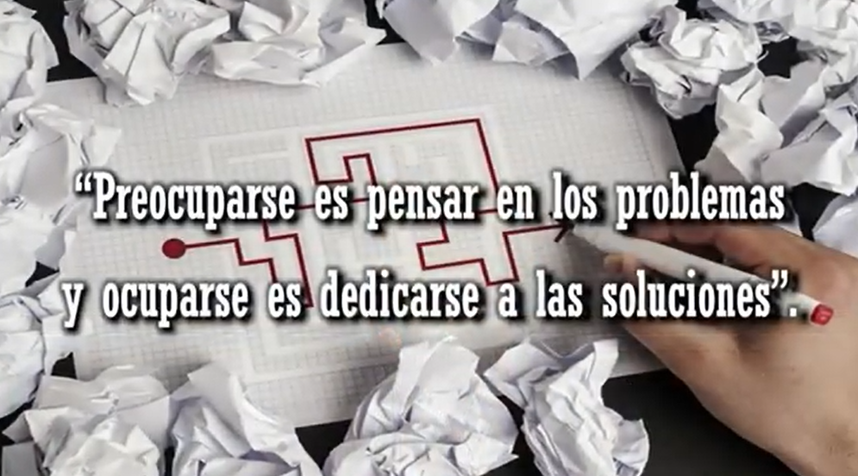
A: —That word "how" doesn't imply a word, but rather a technology. How can we fly an airplane? I can't tell you, give you a lecture to get you to learn how to fly; you have to take a course. So, how do you inspire young people? That's a question you have to ask yourself: What do I do to inspire young people? Because you're leading young people along false teaches, false paths, and I don't want to be preoccupied here; I want to be occupied. To worry is to think about problems, and to be busy is to dedicate oneself to solutions.
How do I inspire young people? So, I begin to do my job, first, by looking at the young people of today. What are they looking for? What do they do? How do they have fun? What do they think? How do they love? I get close to them and awaken that little worm of restlessness. You who consider yourselves pioneers of the Era of Aquarius, take responsibility. What should I do to contribute to not polluting the environment? What should I do, so families have everything they need? What should I do so that there is no more war in humanity? Take on the search for solutions. I contribute with a prayer, a thought, an article for the press, I go on television, etc.; I go on TikTok, for whatever, but I have to contribute something. I can't keep that to myself.
As they told me in Ecuador, you don't keep that to yourself. That's not mine, it's humanity's; in silence. But I understood, and I took responsibility and established a movement. Throughout the Americas, from Ecuador, I traveled through indigenous America, not colonized, mestizo America, from Chile to Canada, talking with Elders, with the people, family, and everyone, and there we shared with ourselves. The Elder Brother told me, “When you go with the Indigenous Elders, it should be as equals, not you more than them, nor they more than you, as equals... You present what you have received, and they present what they have stored.” And that’s what I did.
Q: —How do we know what level we are at on our Path, in the word, in the situation, or if we are already flying?
A: —That's self-analysis, self-reflection, self-examination, the Recapitulation Meditation I have taught, at night, going over the lesson of the day. If you find the lesson that produced a change in you, it's a day won in your life; you've gone up a step. If you didn't learn anything that day and blame others, it's a day lost; you've gone down a step. So, measure yourself, don't ask anyone, that, “Doctor cure me!” No, you have to cure yourself if you take vitamins and you change your habits. The doctor doesn't cure, the doctor advises, but don't think the doctor is going to cure you. Don't be lazy.
Q: —As a young person, and if I don't have my financial situation sorted yet, is it more difficult to be in the Order?
A: —No, because the Order will give you discipline so you can get ahead financially, in your human relationships, in your outlook on life, etc. Because sometimes the economy is bad for you because you have scattered thoughts, you're insecure, they're not going to give you a job, they ask you questions and you don't have the answer, they reject everything. You have to strengthen your character, not get caught up in difficulties.
Q: —I'm thinking of a solution that could be a youth Order that's accessible to young people, financially. A youth Order.
A: —Well, young people who have that interest should organize a youth business group, now that there's so much motivation and encourage that initiative. Be entrepreneurs, take advantage of that campaign that is available now. Don't let yourselves be caught up in circumstances, don't be weak of character. In youth, when coming of age, two paths appear, and the young person decides. There's a path that leads to decrepit old age and another path that leads to happy old age, and the young person should eat at once because later it'll be more difficult.
Good.
Q: —How do you see the Catholic Church today?
A: —I see it as more beautiful. I sometimes go to Mass on Sundays, and sometimes I correct the priest, but I participate. I think it's a Cosmic Ceremony because you have two hundred people attending Mass. I say, “Look, what a Cosmic Ceremony! With two hundred people, I give myself a treat.” And I support the priest; I send him my energy.
I once asked him, "Listen, Father, what's this about God saving Mary, saving her from what?" Didn't he say that she ascended to Heaven two thousand years ago?
“Well, it's that it was in Latin.”
“And why didn’t they translate that word, and they translated the rest?”
“Well, that's what the doctrine says, that's what the Church says.”
He dodged that, right?
A woman later told me, "Thank you, Master, you made me look up what ‘salve’ means." And she was at Mass explaining, right? That...

He would also light six candles, three here and three there. I told him, "Look, Father, six is a neutral number. You have to use numbers; there is wisdom in numbers."
"Yes, there is wisdom."
“So, put an odd number, because six is three minus three, zero, it neutralizes.”
Now he puts five, or seven.
So, I see it as beautiful. They are fighting, making an effort; the nuns are complaining, Cardinal so-and-so... The Pope, this... I say, how beautiful, they are entering the Era of Aquarius, my people, because I’m Catholic from my family, but I am not closed to the Catholic Church [...] But there are errors that are made in science, in politics, in everything, that is not the fault of the Catholic Church itself. What interests us about the Catholic Church is not the institution, but that they keep the presence of Christ alive every day through Communion. For two thousand years they have kept it present, which happened two thousand years ago. And one feels that Christ is present, in body and blood.
What is the blood of a Christ? Christ is not Jesus' last name; Christ is a title. The blood of a doctor—what is the blood of a doctor, the one that gives us life? The medicine, or rather, the body of a doctor is the medicine. So what is the blood of a doctor? The doctor's interest in the patient, the love he or she shows.
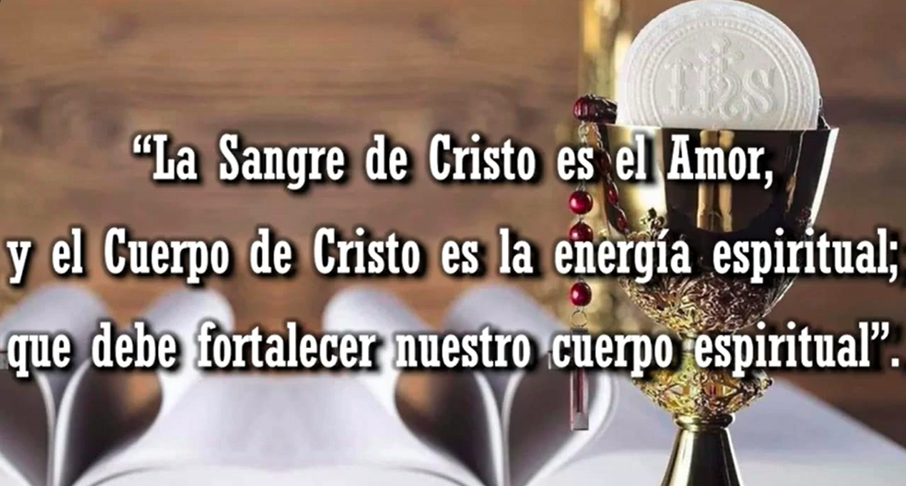
So, the blood of Christ is Love, and the body of Christ is the spiritual energy that must strengthen our spiritual body. It's not just about building muscles in the body; it's about building muscles in the spirit.
Q:—How do we distinguish and manage the spiritual ego?
A: —The how, another how, I invite you to the Initiatic College, to practice the disciplines. And apart from that, you'll learn to drive your car, your body, and to use the best gasoline, the best food, so that your spirit travels the right path. Don't add poison to your body, because it will block your spirit.
Q:Here are several questions: —Why or how is it possible that with all the contributions of our Masters and centuries of study, the new modern civilization is declining, because of the new generations who don't contribute or take advantage of so much intelligence given to them...?
A:—Ah, criticizing youth, when they are victims of society, of the parent’s education, of school, etc. Someone said on Facebook: instead of criticizing children, the youth of today, criticize their parents who didn't know how to strengthen them.
Q: (Continues...) ...and they act very modernized amidst so much technology that's only destroying human beings.
A: (Continues...) That technology is being developed by the old, not the young. And the young... When I was young, I used what society offered me; I danced boleritos, cumbias, whatever was in vogue at the time, waltzes. Today's youth dance to the music they're offered, eat the food the adults offer them, the drugs the adults sell them. The youth bring the spirit of the New Era, but they've fallen into the hands of false teachers, of the older people, of the government, who want to continue misleading them so that there's no belief in a world of peace. No, war is business. We have to drill war music into their heads, drums, strong, strong military rhythms.
Q: —How can we instill the knowledge of the New Era in young people?
A: —How? Another how. You should study the psychology of youth, pedagogy, etc., so that you know how you will guide youth, to awaken in them the energy that young people bring, who disagree with adults , who aspire to a different world, without weapons, without contamination, without disease; but that the adults [...]. May you be educators of the new humanity. The Maestre sets the goal of re-educating humanity, and that begins in the home with parents [...] who raise their children.
Q: Is it necessary to reach Initiatic degrees to attain enlightenment, or can it be achieved by following the teachings of life and the Path?
A: —Look, the Degrees are degrees of spiritual consciousness, it’s not because of the emblem, never strive for a simple ornament that you carry on the chest. Stive for what this represents: KNOW, WANT, DARE, SILENCE... TO WANT-TO KNOW, TO WANT-TO DARE, TO WANT-TO SILENCE; TO WANT-TOKNOW, TO WANT-TO DARE, TO WANT- TO SILENCE etc., and practice that. This is nothing more than a call to work, it’s not an ornament; it’s not to show off, it’s not for [...] little things.

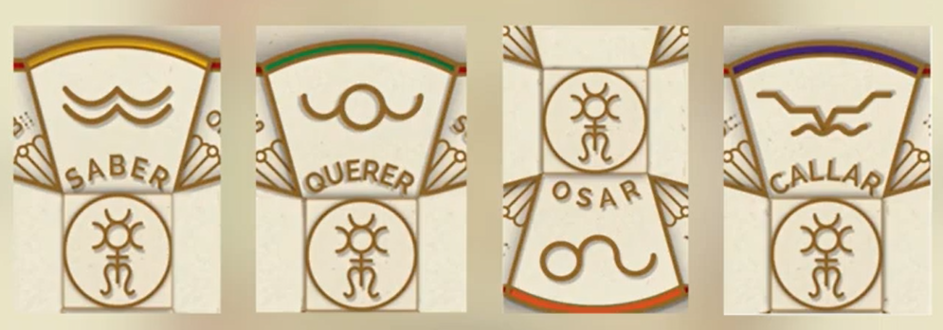
A degree of Consciousness represents this: the degree of maturity of consciousness, of spiritual maturity, of human maturity that manifests itself in attitudes, in behavior, in vocabulary, in the topics of conversation you have, in the decisions you make, in your conduct in the family, in the work environment, with friends, as a citizen, as a member of the New Humanity, etc. RESPONSIBILITY, the smallest chapter in The Great Messages of Maestre de la Ferrière, and for me, the key that gives meaning to all his writings, two and a half pages, three pages.
RESPONSIBILITY, it's there in marvelous codes, if one applies it to one's life, if one reads it... [nothing more]. One more detail, one more reading; but what is there, I would write it in letters of gold. It's a new commandment for the Humanity of this Era of Aquarius. For the humanity of before, which was illiterate, ten commandments, how easy, right? And the Maestre brings 36 Psychological Purposes. Instead of giving them a command, he gives them a purpose. In each Psychological Purpose, there is a purpose that one must cultivate. It's not obvious; one has to investigate in the pages of those little books, those pamphlets, what Purpose #1 is, #2... The title already gives a clue about each purpose, but the work is one's own. No Master writes clearly; he makes it difficult so that one uses the head, to develop one’s brain.
I taught at the university, and I didn't give all the teachings. I told them, I'll give you an overview, and you consult such authors, ask this professor, meet to discuss. If I give you all the teachings, you become lazy; what you do is copy and memorize; and I never accepted that. So, the Initiatic College, at first, an Initiatic school, two hours a week. What percentage of the week is two hours? Not even one percent, and the rest of the time they're caught up in the tangles of the world. And I teach that the Initiatic College is everyday life, that every day you're in the Initiatic College, you’re in the Kingdom of Wisdom, you’re working to correct yourselves, you're hearing the voice of Wisdom.
Be it the Bible, the Bhagavad Gita, whatever it is, breakfast for the body, even a little phrase for the spirit, at noon the same. But only for the body, then they walk around like that, all crooked. A little reading with a little meditation, three times a day, three meals for the being, for the spirit. Have your collection of sacred works, the older the better. Because now there are so many commentaries and tangles, and... And they write to sell, they give it a pretty title, but ancient writings are pills of concentrated wisdom.

Superior Course in Theurgy, By the Ven. Master T. A-O Domingo Días Porta
All Rights Reserved

