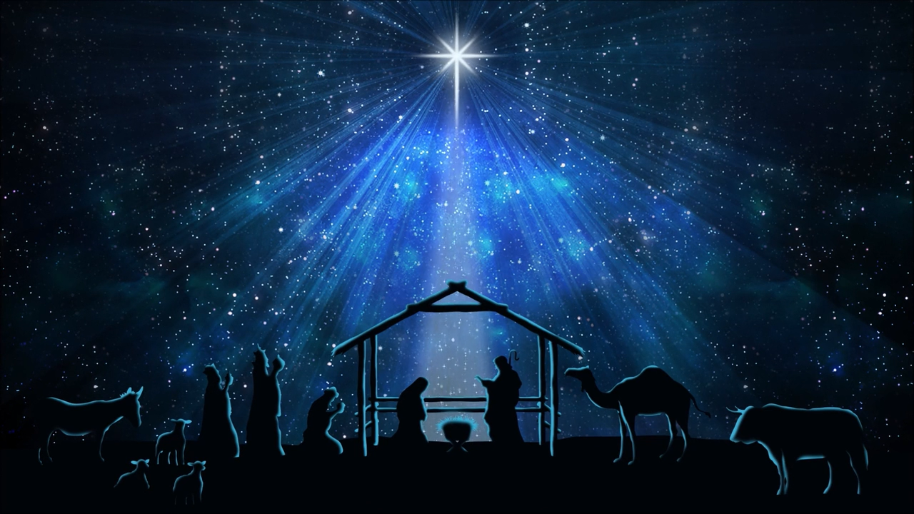
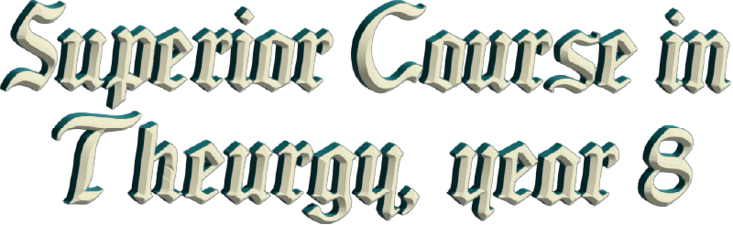
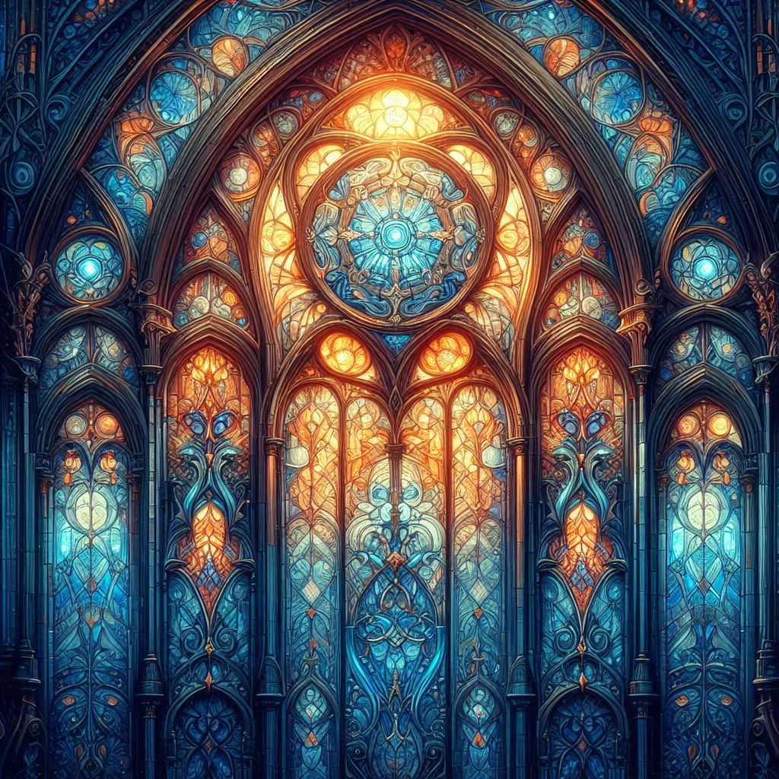



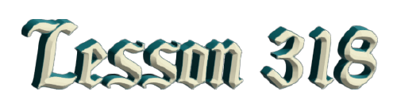
By Ven. Master T. A-O Domingo Días Porta

D
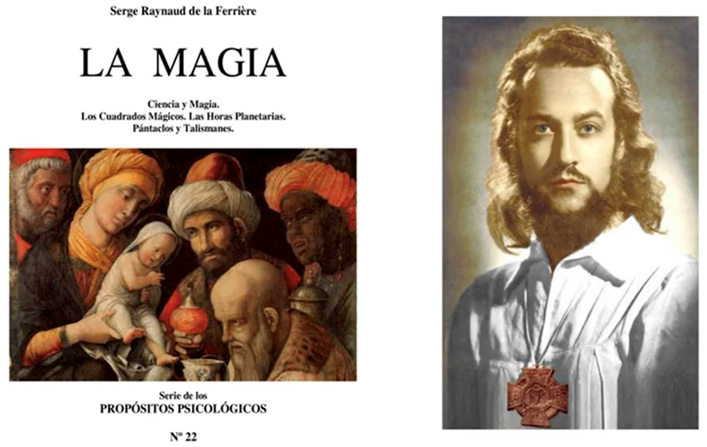
r. de la Ferrière, our Maestre, in his treatise on magic, begins the first page by talking about Christmas. And I wonder why, if it's about magic, why does he talk about Christmas? Then, one begins to study, “Oh, of course! Christmas is magical.” When you're a child, Christmas is full of magic, of mysteries, and your parents perform magic tricks for you, all that. But Christianity began with magic, with the Three Wise Men; that was the first, not the incarnation of Master Jesus, because he was a baby. Christianity didn't exist yet. But when the Three Wise Men were guided by the stars, that is, by astrology, those three kings, who weren't kings but were Magicians, applied the science of the stars.
At Christmas, the little star is placed and celebrated in churches, but people don't know the meaning of all that; Santa Claus, Saint Nicholas, who comes through the chimney, through the window, that has meaning. What happens is that these last two thousand years were an era of silence; the Masters couldn't speak. If they sacrificed Christ, what about a lesser master than Christ? They burned them at the stake, they hung them from the gallows. It was an era of silence. Back then, everything was kept in symbols, in legends, the ascension in body and soul. People hear but don't understand. Now is when the Door of Mysteries is opening, after two thousand years of silence, and our Maestre, Dr. de la Ferrière, is the one who brings the authority to open the mysteries and clarify those legends, those myths, those parables, because we are in the era of science. Science clarifies; stop with the stories, water is H2O, Hydrogen, and Oxygen. Stop with the stories, this and that, let's investigate.
Stop with the stories, that Christ ascended in body and soul. Let's investigate what lesson is hidden there for Christians. For Muslims, how did Muhammad the prophet ascend to Heaven from Jerusalem? That's not something to blindly believe in. But the mentality of people in these last two thousand years was —well, no, it was enough to believe, and that's what they said in the Church: just believe, don't ask questions, because it was a time of silence, you couldn't talk. Sometimes the pastors and priests themselves don't... I ask them questions, and they don't... And there are others who do, they investigate.
Well, then, Christianity began with the three Sacred Sciences. What are the three sacred sciences? Alchemy, Astrology, and Magic. Astrology, the Star of Bethlehem is a symbol to consult. The sages always consult the will of GOD in heaven and set out on their way. And the sages were three Masters who led the Initiatic College of Europe; one was white, came on horseback, and wore a crown. The other came on a camel, came from Africa, from the Initiatic College of Africa, and wore feathers. And the other came on an elephant from India, wearing a turban. And each one brought... One brought him gold, the other incense, and [the other] myrrh.
A baby doesn't need that, no, it doesn't matter... The Baby Jesus who... “Here I bring you incense”, and he'll say, "What I want is a bottle and diapers.” That's a symbol of the three sacred sciences. Incense is the air that rises, it's Astrology, it goes to heaven. Gold is Alchemy; in alchemy, it's said "transmute lead into gold", but alchemists conducted experiments to see if lead really turns into gold, as an experiment only, not to make gold. Because true alchemy is converting the lead of base passions into the gold of sublime passions, as is said of Master Jesus, the life, passion, and death of Our Lord Jesus Christ. He was passionate, not blindly, he wasn't like the Aries, who rushes in like that, blindly. He was born in Capricorn.
Capricorn is a very beautiful symbol of wisdom, a very profound symbol. It's called the "Gate of the Gods," through which the will of GOD descends through an incarnate being, a human being, for a specific era. Master Siddartha Gautama Buddha incarnated in the Era of Aries. He was passionate, but clear, and masterful. And he brought the science of the mind. One of whose centers is meditation, facing ourselves, our mind. Master Jesus in the Era of Pisces, which is water, which are the feelings, where Venus is exalted in Pisces; the planet of love has great power.
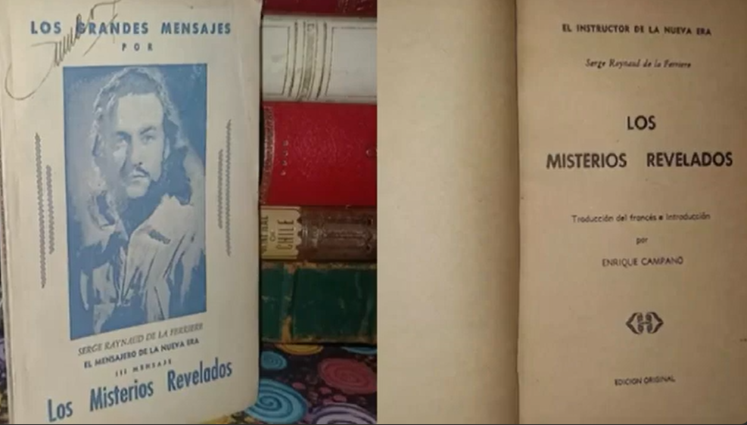
Master Jesus brought the science of love, which most Christians didn't study, and that's why there are problems with love among Christians, because it was a time of silence. So, the teachings of Master Jesus... well, "it's enough to believe." No, "Love one another," what does that mean? You have to get your head around that. And the Era of Aquarius is the era of Knowledge, it's the era of science. We want those mysteries to be clarified. Our Maestre, Dr. de la Ferrière, wrote... in one of his books, "The Revealed Mysteries." There are keys to deciphering what has been a mystery until now. They aren't clarified there, but he gives the keys so that one can use their brain, their mind.
It would be very convenient for someone to write everything down, and for people to copying and repeating it; that wouldn't awaken their divine consciousness. So, the Masters give us tasks; everything Christ said were tasks that we had to fulfill. Some apostles, saints, and some Christian philosophers fulfilled their duty. Saint Francis, who wasn't a saint, but was a rich young man, lived in a palace, and he decided, "No, I want to clarify." And he went to the mountain to meditate, and the mountain answered. The mountain is the temple of God. In the city, there are temples made by humans, but in nature, everything there comes from the hand of God, not from the hand of man.
So, Francis went to the mountain. From the first time, he understood interesting things. And Master Muhammad, the prophet, was six hundred years after Christ, but within the Era of Pisces. Those who have read the story of Muhammad have already realized his struggle. He received the book, the Quran, because the Bible is a collection of books: according to Moses, according to Jeremiah, according to this one, that one. But the Quran is from a single man, Muhammad, who received it in a cave in the desert. He didn't know how to write; he was a merchant. At that time, almost no one knew how to write, and in Jesus' time, there were no schools, everyone was illiterate, there were no bookstores, libraries, or universities. If you wanted to write a letter, you would go to the scribe. Scribes were those who did know how to write, they were very few.
So, Muhammad received letters, and he at that time, since there were no books or writing, relied heavily on memory. The apostles of Master Jesus didn't write, and they preserved everything they saw in their memories. The Gospels began to be written a hundred years after Master Jesus. The apostles had already died, but they had left disciples who also passed them on. Here in America, the same thing happens; in our indigenous cultures, there is no writing, but memory is used. There are Mayan hieroglyphics, the quipus of the Incas in Peru, but those were for a few who could read them.
Well, then, magic must be cleansed because it has been discredited, misunderstood, and confused with witchcraft and other evil things. And if there have been some who pass themselves off as magicians, but aren't magicians, they're sorcerers; they presume to be magicians and then cause harm, but the word magic in its purity is symbolized by the Three Wise Men, three Masters, three noble ones. They weren't kings of empires; they were kings of themselves. They knew how to govern their lives, their feelings, their thoughts, their destiny. They didn't live blindly like most people, waiting to see what happens, but rather they learned to take the reins of life into their own hands. How did they learn? In the Initiatic Colleges, in the schools of wisdom, with the disciplines.
So, a magician, a true Magician as the Maestre says, there on the page I sent you: Magician –Magisterium– Mastery – Master. The word Magic is linked to Mastery. The Magician is the one who has performed the miracle of transforming himself, who didn't object, who didn't say, "It's just that I don't have the will, it's just that, it's just that I can't, it's just that..." He stopped the nonsense and set out; he is the one who achieves mastery, true Magisterium, becoming the Master of himself. Master Jesus had Magisterium; he was a Magician. He had divine power because he renounced the ordinary human condition. As a Magician, he stopped the storm, he walked on water; but it wasn't witchcraft, it was Divine Magic, the power of GOD.
As an Alchemist, because Master Jesus mastered the transformation of lead into gold, transforming base passion into the gold of sublime passion. As an Alchemist, what did he do? He transformed water into wine, at the wedding, at the Wedding at Canan; there is wisdom in that. "He who has ears will hear, and he who has eyes will see." That is alchemy, and he was an Astrologer, of that superior astrology; he retired to a mountain to pray and communicated with GOD through the light of the heavens.
Because he gave us the Lord's Prayer, it is a prayer that is more than a prayer, it is a mantra, it is a power. But most Christians don’t study the prayer, they just repeat it. When they say, "Father," why call GOD "Father" if your dad is here? What does the word "father" imply? You have to study, and then one understands what Christ put there. "Our Father". Never say "My Father", say "Our Father" and the gates of Heaven open. When you say, "My Father," Saint Peter closes the door, “Selfish people don't enter here.”
"Who is in Heaven." What heaven is that? I would ask a priest, a Christian, a pastor, a pope, and they would tell me, well, that one [the sky, the firmament] No, "being" is the specific place, I am here, we are here, "well, we are in Mérida," that doesn't mean anything. The Zodiac contains the will of GOD, it is written for all time, that is the Bible of GOD, The Book of Wisdom. Whoever knows how to read that book will decipher all secrets, all mysteries.
Nosotros les damos al punto de partida, les hemos dado la clave, ya en el segundo semestre vamos a hacer las We give you the starting point, we have given you the key, and in the second semester we will do the practical work to understand this most sacred book. There are other constellations, other stars, but for us on Earth, that one... The divine will is written there, destiny is there. We all have a destiny; those who deny destiny have a destiny, "I don't agree with destiny, that doesn't exist!" And soon, boom, he fell ill! He got the coronavirus.
“Ah, you wanted that?”
"No, it's just the environment..."
Ah, fate, right? Fate got you.”
That's studying in the horoscope, destiny, and free will, but almost no one has free will, people don't... People are guided by customs, by propaganda, by fashion, by what the environment offers; almost no one knows how to manage what's called free will.
From the time you're little, you're influenced by your parents' customs, by the language your parents teach you, by what you eat; all of that is destiny. You don't choose which father you're born with. If everyone chose, imagine the chaos there would be. Everyone wants millionaire complacent parents; they want to be born in palaces. But GOD says, “No, this is not chaos. There's order here, there are laws.” According to each person's level of maturity, one will end up here, another there. But it's not like GOD is after you. That's why one says, "Hallowed be Thy name." People imagine that GOD is after every human being, watching them to see if He catches them in sin and send them to hell.
GOD isn't concerned with that. He's all-powerful, He is not a person, He is not a man. As humans, to get a little closer to GOD, we imagine Him as a human being, not an old man over there, or GOD, Master Jesus, the second person, or as the Holy Spirit. But that's to start with, that's the first lesson, it's elementary school. Then there comes a time when one realizes that GOD is everywhere, he is not just in a body, he is in the wall, he is on the ceiling, he is on the floor, he is on the battlefield, he is in a garden, he is in the cemetery, everywhere, he is all-powerful. No one can prohibit HIM, “I can't enter the cemetery, no, get out, you scoundrel!”
For HIM, death does not exist, GOD is the author of Life, in no religion is it said that GOD created death. Death does not exist, GOD created Life. "But so-and-so died!" He didn't die. He's still out there, alive and kicking. It's just that you don't have internal vision; you don't know how to see! He left the body, that's all, because it was in the way, it was no longer useful. But that's not death. The body doesn't die. If the body died, it would be useless. The body in the grave is full of life, and that's why little animals go there to feed, because there is life. There is no human life because there is no cellular life, molecular life, but there is life, there are tissues, there are organs. They don't function, but the food is there.
It's like oranges that have fallen to the ground. They're no longer on the tree, they're no longer receiving sap, but there is food. And people who eat meat say, "No, there is life. There are proteins and this, that...".
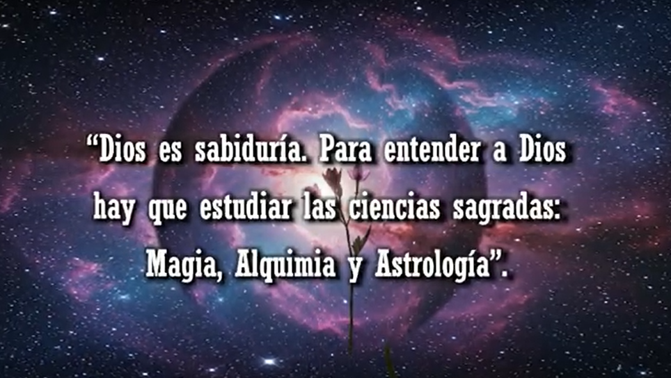
So, little by little opining up toward GOD. But GOD is wisdom, as the Bible says, the Old Testament, in the Psalms, in the Book of Solomon, GOD is wisdom. To understand GOD, you must study the Sacred Sciences: Magic, Alchemy, and Astrology, and that science includes the science we study at university. To advance in magic, you must know physics, you must know electronics, you must know... The science of today, in ancient times, was the science of the past: Astronomy. So, that's how we understand GOD.
I told a priest, “Look, GOD is not just a matter of religion, GOD is a matter of Science.” Our Maestre said that where he most felt the presence of GOD is in mathematics. Not singing Gregorian chants or praying, but in mathematics was where he felt the closeness of GOD, the perfection of numbers, which reflect the perfection of life. Everything is a number: how old am I, I live in house number such-and-such, my ID number is such-and-such. Numbers, numbers.
Most people repeat numbers but don't know the meaning of each number, the philosophy of numbers, numerology, the science of numbers, the symbolism of numbers: 7 chakras, 7 planets, 7 days of the week, 7 colors of the rainbow, 7 musical notes, 7. Why 7? 7 virtues, 7 sins. What does 7 entails? Of course, because 7 isn't 1 and 6, or 2 and 5; 7 is 3 and 4, the spiritual trinity and the four elements of matter. 7 encapsulates everything: 3 represents spirit, 4 represents matter.
So, that's how we're going to delve into what magic entails as a science, as an art, as a philosophy in these upcoming meetings. Not a belief, not that if I step under a ladder, it's bad luck, that's a belief. It can't be proven; it can't be explained. The symbolism of numbers, not university mathematics, which is for commerce, for engineering, for sending ships into space, but for us. How to use that type of mathematics applied to our lives? What does it mean that a person is 28 years old? What can I do at 28? 7 x 4! Four times 7, a cycle has closed.
The first 7 years, early childhood; from 7 to 14, second childhood, which implies the entry into puberty, adolescence; from 14 to 21, youth; 21 to 28, young adulthood, a cycle has already closed. So, he enters... 28 to 35. So, those who know the philosophy of numbers, at 28 years old, start to take measures because they already know they can't continue acting like they did when they were 15, 21. That things are serious, and they prepare. That's what we're going to study.
Dr. de la Ferrière, our Master, wrote a book on the symbolism of numbers. He gives clues, he doesn't explain everything, he gives the clues. A Great Master gives clues, keys to open doors of knowledge, and the disciple must do the work, apply the key and enter, and not be handed all the bread already eaten, the salad prepared. The disciple has to do his part, and that indicates sacrifice; life is sacrifice, properly understood, because what does GOD do? He sacrifices himself to give life; he constantly has to... He didn't just create—that's in the past. He has to be maintaining the universes, the galaxies, the stars, the atoms, the human anthill, the tigers, the fish; He becomes a sacrifice.
But not the sacrifice of the current word that people see as something ugly, something bad, but rather a "sacred offering," a sacred dedication. That makes what is called GOD happy, giving oneself to others. Like a mother gives herself to her children, a father to the family, a ruler to the country, with love. If the disciple doesn't make a sacrifice, well... He doesn't study, he doesn't read, well, he's not a disciple. He got used to it in elementary school, in high school, maybe in college. When I was in college, during exams there were classmates who wanted me to tip them off. I said, no, that's deceiving the professor, the university, the country. You have to make sacrifices. Forget the parties; you're a student. Don't look for a girlfriend because you'll get entangled, and your mind won't be able to study. Sa-cri-fice...
Numbers, the holy trinity, why Three? Why twelve apostles, twelve signs of the zodiac, twelve months of the year, twelve gifts of the Holy Spirit? Why twelve? 3 x 4, multiplication of spirit and matter..., 12 x 3 = 36. At thirty-six years old, you have experienced multiplication. If you have directed your life well, if not, you only know about four, you know nothing about three. You know nothing about the spiritual. You have dedicated yourself to your profession and you don't have time. Those thirty-six years were not well spent.
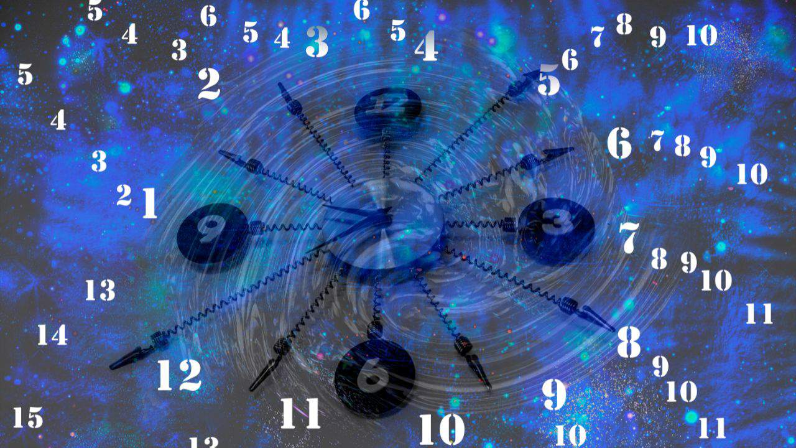
23, 46, 92. In Christianity, which is based on the Hebrew tradition in the Kabbalah, GOD has 72 names represented in the 9 angelic choirs, 9 choirs... For example, one choir, Archangels, 8 archangels; another choir, Angels, 8 angels; another choir, Seraphim, Powers, Dominions, etc.; 72. But those names, Archangel Saint Michael, Michael in Hebrew means... It's not the name we're used to, he wasn't called that, it's a power of GOD. Like saying Minister of Education, he's not called that, it's a power that the president gives to that man named Antonio Ramírez, but he holds the position of Minister of Education, the Minister of Agriculture, of the Economy.
Thus, GOD delegates, in his government, he delegates functions. Whoever wants to ask God for bread, what will God say? Not even God will receive them. Saint Peter will say, "Look, there's the Minister of Food. Don't bother God with that nonsense, go there in your human anthill [...] food so he can give you bread. That, “God, heal me.” Look, there are the doctors, healers, in short... Medicine Man, Medicine Woman, nurse; don't bother God with that. God delegates, delegates, delegates, and He takes care of the most important things, like the president of the republic. He delegates all those tasks to the ministers, and He is in charge of seeing how the country is doing, and he reviews and holds each minister accountable, and he travels the country and observes, and takes measures.
But if the president of the country is dedicated to the economy, well, then he's going astray, because the president is doing the math at the Central Bank. What presidents do you know who studied the profession of being president? No one. So, there's the president who studied to be a lawyer, an engineer, a politician, a soldier. They don't know. When they become president... their heads are boiling; they’ve never seen anything like that. In the past, it wasn't like this. In the past, to be king, the king's children had to go to government school, let's say, for that profession. They were prepared from childhood. A s one sees in the life of Buddha, who lived in a palace. His father was a king, and how he was educated to be a king.
And when he resigned, his father, who was already old said, "But son, we educated you for that."
"But Dad, I don't want to be locked up in the palace. I want to go to humanity. I want to share what I've received."
But well, that's how it was in the past. When a king, who had been educated since childhood, died, he would leave his eldest son or daughter, he was at peace because he knew he was already prepared. And so then the king when he would call his eldest son or daughter and say, “Look, here we have this problem. Go to the Council of Ministers so you can see what being a king is all about." So the prince was already prepared. And that's what Siddartha Gautama, who became Buddha, did when he was young. He participated as a listener, and the father sometimes asked his son, the prince, for advice. “In this situation with the neighbor, where there's a risk of conflict, what do you advise?” So Siddartha, who wasn't yet a Buddha, gave advice, and the father said, "No, it's not like that, son, but it's good that you're intervening. I'll explain how things are."
That's not how it is today, thus, peoples are adrift, countries, because of Putin, Biden, this one, that one, the other. We realize that this school is missing, that it wouldn't involve going through all the faculties of the university, no, not that, it would take a lifetime. That school will arrive when the theocratic system of government is established, the government of GOD it’s called. Which is not of a man commanding and with an inquisition, there is nothing of that; it is not a religious government, it is a government of wise men.
Humanity is going on that path. When the people say: "No, we can't do it anymore, this doesn't work, neither democracy nor dictatorship, nor communism nor capitalism nor...” We're still with the same things, with disease, with wars; poverty on one side and too much wealth on the other. The Earth is sick, we're polluting it, and no one is taking care of it. Then, the true apostles will emerge, saying, “Look, we bring the solution.” That day will come, it's not far off, but we won’t see it, future generations will. But we already realize where the consciousness of humanity is heading toward a profound change. Spaceships sent into space, cell phones, computers, the Internet, are worthless if we don't resolve the flaws in the lives of the people, of individuals, of nations.

Superior Course in Theurgy, By the Ven. Master T. A-O Domingo Días Porta
All Rights Reserved

