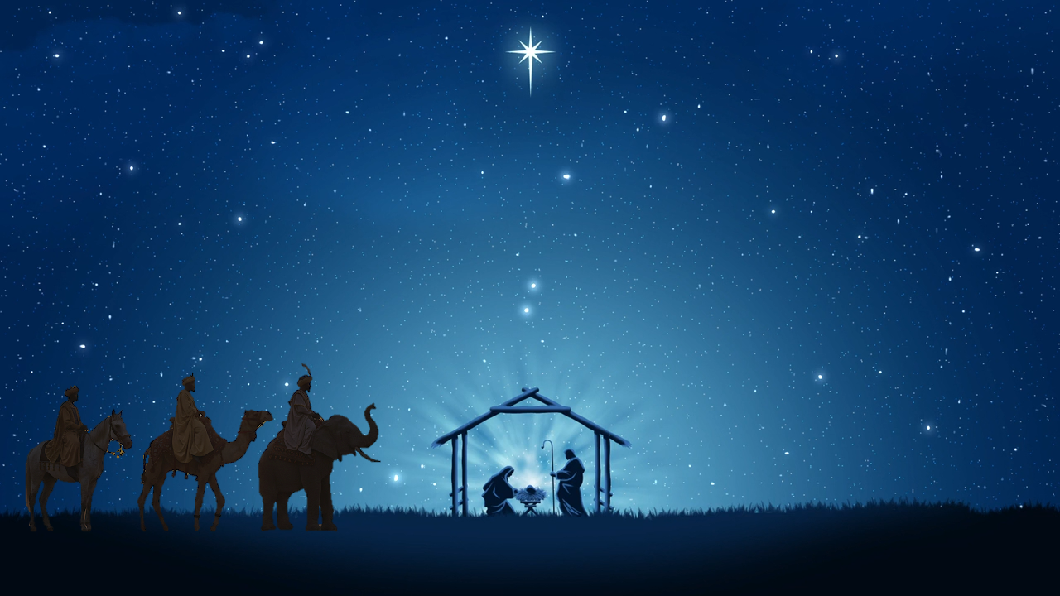
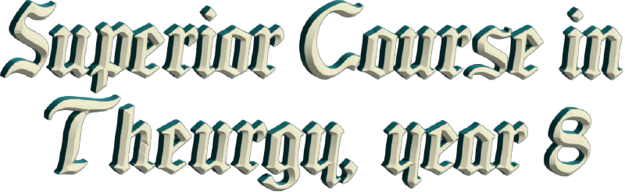
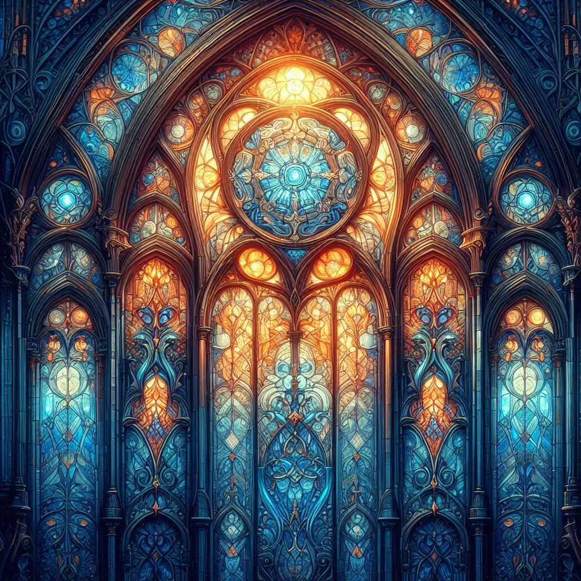



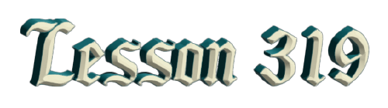
By Ven. Master T. A-O Domingo Días Porta

T
he Three Wise Men—they weren't kings, but each of them represented the Initiatic College of each continent. And at that time, there was a theocratic government in a certain area, not in all of Europe, not in all of Africa, not in all of Asia, but the Masters intervened in some of those governments. So, they brought both spiritual and moral authority, representation of their people. But where were they going? They communicated. The Masters of Africa, Asia, and Europe communicated because they were observing in the sky that the planets were going to take a certain position, and that brought about a great change. The Era of Pisces was approaching, the Sun was there. And they communicated and consulted and agreed on where the divine will, for the change of Humanity, would occur. And they found where the three continents met: the pilgrims, the merchants, the travelers, the armies—a place in Asia Minor where there was a crossroads. There came the path from Africa, the path from the East, the path from India, and the path from Europe.
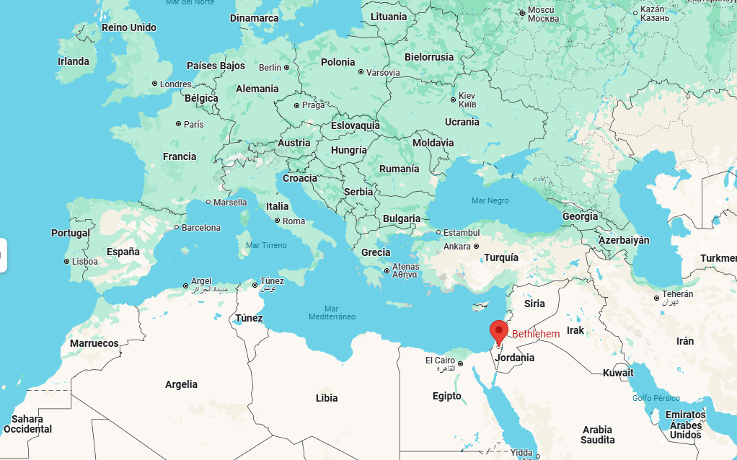
That place was called Bethlehem. Since the three continents, the three peoples, the three kingdoms meet there, the descent of GOD's will, must occur in that place. So, the three Initiatic centers each delegated to their Supreme Master the power to go to that place to protect, because there was a danger that materialistic forces would prevent that. What they call "The Massacre of the Innocents." Then the Supreme Masters Europe, Africa, and Asia left and met. “We’ll meet on such date.” Of course, they didn't come alone; they already had their retinue. If they were kings, they would bring an army, but since they were Masters, they were spiritual kings, they brought minor masters and some disciples, assistants. A long journey from India until they arrived there to that area, and from central Africa to here, from Europe… They didn't come alone.
Of course, the important thing, what the symbol highlights, is the three Wise Men alone, because the teachings preserved for two thousand years are now becoming clearer. So, it is very beautiful to study the history of Buddhism, Christianity, Islam, and the traditions of the Americas, deciphering the symbolism to apply it to one's life. Not to be limited to the story of the Three Wise Men, no, magic in life, in my life. What can I learn from that event? How the Three Wise Men taught the parents the three sciences so that their child wouldn't become just another human being, but rather a child of GOD. He brings power; he is not a baby.
In the baby's body is the ELDER of Wisdom. “You are not his parents, you are his protectors, his guides. You have to know about this, this, and this. Take out his horoscope so you can see about your child, the one you call your child, but who does not belong to you.” That's why Jesus, once they told him, "Master, your mother and your brothers are waiting for you," said, "My mother and my brothers are those who follow my path." He didn't feel like a mom's son, he felt like a son of GOD. It's not that he didn't respect his mother, of course he did, she's there at Calvary, but he wasn't in that human condition of "Oh, yes, please, I'll go see my mom." No! I'm fulfilling GOD's will, let mom wait.
Magic leads to Magisterium to Mastery. We begin as disciples trying to master our feelings, our emotions, our human relationships, to open the field of light. Not to make our lives miserable like fools because this one told me, because that one did me, because it was this way. Don't hurt yourself, don't destroy yourself, the divine spark is in you, that's magic. That song, "You have white magic," reflects a man's feelings toward a woman who possesses magic, but he doesn't understand it. He says, "You've cast a spell on me." What is a spell in magic? How do you cast out a shadow? How did Christ cast out the demons of the possessed? That's magic, powerful healing magic.
And Christ also told the disciples, this illness is not cured except with prayer. When they brought a sick person to Him, “This person is not cured except with prayer, no medication, nothing at all. And with prayer He cured, but, a prayer of power, “Our Father who art in Heaven…”, that opens our minds, “…hallowed be Thy name…”. What does that mean? It’s said quickly but it’s not understood, hallowing the name of GOD, what’s that, or of the Father? That requires study. It’s a prayer that comes from the Son of GOD, it comes from Christ. I don’t know, upon hearing it, I would say “the cat’s in the bag,” there’s mystery there, there’s wisdom there, word for word. “…Thy kingdom come…”, what is it, what kingdom are you asking for? Do you know what you’re asking for? You, poor, deranged, anguished person, asking for the Kingdom of the Angels. Are you prepared for that? Better not say that, first prepare yourself.
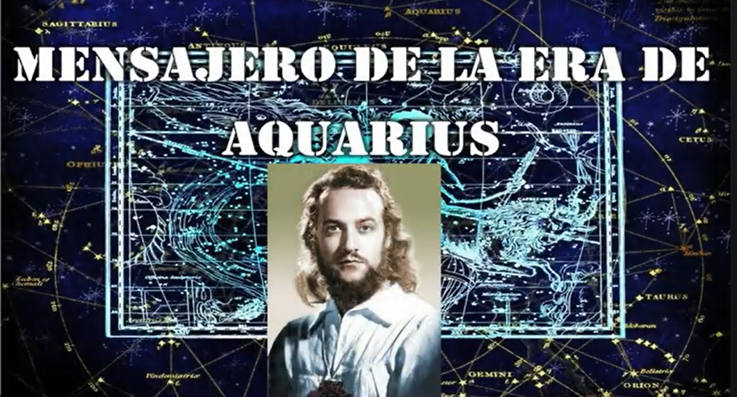
We have the Universal Prayer that our Maestre brought. Our Master is the messenger of the Era of Aquarius. He brings the Gospel of Knowledge, of Wisdom, because that is the word of Aquarius. Master Jesus, of love. Not today, now it's not about loving, there's a lot of confusion. Today it's about knowing how to love, knowing how to eat, knowing how to work; knowledge comes first. Everyone goes to school, children, young people, and the elderly, because they don't know.
Well, then, the Universal Prayer that the Maestre brings, the first four phrases, are a way of sanctifying the name of GOD. To sanctify the name of GOD, is not just simply saying GOD, but more as if you're going to speak with a president. President of the United States. “Hello Biden!” No! That's not right, he's not Biden, he's the president. "Your Excellency, Mr. President of the United States of America," with all due respect. And thus, don’t say the name of God so simply. Merciful, Infinite, Almighty, Eternal, acknowledge him, bow down. In the Universal Prayer, it says, “Blessed, merciful God, One-Many Father of the Universe, Sublime Creator of all beauties, Heavenly Giver of kindness and forgiveness…”
By saying this, the gates of Heaven open, the Angels descend, because you are saying it with knowledge, with conscience, with respect, wanting to feel like a child of GOD. And in the second part of that prayer is what one must fulfill to deserve the coming of the Kingdom of GOD, because “While you are at war, sick, and anguished, and making a mess of love, please do not keep asking me for the Kingdom of GOD.” The second part says, “…our hearts are saturated with Your love…”—divine love, not the love of the songs—“…let Your beauty vibrate in our spirits…”
May we admire the beauty of GOD's work even in what people believe to be ugly, feeling that there is science there. And so the prayer continues, setting the rules to dare to ask for the Kingdom of God. That's no small feat. It's better to vote for a president, a candidate, but asking GOD to come and preside on Earth! If humans have persecuted the Masters and burned libraries, how dare they ask. But they have the right to ask as long as they comply with the rules:
"Dad, I want to be an engineer. Give me a ruler and a compass."
“Son, no, you have to go through several stages. But I'll buy you the compass and the ruler, but you're not going to be an engineer yet. [You must first] prepare yourself.”
Humanity is on the verge of a very great transformation because Humanity, through its peoples, has gone through many trials, many sacrifices. Mistakes have been made, evils have been committed, but there is always the noble side because we come from GOD. Even in the common criminal there is the divine spark, “He can be transformed”, said Christ. In the blink of an eye, the one who is down can be transformed and rise, with passion, true love, being merciful, being like GOD.
Intervention by María Guadalupe Abundis de Días:
Let's close our eyes for a moment, but close them like this, with pleasure. And we will repeat: Universal Prayer —A prayer that we bring—clarifies Master Domingo—, an appeal to God:
“Blessed Merciful GOD, One=Many Father of the Universe, Sublime Creator of all beauties, Heavenly Giver of kindness and forgiveness...
—Second part—the Master notes—,
in this solemn hour, when our hearts are saturated with Your Love, when Your Beauty vibrates in our spirit and we see You with the eyes of the soul, we implore you Lord, in the name of Christ our Redeemer, peace and harmony for the World, that the sufferings and hardships of the poor on Earth may cease, and that there may be abundance in harvests and Light, so that happiness may reign in both planes, in the human material and in the mystical divine . Bless our world, Father, and may peace reign in the hearts of all beings on Earth. Amen.”
Master Domingo. —Look at that whole prayer, the requirements are there, everything we have to do. And GOD, with all love and affection, comes to establish the Kingdom, and HE will be the Supreme President, the Divine consciousness that is everywhere. We must grasp and transform that Divine consciousness into an art of living, into a science of living, and not remain only in prayer, waiting and waiting. Two thousand years is enough to have waited.
Well, here's a question, let's see.
Q. —So, magic has to do with knowledge, with understanding?
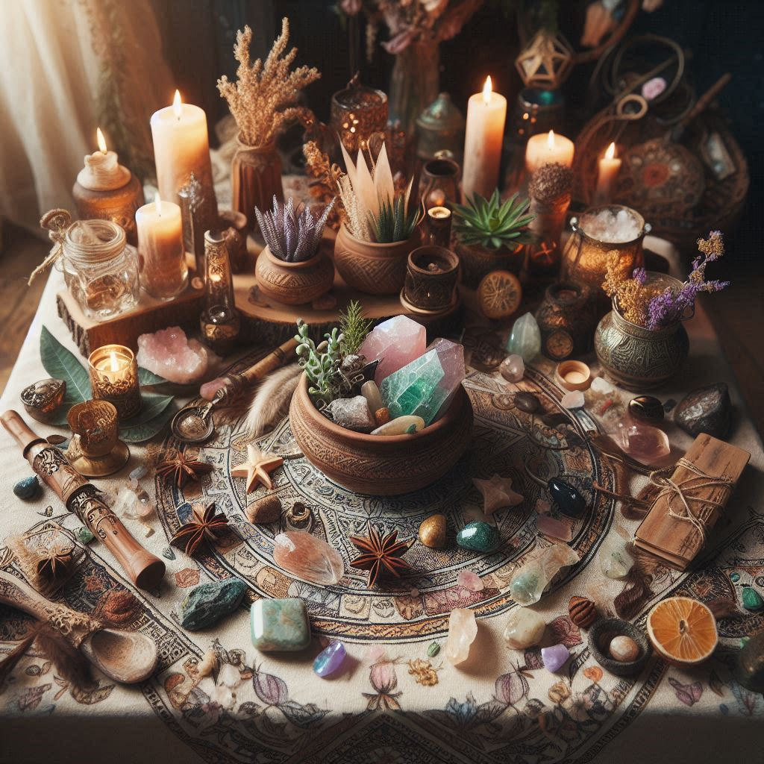
A. —Magic, understood like this, as sacred, is the queen of all sciences. To understand magic, you must know about crystals, minerals, vegetation, medicinal and nutritional plants. You must know the animal kingdom. We are part of the animal kingdom. We cannot understand each other if we do not approach the other companions on this beautiful journey on the ship Earth; they are also crew members. Fortunately, there are already movements calling for respect for animals.
A dog locked in a house... A dog is made to roam in nature; he doesn't wear shoes or pants or anything. Why don't you take him out into nature, even if only occasionally, to enjoy himself? That's his world. A bird locked in a cage, what did he commit to deserve to be put in prison? What does the selfish person want, what, to hear him sing? He doesn't sing, he's crying. And you want the Kingdom of GOD if you don't have true love, the love of Christ. "Love one another," that's a very profound study; it's not easy to practice. Love those you don't like, love those who have hurt you. Christ said, "To love a friend, anyone can do that." The important thing is to love your enemy, to wish them well, to return good for evil... and you win points.
The Sacred Offering, "sacrifice," sacrifice your selfishness, your disdain, your hatred, your sadness. The Holy Sacrifice of the Mass says the Catholic Church. Why sacrifice? And yes, it's true, but it must be studied. Evoking Christ's sacrifice in the Mass isn't for history, for a memory, no, it's for you to seek your transformation. When they give you the Host, "the body of Christ," are you going to meditate on what that is? Do you understand what that means, what they're transmitting to you? What is it? You're taking the body of Christ. Do you know the responsibility you assume to stop being an ordinary, problematic body? Are you really accepting that, or is it purely out of belief, just to spend a moment of prayer?
In the evangelical religion, they sing the Gospels, they read, they discuss them. But I'd like to see if they really practice what they're reading, because if not, well, it's a moment to feel at peace, calm. But to bring the word of God into life…the word of GOD is like saying food, a fruit; you have to digest it.
The Bible is not a religious book, it's a book of wisdom. That religions have maintained it, disseminated it, is fine, and we appreciate it, but they don't teach the keys that are in the Bible. "In the beginning, the spirit of GOD hovered over the waters." Have they explained that, why there was spirit and water in the beginning? I would ask a Christian, a Catholic. “Do you know how to unfold that thesis; do you know how to develop it? Write me a three-page essay, without beating around the bush, but with a foundation”.
Master Buddha— when Siddhartha Gautama reached the state of Buddha, like Jesus reached the state of Christ— was asked about the Origin, about reincarnation, that doesn't interest you, that's not your business, what are you going to do with that? Your task is to transform your life, to change your way of being, to stop being what you are so that you can become what you should be. Forget about the beginning, the end of the world, that's of no use to you, it doesn't change you. He was very practical; his gospels were about the mind, awakening the wisdom that lies dormant here [in the head], like seeds kept in a bag. That's what you have to dedicate yourself to. And what is in the Bible, in the Book of Genesis? A Kabbalist told us, "There is no talk about Creation in there; people have taken it that way in religions, but Genesis is a treatise on psychology; it talks about the structure of the human being."
Thus, one reads it differently. Genesis then speaks to us, "In the beginning, the Spirit of GOD hovered over the waters." What is in me? Before I was born, I floated in the waters of the womb. The Spirit of GOD was there, me, in the form of a little fish. Because in genetic psychology, in science, it is said that ontogenesis repeats phylogenesis. Ontogenesis is the development of the human being in the mother's womb; phylogenesis is the evolution of animals of life on Earth. So, in the mother's womb, one goes through all the stages that animals, all species, plants, went through... One is floating in the water like a little fish, going through the fish stage and thus evolving in the womb.
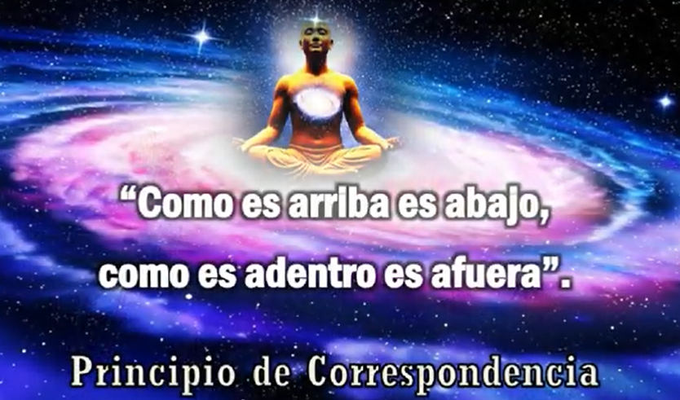
But before, it was a mineral, a little spark carried in the sperm, a mineral that was deposited in the mother's egg. And it goes through the mineral stage and then approaches the protozoan stage, in short... The invisible minerals, the... It becomes a little fish, then it becomes an amphibian, like the turtle and the crocodile; it goes to the edge of the womb; it attaches itself to the womb, by the umbilical cord. And so, one repeats in nine months, millions of years of evolution. Science says, ancient science says—Magic—"As within, so without, as above, so below, as in the great, so in the small." It's a very profound formula, a key. The Solar System is like the atom, the atom is like the solar system.
Well, there's another question. So, yes, knowledge. Magic isn't belief; you have to know chemistry to understand Alchemy.
Q. —What planet rules the Era of Aquarius?
A. —We already explained, Uranus. Uranus is the ruler of the sign of Aquarius and therefore of the Era of Aquarius, the planet of science, of profound transformations, of deep revolutions. Not political or military revolutions; that's the surface, no, not that. It leads nowhere. From within, from the human soul, from the depths of the Earth, from the soul of the Earth that is suffering today from the damage done to it, and the co-ruler, Saturn. The co-ruler of the sign of Aquarius is Saturn, co-ruler of the Era of Aquarius.
It is said... The Maestre says it could have been Venus, which they saw... it was very bright because it was very close to Earth, but that is what... the Maestre was speaking, in code, that is, Venus is exalted in the sign of Pisces. Venus does not rule Pisces. Pisces is ruled by Jupiter and Neptune, but the planet of Love is exalted. Thus, Master Jesus was the incarnation of Venus, the Master of Love. That is a key that is there. When you read a writing by a great Master, you have to go with a magnifying glass because they said... Master Jesus said, "The letter kills, the spirit gives life." You repeat by memory what the Bible says, you are dead. You decipher what the Bible says, you have life.
So, Master Jesus speaks in parables, in codes that one has to decipher. Maestre de la Ferrière clarifies, because we are in the Era of Science, the Era of Knowledge. But in what he clarifies, he provides clues, clues, which is what one must grasp. "Clue" means a key to open a world of wisdom, like opening a room. I gave you the clues to open the world of astrology. So, there you go, you no longer hesitate, you are on firm ground. Twelve signs, so many planets, so many houses, the aspects, this, that. You are now on solid ground to understand the sky that pertains to us, the Zodiac, the stars that surround the Solar System, a belt of stars, and within it is the solar system. These are ours, the ones GOD placed for us. There is wisdom there, it's not just for casting horoscopes and making money; no, you are desecrating the Sacred Science.
The other stars that are above, to the north and south, those don't pertain to us, but rather those that surround the Solar System. In addition to the signs, you need to know the main stars in each constellation—not the signs, but the stars of the astronomical zodiac. Regulus, for example, the largest star in the constellation of Leo—that's very important. There are about seven important stars in the Zodiac. That's a study we'll do later because we're in the ABCs of the sky that GOD gave us, the Zodiac, because the parable of the sower can't be given like that.
There are seeds that fall on hard ground, on rock, and they don't germinate. This is an opportunity you have; it's not a cult, I'm not asking for conversions, it's not a religion, it's not... We want to give because life is sacrifice. GOD sacrifices Himself; He gives, He gives. Master Jesus sacrificed Himself, the Buddha. The more you give, the more you receive. The Sun pours out its light every day and never runs out of light; it receives, receives... It gives and receives! He who gives, receives; that is surrender, having faith, "Men of little faith, why do you doubt?" when you are being given a hand, said Master Jesus. He is worthy of all respect, because if we have, in the Era of Aquarius in a first stage, it is: to add to the love that Christ taught, to add to it Knowledge.
First of all, "correct human relations," without creating conflicts, is the first priority, a world at peace. The rest comes later, it's fixed little by little, as long as there's no peace, it's useless. New technologies, more money, more equipment. I'd like to go to the United Nations and tell them that. Tell them, peace isn't a word, it's a science. You don't shout in the streets demanding peace, you apply the science of peace. That has its strategies, its techniques, with its progressive steps, but people study the science of war, the art of war. There are books on that; they don't study the science of peace and the art of peace.
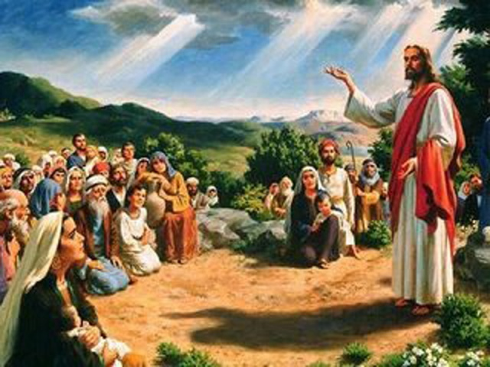
And Master Jesus also brought peace. Whenever, wherever he went to teach, first [he would say], "Peace be with you," and so on, like this. They paint Him like this, with the hand on the heart. The greeting is like this, the ancient greeting [the hand with the four fingers extended and the thumb turned inside the hand], self-control so that there is harmony in the World. This greeting is a mudra, the mudra of peace, the fingers together, because there are some who greet like this [with their fingers open], it means they are very rebellious, very independent. No, close together, submit to discipline so that your spiritual will gives you strength. And the hand... [left] here too, over the solar plexus, to control emotions, to truly radiate peace, saying the word peace like a mantra. Peace! And one visualizes waves of peace coming out of my Being towards the whole world.
So, it has the power of a mantra, it's a mudra, and it's the correct posture. And what we bring will help religions transform, teach the mysteries, explain them. We can go there. I went to the church of La Pedregosa to speak with the priest and those who assembled, the Knights of Saint Raphael, to give my point of view. So, Father Efraín respected me; he called me, "Master, thank you." So, go to the United Nations, going to the OAS, going to speak with the Pope in the Vatican and the cardinals. They are waiting because they guard what is from the past, but from the future, those who bring the teachings of the Era, we can speak of the future with complete authority. There will be no atomic war, impossible.
The assembly of wise men who care for the planet is vigilant, so that humanity does not fall into the abyss. They can commit atrocities, but only up to a certain limit. Like the father who lets his son get into mischief and is watching over him, "No, it's over, time to eat!" That's how the Assembly of Sages is, in a sacred place, on retreat, vigilant. And religions need to hear this, but many are closed off, they don't want to know. Well, that's their problem, but people are distancing themselves from them. People are getting tired because we're growing up in a world of wisdom, of science. And religion has science. Take it out of the museums, take it out of the libraries, teach it.
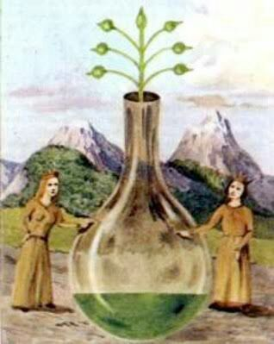
Well, then, about Spagyria. Spagyria is the part of Alchemy that is applied, for example, to medicinal plants. Not what people are used to, where you pull up a medicinal plant and boil it, no. There are those who say, “No, the plant has a spirit, it knows how to love. Please, respect it.” That plant gives its healing virtue: this one, on the full moon; this one, on the waning moon, and it should be collected at such and such a time. And there's a prayer to approach the plant world, and you're going to prepare it this way. I cited a book in English, which explains how to make a tincture of medicinal plants with Alchemy, and I included an internet address where there's also an explanation.
Everything written is a beginning; a Master is always needed. No one becomes a pilot by reading books if they don't have a teacher. No one becomes a doctor by reading books if they don't have professors. There has to be transmission from lip to ear, and that's not in the books.
So, there are alchemy books, yes, but whoever reads an alchemy book doesn't know what to do with it; they need a Master alchemist. Master Jesus, when he turned water into wine, gave a lesson in alchemy at the wedding at Cannan! At the wedding, on love! Alchemy implies love. Don't pull up the plant like that, "love one another." There is the presence of GOD in that little herb; it's everywhere.
Okay, so we've accomplished the task, informally, because I have to transmit some things. Because of my age, I have my suitcase ready when I have to leave, and there are things I can't keep that aren't mine; they're, as they say now, "the heritage of humanity." If they passed them on to me, I have to pass them on. Time has its laws too.
Very well, I have spoken, period. [ringing of bells]. The greeting is a bit military, like this, [...] not like this [forward], not like this either [down and to the side], on the same plane of the body, the hand, the arm. We inhale and visualize that peace brought by Christ, may it cover the entire Earth, may it spring forth in all souls, in all hearts. Thus, filled with visualization, we pronounce the word like a mantra: PASH!... In lak'ech (I am you), A’ lak’ en (you are me). We give thanks to GOD, the Creator.
Very well...

Superior Course in Theurgy, By the Ven. Master T. A-O Domingo Días Porta
All Rights Reserved

