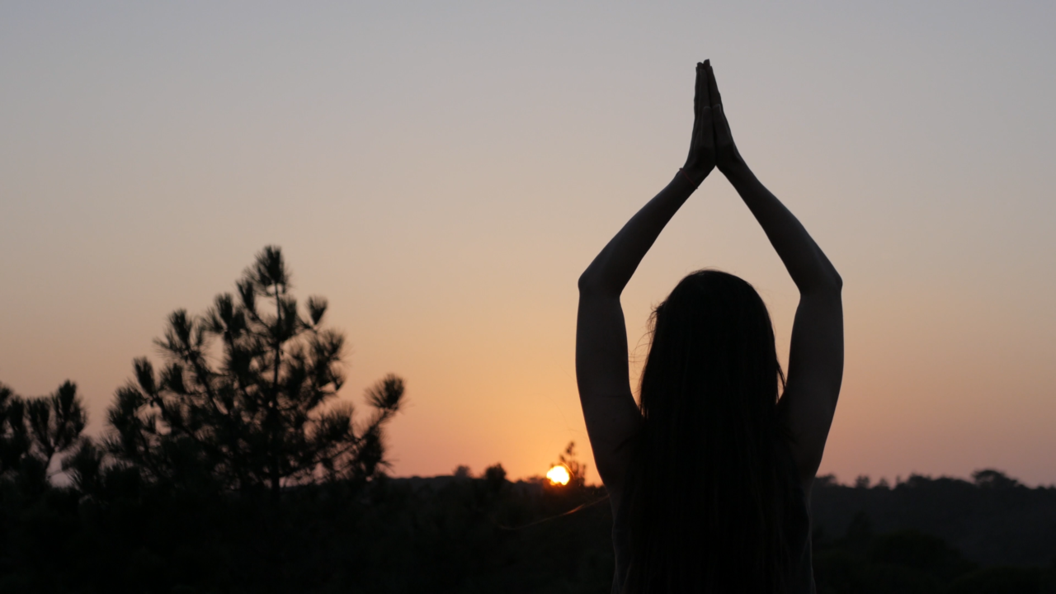
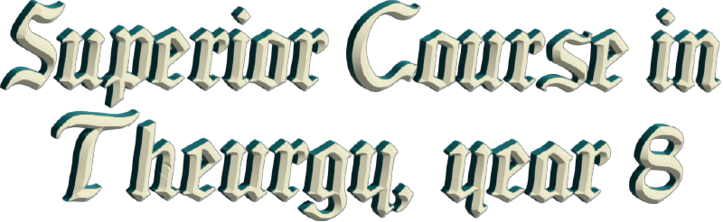
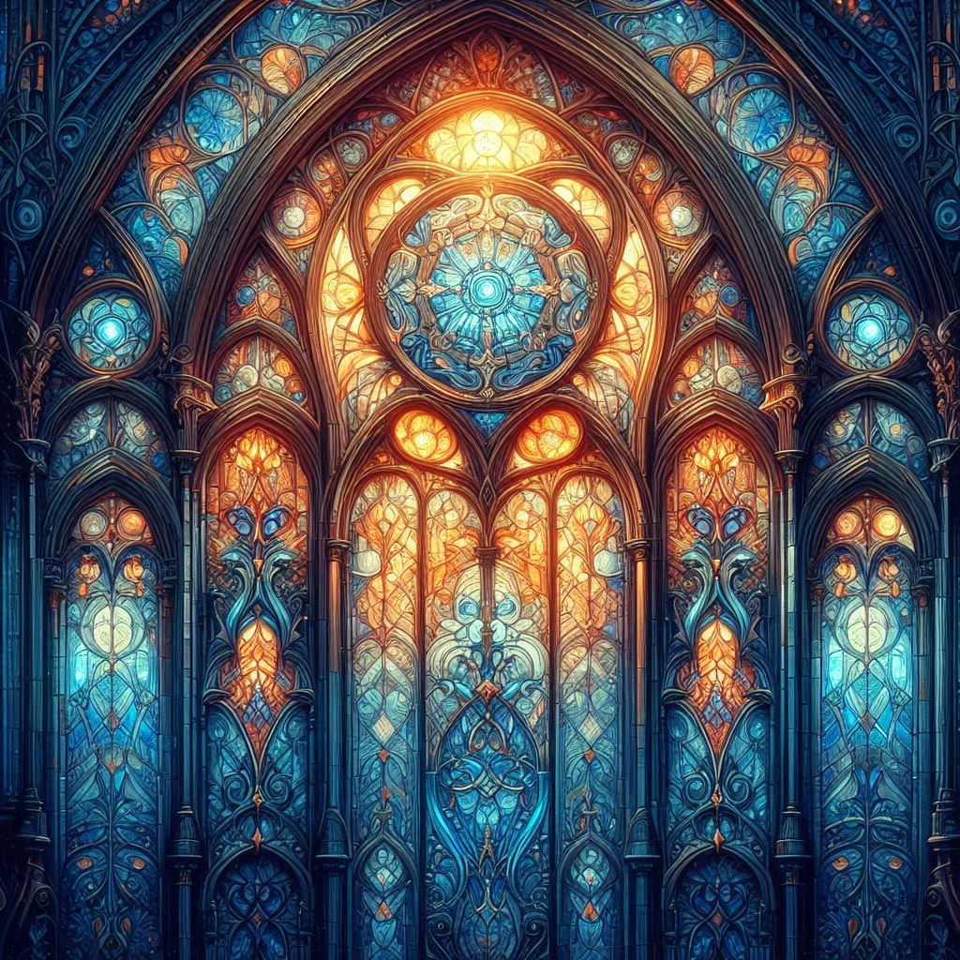

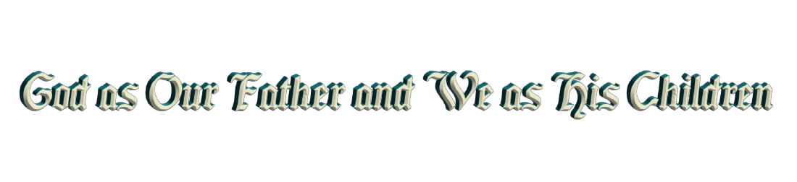

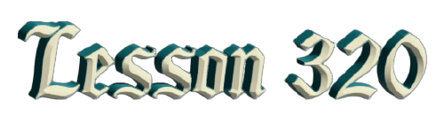
By Ven. Master T. A-O Domingo Días Porta

I
f we have a human father on Earth, why do we call GOD Father if HE doesn't behave like a father? He's very far from us, right? For many people, it seems like he is alone, is not heard, it seems like He’s mute […] due to this lack of education.
So, in what sense can we see GOD as a father? How do we take that? How do we explain it in our lives, how do we react before the Father? And that's already a first lesson, it's a discipline, not expecting GOD to behave like a dad, to be with us every day, to give us money, to give us food, etc., because that's not the idea of God.
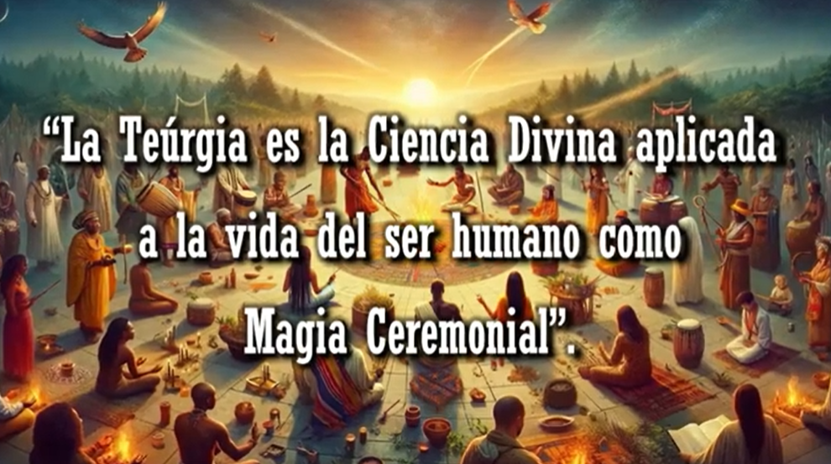
So, in what sense should we... What did Christ, Master Jesus, want to make us understand when he used that word? it's not only His, the Jewish tradition already talked about the Father, but if Master Jesus took it, that means that GOD agrees. So, the point is, for us, we must act as children of GOD, behave as children of God, and not ask GOD and expect Him to be like a dad. No, our behavior toward GOD, is helping Him, serving Him. That is what is called Theurgy, the divine science applied to human life. We study Theurgy, which is Ceremonial Magic on the Divine Plane, so that we contribute to the work of GOD and not go against the work of GOD. When we pollute nature, when we destroy it, we are against Theurgy, the work of GOD. GOD builds nature, and humans come to destroy it.
When we get sick, we are against divine work, because GOD established health, not sickness. Some people become distressed, suffer, etc., they lack the divinity of a child of GOD, they are crawling on the ground like a beggar. Being a spiritual prince or princess, the human being forgets their condition, and so on. The word "Father" gives us a standard of conduct as His children. Instead of wanting to have everything, we want to contribute to the work of GOD, we want to support it, we want to help; we want a happy humanity, a happy people, a happy family. A healthy humanity, a healthy people, a healthy family. A life full of wisdom, not ignorance, not superstition, not fear. We are already in an age of culture, of literacy, of science, so we are obliged to have that dignity as children of GOD, children of Heaven, of the Light, children of the Sun.
Then our, “our Father”, let us never say "my father" because He is not the personal property of anybody. Let us say "our Father" because what one applies to GOD is for the good of all. If we ask GOD for happiness, let us not say "give me happiness," no, "give us all happiness," in case we are going to ask him... One asks GOD for what pertains to GOD. If we ask him for money, Saint Peter will not let us enter. Look, GOD appointed a minister of finance, he appointed banks; you need money, go to the bank, go to the minister of economy, of finance.
"My God, heal me!"
Saint Peter tells them, "No, you can't pass.”
GOD placed doctors, healers, shamans on Earth, choose from naturopaths, hospitals, pharmacies. The Lord, GOD, is very busy with his duties, and HE delegates, like the government of Earth. He delegates to his angels and so on, those small functions, of health, of the economy, of... And on Earth, GOD establishes governments for the people who are in charge of that as well. And thus, the president of a country. The president of a country delegates functions to his ministers so that people don’t go to him with things that aren't his responsibility. The president is supposed to preside; he isn’t in charge of the economy, of industry, of education. That's how the human president, places his ministers on Earth.
And the president is responsible for "presiding" over the lives of the people. The true president, as there are presidents, ensures that there is no disease in the country, that there are no families in poverty, that there are no abandoned children, etc., the human aspect, presiding over the people.
And so GOD also has his functions. When it is said in the Lord's Prayer, "...give us this day our daily bread," the people are asking... GOD would say, “I put bakers there for you.” The correct thing is, bread of wisdom, the bread of wisdom. We see this in The Holy Supper, The Lat Supper, where the Master Jesus says, "Eat of this bread..." What else does he say? "...for this bread is My body." But not the body of Jesus, the body of Christ. Christ is not Jesus' last name, Christ is a title. Jesus "The Christ," as we say John the physician, the function, the profession, let's say, "Christ."
So, to eat the bread of Christ is to eat wisdom. Just as we nourish the body, we must nourish our spirit, but many people are mentally and spiritually malnourished; no matter how much they fill their stomachs, there is malnutrition.
Well, that's just talking about our daily bread, but [...] our daily bread, the Lord's Prayer: "Our Father who art in Heaven...". What heaven? Because heaven is very large. The verb "to be" indicates a clear location, "...who art in Heaven," there is a factor, which star, in what planet?
If I ask people—"And you, where are you?"
"I'm in Mérida."
“No, I don't know how to find you; you haven't told me anything; you have to give me the exact address.”
And so, "Our Father who art in Heaven..."—that heaven has its study. Where can we find Him? We, as human beings, want to understand life, want to understand what it's all about.
Well [...], what we can ask of GOD, as the one who presides over the Universe, is that wisdom, because He is the author of the laws that govern plants, minerals, animals, humans, stars, planets, atoms. Everything is subjected to the laws; science has proven all of this. GOD acts by laws, not by whims, He complies with the Law. If we want to ask for something, He says, “I established the Law.” How you should live, how you should eat, you should behave. You commit and error and you want GOD to correct you! No, correct yourself. Thus, that heaven is represented there, it is the Zodiac. Through the wisdom that is written there, in that corner of the sky, the belt of stars that surrounds the Earth and the solar system, those universal laws are written. Everything that it rules: the existence of the atom, the galaxy, the infinite, space, eternal time, small time, small space, the human era, etc.; everything is recorded there. It is not simply a personal horoscope, there is much more than that in there, but we must study the “Science of GOD”; GOD is science.
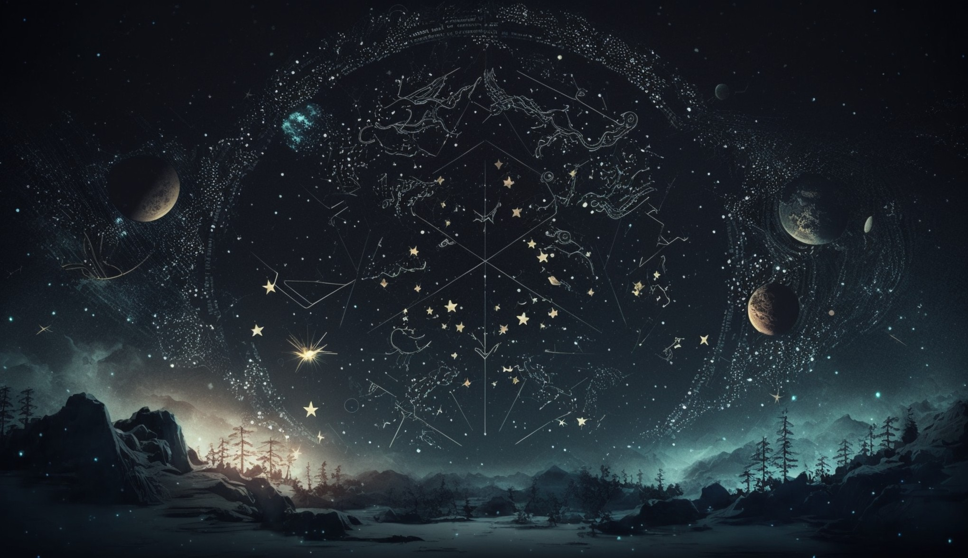
It's not just talking like that, like an ignorant person who talks about GOD, without foundation. This... is nonsense. GOD is science, GOD is not improvisation, God is scientific. Not only Religion deals with GOD, Science deals with GOD, if it’s properly focused. Today's Science is materialistic. It pushes aside the spiritual, the human, and it dedicates itself to study atoms, mechanics, electricity, the stars, etc., without helping us understand our connection with those atoms, with those galaxies, with those stars, with energy, electricity, etc., magnetism.
So, that's the Science of GOD, of science, let's say science. Higher Science is Theurgy, the Divine Work; how does that which is called GOD act, and what is that which is called GOD? Is it a person who lives somewhere? Or is it everywhere and therefore has no form? If it had form, it would be in one place, but if it is everywhere, it has no form.
Well then, heaven, that refers to the Zodiac, the stars that surround the Earth and the solar system in which we live. Our home, the Solar System, is not only, as some say, Mother Earth; no, the mother, is the solar system. The Earth's life depends on the energies of the sun, the moon, the planets, the cosmic radiation that science studies, etc. Everything is energy; matter is not solid, matter is made up of atoms, they are separated from each other, matter [...]. Solar energy passes through walls, cosmic radiation passes through them, radioactivity, etc., passes through bodies. We are totally accompanied; they enter and leave towards the ground. Like X-rays enter the body and leave the body, such are the energies of what we call matter. Matter is made up of atoms, and atoms are energy fields.
The atomic bomb harnesses that energy; a few atoms explode and destroy a city, and even more. The atom is a container of energy. The atom isn't solid, it is formed by a nucleus, the protons, and electrons that revolve around it like a solar system. And between one electron and another, there's a space. Between the electrons and in the center of the atom, there's a lot of space. Of course, they’re so tiny, that's measured... The millimeter is too large to measure the space inside the atom. A millionth of a millimeter, but there's more space in the atom, than... in that particle.
In each electron, if we analyze it, it’s energy. It’s made up of smaller particles that are separated, and the space there, is made up of electrons, protons and other things; that space is energy. There's no empty space. When we say, "the glass is empty," it's empty of liquid, but full of air. If we remove the air, it's full of energy. There is no absolute emptiness.
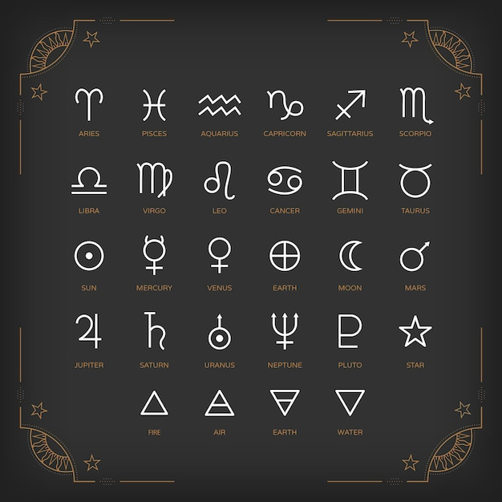
Well then, GOD is science. His science is reflected in the sky of the zodiac. One could study other stars, but as long as we don’t understand the sky where the Wisdom of GOD dwells, we can’t pretend to study things that are further away from us. The Zodiac is our body, our cosmic school. I already explained the alphabet to you the other day, the astrological alphabet, with which words are formed, that construct sentences to transmit knowledge. Just as in languages like, English, Spanish, Chinese, etc., there are letters that form words to transmit knowledge, like a song, whatever. Thus, […] has its language. Chemistry has its language; physics has its language. And only the chemist can read the language of chemistry; the rest of us are illiterate in that. So, in the Book of GOD, in that writing, that cosmic bible of the zodiac, there we have an alphabet that I already explained to you. And, with that alphabet one writes. I gave you an example of a writing of the other day.
Can someone write the letters of the four elements for me on the blackboard? A volunteer, if there are no men volunteers, then women volunteers. Who wants to step forward? Let's see, the letters of the astrological alphabet of the four elements, not in Spanish, English, or Chinese. How do you write fire, the symbol? Lager so they can see it. that's fire. You don't have to put four letters. No, science always tries to reduce the writing, not the language of letters. So, first fire. Put an ‘f’ below fire. Which one is this? Water. Look, so you don't forget, fire, a triangle with the point pointing up, it's like the small flame of a candle fire. And the next one? A triangle with the point downward, like a pointed cup of water, a paper cone. Now you remember, water is the paper cone, fire is the little flame.
Which one is that, with the point pointing up, like fire, crossed by a little line? That's air, as if it were a cloud crossing a mountain. Like we see here, air. A mountain crossed by [...]. And earth, like water, with the point pointing down, a triangle crossed by a little line. It's like an arrow that fell to earth, represented by […].
[That is] the alphabet of the elements. Now we are going to see the alphabet of the planets. How do you write the planets? Another candidate, another victim. You need to study, because we are in the Era of Knowledge, not of belief without taking notes, and putting away de notebook, and accepting, in that goes your own life. Look you are rejuvenating; you are among youth […] That is the best way to rejuvenate. Nobody is taking liquids to rejuvenate and operate. You can study and you will always maintain a youthful mind.
Let's see, write down the Sun, but without looking. Don’t copy on the exam, no professor would accept that! Which one is that. That's the letter of the Sun. Now the moon is half a circle, no, backwards, it's like a "V." That is Mercury, the closest to the sun (Mercury). Don't give her the answer. That's Taurus, it's similar but, with a semicircle like this. That’s Mercury the closest to the sun. In how many days does Mercury orbit around the sun? 365? No its too close to the sun. Eighty-eight days. Mercury's year lasts 88 days, three months or so. That represents the mind, the mind is quick. Those who have Mercury very strong in their horoscope are quick-minded. They understand quickly, they express themselves rapidly.
That's Venus, Venus has a circle on top. Those elements that form the alphabet of the planets that form a semicircle, a circle, and a cross. Who knows the meaning of that? What is the meaning of a semicircle, a circle in the language of astrology. It's easier to understand the cross. What does the cross represent? Matter. More than matter, our material life, our occupations, our home, our life, etc.
Well, then, the circle is... Matter and... and spirit. The circle represents the Spirit. Matter and Spirit, the law of polarity. And the semicircle, what links matter with the spirit. It is the emotional part, the feelings, the emotivity. The bridge that unites the spirit with matter, are the feelings, emotivity. Which is why there are emotions that are more on the side of the spirit, and some are very possessive, very materialistic. Also, negative emotions like hatred are emotions linked to the material.
So, let’s say this is the kingdom of the spirit in the world above. This is the kingdom of matter. An energetic bridge is made to link the spirit with matter. This is the emotional part, the feelings, the desire, the passions, the taste for something, all which moves us. Elevated feelings are closer to the Kingdom of the Spirit, and denser feelings, are closer to [...] body, spirit... And what do you call what links the spirit with the body? The soul, but in our studies? It's called "the plastic mediator," it's a bridge that adapts upwards, downwards, a mediator, an intermediary, the soul, the plastic mediator, the etheric body, the energetic body. With that etheric body or soul, it is the one we use to dream. The body in bed asleep, and it doesn’t know, and we go from there on one great adventure, or at a party toasting, or traveling in the jungle, etc. Those dreams that we have, those are achieved thanks to the soul. One does not separate from the body; a cord is left. What is it called, what unites the soul to the physical body, like the umbilical cord? It is called the silver cord. It is the one that wakes us up when we are dreaming, it quickly, brings the soul back.
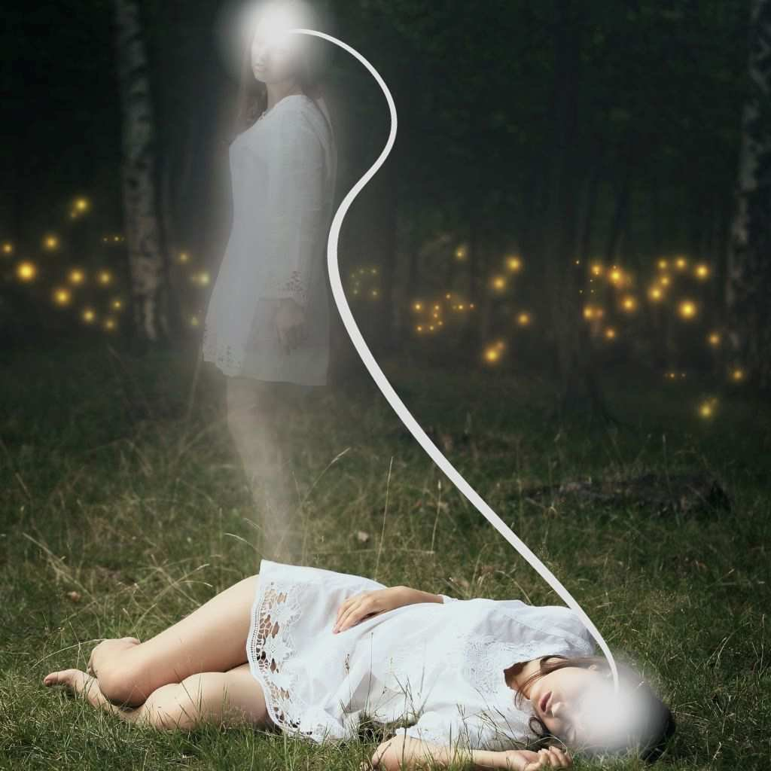
The silver cord, when one dies, unravels on the third day. That's why the body is not buried until the third day, so that separation can take place. There's still a very fine thread that on the third day when he is going to be born […]. A fine thread that links the child with his beloved family members, or to his money that was buried, as was done back then […] under the mattress of the bed. The very materialistic soul doesn't want to let go of its money; it remains a soul in pain for a time, going around looking after its money, or its house, its family, until at last it accepts, “I can’t intervene in this world anymore.” He wants to embrace his children, his things, and they pass through the body. And one doesn’t see this. If he was very materialistic, it will take a longer time. But if the human condition was normal, there comes a time when he says goodbye.
Fine, then we are [placing them] in order closest to the sun. The closest to the sun, Mercury, followed by Venus, then the Earth. The Earth: matter dominates the spirit. In Mars the cross transforms into an arrow. It is matter propelling it, taking the energy of Mars, the planet of action, of war, of struggle, of adventure. It depends on how our being takes the energy from Mars. Now then, after Mars… Look these two planets are called the interior planets, because they are between the Earth and the Sun. After the Earth, there are exterior planets; they are from the Earth towards space.

Superior Course in Theurgy, By the Ven. Master T. A-O Domingo Días Porta
All Rights Reserved

